Sensor details

05 March 2019

17:17

<<2\_Sensor 26\_3um\_3D Hetro Nanostructures CoFe\_drawing of crosses before measurments 05\_03\_2019.pdf>>

* + This sensor is old fabicated by Merlin. It has 3µm cross size.
  + It has been handed to Fabritizo to grow these structures shown below

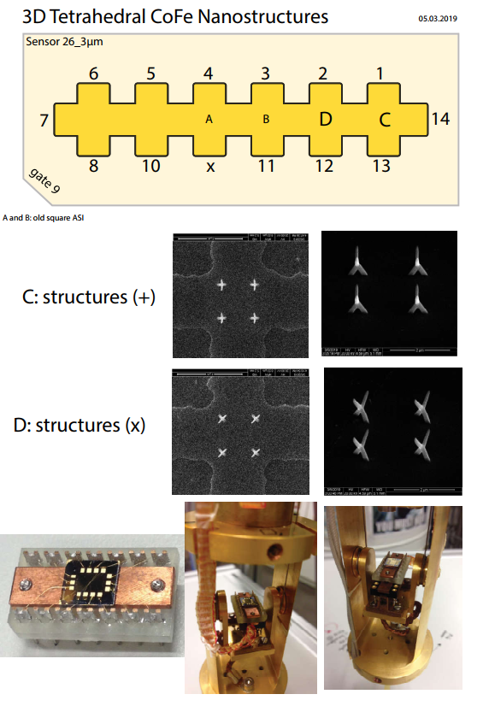

Loading inside the IVC

05 March 2019

17:30

* + The sensor Has been loaded on the Yoke directly after taking it out from the SEM chamber.
  + Closing the IVC very quick.
  + Pumping out the IVC for two hours (10^-5 mbar)

Loading inside Janis

06 March 2019

09:30

* + Mohanad, Jens and Jonathan, managed to load the IVC inside Janis. The process was very gentle and the He level was 15 in. We let the system relax and filled He after 1 hour.

Introducing an exchange gas\_attention please\_!!

06 March 2019

13:30

**Important Notes:**

* + We had problem when we introduced and exchange gas. The temperature was around 200K and we introduced 1mbar for 1s. The process of cooling was very fast and we lost a lot of He(l). The cooling rate was very high and we reached 4k in 1.5 hour. That was not good and we should next time wait at least one day to cool naturally and then intorduce an exchange gas.

**Important Notes:**

Don't introduce exchange gas too early (T > 200 K)

Be careful and introduce as little exchange gas as possible

<<20190306-1600-I1-1-13\_I2-8-6\_GBIP8-14-7\_Vin-1V\_R1-9.25KO\_R2-1MO\_T-10K\_0degSensor\_3D-Tetra\_Nano\_CoFe\_SR-0.02-T-min\_Gradio\_Up.dat>><<20190306-1600-I1-1-13\_I2-8-6\_GBIP8-14-7\_Vin-1V\_R1-9.25KO\_R2-1MO\_T-10K\_0degSensor\_3D-Tetra\_Nano\_CoFe\_SR-0.02-T-min\_Gradio\_down.dat>>

M1: + Gradio 10K

**Filename:**

20190306\_1600\_...

Wednesday, 6. March 2019

15:31

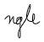

|  |  |
| --- | --- |
| + 200 mT | -200 mT |
| 4 μV | -11 μV |

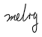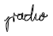

**Experiment Setup:**

T = 10K

|  |  |
| --- | --- |
|  | 1 |
|  | 1 MΩ |
|  | 9,25 kΩ |
|  | 0 |
|  | 1 MΩ |
|  | 1 μA |
|  | 1 μA |
|  | 0 |
| Sens: | 20 μV |





**Lock-In Setup:**

|  |  |
| --- | --- |
| Sens: | 20 μV |
| τ: | 1s |
| Float/Ground: | Ground |
| AC/DC: | AC |
| A/A-B: | A-B |
| Reserve: | Normal |
| Source: | Internal |

**Cables Setup:**

|  |  |
| --- | --- |
|  | 13-1 |
|  | * 1. 8 |
|  | * 1. 7 |

**Magnet Setup:**

|  |  |
| --- | --- |
| Range: | ± 200 mT |
| Rate: | 20 mT/min |

**Important Notes:**

M2: + Gradio 20K

**Filename:**

20190306\_1700\_...

Mittwoch, 6. März 2019

16:00

**Cables Setup:**

|  |  |
| --- | --- |
|  | 1-13 |
|  | * 1. 8 |
|  | * 1. 7 |

**Experiment Setup:**

|  |  |
| --- | --- |
| T | 20 K |
|  | 1 V |
|  | 1 MΩ |
|  | 10,5 kΩ |
|  | 0 |
|  | 1 MΩ |
|  | 0,99 μA |
|  | 1 μA |
|  | 0 |

**Lock-In Setup:**

|  |  |
| --- | --- |
| Sens: | 20 μV |
| τ: | 1s |
| Float/Ground: | Ground |
| AC/DC: | AC |
| A/A-B: | A-B |
| Reserve: | Normal |
| Source: | Internal |

50\*210/1000 = 10,5

**Magnet Setup:**

|  |  |
| --- | --- |
| Range: | ± 250 mT |
| Rate: | 8 mT/min |

**Gradiometry Balance:**

|  |  |
| --- | --- |
|  | 9.5 μV |
|  | -14.2μV |
| Mean: | -2.5 μV |

**Important Notes:**

M3: + Gradio 30K

**Filename:**

20190307\_0900…

Donnerstag, 7. März 2019

09:24

**Cables Setup:**

|  |  |
| --- | --- |
|  | 1-13 |
|  | * 1. 8 |
|  | * 1. 7 |

**Experiment Setup:**

|  |  |
| --- | --- |
| T | 30 K |
|  | 1 V |
|  | 1 MΩ |
|  | 44,4 kΩ |
|  | 0 |
|  | 1 MΩ |
|  | 0,99 μA |
|  | 1 μA |
|  | 0 |

**Lock-In Setup:**

|  |  |
| --- | --- |
| Sens: | 10 μV |
| τ: | 1s |
| Float/Ground: | Ground |
| AC/DC: | AC |
| A/A-B: | A-B |
| Reserve: | Normal |
| Source: | Internal |

**Magnet Setup:**

|  |  |
| --- | --- |
| Range: | ± 400 mT |
| Rate: | 30 mT/min |

**Important Notes:**

R12 = 50\*888/1000=44,4 kΩ

M4: + Gradio 1T

**Filename:**

20190307\_1200…

Donnerstag, 7. März 2019

11:51

|  |  |
| --- | --- |
| 1st Run | Down |
| 1st Run | Up |
| 2nd Run | Down again |
| 2nd Run | Up again |

Measured everything twice to make sure it's reproducable

**Cables Setup:**

|  |  |
| --- | --- |
|  | 1-13 |
|  | * 1. 8 |
|  | * 1. 7 |

**Experiment Setup:**

|  |  |
| --- | --- |
| T | 30 K |
|  | 1 V |
|  | 1 MΩ |
|  | 6,05 kΩ |
|  | 0,19 kΩ |
|  | 1 MΩ |
|  | 1 μA |
|  | 1 μA |
|  | 0 |
|  | Pos 1 (6.8 pF) |
|  | Pos 6 (56 pF) |

**Lock-In Setup:**

|  |  |
| --- | --- |
| Sens: | 20 μV |
| τ: | 1s |
| Float/Ground: | Ground |
| AC/DC: | AC |
| A/A-B: | A-B |
| Reserve: | Normal |
| Source: | Internal |

**Magnet Setup:**

|  |  |
| --- | --- |
| Range: | ± 1T |
| Rate: | 150 mT/min |

**Gradiometry Balance:**

|  |  |
| --- | --- |
|  | 30 μV |
|  | -24 μV |
| Mean | 3μV |

**Important Notes:**

Changing Grounding of Gate (9) and

Grounding Connection 4

Both grounded by connecting it to voltage source with Output of 0 V (at + connection, which is the inner connection of the coax-cable).

The - part (outer shield of coax-cable) is not connected.

50\*121/1000 = 6,05

10\*19/1000 = 0,19

M5: + Gradio 1.5T

**Filename:**

201903

Donnerstag, 7. März 2019

16:39

**Cables Setup:**

|  |  |
| --- | --- |
|  | 1-13 |
|  | * 1. 8 |
|  | * 1. 7 |

**Experiment Setup:**

|  |  |
| --- | --- |
| T | 30 K |
|  | 1 V |
|  | 1 MΩ |
|  | 6,25 kΩ |
|  | 0 |
|  | 1 MΩ |
|  | 1 μA |
|  | 1 μA |
|  | 0 |
|  | Pos 1 |
|  | Pos 6 |

**Lock-In Setup:**

|  |  |
| --- | --- |
| Sens: | 20 μV |
| τ: | 1s |
| Float/Ground: | Ground |
| AC/DC: | AC |
| A/A-B: | A-B |
| Reserve: | Normal |
| Source: | Internal |

**Magnet Setup:**

|  |  |
| --- | --- |
| Range: | ± 1500 mT |
| Rate: | 100 mT/min |

**Important Notes:**

50\*125/1000=6,25

----- Angle: 0deg ----

Dienstag, 12. März 2019

13:44

C: Changing angle 0deg (reference angle)

10 March 2019

19:37

|  |  |
| --- | --- |
| (1) Structures measured | Empty Cross |
| (2) Measurement type | Angle Changing |
| **(3) Cables Setup:** | |  |  |  | | --- | --- | --- | |  | *14 - 7* |  | |  |  |  | | Gate (9) |  |  | |
| **(4) Magnet Setup:** | B = 1 T |
| **(5) Experiment Setup:** | |  |  | | --- | --- | | T |  | |  |  | |  | 1 MΩ | |  | 0 | |
| **(6) Lock-In Setup:** | |  |  | | --- | --- | | Sens: | 20 μV | | τ: | 1s | | Float/Ground: | Ground | | AC/DC: | AC | | A/A-B: | A-B | | Reserve: | Normal | | Source: | Internal | |
| **(7) Important Notes:** | Hall Voltage of empty cross @ 1 T before changing angle (old angle 45deg) is -7.826 mV instead of expected cos(45)\*11.164 = 7.894 |
| **(8) Filename and data:** | No File created |

Hall Voltage:



Update: this formula is not write you have to multiply by 360 not dividing by

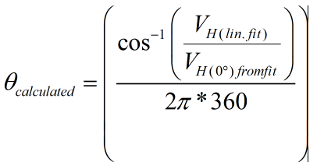

M6: Plusses\_Hloop\_0deg

06 March 2019

17:00

|  |  |
| --- | --- |
| (1) Structures measured | Plusses C |

**(8) Filename and data:**

20190

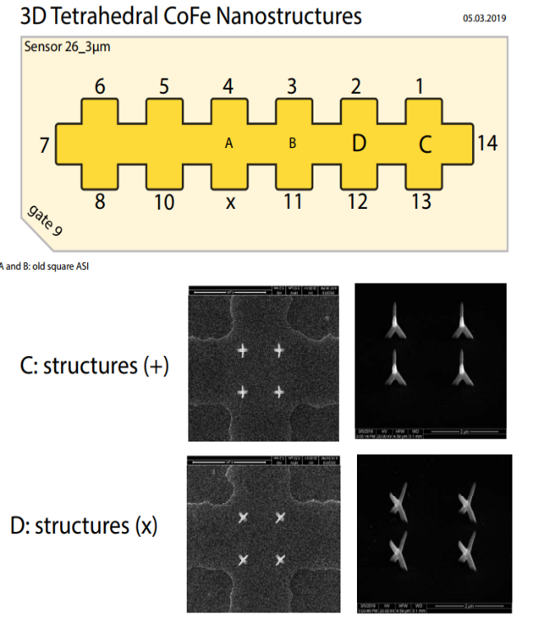

|  |  |
| --- | --- |
| **(2) Measurement type** | Hloop\_gradiometry |
|  |  |
|  |  |
|  |  |

<<20190306-1700-I1-1-13\_I2-8-6\_GBIP8-14-7\_Vin-1V\_R1-1.01MO\_R2-1MO\_T-20K\_0degSensor\_3D-Tetra\_Nano\_CoFe\_SR-0.008-T-min\_Gradio\_Up.dat>>

**(3) Cables Setup:**

|  |  |
| --- | --- |
|  | 1-13 |
|  | 8-6 |
|  | * 1. 7 |

<<20190306-1700-I1-1-13\_I2-8-6\_GBIP8-14-7\_Vin-1V\_R1-1.01MO\_R2-1MO\_T-20K\_0degSensor\_3D-Tetra\_Nano\_CoFe\_SR-0.008-T-min\_Gradio\_down.dat>>

**(4) Magnet Setup:**

|  |  |
| --- | --- |
| Range: |  |
| Rate: |  |

**(5) Experiment Setup:**

|  |  |
| --- | --- |
| T |  |
|  |  |
|  | 1 MΩ |
|  | 0 |
|  | 0 |
|  | 1 MΩ |
|  | 1 μA |
|  | 1 μA |
|  | 0 |
|  |  |

R1=1.01MO

R2=1MO

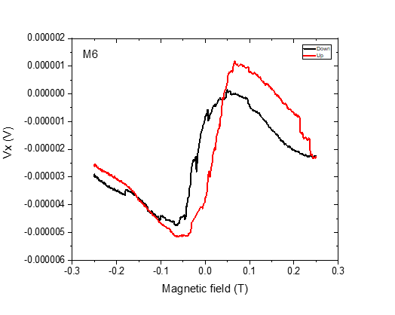

**(6) Lock-In Setup:**

|  |  |
| --- | --- |
| Sens: | 20 μV |
| τ: | 1s |
| Float/Ground: | Ground |
| AC/DC: | AC |
| A/A-B: | A-B |
| Reserve: | Normal |
| Source: | Internal |

**(7) Important Notes:**

M7: Plusses\_Hloop\_0deg

07 March 2019

09:13

|  |  |
| --- | --- |
| (1) Structures measured | Plusses |

**(8) Filename and data:**

20190



|  |  |
| --- | --- |
| **(2) Measurement type** | Hloop\_gradiometry |
|  |  |
|  |  |
|  |  |

<<20190307-0900-I1-1-13\_I2-8-6\_GBIP8-14-7\_Vin-1V\_R1-1.01MO\_R2-1MO\_T-30K\_0degSensor\_3D-Tetra\_Nano\_CoFe\_SR-0.03-T-min\_B-0.4T\_Gradio\_Up.dat>>

**(3) Cables Setup:**

|  |  |
| --- | --- |
|  | 1-3 |
|  | * 1. 8 |
|  | * 1. 7 |

<<20190307-0900-I1-1-13\_I2-8-6\_GBIP8-14-7\_Vin-1V\_R1-1.01MO\_R2-1MO\_T-30K\_0degSensor\_3D-Tetra\_Nano\_CoFe\_SR-0.03-T-min\_B-0.4T\_Gradio\_down.dat>>

**(4) Magnet Setup:**

|  |  |
| --- | --- |
| Range: |  |
| Rate: |  |

**(5) Experiment Setup:**

|  |  |
| --- | --- |
| T |  |
|  |  |
|  | 1 MΩ |
|  | 0 |
|  | 0 |
|  | 1 MΩ |
|  | 1 μA |
|  | 1 μA |
|  | 0 |
|  |  |

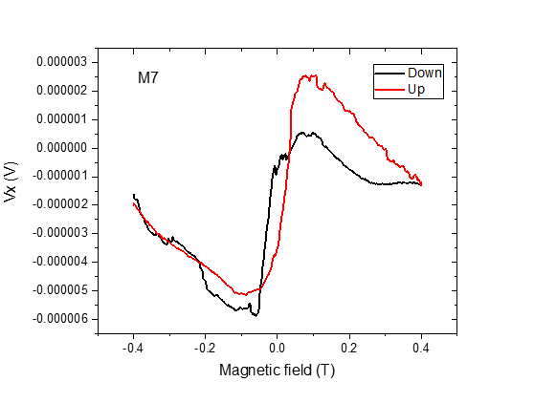

**(6) Lock-In Setup:**

|  |  |
| --- | --- |
| Sens: | 20 μV |
| τ: | 1s |
| Float/Ground: | Ground |
| AC/DC: | AC |
| A/A-B: | A-B |
| Reserve: | Normal |
| Source: | Internal |

**(7) Important Notes:**

M8: Plusses\_Hloop\_0deg

07 March 2019

09:28

|  |  |
| --- | --- |
| (1) Structures measured | Plusses |



|  |  |
| --- | --- |
| **(2) Measurement type** | Hloop\_gradiometry |
|  |  |
|  |  |
|  |  |

**(3) Cables Setup:**

|  |  |  |
| --- | --- | --- |
|  |  |  |
|  |  |  |
|  |  |  |
| Gate (9) |  |  |

**(8) Filename and data:**

20190

<<20190307-1200-I1-1-13\_I2-8-6\_GBIP8-14-7\_Vin-1V\_R11-1MO\_R12-6.05KO\_R13-0\_R21-1MO\_C11-1\_C21-6\_T-30K\_0deg\_plusses\_SR-0.15-T-min\_B-1T\_gate-0V\_Gradio\_Up.dat>>

<<20190307-1200-I1-1-13\_I2-8-6\_GBIP8-14-7\_Vin-1V\_R11-1MO\_R12-6.05KO\_R13-0\_R21-1MO\_C11-1\_C21-6\_T-30K\_0deg\_plusses\_SR-0.15-T-min\_B-1T\_gate-0V\_Gradio\_down.dat>>

**(4) Magnet Setup:**

|  |  |
| --- | --- |
| Range: |  |
| Rate: |  |

**(5) Experiment Setup:**

|  |  |
| --- | --- |
| T |  |
|  |  |
|  | 1 MΩ |
|  | 6.05kO |
|  | 0 |
|  | 1 MΩ |
|  | μA |
|  | μA |
|  | 0 |
|  |  |

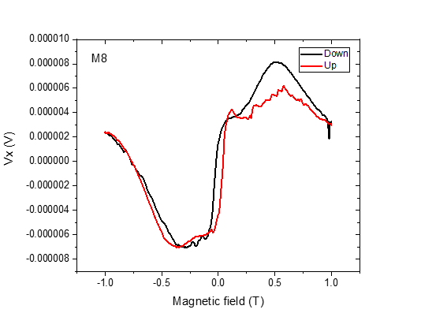

**(6) Lock-In Setup:**

|  |  |
| --- | --- |
| Sens: | 20 μV |
| τ: | 1s |
| Float/Ground: | Ground |
| AC/DC: | AC |
| A/A-B: | A-B |
| Reserve: | Normal |
| Source: | Internal |

**(7) Important Notes:**

M9: Plusses\_Hloop\_2nd of M8\_0deg2

07 March 2019

09:53



|  |  |
| --- | --- |
| (1) Structures measured | Plusses |

|  |  |
| --- | --- |
| **(2) Measurement type** | Hloop\_gradiometry |
|  |  |
|  |  |
|  |  |

**(3) Cables Setup:**

|  |  |  |
| --- | --- | --- |
|  |  |  |
|  |  |  |
|  |  |  |
| Gate (9) |  |  |

**(8) Filename and data:**

<<2nd\_20190307-1200-I1-1-13\_I2-8-6\_GBIP8-14-7\_Vin-1V\_R11-1MO\_R12-6.05KO\_R13-0\_R21-1MO\_C11-1\_C21-6\_T-30K\_0deg\_plusses\_SR-0.15-T-min\_B-1T\_gate-0V\_Gradio\_up.dat>>

<<2nd\_20190307-1200-I1-1-13\_I2-8-6\_GBIP8-14-7\_Vin-1V\_R11-1MO\_R12-6.05KO\_R13-0\_R21-1MO\_C11-1\_C21-6\_T-30K\_0deg\_plusses\_SR-0.15-T-min\_B-1T\_gate-0V\_Gradio\_down.dat>>

**(4) Magnet Setup:**

|  |  |
| --- | --- |
| Range: |  |
| Rate: |  |

**(5) Experiment Setup:**

|  |  |
| --- | --- |
| T |  |
|  |  |
|  | 1 MΩ |
|  | 6.05kO |
|  | 0 |
|  | 1 MΩ |
|  | μA |
|  | μA |
|  | 0 |
|  |  |

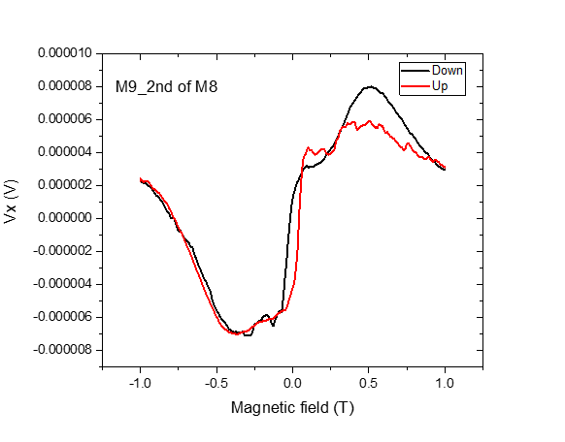

**(6) Lock-In Setup:**

|  |  |
| --- | --- |
| Sens: | 20 μV |
| τ: | 1s |
| Float/Ground: | Ground |
| AC/DC: | AC |
| A/A-B: | A-B |
| Reserve: | Normal |
| Source: | Internal |

**(7) Important Notes:**

M10: Plusses\_Hloop\_0deg

07 March 2019

10:03



|  |  |
| --- | --- |
| (1) Structures measured | Plusses |

|  |  |
| --- | --- |
| **(2) Measurement type** | Hloop\_gradiometry |
|  |  |
|  |  |
|  |  |

**(3) Cables Setup:**

|  |  |  |
| --- | --- | --- |
|  |  |  |
|  |  |  |
|  |  |  |
| Gate (9) |  |  |

**(8) Filename and data:**

<<20190307\_1700\_I1-1-13\_I2-8-6\_GBIP8-14-7\_Vin-1V\_R11-1MO\_R12-6.25kO\_R13-0\_R21-1MO\_C11-1\_C21-6\_T-30K\_0deg\_plusses\_SR-0.1-T-min\_B-1.5T\_gate-0V\_Gradio\_Up.dat>>

<<20190307\_1700\_I1-1-13\_I2-8-6\_GBIP8-14-7\_Vin-1V\_R11-1MO\_R12-6.25kO\_R13-0\_R21-1MO\_C11-1\_C21-6\_T-30K\_0deg\_plusses\_SR-0.1-T-min\_B-1.5T\_gate-0V\_Gradio\_down.dat>>

**(4) Magnet Setup:**

|  |  |
| --- | --- |
| Range: |  |
| Rate: |  |

**(5) Experiment Setup:**

|  |  |
| --- | --- |
| T |  |
|  |  |
|  | 1 MΩ |
|  | 6.25kO |
|  | 0 |
|  | 1 MΩ |
|  | μA |
|  | μA |
|  | 0 |
|  |  |

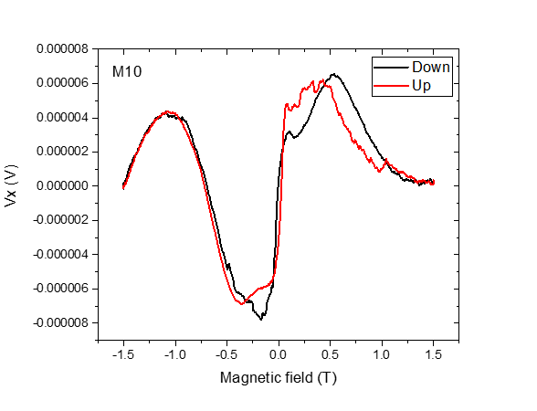

**(6) Lock-In Setup:**

|  |  |
| --- | --- |
| Sens: | 20 μV |
| τ: | 1s |
| Float/Ground: | Ground |
| AC/DC: | AC |
| A/A-B: | A-B |
| Reserve: | Normal |
| Source: | Internal |

**(7) Important Notes:**

M11: Plusses\_Hloop\_0deg0

08 March 2019

08:00



|  |  |
| --- | --- |
| (1) Structures measured | Plusses |

|  |  |
| --- | --- |
| **(2) Measurement type** | Hloop\_gradiometry |
|  |  |
|  |  |
|  |  |

**(3) Cables Setup:**

|  |  |  |
| --- | --- | --- |
|  |  |  |
|  |  |  |
|  |  |  |
| Gate (9) |  |  |

**(8) Filename and data:**

<<20190308\_0800\_I1-1-13\_I2-8-6\_GBIP8-14-7\_Vin-2V\_R11-1MO\_R12-8.9kO\_R13-0\_R21-1MO\_C11-1\_C21-6\_T-30K\_0deg\_plusses\_SR-0.1-T-min\_B-0.5T\_gate-0V\_Gradio\_up.dat>>

<<20190308\_0800\_I1-1-13\_I2-8-6\_GBIP8-14-7\_Vin-2V\_R11-1MO\_R12-8.9kO\_R13-0\_R21-1MO\_C11-1\_C21-6\_T-30K\_0deg\_plusses\_SR-0.1-T-min\_B-0.5T\_gate-0V\_Gradio\_down.dat>>

**(4) Magnet Setup:**

|  |  |
| --- | --- |
| Range: |  |
| Rate: |  |

**(5) Experiment Setup:**

|  |  |
| --- | --- |
| T |  |
|  |  |
|  | 1 MΩ |
|  | 8.9kO |
|  | 0 |
|  | 1 MΩ |
|  | μA |
|  | μA |
|  | 0 |
|  |  |

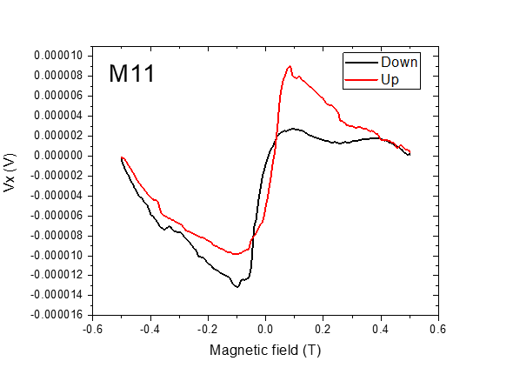

**(6) Lock-In Setup:**

|  |  |
| --- | --- |
| Sens: | 20 μV |
| τ: | 1s |
| Float/Ground: | Ground |
| AC/DC: | AC |
| A/A-B: | A-B |
| Reserve: | Normal |
| Source: | Internal |

**(7) Important Notes:**

M12: Plusses\_Hloop\_0deg

08 March 2019

09:00



|  |  |
| --- | --- |
| (1) Structures measured | Plusses |

|  |  |
| --- | --- |
| **(2) Measurement type** | Hloop\_gradiometry |
|  |  |
|  |  |
|  |  |

**(3) Cables Setup:**

|  |  |  |
| --- | --- | --- |
|  |  |  |
|  |  |  |
|  |  |  |
| Gate (9) |  |  |

**(8) Filename and data:**

<<20190308\_0900\_I1-1-13\_I2-8-6\_GBIP8-14-7\_Vin-2.5V\_R11-1MO\_R12-9kO\_R13-0\_R21-1MO\_C11-1\_C21-6\_T-30K\_0deg\_plusses\_SR-0.1-T-min\_B-0.5T\_gate-0V\_Gradio\_up.dat>>

<<20190308\_0900\_I1-1-13\_I2-8-6\_GBIP8-14-7\_Vin-2.5V\_R11-1MO\_R12-9kO\_R13-0\_R21-1MO\_C11-1\_C21-6\_T-30K\_0deg\_plusses\_SR-0.1-T-min\_B-0.5T\_gate-0V\_Gradio\_down.dat>>

**(4) Magnet Setup:**

|  |  |
| --- | --- |
| Range: |  |
| Rate: |  |

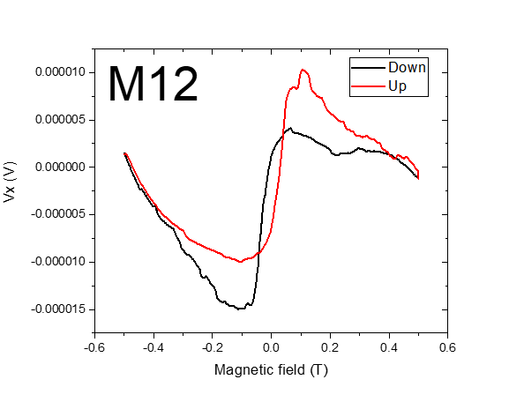

**(5) Experiment Setup:**

|  |  |
| --- | --- |
| T |  |
|  |  |
|  | 1 MΩ |
|  | 8.9kO |
|  | 0 |
|  | 1 MΩ |
|  | μA |
|  | μA |
|  | 0 |
|  |  |

**(6) Lock-In Setup:**

|  |  |
| --- | --- |
| Sens: | 20 μV |
| τ: | 1s |
| Float/Ground: | Ground |
| AC/DC: | AC |
| A/A-B: | A-B |
| Reserve: | Normal |
| Source: | Internal |

**(7) Important Notes:**

M13: Crosses\_Hloop\_0deg

08 March 2019

10:24



|  |  |
| --- | --- |
| (1) Structures measured | Crosses |

|  |  |
| --- | --- |
| **(2) Measurement type** | Hloop\_gradiometry |
|  |  |
|  |  |
|  |  |

**(3) Cables Setup:**

|  |  |  |
| --- | --- | --- |
|  |  |  |
|  |  |  |
|  |  |  |
| Gate (9) |  |  |

**(8) Filename and data:**

<<20190308\_1000\_I1-2-12\_I2-8-6\_GBIP8-14-7\_Vin-2.5V\_R11-1MO\_R12-5.25kO\_R13-0\_R21-1MO\_C11-1\_C21-6\_T-30K\_0deg\_Crosses\_SR-0.1-T-min\_B-0.5T\_gate-0V\_Gradio\_up.dat>>

<<20190308\_1000\_I1-2-12\_I2-8-6\_GBIP8-14-7\_Vin-2.5V\_R11-1MO\_R12-5.25kO\_R13-0\_R21-1MO\_C11-1\_C21-6\_T-30K\_0deg\_Crosses\_SR-0.1-T-min\_B-0.5T\_gate-0V\_Gradio\_down.dat>>

**(4) Magnet Setup:**

|  |  |
| --- | --- |
| Range: |  |
| Rate: |  |

**(5) Experiment Setup:**

|  |  |
| --- | --- |
| T |  |
|  |  |
|  | 1 MΩ |
|  | 5.25kO |
|  | 0 |
|  | 1 MΩ |
|  | μA |
|  | μA |
|  | 0 |
|  |  |

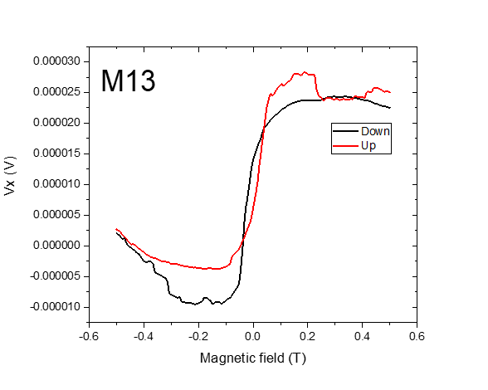

**(6) Lock-In Setup:**

|  |  |
| --- | --- |
| Sens: | 20 μV |
| τ: | 1s |
| Float/Ground: | Ground |
| AC/DC: | AC |
| A/A-B: | A-B |
| Reserve: | Normal |
| Source: | Internal |

**(7) Important Notes:**

M14: Empty cross\_Carrier concentration

08 March 2019

10:56



|  |  |
| --- | --- |
| (1) Structures measured | Empty cross 6-8 |

|  |  |
| --- | --- |
| **(2) Measurement type** | Hall effect |
|  |  |
|  |  |
|  |  |

**(3) Cables Setup:**

|  |  |  |
| --- | --- | --- |
|  |  |  |
|  |  |  |
|  |  |  |
| Gate (9) |  |  |

**(8) Filename and data:**

**(4) Magnet Setup:**

|  |  |
| --- | --- |
| Range: |  |
| Rate: |  |

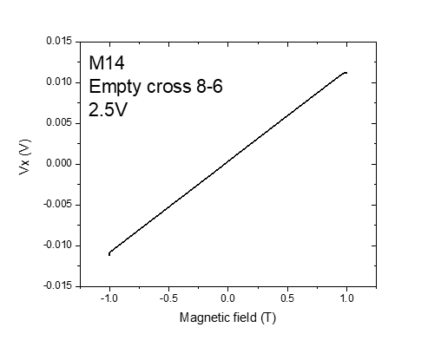

**(5) Experiment Setup:**

|  |  |
| --- | --- |
| T |  |
|  |  |
|  | 1 MΩ |
|  | 0 |
|  | 0 |
|  | 1 MΩ |
|  | μA |
|  | μA |
|  | 0 |
|  |  |

**(6) Lock-In Setup:**

|  |  |
| --- | --- |
| Sens: | 20 μV |
| τ: | 1s |
| Float/Ground: | Ground |
| AC/DC: | AC |
| A/A-B: | A-B |
| Reserve: | Normal |
| Source: | Internal |

<<20190308\_1030\_I-14-7\_GBIP8-8-6\_Vin-2.5V\_R11-1MO\_sens50mV\_gate0V\_.dat>>

**(7) Important Notes:**

M15: Crosses\_Hloop\_0deg

08 March 2019

11:06



|  |  |
| --- | --- |
| (1) Structures measured | Crosses |

|  |  |
| --- | --- |
| **(2) Measurement type** | Hloop\_gradiometry |
|  |  |
|  |  |
|  |  |

**(3) Cables Setup:**

|  |  |  |
| --- | --- | --- |
|  |  |  |
|  |  |  |
|  |  |  |
| Gate (9) |  |  |

**(8) Filename and data:**

<<20190308\_1100\_I1-2-12\_I2-8-6\_GBIP8-14-7\_Vin-2.5V\_R11-1MO\_R12-5.7kO\_R13-0\_R21-1MO\_C11-1\_C21-6\_T-30K\_0deg\_Crosses\_SR-0.1-T-min\_B-0.7T\_gate-9-5\_Gradio\_down.dat>>

<<20190308\_1100\_I1-2-12\_I2-8-6\_GBIP8-14-7\_Vin-2.5V\_R11-1MO\_R12-5.7kO\_R13-0\_R21-1MO\_C11-1\_C21-6\_T-30K\_0deg\_Crosses\_SR-0.1-T-min\_B-0.7T\_gate-9-5\_Gradio\_up.dat>>

**(4) Magnet Setup:**

|  |  |
| --- | --- |
| Range: |  |
| Rate: |  |

**(5) Experiment Setup:**

|  |  |
| --- | --- |
| T |  |
|  |  |
|  | 1 MΩ |
|  | 5.7kO |
|  | 0 |
|  | 1 MΩ |
|  | μA |
|  | μA |
|  | 0 |
|  |  |

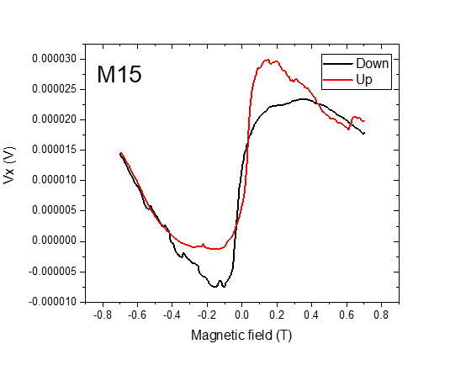

**(6) Lock-In Setup:**

|  |  |
| --- | --- |
| Sens: | 20 μV |
| τ: | 1s |
| Float/Ground: | Ground |
| AC/DC: | AC |
| A/A-B: | A-B |
| Reserve: | Normal |
| Source: | Internal |

**(7) Important Notes:**

M16: ASI\_Hloop\_0deg

08 March 2019

11:11



|  |  |
| --- | --- |
| (1) Structures measured | ASI\_crossB |

|  |  |
| --- | --- |
| **(2) Measurement type** | Hloop\_gradiometry |
|  |  |
|  |  |
|  |  |

**(3) Cables Setup:**

|  |  |  |
| --- | --- | --- |
|  |  |  |
|  |  |  |
|  |  |  |
| Gate (9) |  |  |

**(8) Filename and data**

<<20190308\_1100\_I1-3-11\_I2-8-6\_GBIP8-14-7\_Vin-2.5V\_R11-1MO\_R12-4.6kO\_R13-0\_R21-1MO\_C11-1\_C21-6\_T-30K\_0deg\_ASI\_cross B\_SR-0.05-T-min\_B-0.3T\_gate-9-5\_Gradio\_up.dat>>

**(4) Magnet Setup:**

|  |  |
| --- | --- |
| Range: |  |
| Rate: |  |

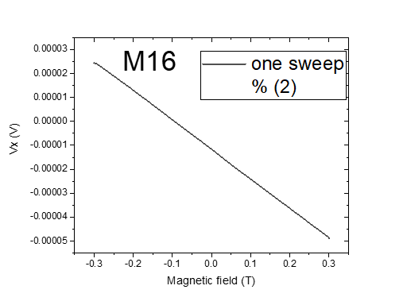

**(5) Experiment Setup:**

|  |  |
| --- | --- |
| T |  |
|  |  |
|  | 1 MΩ |
|  | 4.6kO |
|  | 0 |
|  | 1 MΩ |
|  | μA |
|  | μA |
|  | 0 |
|  |  |

**(6) Lock-In Setup:**

|  |  |
| --- | --- |
| Sens: | 20 μV |
| τ: | 1s |
| Float/Ground: | Ground |
| AC/DC: | AC |
| A/A-B: | A-B |
| Reserve: | Normal |
| Source: | Internal |

**(7) Important Notes:**

C: Changing angle 90deg (Parallel to the sensor plane)

10 March 2019

19:37

|  |  |
| --- | --- |
| (1) Structures measured | Empty Cross |
| (2) Measurement type | Angle Changing |
| **(3) Cables Setup:** | |  |  |  | | --- | --- | --- | |  | *14 - 7* |  | |  |  |  | | Gate (9) |  |  | |
| **(4) Magnet Setup:** | B = 1 T |
| **(5) Experiment Setup:** | |  |  | | --- | --- | | T |  | |  |  | |  | 1 MΩ | |  | 0 | |
| **(6) Lock-In Setup:** | |  |  | | --- | --- | | Sens: | 20 μV | | τ: | 1s | | Float/Ground: | Ground | | AC/DC: | AC | | A/A-B: | A-B | | Reserve: | Normal | | Source: | Internal | |
| **(7) Important Notes:** | Hall Voltage of empty cross @ 1 T before changing angle (old angle 45deg) is -7.826 mV instead of expected cos(45)\*11.164 = 7.894 |
| **(8) Filename and data:** | <<20190308\_1600\_I-14-7\_GB8-1-13\_GB9-2-12\_GB13-6-8\_Vin-2.5V\_R11-1MO\_C11-1\_C21-6\_T-30K\_90degSensor\_plus\_cros\_emp\_SR-0.1-T-min\_B-1T\_gate-0V\_Parallel\_down.dat>>    <<20190308\_1600\_I-14-7\_GB8-1-13\_GB9-2-12\_GB13-6-8\_Vin-2.5V\_R11-1MO\_C11-1\_C21-6\_T-30K\_90degSensor\_plus\_cros\_emp\_SR-0.1-T-min\_B-1T\_gate-0V\_Parallel\_up.dat>> |

Hall Voltage:



M17: Plusses\_Hloop\_90deg

11 March 2019

11:17



|  |  |
| --- | --- |
| (1) Structures measured | Plusses |

|  |  |
| --- | --- |
| **(2) Measurement type** | Hloop\_Gradio\_for fun |
|  |  |
|  |  |
|  |  |

**(3) Cables Setup:**

|  |  |  |
| --- | --- | --- |
|  |  |  |
|  |  |  |
|  |  |  |
| Gate (9) |  |  |

**(8) Filename and data:**

<<20190308\_1500\_I1-1-13\_I2-8-6\_GBIP8-14-7\_Vin-2.5V\_R11-1MO\_R12-0\_R13-0\_R21-1MO\_C11-1\_C21-6\_T-30K\_90degSensor\_plusses\_SR-0.1-T-min\_B-0.5T\_gate-0V\_Gradio\_down.dat>>

<<20190308\_1500\_I1-1-13\_I2-8-6\_GBIP8-14-7\_Vin-2.5V\_R11-1MO\_R12-0\_R13-0\_R21-1MO\_C11-1\_C21-6\_T-30K\_90degSensor\_plusses\_SR-0.1-T-min\_B-0.5T\_gate-0V\_Gradio\_Up.dat>>

**(4) Magnet Setup:**

|  |  |
| --- | --- |
| Range: |  |
| Rate: |  |

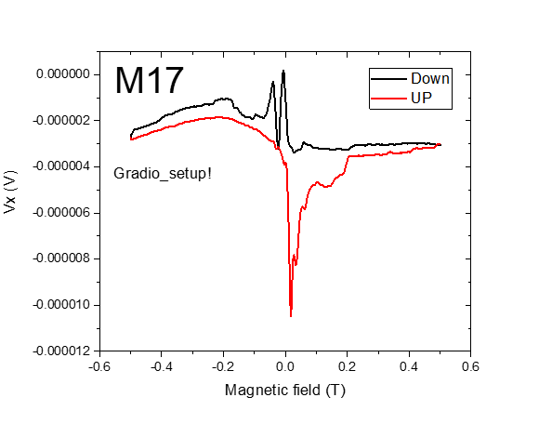

**(5) Experiment Setup:**

|  |  |
| --- | --- |
| T |  |
|  |  |
|  | 1 MΩ |
|  | 0 |
|  | 0 |
|  | 1 MΩ |
|  | μA |
|  | μA |
|  | 90 |
|  |  |

**(6) Lock-In Setup:**

|  |  |
| --- | --- |
| Sens: | 20 μV |
| τ: | 1s |
| Float/Ground: | Ground |
| AC/DC: | AC |
| A/A-B: | A-B |
| Reserve: | Normal |
| Source: | Internal |

**(7) Important Notes:**

The gradio\_setup is not usefull at 90deg\_therofre, this measurment done for fun!!

M18 and 18.1: Plusses\_Crosses\_empty\_Hloop\_90deg\_2times

08 March 2019

11:27



|  |  |
| --- | --- |
| (1) Structures measured | Plusses\_Crosses\_empty |

|  |  |
| --- | --- |
| **(2) Measurement type** | Hloop\_parallel |
|  |  |
|  |  |
|  |  |

**(3) Cables Setup:**

|  |  |  |
| --- | --- | --- |
| *VH (GB8)* |  |  |
| *VH(GB9)* |  |  |
| *VH(GB13)* |  |  |
|  |  |  |
| Gate (9) |  |  |

**(8) Filename and data:**

<<20190308\_1600\_I-14-7\_GB8-1-13\_GB9-2-12\_GB13-6-8\_Vin-2.5V\_R11-1MO\_C11-1\_C21-6\_T-30K\_90degSensor\_plus\_cros\_emp\_SR-0.1-T-min\_B-1T\_gate-0V\_Parallel\_down.dat>>

<<20190308\_1600\_I-14-7\_GB8-1-13\_GB9-2-12\_GB13-6-8\_Vin-2.5V\_R11-1MO\_C11-1\_C21-6\_T-30K\_90degSensor\_plus\_cros\_emp\_SR-0.1-T-min\_B-1T\_gate-0V\_Parallel\_up.dat>>

<<2nd\_20190308\_1500\_I-14-7\_GB8-1-13\_GB9-2-12\_GB13-6-8\_Vin-2.5V\_R11-1MO\_C11-1\_C21-6\_T-30K\_90degSensor\_plus\_cros\_emp\_SR-0.1-T-min\_B-1T\_gate-0V\_Parallel\_down.dat>>

<<2nd\_20190308\_1500\_I-14-7\_GB8-1-13\_GB9-2-12\_GB13-6-8\_Vin-2.5V\_R11-1MO\_C11-1\_C21-6\_T-30K\_90degSensor\_plus\_cros\_emp\_SR-0.1-T-min\_B-1T\_gate-0V\_Parallel\_up.dat>>

**(4) Magnet Setup:**

|  |  |
| --- | --- |
| Range: |  |
| Rate: |  |

**(5) Experiment Setup:**

|  |  |
| --- | --- |
| T |  |
|  |  |
|  | 1 MΩ |
|  | 0 |
|  | 0 |
|  | 1 MΩ |
|  | μA |
|  | μA |
|  | 90 |
|  |  |

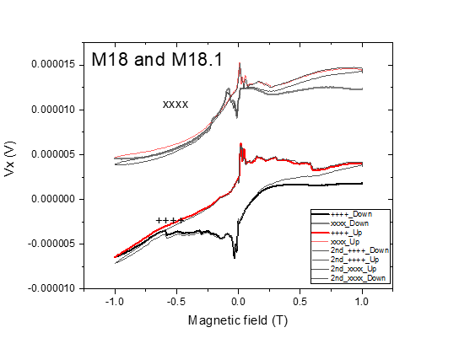

**(6) Lock-In Setup:**

|  |  |
| --- | --- |
| Sens: | 20 μV |
| τ: | 1s |
| Float/Ground: | Ground |
| AC/DC: | AC |
| A/A-B: | A-B |
| Reserve: | Normal |
| Source: | Internal |

**(7) Important Notes:**

M18.1 has same parameters of M8

M19: Plusses\_Crosses\_empty\_Hloop\_90deg\_15mT/min

09 March 2019

12:07

|  |  |
| --- | --- |
| (1) Structures measured | Plusses\_Crosses\_empty |



|  |  |
| --- | --- |
| **(2) Measurement type** | Hloop\_parallel |
|  |  |
|  |  |
|  |  |

**(3) Cables Setup:**

|  |  |  |
| --- | --- | --- |
| *VH (GB8)* |  |  |
| *VH(GB9)* |  |  |
| *VH(GB13)* |  |  |
|  |  |  |
| Gate (9) |  |  |

**(8) Filename and data:**

<<20190309\_1200\_I-14-7\_GB8-1-13\_GB9-2-12\_GB13-6-8\_Vin-2.5V\_R11-1MO\_C11-1\_C21-6\_T-30.9K\_90degSensor\_plus\_cros\_emp\_SR-0.015-T-min\_B-1.5T\_gate-0V\_Parallel\_up.dat>>

<<20190309\_1200\_I-14-7\_GB8-1-13\_GB9-2-12\_GB13-6-8\_Vin-2.5V\_R11-1MO\_C11-1\_C21-6\_T-30.9K\_90degSensor\_plus\_cros\_emp\_SR-0.015-T-min\_B-1.5T\_gate-0V\_Parallel\_down.dat>>

**(4) Magnet Setup:**

|  |  |
| --- | --- |
| Range: |  |
| Rate: |  |

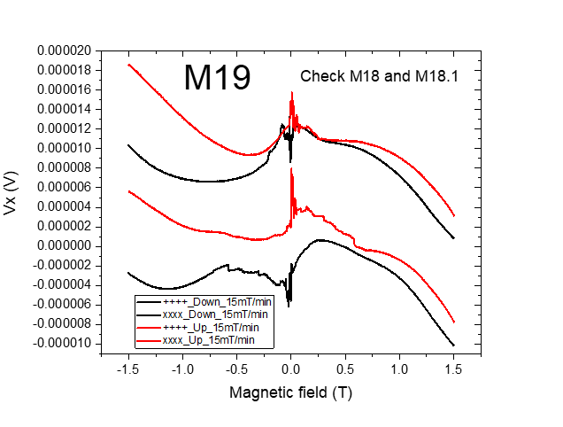

**(5) Experiment Setup:**

|  |  |
| --- | --- |
| T |  |
|  |  |
|  | 1 MΩ |
|  | 0 |
|  | 0 |
|  | 1 MΩ |
|  | μA |
|  | μA |
|  | 90 |
|  |  |

**(6) Lock-In Setup:**

|  |  |
| --- | --- |
| Sens: | 20 μV |
| τ: | 1s |
| Float/Ground: | Ground |
| AC/DC: | AC |
| A/A-B: | A-B |
| Reserve: | Normal |
| Source: | Internal |

**(7) Important Notes:**

\_Very slow sweeping rate done during the weekend and at different days

C: Changing angle 45deg

10 March 2019

19:37

|  |  |
| --- | --- |
| (1) Structures measured | Empty Cross |
| (2) Measurement type | Angle Changing |
| **(3) Cables Setup:** | |  |  |  | | --- | --- | --- | |  | *14 - 7* |  | |  |  |  | | Gate (9) |  |  | |
| **(4) Magnet Setup:** | B = 1 T |
| **(5) Experiment Setup:** | |  |  | | --- | --- | | T |  | |  |  | |  | 1 MΩ | |  | 0 | |
| **(6) Lock-In Setup:** | |  |  | | --- | --- | | Sens: | 20mV | | τ: | 1s | | Float/Ground: | Ground | | AC/DC: | AC | | A/A-B: | A-B | | Reserve: | Normal | | Source: | Internal | |
| **(7) Important Notes:** | Hall Voltage of empty cross @ 1 T before changing angle (old angle 45deg) is -7.826 mV instead of expected cos(45)\*11.164 = 7.894 |
| **(8) Filename and data:** | No File created |

Hall Voltage:



M20: Plusses\_Hloop\_45deg

10 March 2019

14:00



|  |  |
| --- | --- |
| (1) Structures measured | Plusses |

|  |  |
| --- | --- |
| **(2) Measurement type** | Hloop\_gradiometry |
|  |  |
|  |  |
|  |  |

**(3) Cables Setup:**

|  |  |  |
| --- | --- | --- |
|  |  |  |
|  |  |  |
|  |  |  |
| Gate (9) |  |  |

**(8) Filename and data:**

<<20190310\_1400\_I1-1-13\_I2-8-6\_GBIP8-14-7\_Vin-2.5V\_R11-1MO\_R12-5.5\_R13-0\_R21-1MO\_C11-1\_C21-6\_T-30K\_45degSensor\_plusses\_SR-0.1-T-min\_B-0.5T\_gate-0V\_Gradio\_down.dat>>

<<20190310\_1400\_I1-1-13\_I2-8-6\_GBIP8-14-7\_Vin-2.5V\_R11-1MO\_R12-5.5\_R13-0\_R21-1MO\_C11-1\_C21-6\_T-30K\_45degSensor\_plusses\_SR-0.1-T-min\_B-0.5T\_gate-0V\_Gradio\_up.dat>>

**(4) Magnet Setup:**

|  |  |
| --- | --- |
| Range: |  |
| Rate: |  |

**(5) Experiment Setup:**

|  |  |
| --- | --- |
| T |  |
|  |  |
|  | 1 MΩ |
|  | 5.5kO |
|  | 0 |
|  | 1 MΩ |
|  | μA |
|  | μA |
|  | 45 |
|  |  |

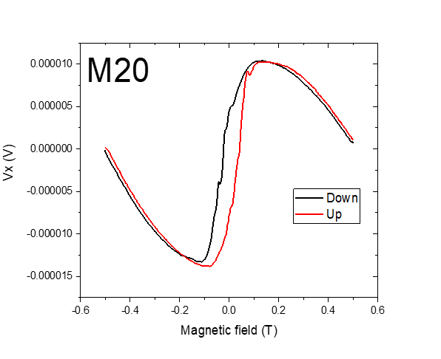

**(6) Lock-In Setup:**

|  |  |
| --- | --- |
| Sens: | 20 μV |
| τ: | 1s |
| Float/Ground: | Ground |
| AC/DC: | AC |
| A/A-B: | A-B |
| Reserve: | Normal |
| Source: | Internal |

**(7) Important Notes:**

M21: Crosses\_Hloop\_45deg

11 March 2019

13:49



|  |  |
| --- | --- |
| (1) Structures measured | Crosses |

|  |  |
| --- | --- |
| **(2) Measurement type** | Hloop\_gradiometry |
|  |  |
|  |  |
|  |  |

**(3) Cables Setup:**

|  |  |  |
| --- | --- | --- |
|  |  |  |
|  |  |  |
|  |  |  |
| Gate (9) |  |  |

**(8) Filename and data:**

<<20190310\_1400\_I1-2-12\_I2-8-6\_GBIP8-14-7\_Vin-2.5V\_R11-1MO\_R12-4.75\_R13-0\_R21-1MO\_C11-1\_C21-6\_T-30K\_45degSensor\_Crosses\_SR-0.1-T-min\_B-0.5T\_gate-0V\_Gradio\_up.dat>>

<<20190310\_1400\_I1-2-12\_I2-8-6\_GBIP8-14-7\_Vin-2.5V\_R11-1MO\_R12-4.75\_R13-0\_R21-1MO\_C11-1\_C21-6\_T-30K\_45degSensor\_Crosses\_SR-0.1-T-min\_B-0.5T\_gate-0V\_Gradio\_down.dat>>

**(4) Magnet Setup:**

|  |  |
| --- | --- |
| Range: |  |
| Rate: |  |

**(5) Experiment Setup:**

|  |  |
| --- | --- |
| T |  |
|  |  |
|  | 1 MΩ |
|  | 4.75kO |
|  | 0 |
|  | 1 MΩ |
|  | μA |
|  | μA |
|  | 45 |
|  |  |

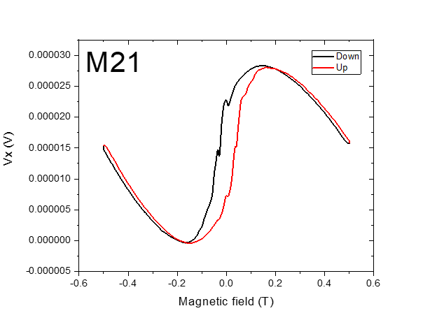

**(6) Lock-In Setup:**

|  |  |
| --- | --- |
| Sens: | 20 μV |
| τ: | 1s |
| Float/Ground: | Ground |
| AC/DC: | AC |
| A/A-B: | A-B |
| Reserve: | Normal |
| Source: | Internal |

**(7) Important Notes:**

Fast sweeping

M22: Crosses\_Hloop\_45deg\_8mT/min

11 March 2019

13:49



|  |  |
| --- | --- |
| (1) Structures measured | Crosses |

|  |  |
| --- | --- |
| **(2) Measurement type** | Hloop\_gradiometry |
|  |  |
|  |  |
|  |  |

**(3) Cables Setup:**

|  |  |  |
| --- | --- | --- |
|  |  |  |
|  |  |  |
|  |  |  |
| Gate (9) |  |  |

**(8) Filename and data:**

<<20190311\_0900\_I1-2-12\_I2-8-6\_GBIP8-14-7\_Vin-2.5V\_R11-1MO\_R12-4.75\_R13-0\_R21-1MO\_C11-1\_C21-6\_T-30K\_45degSensor\_Crosses\_SR-0.008-T-min\_B-0.5T\_gate-0V\_Gradio\_up.dat>>

<<20190311\_0900\_I1-2-12\_I2-8-6\_GBIP8-14-7\_Vin-2.5V\_R11-1MO\_R12-4.75\_R13-0\_R21-1MO\_C11-1\_C21-6\_T-30K\_45degSensor\_Crosses\_SR-0.008-T-min\_B-0.5T\_gate-0V\_Gradio\_down.dat>>

**(4) Magnet Setup:**

|  |  |
| --- | --- |
| Range: |  |
| Rate: |  |

**(5) Experiment Setup:**

|  |  |
| --- | --- |
| T |  |
|  |  |
|  | 1 MΩ |
|  | 4.75kO |
|  | 0 |
|  | 1 MΩ |
|  | μA |
|  | μA |
|  | 45 |
|  |  |

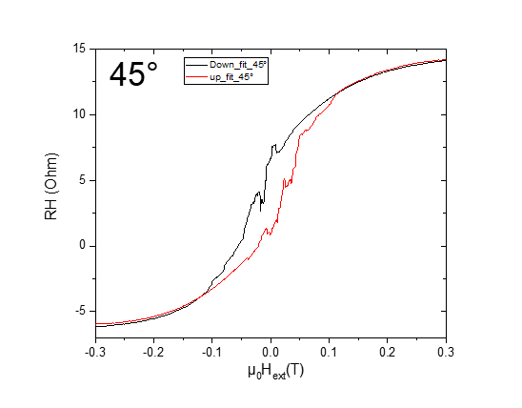

**(6) Lock-In Setup:**

|  |  |
| --- | --- |
| Sens: | 20 μV |
| τ: | 1s |
| Float/Ground: | Ground |
| AC/DC: | AC |
| A/A-B: | A-B |
| Reserve: | Normal |
| Source: | Internal |

**(7) Important Notes:**

Very slow sweeping

M23: Plusses\_Hloop\_45deg\_8mT/min

11 March 2019

14:27



|  |  |
| --- | --- |
| (1) Structures measured | Plusses |

|  |  |
| --- | --- |
| **(2) Measurement type** | Hloop\_gradiometry |
|  |  |
|  |  |
|  |  |

**(8) Fil**

<<20190311\_1400\_I1-1-13\_I2-8-6\_GBIP8-14-7\_Vin-2.5V\_R11-1MO\_R12-5.5kO\_R13-0\_R21-1MO\_C11-1\_C21-6\_T-30K\_45degSensor\_Plusses\_SR-0.008-T-min\_B-0.5T\_gate-0V\_Gradio\_up.dat>>

<<20190311\_1400\_I1-1-13\_I2-8-6\_GBIP8-14-7\_Vin-2.5V\_R11-1MO\_R12-5.5kO\_R13-0\_R21-1MO\_C11-1\_C21-6\_T-30K\_45degSensor\_Plusses\_SR-0.008-T-min\_B-0.5T\_gate-0V\_Gradio\_down.dat>>

**ename and data:**

**(3) Cables Setup:**

|  |  |  |
| --- | --- | --- |
|  |  |  |
|  |  |  |
|  |  |  |
| Gate (9) |  |  |

**(4) Magnet Setup:**

|  |  |
| --- | --- |
| Range: |  |
| Rate: |  |

**(5) Experiment Setup:**

|  |  |
| --- | --- |
| T |  |
|  |  |
|  | 1 MΩ |
|  | 5.5kO |
|  | 0 |
|  | 1 MΩ |
|  | μA |
|  | μA |
|  | 45 |
|  |  |

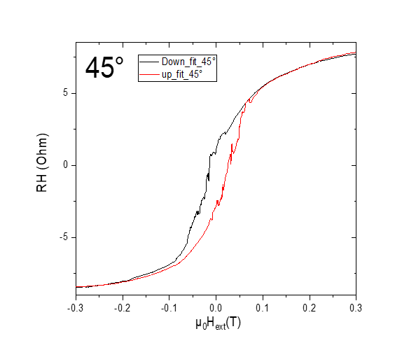

**(6) Lock-In Setup:**

|  |  |
| --- | --- |
| Sens: | 20 μV |
| τ: | 1s |
| Float/Ground: | Ground |
| AC/DC: | AC |
| A/A-B: | A-B |
| Reserve: | Normal |
| Source: | Internal |

**(7) Important Notes:**

M24: 45deg All Crosses (±1T)\_2 concentration

10 March 2019

19:37

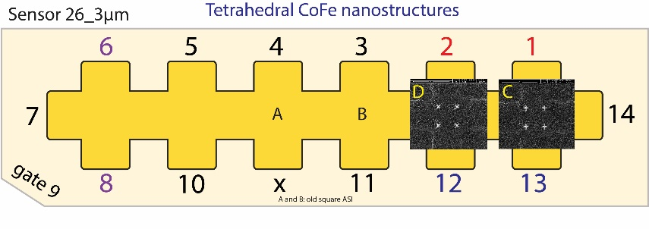

|  |  |
| --- | --- |
| (1) Structures measured | Plusses\_Crosses\_empty |
| (2) Measurement type | Hloop\_parallel |
| **(3) Cables Setup:** | |  |  |  | | --- | --- | --- | |  |  |  | |  |  |  | |  |  |  | |  |  |  | | Gate (9) |  |  | |
| **(4) Magnet Setup:** |  |
| **(5) Experiment Setup:** | |  |  | | --- | --- | | T |  | |  |  | |  | 1 MΩ | |  | 45 | |
| **(6) Lock-In Setup:** | |  |  | | --- | --- | | Sens: | 20 mV | | τ: | 1s | | Float/Ground: | Ground | | AC/DC: | AC | | A/A-B: | A-B | | Reserve: | Normal | | Source: | Internal | |
| **(7) Important Notes:** |  |
| **(8) Filename and data:** | <<20190312\_1200\_I-14-7\_GB8-1-13\_GB9-2-12\_GB13-6-8\_Vin-2.5V\_R11-1MO\_C11-1\_C21-6\_T-30K\_45degSensor\_plus\_cros\_emp\_SR-0.1-T-min\_B-1T\_gate-0V\_Parallel\_up.dat>>    <<20190312\_1200\_I-14-7\_GB8-1-13\_GB9-2-12\_GB13-6-8\_Vin-2.5V\_R11-1MO\_C11-1\_C21-6\_T-30K\_45degSensor\_plus\_cros\_emp\_SR-0.1-T-min\_B-1T\_gate-0V\_Parallel\_down.dat>> |

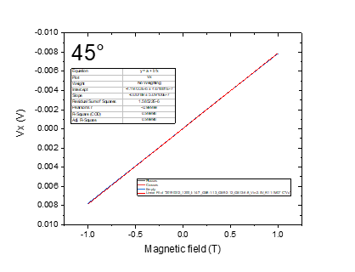

C: Changing angle 42.5deg

Dienstag, 12. März 2019

13:44

M25: Change Angle 42.5

12 March 2019

20:37

Aiming for Hall Voltage:



**Voltage measured:**



Voltage Measured next day before changing Angle again

8.286mV

|  |  |
| --- | --- |
| (1) Structures measured | Empty Cross |
| (2) Measurement type | Angle Changing |
| **(3) Cables Setup:** | |  |  |  | | --- | --- | --- | |  | *14 - 7* |  | |  |  |  | | Gate (9) |  |  | |
| **(4) Magnet Setup:** | B = 1 T |
| **(5) Experiment Setup:** | |  |  | | --- | --- | | T |  | |  |  | |  | 1 MΩ | |  | 42.5 | |
| **(6) Lock-In Setup:** | |  |  | | --- | --- | | Sens: | 20mV | | τ: | 1s | | Float/Ground: | Ground | | AC/DC: | AC | | A/A-B: | A-B | | Reserve: | Normal | | Source: | Internal | |
| **(7) Important Notes:** | Hall Voltage of empty cross @ 1 T before changing angle (old angle 45deg) is -7.826 mV instead of expected cos(45)\*11.164 = 7.894 |
| **(8) Filename and data:** | No File created |



Dienstag, 12. März 2019

12:19

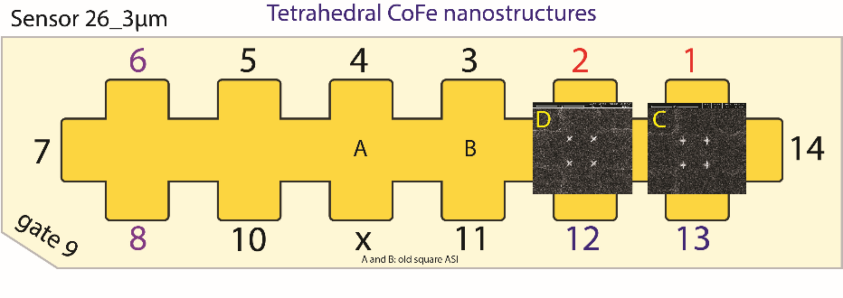

|  |  |
| --- | --- |
| (1) Structures measured | Plusses |
| **(2) Measurement type** | Hloop\_gradiometry |
| **(3) Cables Setup:** | |  |  | | --- | --- | |  | 1-13 | |  | 8-6 | |  | * 1. 7 |  |  |  |  | | --- | --- | --- | | Gate (9) |  |  | |
| **(4) Magnet Setup:** |  |
| **(5) Experiment Setup:** | |  |  | | --- | --- | | T |  | |  |  | |  | 1 MΩ | |  | 9,5 kΩ | |  | 0 | |  | 1 MΩ | |  | 42.5 | |
| **(6) Lock-In Setup:** | |  |  | | --- | --- | | Sens: | 20 μV | | τ: | 1s | | Float/Ground: | Ground | | AC/DC: | AC | | A/A-B: | A-B | | Reserve: | Normal | | Source: | Internal | |
| **(7) Important Notes:** |  |
| **(8) Filename and data:** | <<20190312\_1500\_I1-1-13\_I2-8-6\_GBIP8-14-7\_Vin-2.5V\_R11-1MO\_R12-9.5kO\_R13-0\_R21-1MO\_C11-1\_C21-6\_T-30K\_42.5degSensor\_plusses\_SR-0.008-T-min\_B-0.3T\_gate-0V\_Gradio\_down.dat>>  <<20190312\_1500\_I1-1-13\_I2-8-6\_GBIP8-14-7\_Vin-2.5V\_R11-1MO\_R12-9.5kO\_R13-0\_R21-1MO\_C11-1\_C21-6\_T-30K\_42.5degSensor\_plusses\_SR-0.008-T-min\_B-0.3T\_gate-0V\_Gradio\_up.dat>> |

R11 = 190/1000\*50 = 9,5

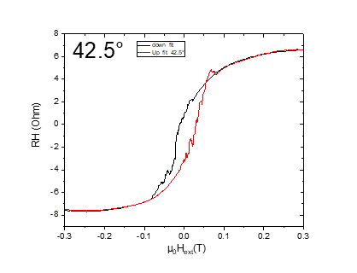

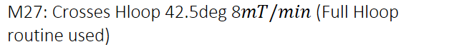



Dienstag, 12. März 2019

12:19

|  |  |
| --- | --- |
| (1) Structures measured | Crosses |
| **(2) Measurement type** | Hloop\_gradiometry |
| **(3) Cables Setup:** | |  |  | | --- | --- | |  | 2-12 | |  | 8-6 | |  | * 1. 7 |  |  |  |  | | --- | --- | --- | | Gate (9) |  |  | |
| **(4) Magnet Setup:** |  |
| **(5) Experiment Setup:** | |  |  | | --- | --- | | T |  | |  |  | |  | 1 MΩ | |  | 9 kΩ | |  | 0 | |  | 1 MΩ | |  | 42.5 | |
| **(6) Lock-In Setup:** | |  |  | | --- | --- | | Sens: | 20 μV | | τ: | 1s | | Float/Ground: | Ground | | AC/DC: | AC | | A/A-B: | A-B | | Reserve: | Normal | | Source: | Internal | |
| **(7) Important Notes:** | Here we have used the routine. After finishing, the magnet did not go to the Zero!!!. I had to do that manually.  We left the Temp at 30K over the night (He level 35.80in at 9pm) |
| **(8) Filename and data:** | <<20190312\_1800\_I1-1-13\_I2-8-6\_GBIP8-14-7\_Vin-2.5V\_R11-1MO\_R12-9kO\_R13-0\_R21-1MO\_C11-1\_C21-6\_T-30K\_42.5degSensor\_crosses\_SR-0.008-T-min\_B-0.3T\_gate-0V\_Gradio\_down.dat>>  <<20190312\_1800\_I1-1-13\_I2-8-6\_GBIP8-14-7\_Vin-2.5V\_R11-1MO\_R12-9kO\_R13-0\_R21-1MO\_C11-1\_C21-6\_T-30K\_42.5degSensor\_crosses\_SR-0.008-T-min\_B-0.3T\_gate-0V\_Gradio\_up.dat>> |

R11 = 180/1000\*50 = 9

*To check:*

*The magnet did not go to zero. This might be the rate was set to value and magnetd did not respond unless there is rate set to tthe set point.*

*He(L) level next day after leaving the temp. At 30K and heater at 500mW. The heating range was 17.2%*

*He(l) level next day (8:14 am) was 34.55in at 30K and heater was 17.7%mW.*

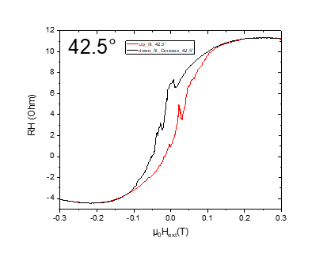

M28: 42.5 deg All Crosses (±1T)\_Carrier concentration

10 March 2019

19:37



|  |  |
| --- | --- |
| (1) Structures measured | Plusses\_Crosses\_empty |
| (2) Measurement type | Hloop\_parallel |
| **(3) Cables Setup:** | |  |  |  | | --- | --- | --- | |  |  | C | |  |  | D | |  |  |  | |  |  |  | | Gate (9) |  |  | |
| **(4) Magnet Setup:** |  |
| **(5) Experiment Setup:** | |  |  | | --- | --- | | T |  | |  |  | |  | 1 MΩ | |  | 42.5 | |
| **(6) Lock-In Setup:** | |  |  | | --- | --- | | Sens: | 20 mV | | τ: | 1s | | Float/Ground: | Ground | | AC/DC: | AC | | A/A-B: | A-B | | Reserve: | Normal | | Source: | Internal | |
| **(7) Important Notes:** |  |
| **(8) Filename and data:** | <<20190313\_0800\_I-7-14\_GB8-1-13\_GB9-2-12\_GB13-6-8\_Vin-2.5V\_R11-1MO\_C11-1\_C21-6\_T-30K\_42.5degSensor\_plus\_cros\_emp\_SR-0.5-T-min\_B-1T\_gate-0V\_Parallel\_down.dat>>    <<20190313\_0800\_I-7-14\_GB8-1-13\_GB9-2-12\_GB13-6-8\_Vin-2.5V\_R11-1MO\_C11-1\_C21-6\_T-30K\_42.5degSensor\_plus\_cros\_emp\_SR-0.5-T-min\_B-1T\_gate-0V\_Parallel\_up.dat>> |

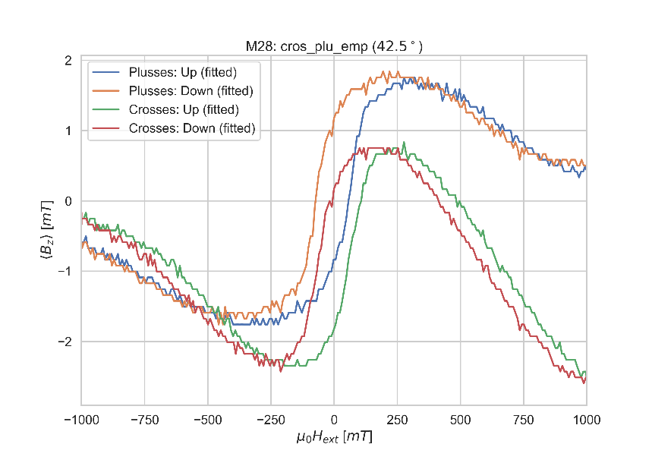

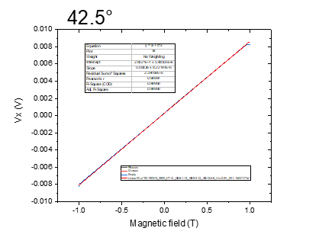

C: Changing angle 40deg

Dienstag, 12. März 2019

13:44

At 1T, 30k, 2.5V





Note: VH(42.5) next day before changing to new angle, was 8.286mV



Dienstag, 12. März 2019

12:19



|  |  |
| --- | --- |
| (1) Structures measured | Plusses |
| **(2) Measurement type** | Hloop\_gradiometry |
| **(3) Cables Setup:** | |  |  | | --- | --- | |  | 1-13 | |  | 8-6 | |  | * 1. 7 |  |  |  |  | | --- | --- | --- | | Gate (9) |  |  | |
| **(4) Magnet Setup:** |  |
| **(5) Experiment Setup:** | |  |  | | --- | --- | | T |  | |  |  | |  | 1 MΩ | |  | 9,5 kΩ | |  | 0 | |  | 1 MΩ | |  | 40 | |
| **(6) Lock-In Setup:** | |  |  | | --- | --- | | Sens: | 20 μV | | τ: | 1s | | Float/Ground: | Ground | | AC/DC: | AC | | A/A-B: | A-B | | Reserve: | Normal | | Source: | Internal | |
| **(7) Important Notes:** |  |
| **(8) Filename and data:** | <<20190313\_0800\_I1-1-13\_I2-8-6\_GBIP8-14-7\_Vin-2.5V\_R11-1MO\_R12-9.5kO\_R13-0\_R21-1MO\_C11-1\_C21-6\_T-30K\_40degSensor\_plusses\_SR-0.008-T-min\_B-0.3T\_gate-0V\_Gradio\_up.dat>>    <<20190313\_0800\_I1-1-13\_I2-8-6\_GBIP8-14-7\_Vin-2.5V\_R11-1MO\_R12-9.5kO\_R13-0\_R21-1MO\_C11-1\_C21-6\_T-30K\_40degSensor\_plusses\_SR-0.008-T-min\_B-0.3T\_gate-0V\_Gradio\_down.dat>> |

R11 = 190/1000\*50 = 9,5

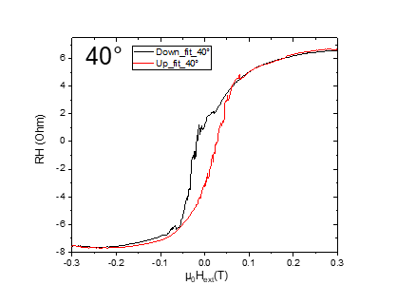

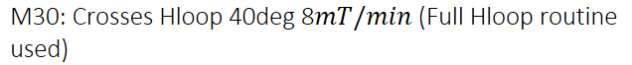



Dienstag, 12. März 2019

12:19

|  |  |
| --- | --- |
| (1) Structures measured | Crosses |
| **(2) Measurement type** | Hloop\_gradiometry |
| **(3) Cables Setup:** | |  |  | | --- | --- | |  | 2-12 | |  | 8-6 | |  | * 1. 7 |  |  |  |  | | --- | --- | --- | | Gate (9) |  |  | |
| **(4) Magnet Setup:** |  |
| **(5) Experiment Setup:** | |  |  | | --- | --- | | T |  | |  |  | |  | 1 MΩ | |  | 8.7 kΩ | |  | 0 | |  | 1 MΩ | |  | 40 | |
| **(6) Lock-In Setup:** | |  |  | | --- | --- | | Sens: | 20 μV | | τ: | 1s | | Float/Ground: | Ground | | AC/DC: | AC | | A/A-B: | A-B | | Reserve: | Normal | | Source: | Internal | |
| **(7) Important Notes:** |  |
| **(8) Filename and data:** | <<20190313\_1100\_I1-2-12\_I2-8-6\_GBIP8-14-7\_Vin-2.5V\_R11-1MO\_R12-8.7kO\_R13-0\_R21-1MO\_C11-1\_C21-6\_T-30K\_40degSensor\_Crosses\_SR-0.008-T-min\_B-0.3T\_gate-0V\_Gradio\_up.dat>>  <<20190313\_1100\_I1-2-12\_I2-8-6\_GBIP8-14-7\_Vin-2.5V\_R11-1MO\_R12-8.7kO\_R13-0\_R21-1MO\_C11-1\_C21-6\_T-30K\_40degSensor\_Crosses\_SR-0.008-T-min\_B-0.3T\_gate-0V\_Gradio\_down.dat>> |

R11 = 174/1000\*50 = 8,7 kO

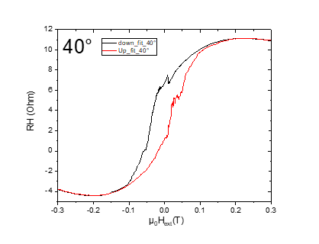

M31: 40 deg All Crosses (±1T)\_Carrier concentration

10 March 2019

19:37



|  |  |
| --- | --- |
| (1) Structures measured | Plusses\_Crosses\_empty |
| (2) Measurement type | Hloop\_parallel |
| **(3) Cables Setup:** | |  |  |  | | --- | --- | --- | |  |  | C | |  |  | D | |  |  |  | |  |  |  | | Gate (9) |  |  | |
| **(4) Magnet Setup:** |  |
| **(5) Experiment Setup:** | |  |  | | --- | --- | | T |  | |  |  | |  | 1 MΩ | |  | 40 | |
| **(6) Lock-In Setup:** | |  |  | | --- | --- | | Sens: | 20 mV | | τ: | 1s | | Float/Ground: | Ground | | AC/DC: | AC | | A/A-B: | A-B | | Reserve: | Normal | | Source: | Internal | |
| **(7) Important Notes:** |  |
| **(8) Filename and data:** | <<20190313\_1400\_I-7-14\_GB8-1-13\_GB9-2-12\_GB13-6-8\_Vin-2.5V\_R11-1MO\_C11-1\_C21-6\_T-30K\_40degSensor\_plus\_cros\_emp\_SR-0.5-T-min\_B-1T\_gate-0V\_Parallel\_down.dat>>    <<20190313\_1400\_I-7-14\_GB8-1-13\_GB9-2-12\_GB13-6-8\_Vin-2.5V\_R11-1MO\_C11-1\_C21-6\_T-30K\_40degSensor\_plus\_cros\_emp\_SR-0.5-T-min\_B-1T\_gate-0V\_Parallel\_up.dat>> |

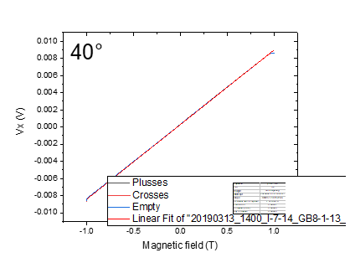

C: Changing angle 35

12 March 2019

20:37

Aiming for Hall Voltage:



**Voltage measured:**



|  |  |
| --- | --- |
| (1) Structures measured | Empty Cross |
| (2) Measurement type | Angle Changing |
| **(3) Cables Setup:** | |  |  |  | | --- | --- | --- | |  | *14 - 7* |  | |  |  |  | | Gate (9) |  |  | |
| **(4) Magnet Setup:** | B = 1 T |
| **(5) Experiment Setup:** | |  |  | | --- | --- | | T |  | |  |  | |  | 1 MΩ | |  | 35 | |
| **(6) Lock-In Setup:** | |  |  | | --- | --- | | Sens: | 20mV | | τ: | 1s | | Float/Ground: | Ground | | AC/DC: | AC | | A/A-B: | A-B | | Reserve: | Normal | | Source: | Internal | |
| **(7) Important Notes:** | Voltage before changinig angle: 8,632 mV |
| **(8) Filename and data:** | No File created |



Dienstag, 12. März 2019

12:19



|  |  |
| --- | --- |
| (1) Structures measured | Plusses |
| **(2) Measurement type** | Hloop\_gradiometry |
| **(3) Cables Setup:** | |  |  | | --- | --- | |  | 1-13 | |  | 8-6 | |  | * 1. 7 |  |  |  |  | | --- | --- | --- | | Gate (9) |  |  | |
| **(4) Magnet Setup:** |  |
| **(5) Experiment Setup:** | |  |  | | --- | --- | | T |  | |  |  | |  | 1 MΩ | |  | 9,15 kΩ | |  | 0 | |  | 1 MΩ | |  | 35 | |  |  | |  |  | |
| **(6) Lock-In Setup:** | |  |  | | --- | --- | | Sens: | 20 μV | | τ: | 3s | | Float/Ground: | Ground | | AC/DC: | AC | | A/A-B: | A-B | | Reserve: | Normal | | Source: | Internal | |
| **(7) Important Notes:** | Changed the Time Constant to 3s and readout every 3s to increase sensitivity |
| **(8) Filename and data:** | <<20190313\_1500\_I1-1-13\_I2-8-6\_GBIP8-14-7\_Vin-2.5V\_R11-1MO\_R12-9.15kO\_R13-0\_R21-1MO\_C11-1\_C21-6\_T-30K\_35degSensor\_plusses\_SR-0.008-T-min\_B-0.3T\_gate-0V\_Gradio\_up.dat>>    <<20190313\_1500\_I1-1-13\_I2-8-6\_GBIP8-14-7\_Vin-2.5V\_R11-1MO\_R12-9.15kO\_R13-0\_R21-1MO\_C11-1\_C21-6\_T-30K\_35degSensor\_plusses\_SR-0.008-T-min\_B-0.3T\_gate-0V\_Gradio\_down.dat>> |

R11 = 183/1000\*50 = 9,15

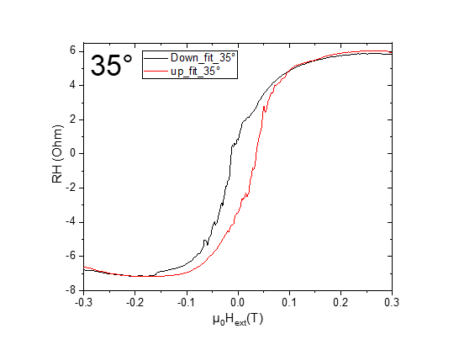

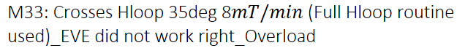



Dienstag, 12. März 2019

12:19

|  |  |
| --- | --- |
| (1) Structures measured | Crosses |
| **(2) Measurement type** | Hloop\_gradiometry |
| **(3) Cables Setup:** | |  |  | | --- | --- | |  | 2-12 | |  | 8-6 | |  | * 1. 7 |  |  |  |  | | --- | --- | --- | | Gate (9) |  |  | |
| **(4) Magnet Setup:** |  |
| **(5) Experiment Setup:** | |  |  | | --- | --- | | T |  | |  |  | |  | 1 MΩ | |  | 8.7 kΩ | |  | 0 | |  | 1 MΩ | |  | 35 | |
| **(6) Lock-In Setup:** | |  |  | | --- | --- | | Sens: | 20 μV | | τ: | 1s | | Float/Ground: | Ground | | AC/DC: | AC | | A/A-B: | A-B | | Reserve: | Normal | | Source: | Internal | |
| **(7) Important Notes:** | 1. He (l) level at 21:32, was 32.58in at 17.5% 500mW, 30K heater. Check it out next day to see how much He(l) will be consumed if the heater left on to stabalize the temperature. 2. Checked next day at 7:53 am, He(l) level was 31.44in |
| **(8) Filename and data:** | <<20190313\_1730\_I1-1-13\_I2-8-6\_GBIP8-14-7\_Vin-2.5V\_R11-1MO\_R12-5kO\_R13-0\_R21-1MO\_C11-1\_C21-6\_T-30K\_35degSensor\_crosses\_SR-0.008-T-min\_B-0.3T\_gate-0V\_Gradio\_down\_.dat>> |

R11 = 174/1000\*50 = 8,7 kO

**To check\_**

**I founf the magnet at 0T and EVE saved only one file for up and down sweeps, the heater was on.  
Fix: Checking persistend mode**

**From the curve , there was overload, the sensitivity has to be set to 50µV.**

**Fix: Checking the sensitivity with fast sweep after balancing Gradiomery**

**I found the up sweep file saved at another directory of EVE\ui !. So, double check is realy important.**

**No Fix: Happens when only a Filename is given without a path to save.**

**We have to repeat the mesurements.**

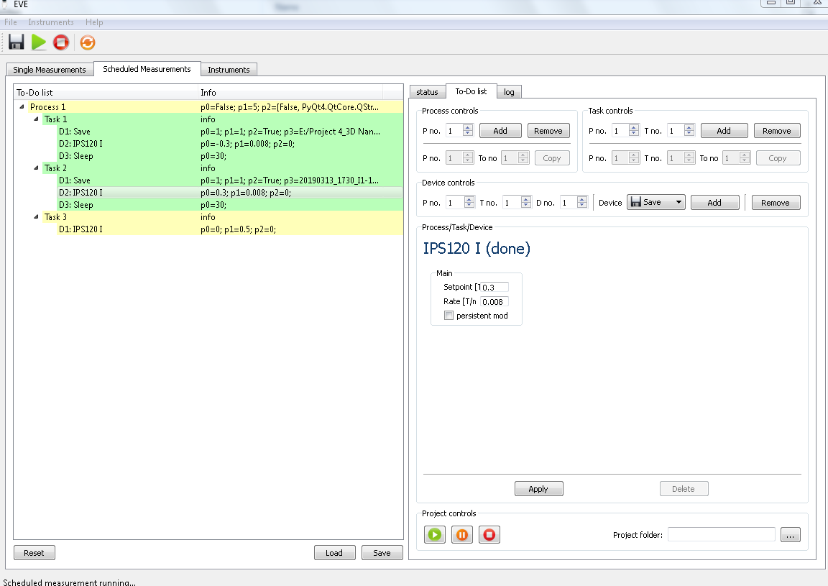

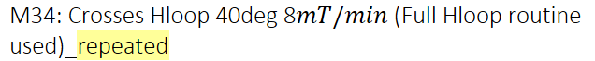



Donnerstag, 14. März 2019

08:00

|  |  |
| --- | --- |
| (1) Structures measured | Crosses |
| **(2) Measurement type** | Hloop\_gradiometry |
| **(3) Cables Setup:** | |  |  | | --- | --- | |  | 2-12 | |  | 8-6 | |  | * 1. 7 |  |  |  |  | | --- | --- | --- | | Gate (9) |  |  | |
| **(4) Magnet Setup:** |  |
| **(5) Experiment Setup:** | |  |  | | --- | --- | | T |  | |  |  | |  | 1 MΩ | |  | 8.7 kΩ | |  | 0 | |  | 1 MΩ | |  | 35 | |
| **(6) Lock-In Setup:** | |  |  | | --- | --- | | Sens: | 20 μV | | τ: | 1s | | Float/Ground: | Ground | | AC/DC: | AC | | A/A-B: | A-B | | Reserve: | Normal | | Source: | Internal | |
| **(7) Important Notes:** |  |
| **(8) Filename and data:** | <<M34\_Crosses\_35deg\_Hloop\_down\_\_Gradio\_20190314\_0800\_I1-2-12\_I2-8-6\_GBIP8-14-7\_Vin-2.5V\_R11-1MO\_R12-8.7kO\_R13-0\_R21-1MO\_C11-1\_C21-6\_T-30K\_SR-0.008-T-min\_B-0.3T\_gate-0V.dat>>    <<M34\_Crosses\_35deg\_Hloop\_up\_\_Gradio\_20190314\_0800\_I1-2-12\_I2-8-6\_GBIP8-14-7\_Vin-2.5V\_R11-1MO\_R12-8.7kO\_R13-0\_R21-1MO\_C11-1\_C21-6\_T-30K\_SR-0.008-T-min\_B-0.3T\_gate-0V.dat>> |

R11 = 174/1000\*50 = 8,7 kO

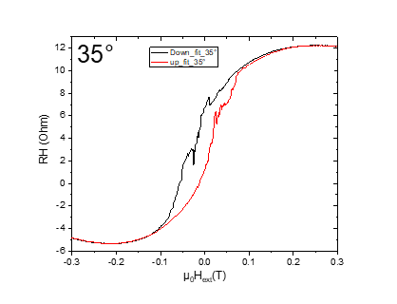

M35: 35deg All Crosses (±1T)\_Carrier concentration

10 March 2019

19:37



|  |  |
| --- | --- |
| (1) Structures measured | Plusses\_Crosses\_empty |
| (2) Measurement type | Hloop\_parallel |
| **(3) Cables Setup:** | |  |  |  | | --- | --- | --- | |  |  | C | |  |  | D | |  |  |  | |  |  |  | | Gate (9) |  |  | |
| **(4) Magnet Setup:** |  |
| **(5) Experiment Setup:** | |  |  | | --- | --- | | T |  | |  |  | |  | 1 MΩ | |  | 35 | |
| **(6) Lock-In Setup:** | |  |  | | --- | --- | | Sens: | 20 mV | | τ: | 1s | | Float/Ground: | Ground | | AC/DC: | AC | | A/A-B: | A-B | | Reserve: | Normal | | Source: | Internal | |
| **(7) Important Notes:** | All 3 Lock Ins have been initialized with GPIB 8. |
| **(8) Filename and data:** | <<M35\_cros\_plu\_emp\_35\_Hloop\_down\_Parallel\_20190314\_1000\_I-7-14\_GB8-1-13\_GB9-2-12\_GB13-6-8\_Vin-2.5V\_R11-1MO\_C11-1\_C21-6\_T-30K\_SR-0.5-T-min\_B-1T\_gate-0V\_.dat>>    <<M35\_cros\_plu\_emp\_35\_Hloop\_up\_Parallel\_20190314\_1000\_I-7-14\_GB8-1-13\_GB9-2-12\_GB13-6-8\_Vin-2.5V\_R11-1MO\_C11-1\_C21-6\_T-30K\_SR-0.5-T-min\_B-1T\_gate-0V\_.dat>> |

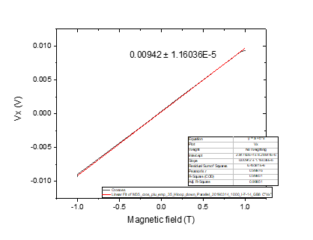

C: Changing angle 30

12 March 2019

20:37

Aiming for Hall Voltage:



**Voltage measured:**



|  |  |
| --- | --- |
| (1) Structures measured | Empty Cross |
| (2) Measurement type | Angle Changing |
| **(3) Cables Setup:** | |  |  |  | | --- | --- | --- | |  | *14 - 7* |  | |  |  |  | | Gate (9) |  |  | |
| **(4) Magnet Setup:** | B = 1 T |
| **(5) Experiment Setup:** | |  |  | | --- | --- | | T |  | |  |  | |  | 1 MΩ | |  | 30 | |
| **(6) Lock-In Setup:** | |  |  | | --- | --- | | Sens: | 20mV | | τ: | 1s | | Float/Ground: | Ground | | AC/DC: | AC | | A/A-B: | A-B | | Reserve: | Normal | | Source: | Internal | |
| **(7) Important Notes:** | Voltage before changinig angle: 9,321 mV |
| **(8) Filename and data:** | No File created |



Dienstag, 12. März 2019

12:19



|  |  |
| --- | --- |
| (1) Structures measured | Plusses |
| **(2) Measurement type** | Hloop\_gradiometry |
| **(3) Cables Setup:** | |  |  | | --- | --- | |  | 1-13 | |  | 8-6 | |  | * 1. 7 |  |  |  |  | | --- | --- | --- | | Gate (9) |  |  | |
| **(4) Magnet Setup:** |  |
| **(5) Experiment Setup:** | |  |  | | --- | --- | | T |  | |  |  | |  | 1 MΩ | |  | 8,75 kΩ | |  | 0 | |  | 1 MΩ | |  | 30 | |  |  | |  |  | |
| **(6) Lock-In Setup:** | |  |  | | --- | --- | | Sens: | 20 μV | | τ: | 3s | | Float/Ground: | Ground | | AC/DC: | AC | | A/A-B: | A-B | | Reserve: | Normal | | Source: | Internal | |
| **(7) Important Notes:** |  |
| **(8) Filename and data:** | <<M36\_Plusses\_30deg\_Hloop\_down\_\_Gradio\_20190314\_1100\_I1-2-12\_I2-8-6\_GBIP8-14-7\_Vin-2.5V\_R11-1MO\_R12-8.75kO\_R13-0\_R21-1MO\_C11-1\_C21-6\_T-30K\_SR-0.008-T-min\_B-0.3T\_gate-0V.dat>>    <<M36\_Plusses\_30deg\_Hloop\_up\_\_Gradio\_20190314\_1100\_I1-2-12\_I2-8-6\_GBIP8-14-7\_Vin-2.5V\_R11-1MO\_R12-8.75kO\_R13-0\_R21-1MO\_C11-1\_C21-6\_T-30K\_SR-0.008-T-min\_B-0.3T\_gate-0V.dat>> |

R11 = 175/1000\*50 = 8,75

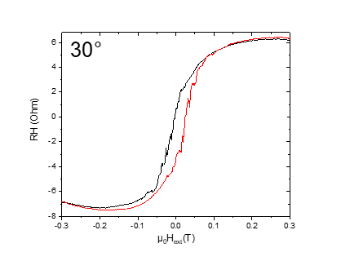



Donnerstag, 14. März 2019

08:00

|  |  |
| --- | --- |
| (1) Structures measured | Crosses |
| **(2) Measurement type** | Hloop\_gradiometry |
| **(3) Cables Setup:** | |  |  | | --- | --- | |  | 2-12 | |  | 8-6 | |  | * 1. 7 |  |  |  |  | | --- | --- | --- | | Gate (9) |  |  | |
| **(4) Magnet Setup:** |  |
| **(5) Experiment Setup:** | |  |  | | --- | --- | | T |  | |  |  | |  | 1 MΩ | |  | 7,75 kΩ | |  | 0 | |  | 1 MΩ | |  | 30 | |
| **(6) Lock-In Setup:** | |  |  | | --- | --- | | Sens: | 20 μV | | τ: | 1s | | Float/Ground: | Ground | | AC/DC: | AC | | A/A-B: | A-B | | Reserve: | Normal | | Source: | Internal | |
| **(7) Important Notes:** |  |
| **(8) Filename and data:** | <<M37\_Crosses\_30deg\_Hloop\_down\_Gradio\_20190314\_1100\_I1-2-12\_I2-8-6\_GBIP8-14-7\_Vin-2.5V\_R11-1MO\_R12-7.75kO\_R13-0\_R21-1MO\_C11-1\_C21-6\_T-30K\_SR-0.008-T-min\_B-0.3T\_gate-0V.dat>>    <<M37\_Crosses\_30deg\_Hloop\_up\_Gradio\_20190314\_1100\_I1-2-12\_I2-8-6\_GBIP8-14-7\_Vin-2.5V\_R11-1MO\_R12-7.75kO\_R13-0\_R21-1MO\_C11-1\_C21-6\_T-30K\_SR-0.008-T-min\_B-0.3T\_gate-0V.dat>> |

R11 = 155/1000\*50 = 7,75 kO

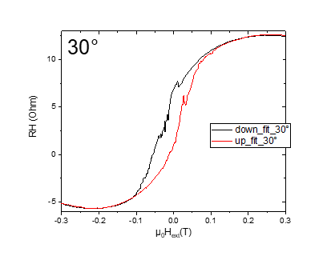

M38: 30deg All Crosses (±1T)\_Carrier concentration

Donnerstag, 14. März 2019

17:02



|  |  |
| --- | --- |
| (1) Structures measured | Plusses\_Crosses\_empty |
| (2) Measurement type | Hloop\_parallel |
| **(3) Cables Setup:** | |  |  |  | | --- | --- | --- | |  |  | C | |  |  | D | |  |  |  | |  |  |  | | Gate (9) |  |  | |
| **(4) Magnet Setup:** |  |
| **(5) Experiment Setup:** | |  |  | | --- | --- | | T |  | |  |  | |  | 1 MΩ | |  | 30 | |
| **(6) Lock-In Setup:** | |  |  | | --- | --- | | Sens: | 20 mV | | τ: | 1s | | Float/Ground: | Ground | | AC/DC: | AC | | A/A-B: | A-B | | Reserve: | Normal | | Source: | Internal | |
| **(7) Important Notes:** |  |
| **(8) Filename and data:** | <<M38\_cros\_plu\_emp\_35\_Hloop\_down\_Parallel\_20190314\_1700\_I-7-14\_GB8-1-13\_GB9-2-12\_GB13-6-8\_Vin-2.5V\_R11-1MO\_C11-1\_C21-6\_T-30K\_SR-0.5-T-min\_B-1T\_gate-0V\_.dat>>    <<M38\_cros\_plu\_emp\_35\_Hloop\_up\_Parallel\_20190314\_1700\_I-7-14\_GB8-1-13\_GB9-2-12\_GB13-6-8\_Vin-2.5V\_R11-1MO\_C11-1\_C21-6\_T-30K\_SR-0.5-T-min\_B-1T\_gate-0V\_.dat>> |

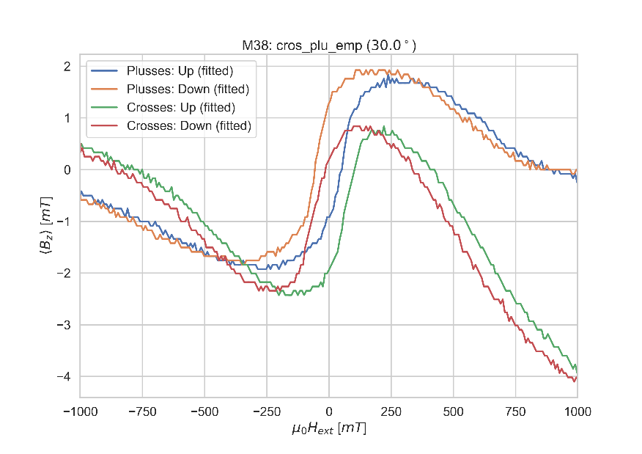

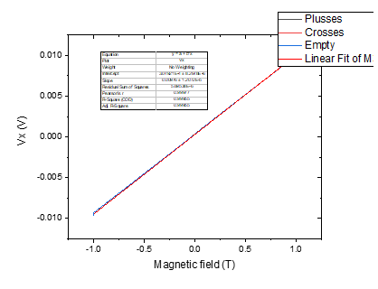

C: Changing angle 25

12 March 2019

20:37

Aiming for Hall Voltage:



**Voltage measured:**



|  |  |
| --- | --- |
| (1) Structures measured | Empty Cross |
| (2) Measurement type | Angle Changing |
| **(3) Cables Setup:** | |  |  |  | | --- | --- | --- | |  | *14 - 7* |  | |  |  |  | | Gate (9) |  |  | |
| **(4) Magnet Setup:** | B = 1 T |
| **(5) Experiment Setup:** | |  |  | | --- | --- | | T |  | |  |  | |  | 1 MΩ | |  | 25 | |
| **(6) Lock-In Setup:** | |  |  | | --- | --- | | Sens: | 20mV | | τ: | 1s | | Float/Ground: | Ground | | AC/DC: | AC | | A/A-B: | A-B | | Reserve: | Normal | | Source: | Internal | |
| **(7) Important Notes:** | Voltage before changinig angle: 9,642 mV |
| **(8) Filename and data:** | No File created |



Freitag, 15. März 2019

08:00



|  |  |
| --- | --- |
| (1) Structures measured | Plusses |
| **(2) Measurement type** | Hloop\_gradiometry |
| **(3) Cables Setup:** | |  |  | | --- | --- | |  | 1-13 | |  | 8-6 | |  | * 1. 7 |  |  |  |  | | --- | --- | --- | | Gate (9) |  |  | |
| **(4) Magnet Setup:** |  |
| **(5) Experiment Setup:** | |  |  | | --- | --- | | T |  | |  |  | |  | 1 MΩ | |  | 8,75 kΩ | |  | 0 | |  | 1 MΩ | |  | 25 | |  |  | |  |  | |
| **(6) Lock-In Setup:** | |  |  | | --- | --- | | Sens: | 50 μV | | τ: | 3s | | Float/Ground: | Ground | | AC/DC: | AC | | A/A-B: | A-B | | Reserve: | Normal | | Source: | Internal | |
| **(7) Important Notes:** |  |
| **(8) Filename and data:** | <<M39\_Plusses\_25deg\_Hloop\_up\_\_Gradio\_20190315\_0800\_I1-2-12\_I2-8-6\_GBIP8-14-7\_Vin-2.5V\_R11-1MO\_R12-8.75kO\_R13-0\_R21-1MO\_C11-1\_C21-6\_T-30K\_SR-0.008-T-min\_B-0.3T\_gate-0V.dat>>    <<M39\_Plusses\_25deg\_Hloop\_down\_\_Gradio\_20190315\_0800\_I1-2-12\_I2-8-6\_GBIP8-14-7\_Vin-2.5V\_R11-1MO\_R12-8.75kO\_R13-0\_R21-1MO\_C11-1\_C21-6\_T-30K\_SR-0.008-T-min\_B-0.3T\_gate-0V.dat>> |

R11 = 172/1000\*50 = 8,6 kO

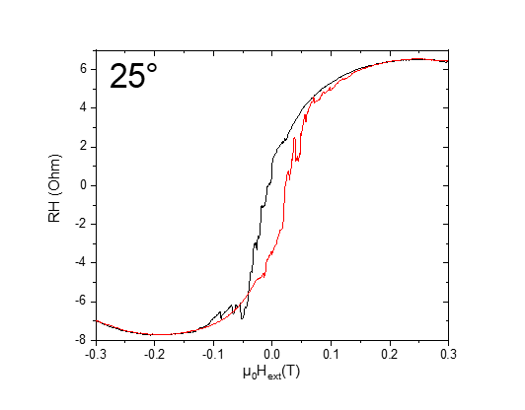



Freitag, 15. März 2019

08:00

|  |  |
| --- | --- |
| (1) Structures measured | Crosses |
| **(2) Measurement type** | Hloop\_gradiometry |
| **(3) Cables Setup:** | |  |  | | --- | --- | |  | 2-12 | |  | 8-6 | |  | * 1. 7 |  |  |  |  | | --- | --- | --- | | Gate (9) |  |  | |
| **(4) Magnet Setup:** |  |
| **(5) Experiment Setup:** | |  |  | | --- | --- | | T |  | |  |  | |  | 1 MΩ | |  | 4.5 kΩ | |  | 0 | |  | 1 MΩ | |  | 25 | |
| **(6) Lock-In Setup:** | |  |  | | --- | --- | | Sens: | 20 μV | | τ: | 1s | | Float/Ground: | Ground | | AC/DC: | AC | | A/A-B: | A-B | | Reserve: | Normal | | Source: | Internal | |
| **(7) Important Notes:** |  |
| **(8) Filename and data:** | <<M40\_Crosses\_25deg\_Hloop\_up\_Gradio\_20190315\_1100\_I1-2-12\_I2-8-6\_GBIP8-14-7\_Vin-2.5V\_R11-1MO\_R12-4.5kO\_R13-0\_R21-1MO\_C11-1\_C21-6\_T-30K\_SR-0.008-T-min\_B-0.3T\_gate-0V.dat>>    <<M40\_Crosses\_25deg\_Hloop\_down\_Gradio\_20190315\_1100\_I1-2-12\_I2-8-6\_GBIP8-14-7\_Vin-2.5V\_R11-1MO\_R12-4.5kO\_R13-0\_R21-1MO\_C11-1\_C21-6\_T-30K\_SR-0.008-T-min\_B-0.3T\_gate-0V.dat>> |

R11 = 90/1000\*50 = 4,5 kO

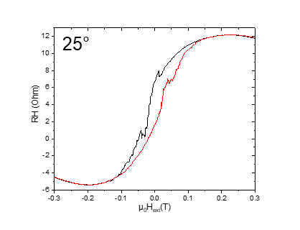

M41: 25deg All Crosses (±1T)\_Carrier concentration

Freitag, 15. März 2019

14:10

|  |  |
| --- | --- |
| (1) Structures measured | Plusses\_Crosses\_empty |
| (2) Measurement type | Hloop\_parallel |
| **(3) Cables Setup:** | |  |  |  | | --- | --- | --- | |  |  | C | |  |  | D | |  |  |  | |  |  |  | | Gate (9) |  |  | |
| **(4) Magnet Setup:** |  |
| **(5) Experiment Setup:** | |  |  | | --- | --- | | T |  | |  |  | |  | 1 MΩ | |  | 25 | |
| **(6) Lock-In Setup:** | |  |  | | --- | --- | | Sens: | 20 mV | | τ: | 1s | | Float/Ground: | Ground | | AC/DC: | AC | | A/A-B: | A-B | | Reserve: | Normal | | Source: | Internal | |
| **(7) Important Notes:** |  |
| **(8) Filename and data:** | <<M41\_cros\_plu\_emp\_25deg\_Hloop\_down\_Parallel\_20190314\_1700\_I-7-14\_GB8-1-13\_GB9-2-12\_GB13-6-8\_Vin-2.5V\_R11-1MO\_C11-1\_C21-6\_T-30K\_SR-0.5-T-min\_B-1T\_gate-0V\_.dat>>    <<M41\_cros\_plu\_emp\_25deg\_Hloop\_up\_Parallel\_20190315\_1400\_I-7-14\_GB8-1-13\_GB9-2-12\_GB13-6-8\_Vin-2.5V\_R11-1MO\_C11-1\_C21-6\_T-30K\_SR-0.5-T-min\_B-1T\_gate-0V\_.dat>> |

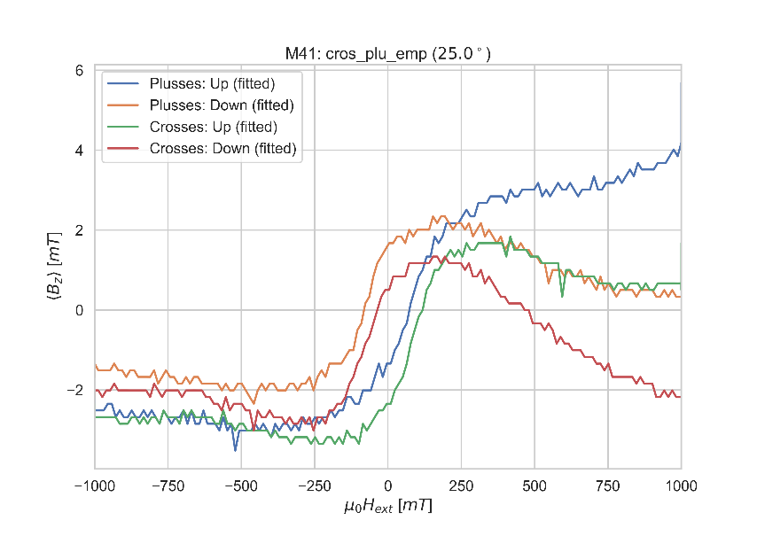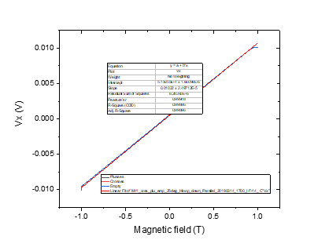

C: Changing angle 20

12 March 2019

20:37

|  |  |
| --- | --- |
| (1) Structures measured | Empty Cross |
| (2) Measurement type | Angle Changing |
| **(3) Cables Setup:** | |  |  |  | | --- | --- | --- | |  | *14 - 7* |  | |  |  |  | | Gate (9) |  |  | |
| **(4) Magnet Setup:** | B = 1 T |
| **(5) Experiment Setup:** | |  |  | | --- | --- | | T |  | |  |  | |  | 1 MΩ | |  | 20 | |
| **(6) Lock-In Setup:** | |  |  | | --- | --- | | Sens: | 20mV | | τ: | 1s | | Float/Ground: | Ground | | AC/DC: | AC | | A/A-B: | A-B | | Reserve: | Normal | | Source: | Internal | |
| **(7) Important Notes:** | Voltage before changinig angle: 10,107 mV |
| **(8) Filename and data:** | No File created |

Aiming for Hall Voltage:



**Voltage measured:**





Freitag, 15. März 2019

14:30



|  |  |
| --- | --- |
| (1) Structures measured | Plusses |
| **(2) Measurement type** | Hloop\_gradiometry |
| **(3) Cables Setup:** | |  |  | | --- | --- | |  | 1-13 | |  | 8-6 | |  | * 1. 7 |  |  |  |  | | --- | --- | --- | | Gate (9) |  |  | |
| **(4) Magnet Setup:** |  |
| **(5) Experiment Setup:** | |  |  | | --- | --- | | T |  | |  |  | |  | 1 MΩ | |  | 8,75 kΩ | |  | 0 | |  | 1 MΩ | |  | 20 | |  | 1 | |  | 6 | |
| **(6) Lock-In Setup:** | |  |  | | --- | --- | | Sens: | 50 μV | | τ: | 3s | | Float/Ground: | Ground | | AC/DC: | AC | | A/A-B: | A-B | | Reserve: | Normal | | Source: | Internal | |
| **(7) Important Notes:** |  |
| **(8) Filename and data:** | <<M42\_Plusses\_20deg\_Hloop\_down\_\_Gradio\_20190315\_1400\_I1-2-12\_I2-8-6\_GBIP8-14-7\_Vin-2.5V\_R11-1MO\_R12-8.75kO\_R13-0\_R21-1MO\_C11-1\_C21-6\_T-30K\_SR-0.008-T-min\_B-0.3T\_gate-0V.dat>>    <<M42\_Plusses\_20deg\_Hloop\_up\_\_Gradio\_20190315\_1400\_I1-2-12\_I2-8-6\_GBIP8-14-7\_Vin-2.5V\_R11-1MO\_R12-8.75kO\_R13-0\_R21-1MO\_C11-1\_C21-6\_T-30K\_SR-0.008-T-min\_B-0.3T\_gate-0V.dat>> |

R11 = 175/1000\*50 = 8,75

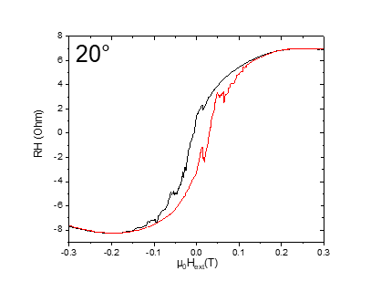



Freitag, 15. März 2019

17:27

|  |  |
| --- | --- |
| (1) Structures measured | Crosses |
| **(2) Measurement type** | Hloop\_gradiometry |
| **(3) Cables Setup:** | |  |  | | --- | --- | |  | 2-12 | |  | 8-6 | |  | * 1. 7 |  |  |  |  | | --- | --- | --- | | Gate (9) |  |  | |
| **(4) Magnet Setup:** |  |
| **(5) Experiment Setup:** | |  |  | | --- | --- | | T |  | |  |  | |  | 1 MΩ | |  | 7 kΩ | |  | 0 | |  | 1 MΩ | |  | 20 | |
| **(6) Lock-In Setup:** | |  |  | | --- | --- | | Sens: | 50 μV | | τ: | 1s | | Float/Ground: | Ground | | AC/DC: | AC | | A/A-B: | A-B | | Reserve: | Normal | | Source: | Internal | |
| **(7) Important Notes:** | The routine worked fine. Go to zero option of the magnet worked fine. The measurment finished without any problems. |
| **(8) Filename and data:** | <<M43\_Crosses\_20deg\_Hloop\_down\_Gradio\_20190315\_1800\_I1-2-12\_I2-8-6\_GBIP8-14-7\_Vin-2.5V\_R11-1MO\_R12-7kO\_R13-0\_R21-1MO\_C11-1\_C21-6\_T-30K\_SR-0.008-T-min\_B-0.3T\_gate-0V.dat>>  <<M43\_Crosses\_20deg\_Hloop\_up\_Gradio\_20190315\_1800\_I1-2-12\_I2-8-6\_GBIP8-14-7\_Vin-2.5V\_R11-1MO\_R12-7kO\_R13-0\_R21-1MO\_C11-1\_C21-6\_T-30K\_SR-0.008-T-min\_B-0.3T\_gate-0V.dat>> |

R11 = 140/1000\*50 = 7,0

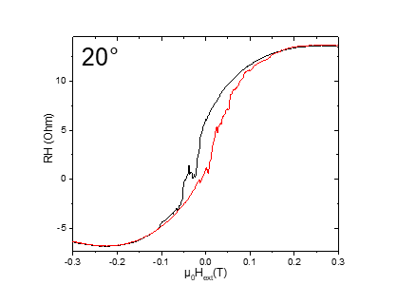

M44: 20deg All Crosses (±1T)\_Carrier concentration

Sonntag, 17. März 2019

08:29

|  |  |
| --- | --- |
| (1) Structures measured | Plusses\_Crosses\_empty |
| (2) Measurement type | Hloop\_parallel |
| **(3) Cables Setup:** | |  |  |  | | --- | --- | --- | |  |  | C | |  |  | D | |  |  |  | |  |  |  | | Gate (9) |  |  | |
| **(4) Magnet Setup:** |  |
| **(5) Experiment Setup:** | |  |  | | --- | --- | | T |  | |  |  | |  | 1 MΩ | |  | 20 | |
| **(6) Lock-In Setup:** | |  |  | | --- | --- | | Sens: | 20 mV | | τ: | 1s | | Float/Ground: | Ground | | AC/DC: | AC | | A/A-B: | A-B | | Reserve: | Normal | | Source: | Internal | |
| **(7) Important Notes:** |  |
| **(8) Filename and data:** | <<M44\_cros\_plu\_emp\_20deg\_Hloop\_up\_Parallel\_20190316\_0800\_I-7-14\_GB8-1-13\_GB9-2-12\_GB13-6-8\_Vin-2.5V\_R11-1MO\_C11-1\_C21-6\_T-30K\_SR-0.5-T-min\_B-1T\_gate-0V\_.dat>>    <<M44\_cros\_plu\_emp\_20deg\_Hloop\_down\_Parallel\_20190316\_0800\_I-7-14\_GB8-1-13\_GB9-2-12\_GB13-6-8\_Vin-2.5V\_R11-1MO\_C11-1\_C21-6\_T-30K\_SR-0.5-T-min\_B-1T\_gate-0V\_.dat>> |



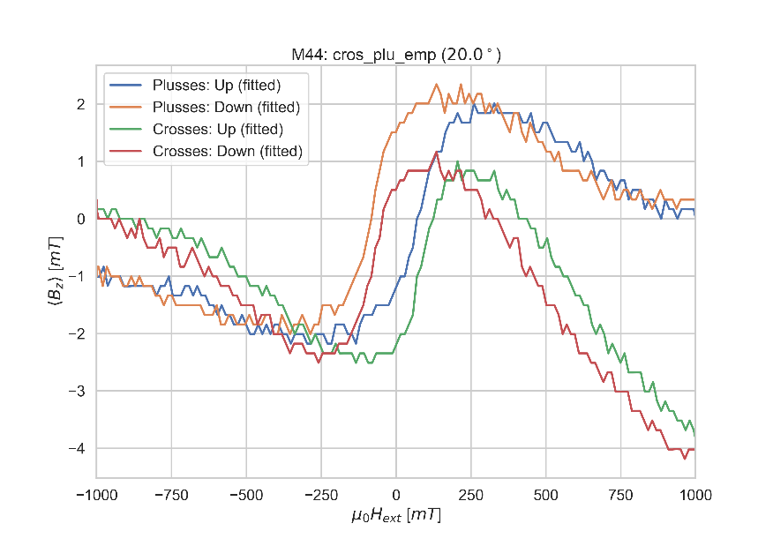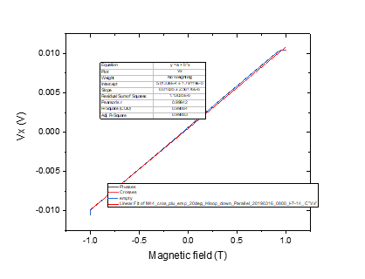

C: Changing angle 15

Samstag, 16. März 2019

08:40

|  |  |
| --- | --- |
| (1) Structures measured | Empty Cross |
| (2) Measurement type | Angle Changing |
| **(3) Cables Setup:** | |  |  |  | | --- | --- | --- | |  | *14 - 7* |  | |  |  |  | | Gate (9) |  |  | |
| **(4) Magnet Setup:** | B = 1 T |
| **(5) Experiment Setup:** | |  |  | | --- | --- | | T |  | |  |  | |  | 1 MΩ | |  | 15 | |
| **(6) Lock-In Setup:** | |  |  | | --- | --- | | Sens: | 20mV | | τ: | 1s | | Float/Ground: | Ground | | AC/DC: | AC | | A/A-B: | A-B | | Reserve: | Normal | | Source: | Internal | |
| **(7) Important Notes:** | Voltage before changinig angle:10,483 mV |
| **(8) Filename and data:** | No File created |

Aiming for Hall Voltage:



Cos(90)=0

**Voltage measured:**





Samstag, 16. März 2019

08:57



|  |  |
| --- | --- |
| (1) Structures measured | Plusses |
| **(2) Measurement type** | Hloop\_gradiometry |
| **(3) Cables Setup:** | |  |  | | --- | --- | |  | 1-13 | |  | 8-6 | |  | * 1. 7 |  |  |  |  | | --- | --- | --- | | Gate (9) |  |  | |
| **(4) Magnet Setup:** |  |
| **(5) Experiment Setup:** | |  |  | | --- | --- | | T |  | |  |  | |  | 1 MΩ | |  | 8,5 kΩ | |  | 0 | |  | 1 MΩ | |  | 15 | |  | 1 | |  | 6 | |
| **(6) Lock-In Setup:** | |  |  | | --- | --- | | Sens: | 50 μV | | τ: | 3s | | Float/Ground: | Ground | | AC/DC: | AC | | A/A-B: | A-B | | Reserve: | Normal | | Source: | Internal | |
| **(7) Important Notes:** |  |
| **(8) Filename and data:** | <<M45\_Plusses\_15deg\_Hloop\_up\_\_Gradio\_20190316\_0800\_I1-2-12\_I2-8-6\_GBIP8-14-7\_Vin-2.5V\_R11-1MO\_R12-8.5kO\_R13-0\_R21-1MO\_C11-1\_C21-6\_T-30K\_SR-0.008-T-min\_B-0.3T\_gate-0V.dat>>    <<M45\_Plusses\_15deg\_Hloop\_down\_\_Gradio\_20190316\_0800\_I1-2-12\_I2-8-6\_GBIP8-14-7\_Vin-2.5V\_R11-1MO\_R12-8.5kO\_R13-0\_R21-1MO\_C11-1\_C21-6\_T-30K\_SR-0.008-T-min\_B-0.3T\_gate-0V.dat>> |

R11 = 170/1000\*50 = 8,5

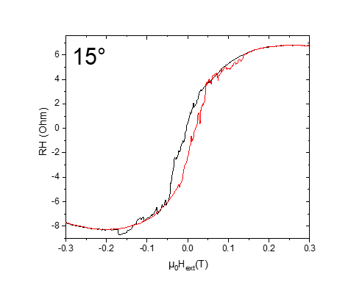



Samstag, 16. März 2019

11:00

|  |  |
| --- | --- |
| (1) Structures measured | Crosses |
| **(2) Measurement type** | Hloop\_gradiometry |
| **(3) Cables Setup:** | |  |  | | --- | --- | |  | 2-12 | |  | 8-6 | |  | * 1. 7 |  |  |  |  | | --- | --- | --- | | Gate (9) |  |  | |
| **(4) Magnet Setup:** |  |
| **(5) Experiment Setup:** | |  |  | | --- | --- | | T |  | |  |  | |  | 1 MΩ | |  | 9.75kΩ | |  | 0 | |  | 1 MΩ | |  | 15 | |
| **(6) Lock-In Setup:** | |  |  | | --- | --- | | Sens: | 50 μV | | τ: | 1s | | Float/Ground: | Ground | | AC/DC: | AC | | A/A-B: | A-B | | Reserve: | Normal | | Source: | Internal | |
| **(7) Important Notes:** |  |
| **(8) Filename and data:** | <<M46\_Crosses\_15deg\_Hloop\_down\_Gradio\_20190316\_1100\_I1-2-12\_I2-8-6\_GBIP8-14-7\_Vin-2.5V\_R11-1MO\_R12-9.75kO\_R13-0\_R21-1MO\_C11-1\_C21-6\_T-30K\_SR-0.008-T-min\_B-0.3T\_gate-0V.dat>>    <<M46\_Crosses\_15deg\_Hloop\_up\_Gradio\_20190316\_1100\_I1-2-12\_I2-8-6\_GBIP8-14-7\_Vin-2.5V\_R11-1MO\_R12-9.75kO\_R13-0\_R21-1MO\_C11-1\_C21-6\_T-30K\_SR-0.008-T-min\_B-0.3T\_gate-0V.dat>> |

R11 = 195/1000\*50 = 9,75

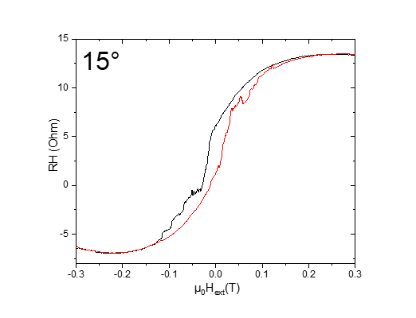

M47: 15deg All Crosses (±1T)\_Carrier concentration

Samstag, 16. März 2019

08:29

|  |  |
| --- | --- |
| (1) Structures measured | Plusses\_Crosses\_empty |
| (2) Measurement type | Hloop\_parallel |
| **(3) Cables Setup:** | |  |  |  | | --- | --- | --- | |  |  | C | |  |  | D | |  |  |  | |  |  |  | | Gate (9) |  |  | |
| **(4) Magnet Setup:** |  |
| **(5) Experiment Setup:** | |  |  | | --- | --- | | T |  | |  |  | |  | 1 MΩ | |  | 15 | |
| **(6) Lock-In Setup:** | |  |  | | --- | --- | | Sens: | 50 mV | | τ: | 1s | | Float/Ground: | Ground | | AC/DC: | AC | | A/A-B: | A-B | | Reserve: | Normal | | Source: | Internal | |
| **(7) Important Notes:** |  |
| **(8) Filename and data:** | <<M47\_cros\_plu\_emp\_15deg\_Hloop\_down\_Parallel\_20190316\_1400\_I-7-14\_GB8-1-13\_GB9-2-12\_GB13-6-8\_Vin-2.5V\_R11-1MO\_C11-1\_C21-6\_T-30K\_SR-0.5-T-min\_B-1T\_gate-0V\_.dat>>    <<M47\_cros\_plu\_emp\_15deg\_Hloop\_up\_Parallel\_20190316\_1400\_I-7-14\_GB8-1-13\_GB9-2-12\_GB13-6-8\_Vin-2.5V\_R11-1MO\_C11-1\_C21-6\_T-30K\_SR-0.5-T-min\_B-1T\_gate-0V\_.dat>> |

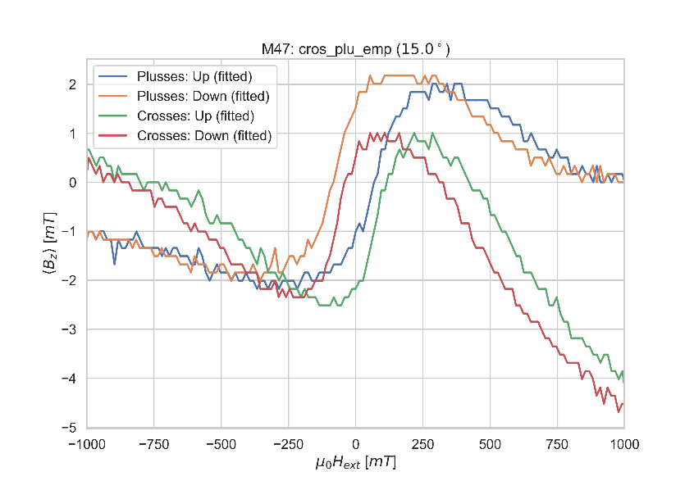

C: Changing angle 10

Samstag, 16. März 2019

14:23

|  |  |
| --- | --- |
| (1) Structures measured | Empty Cross |
| (2) Measurement type | Angle Changing |
| **(3) Cables Setup:** | |  |  |  | | --- | --- | --- | |  | *14 - 7* |  | |  |  |  | | Gate (9) |  |  | |
| **(4) Magnet Setup:** | B = 1 T |
| **(5) Experiment Setup:** | |  |  | | --- | --- | | T |  | |  |  | |  | 1 MΩ | |  | 10 | |
| **(6) Lock-In Setup:** | |  |  | | --- | --- | | Sens: | 20mV | | τ: | 1s | | Float/Ground: | Ground | | AC/DC: | AC | | A/A-B: | A-B | | Reserve: | Normal | | Source: | Internal | |
| **(7) Important Notes:** | Voltage before changinig angle: 10.847 mV |
| **(8) Filename and data:** | No File created |

Aiming for Hall Voltage:



Cos(90)=0

**Voltage measured:**





Samstag, 16. März 2019

14:23

|  |  |
| --- | --- |
| (1) Structures measured | Plusses |
| **(2) Measurement type** | Hloop\_gradiometry |
| **(3) Cables Setup:** | |  |  | | --- | --- | |  | 1-13 | |  | 8-6 | |  | * 1. 7 |  |  |  |  | | --- | --- | --- | | Gate (9) |  |  | |
| **(4) Magnet Setup:** |  |
| **(5) Experiment Setup:** | |  |  | | --- | --- | | T |  | |  |  | |  | 1 MΩ | |  | 8 kΩ | |  | 0 | |  | 1 MΩ | |  | 10 | |  | 1 | |  | 6 | |
| **(6) Lock-In Setup:** | |  |  | | --- | --- | | Sens: | 50 μV | | τ: | 3s | | Float/Ground: | Ground | | AC/DC: | AC | | A/A-B: | A-B | | Reserve: | Normal | | Source: | Internal | |
| **(7) Important Notes:** |  |
| **(8) Filename and data:** | <<M48\_Plusses\_10deg\_Hloop\_down\_\_Gradio\_20190316\_1400\_I1-2-12\_I2-8-6\_GBIP8-14-7\_Vin-2.5V\_R11-1MO\_R12-8kO\_R13-0\_R21-1MO\_C11-1\_C21-6\_T-30K\_SR-0.008-T-min\_B-0.3T\_gate-0V.dat>>    <<M48\_Plusses\_10deg\_Hloop\_up\_\_Gradio\_20190316\_1400\_I1-2-12\_I2-8-6\_GBIP8-14-7\_Vin-2.5V\_R11-1MO\_R12-8kO\_R13-0\_R21-1MO\_C11-1\_C21-6\_T-30K\_SR-0.008-T-min\_B-0.3T\_gate-0V.dat>> |

R11 = 160/1000\*50 = 8

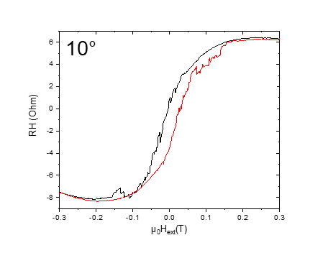

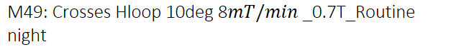

|  |  |
| --- | --- |
| (1) Structures measured | Crosses |
| **(2) Measurement type** | Hloop\_gradiometry |
| **(3) Cables Setup:** | |  |  | | --- | --- | |  | 2-12 | |  | 8-6 | |  | * 1. 7 |  |  |  |  | | --- | --- | --- | | Gate (9) |  |  | |
| **(4) Magnet Setup:** |  |
| **(5) Experiment Setup:** | |  |  | | --- | --- | | T |  | |  |  | |  | 1 MΩ | |  | 1,9kΩ | |  | 0 | |  | 1 MΩ | |  | 10 | |
| **(6) Lock-In Setup:** | |  |  | | --- | --- | | Sens: | 50 μV | | τ: | 1s | | Float/Ground: | Ground | | AC/DC: | AC | | A/A-B: | A-B | | Reserve: | Normal | | Source: | Internal | |
| **(7) Important Notes:** |  |
| **(8) Filename and data:** | <<M49\_Crosses\_10deg\_Hloop\_down\_Gradio\_20190316\_1800\_I1-2-12\_I2-8-6\_GBIP8-14-7\_Vin-2.5V\_R11-1MO\_R12-1,9kO\_R13-0\_R21-1MO\_C11-1\_C21-6\_T-30K\_SR-0.008-T-min\_B-0.7T\_gate-0V.dat>>    <<M49\_Crosses\_10deg\_Hloop\_up\_Gradio\_20190316\_1800\_I1-2-12\_I2-8-6\_GBIP8-14-7\_Vin-2.5V\_R11-1MO\_R12-1,9kO\_R13-0\_R21-1MO\_C11-1\_C21-6\_T-30K\_SR-0.008-T-min\_B-0.7T\_gate-0V.dat>> |

Samstag, 16. März 2019

17:40

R11 = 38/1000\*50 = 1,9

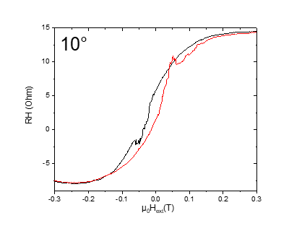

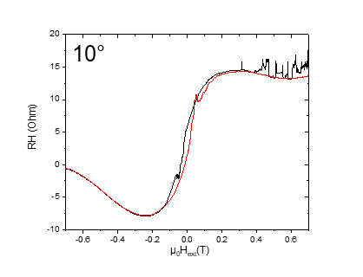

M50: 10deg All Crosses (±1T)\_Carrier concentration

Sonntag, 17. März 2019

07:57

|  |  |
| --- | --- |
| (1) Structures measured | Plusses\_Crosses\_empty |
| (2) Measurement type | Hloop\_parallel |
| **(3) Cables Setup:** | |  |  |  | | --- | --- | --- | |  |  | C | |  |  | D | |  |  |  | |  |  |  | | Gate (9) |  |  | |
| **(4) Magnet Setup:** |  |
| **(5) Experiment Setup:** | |  |  | | --- | --- | | T |  | |  |  | |  | 1 MΩ | |  | 10 | |
| **(6) Lock-In Setup:** | |  |  | | --- | --- | | Sens: | 50 mV | | τ: | 1s | | Float/Ground: | Ground | | AC/DC: | AC | | A/A-B: | A-B | | Reserve: | Normal | | Source: | Internal | |
| **(7) Important Notes:** |  |
| **(8) Filename and data:** | <<M50\_cros\_plu\_emp\_10deg\_Hloop\_down\_Parallel\_20190317\_0800\_I-7-14\_GB8-1-13\_GB9-2-12\_GB13-6-8\_Vin-2.5V\_R11-1MO\_C11-1\_C21-6\_T-30K\_SR-0.5-T-min\_B-1T\_gate-0V\_.dat>>    <<M50\_cros\_plu\_emp\_10deg\_Hloop\_up\_Parallel\_20190317\_0800\_I-7-14\_GB8-1-13\_GB9-2-12\_GB13-6-8\_Vin-2.5V\_R11-1MO\_C11-1\_C21-6\_T-30K\_SR-0.5-T-min\_B-1T\_gate-0V\_.dat>> |

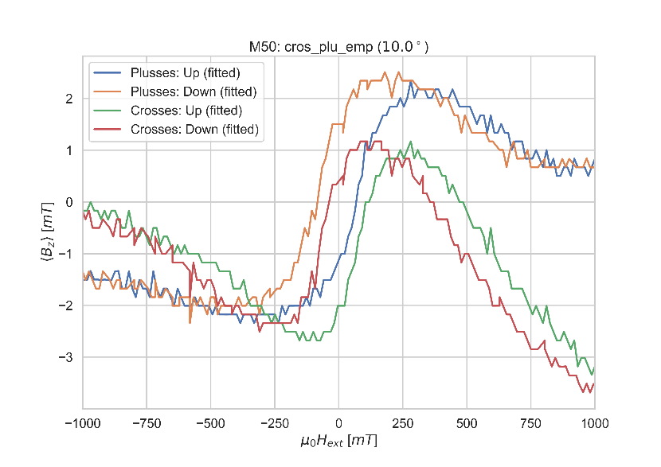

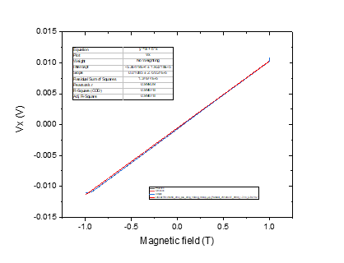

C: Changing angle 5

Sonntag, 17. März 2019

08:05

|  |  |
| --- | --- |
| (1) Structures measured | Empty Cross |
| (2) Measurement type | Angle Changing |
| **(3) Cables Setup:** | |  |  |  | | --- | --- | --- | |  | *14 - 7* |  | |  |  |  | | Gate (9) |  |  | |
| **(4) Magnet Setup:** | B = 1 T |
| **(5) Experiment Setup:** | |  |  | | --- | --- | | T |  | |  |  | |  | 1 MΩ | |  | 5 | |
| **(6) Lock-In Setup:** | |  |  | | --- | --- | | Sens: | 20mV | | τ: | 1s | | Float/Ground: | Ground | | AC/DC: | AC | | A/A-B: | A-B | | Reserve: | Normal | | Source: | Internal | |
| **(7) Important Notes:** |  |
| **(8) Filename and data:** | No File created |

Aiming for Hall Voltage:



Cos(90)=0

**Voltage measured:**





Sonntag, 17. März 2019

08:09

|  |  |
| --- | --- |
| (1) Structures measured | Plusses |
| **(2) Measurement type** | Hloop\_gradiometry |
| **(3) Cables Setup:** | |  |  | | --- | --- | |  | 1-13 | |  | 8-6 | |  | * 1. 7 |  |  |  |  | | --- | --- | --- | | Gate (9) |  |  | |
| **(4) Magnet Setup:** |  |
| **(5) Experiment Setup:** | |  |  | | --- | --- | | T |  | |  |  | |  | 1 MΩ | |  | 5 kΩ | |  | 0 | |  | 1 MΩ | |  | 5 | |  | 1 | |  | 6 | |
| **(6) Lock-In Setup:** | |  |  | | --- | --- | | Sens: | 50 μV | | τ: | 3s | | Float/Ground: | Ground | | AC/DC: | AC | | A/A-B: | A-B | | Reserve: | Normal | | Source: | Internal | |
| **(7) Important Notes:** |  |
| **(8) Filename and data:** | <<M51\_Plusses\_5deg\_Hloop\_down\_\_Gradio\_20190317\_0800\_I1-1-13\_I2-8-6\_GBIP8-14-7\_Vin-2.5V\_R11-1MO\_R12-5kO\_R13-0\_R21-1MO\_C11-1\_C21-6\_T-30K\_SR-0.008-T-min\_B-0.5T\_gate-0V.dat>>    <<M51\_Plusses\_5deg\_Hloop\_up\_\_Gradio\_20190317\_0800\_I1-1-13\_I2-8-6\_GBIP8-14-7\_Vin-2.5V\_R11-1MO\_R12-5kO\_R13-0\_R21-1MO\_C11-1\_C21-6\_T-30K\_SR-0.008-T-min\_B-0.5T\_gate-0V.dat>> |

R11 = 100/1000\*50 = 5

Pay attention to files name : typo error in the plusses name I1-1-12 and it should be 1-13

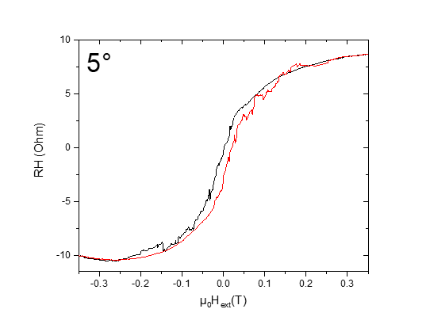



Sonntag, 17. März 2019

13:00

|  |  |
| --- | --- |
| (1) Structures measured | Crosses |
| **(2) Measurement type** | Hloop\_gradiometry |
| **(3) Cables Setup:** | |  |  | | --- | --- | |  | 2-12 | |  | 8-6 | |  | * 1. 7 |  |  |  |  | | --- | --- | --- | | Gate (9) |  |  | |
| **(4) Magnet Setup:** |  |
| **(5) Experiment Setup:** | |  |  | | --- | --- | | T |  | |  |  | |  | 1 MΩ | |  | 3kΩ | |  | 0 | |  | 1 MΩ | |  | 5 | |
| **(6) Lock-In Setup:** | |  |  | | --- | --- | | Sens: | 50 μV | | τ: | 1s | | Float/Ground: | Ground | | AC/DC: | AC | | A/A-B: | A-B | | Reserve: | Normal | | Source: | Internal | |
| **(7) Important Notes:** |  |
| **(8) Filename and data:** | <<M52\_Crosses\_5deg\_Hloop\_up\_Gradio\_20190317\_1300\_I1-2-12\_I2-8-6\_GBIP8-14-7\_Vin-2.5V\_R11-1MO\_R12-3kO\_R13-0\_R21-1MO\_C11-1\_C21-6\_T-30K\_SR-0.008-T-min\_B-0.5T\_gate-0V.dat>>    <<M52\_Crosses\_5deg\_Hloop\_down\_Gradio\_20190317\_1300\_I1-2-12\_I2-8-6\_GBIP8-14-7\_Vin-2.5V\_R11-1MO\_R12-3kO\_R13-0\_R21-1MO\_C11-1\_C21-6\_T-30K\_SR-0.008-T-min\_B-0.5T\_gate-0V.dat>> |

R11 = 60/1000\*50 = 3

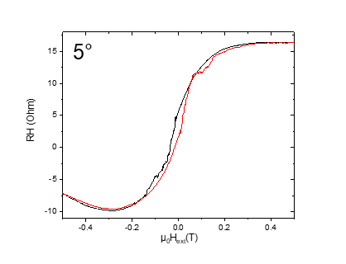

M53: 5deg All Crosses (±1T)\_Carrier concentration

Sonntag, 17. März 2019

17:05

|  |  |
| --- | --- |
| (1) Structures measured | Plusses\_Crosses\_empty |
| (2) Measurement type | Hloop\_parallel |
| **(3) Cables Setup:** | |  |  |  | | --- | --- | --- | |  |  | C | |  |  | D | |  |  |  | |  |  |  | | Gate (9) |  |  | |
| **(4) Magnet Setup:** |  |
| **(5) Experiment Setup:** | |  |  | | --- | --- | | T |  | |  |  | |  | 1 MΩ | |  | 5 | |
| **(6) Lock-In Setup:** | |  |  | | --- | --- | | Sens: | 50 mV | | τ: | 1s | | Float/Ground: | Ground | | AC/DC: | AC | | A/A-B: | A-B | | Reserve: | Normal | | Source: | Internal | |
| **(7) Important Notes:** |  |
| **(8) Filename and data:** | <<M53\_cros\_plu\_emp\_5deg\_Hloop\_down\_Parallel\_20190317\_1700\_I-7-14\_GB8-1-13\_GB9-2-12\_GB13-6-8\_Vin-2.5V\_R11-1MO\_C11-1\_C21-6\_T-30K\_SR-0.5-T-min\_B-1T\_gate-0V\_.dat>>    <<M53\_cros\_plu\_emp\_5deg\_Hloop\_up\_Parallel\_20190317\_1700\_I-7-14\_GB8-1-13\_GB9-2-12\_GB13-6-8\_Vin-2.5V\_R11-1MO\_C11-1\_C21-6\_T-30K\_SR-0.5-T-min\_B-1T\_gate-0V\_.dat>> |

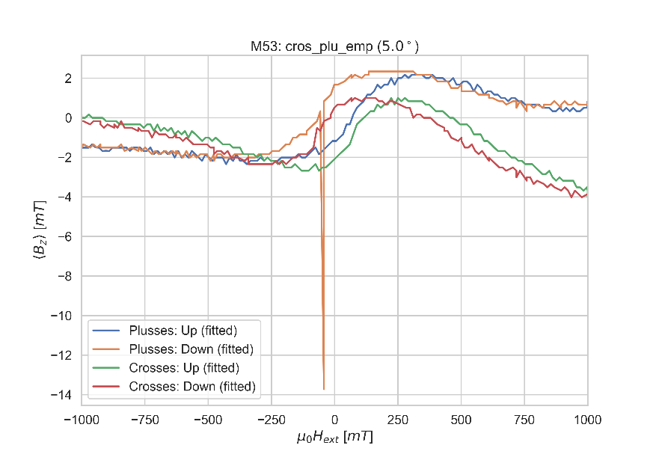

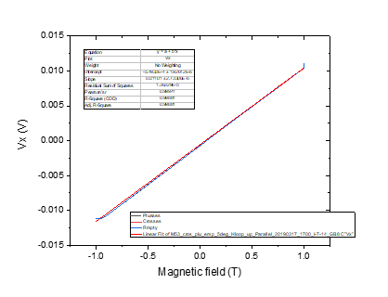

C: Changing angle 0\_2nd\_VH(0)=VH(max)

Sonntag, 17. März 2019

17:32

|  |  |
| --- | --- |
| (1) Structures measured | Empty Cross |
| (2) Measurement type | Angle Changing |
| **(3) Cables Setup:** | |  |  |  | | --- | --- | --- | |  | *14 - 7* |  | |  |  |  | | Gate (9) |  |  | |
| **(4) Magnet Setup:** | B = 1 T |
| **(5) Experiment Setup:** | |  |  | | --- | --- | | T |  | |  |  | |  | 1 MΩ | |  | 0 | |
| **(6) Lock-In Setup:** | |  |  | | --- | --- | | Sens: | 20mV | | τ: | 1s | | Float/Ground: | Ground | | AC/DC: | AC | | A/A-B: | A-B | | Reserve: | Normal | | Source: | Internal | |
| **(7) Important Notes:** |  |
| **(8) Filename and data:** | No File created |

Hall Voltage:



Cos(90)=0

**Voltage measured:**



17 March 2019

18:00

|  |  |
| --- | --- |
| (1) Structures measured | Plusses |
| **(2) Measurement type** | Hloop\_gradiometry |
| **(3) Cables Setup:** | |  |  | | --- | --- | |  | 1-13 | |  | 8-6 | |  | * 1. 7 |  |  |  |  | | --- | --- | --- | | Gate (9) |  |  | |
| **(4) Magnet Setup:** |  |
| **(5) Experiment Setup:** | |  |  | | --- | --- | | T |  | |  |  | |  | 1 MΩ | |  | 9.35 kΩ | |  | 0 | |  | 1 MΩ | |  | 0 | |  | 1 | |  | 6 | |
| **(6) Lock-In Setup:** | |  |  | | --- | --- | | Sens: | 50 μV | | τ: | 3s | | Float/Ground: | Ground | | AC/DC: | AC | | A/A-B: | A-B | | Reserve: | Normal | | Source: | Internal | |
| **(7) Important Notes:** | It might need to be repeated again for higher field range. |
| **(8) Filename and data:** | <<M54\_Plusses\_0deg\_Hloop\_up\_\_Gradio\_20190317\_1800\_I1-1-13\_I2-8-6\_GBIP8-14-7\_Vin-2.5V\_R11-1MO\_R12-9.35kO\_R13-0\_R21-1MO\_C11-1\_C21-6\_T-30K\_SR-0.008-T-min\_B-0.5T\_gate-0V.dat>>    <<M54\_Plusses\_0deg\_Hloop\_down\_\_Gradio\_20190317\_1800\_I1-1-13\_I2-8-6\_GBIP8-14-7\_Vin-2.5V\_R11-1MO\_R12-9.35kO\_R13-0\_R21-1MO\_C11-1\_C21-6\_T-30K\_SR-0.008-T-min\_B-0.5T\_gate-0V.dat>> |

R11 = 187/1000\*50 = 9,35

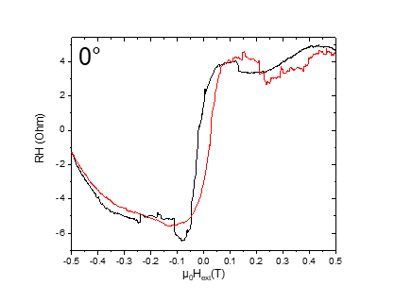



Sonntag, 17. März 2019

22:09

|  |  |
| --- | --- |
| (1) Structures measured | Crosses |
| **(2) Measurement type** | Hloop\_gradiometry |
| **(3) Cables Setup:** | |  |  | | --- | --- | |  | 2-12 | |  | 8-6 | |  | * 1. 7 |  |  |  |  | | --- | --- | --- | | Gate (9) |  |  | |
| **(4) Magnet Setup:** |  |
| **(5) Experiment Setup:** | |  |  | | --- | --- | | T |  | |  |  | |  | 1 MΩ | |  | 5.25kΩ | |  | 0 | |  | 1 MΩ | |  | 0 | |
| **(6) Lock-In Setup:** | |  |  | | --- | --- | | Sens: | 50 μV | | τ: | 1s | | Float/Ground: | Ground | | AC/DC: | AC | | A/A-B: | A-B | | Reserve: | Normal | | Source: | Internal | |
| **(7) Important Notes:** |  |
| **(8) Filename and data:** | <<M55\_Crosses\_0deg\_Hloop\_down\_Gradio\_20190317\_2200\_I1-2-12\_I2-8-6\_GBIP8-14-7\_Vin-2.5V\_R11-1MO\_R12-5.25kO\_R13-0\_R21-1MO\_C11-1\_C21-6\_T-30K\_SR-0.008-T-min\_B-1T\_gate-0V.dat>>  <<M55\_Crosses\_0deg\_Hloop\_up\_Gradio\_20190317\_2200\_I1-2-12\_I2-8-6\_GBIP8-14-7\_Vin-2.5V\_R11-1MO\_R12-5.25kO\_R13-0\_R21-1MO\_C11-1\_C21-6\_T-30K\_SR-0.008-T-min\_B-1T\_gate-0V.dat>> |

R11 = 105/1000\*50 = 5,25

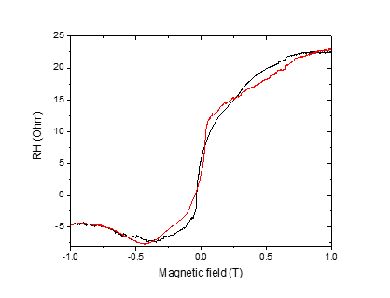

m56: 0deg Empty cross only\_2nd\_ (±1T)\_Carrier concentration

Sonntag, 17. März 2019

17:05

|  |  |
| --- | --- |
| (1) Structures measured | Plusses\_Crosses\_empty |
| (2) Measurement type | Hloop\_parallel |
| **(3) Cables Setup:** | |  |  |  | | --- | --- | --- | |  |  | C | |  |  | D | |  |  |  | |  |  |  | | Gate (9) |  |  | |
| **(4) Magnet Setup:** |  |
| **(5) Experiment Setup:** | |  |  | | --- | --- | | T |  | |  |  | |  | 1 MΩ | |  | 0 | |
| **(6) Lock-In Setup:** | |  |  | | --- | --- | | Sens: | 50 mV | | τ: | 1s | | Float/Ground: | Ground | | AC/DC: | AC | | A/A-B: | A-B | | Reserve: | Normal | | Source: | Internal | |
| **(7) Important Notes:** |  |
| **(8) Filename and data:** | <<m56\_emp\_0deg\_Hloop\_up\_Parallel\_20190318\_0800\_I-7-14\_GB8-6-8\_Vin-2.5V\_R11-1MO\_C11-1\_C21-6\_T-30K\_SR-01-T-min\_B-1T\_gate-0V\_.dat>>    <<m56\_emp\_0deg\_Hloop\_down\_Parallel\_20190318\_0800\_I-7-14\_GB8-6-8\_Vin-2.5V\_R11-1MO\_C11-1\_C21-6\_T-30K\_SR-01-T-min\_B-1T\_gate-0V\_.dat>> |

Note: I did forget doing this at the original location of 0deg. I by mistake changged the angle to 90 and then again to 0 to make this measuremtn. VH(max)= 11.386mV

Note:the parallel measurments is not suitable in 0deg. I did measure only for the empty cross.

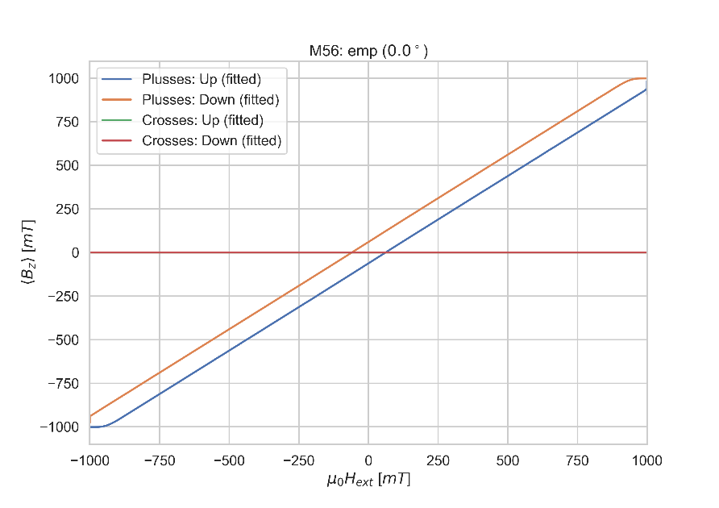

Used this Measurement to calculate Strayfield for other Measurements

C: Changing angle 90deg VH=VH(min)

Montag, 18. März 2019

08:26

|  |  |
| --- | --- |
| (1) Structures measured | Empty Cross |
| (2) Measurement type | Angle Changing |
| **(3) Cables Setup:** | |  |  |  | | --- | --- | --- | |  | *14 - 7* |  | |  |  |  | | Gate (9) |  |  | |
| **(4) Magnet Setup:** | B = 1 T |
| **(5) Experiment Setup:** | |  |  | | --- | --- | | T |  | |  |  | |  | 1 MΩ | |  | 90 | |
| **(6) Lock-In Setup:** | |  |  | | --- | --- | | Sens: | 20mV | | τ: | 1s | | Float/Ground: | Ground | | AC/DC: | AC | | A/A-B: | A-B | | Reserve: | Normal | | Source: | Internal | |
| **(7) Important Notes:** | Voltage before changinig angle: 11,383 mV |
| **(8) Filename and data:** | <<test79\_Full\_Fast\_Sweep\_at\_90deg\_empty\_cross.dat>> |

Aiming for Hall Voltage:



Cos(90)=0

**Voltage measured after balancing (1 μV @ 1T - 6.5 μV @ -1 T see test79.dat):**



m57: Plusses\_Crosses\_empty\_Hloop\_90deg\_10mT/min

Montag, 18. März 2019

10:43

|  |  |
| --- | --- |
| (1) Structures measured | Plusses\_Crosses\_empty |
| (2) Measurement type | Hloop\_parallel |
| **(3) Cables Setup:** | |  |  |  | | --- | --- | --- | |  |  | Plusses (C) | |  |  | Crosses (D) | |  |  | Empty | |  |  |  | | Gate (9) |  |  | |
| **(4) Magnet Setup:** |  |
| **(5) Experiment Setup:** | |  |  | | --- | --- | | T |  | |  |  | |  | 1 MΩ | |  | 90 | |
| **(6) Lock-In Setup:** | |  |  | | --- | --- | | Sens: | 500 μV | | τ: | 1s | | Float/Ground: | Ground | | AC/DC: | AC | | A/A-B: | A-B | | Reserve: | Normal | | Source: | Internal | |
| **(7) Important Notes:** |  |
| **(8) Filename and data:** | <<m57\_cros\_plu\_emp\_90deg\_Hloop\_down\_Parallel\_20190318\_1100\_I-7-14\_GB8-1-13\_GB9-2-12\_GB13-6-8\_Vin-2.5V\_R11-1MO\_C11-1\_C21-6\_T-30K\_SR-0.01-T-min\_B-1T\_gate-0V.dat>>    <<m57\_cros\_plu\_emp\_90deg\_Hloop\_up\_Parallel\_20190318\_1100\_I-7-14\_GB8-1-13\_GB9-2-12\_GB13-6-8\_Vin-2.5V\_R11-1MO\_C11-1\_C21-6\_T-30K\_SR-0.01-T-min\_B-1T\_gate-0V.dat>> |

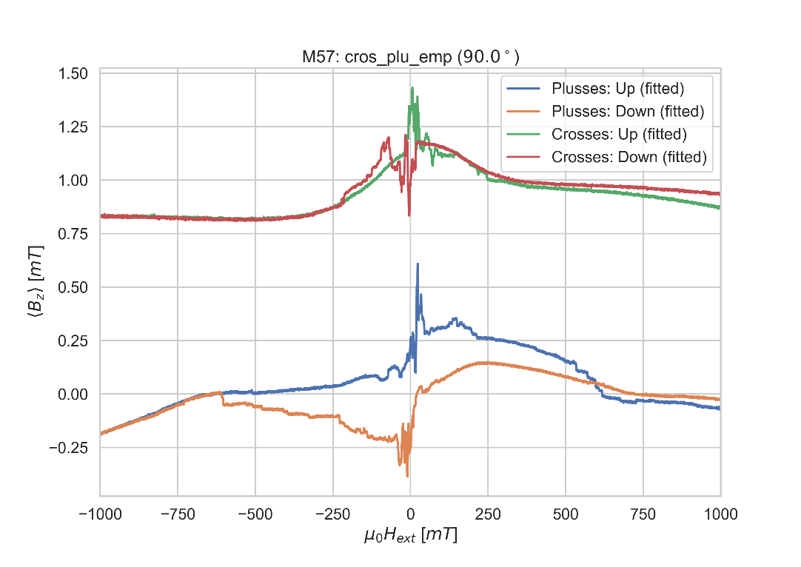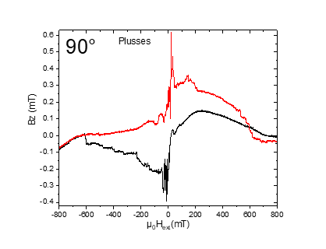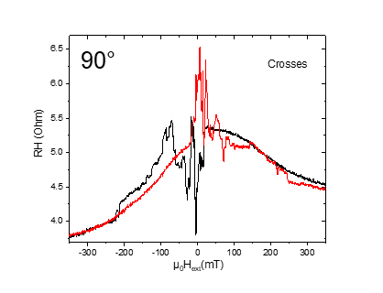

C: Changing angle 85\_

Montag, 18. März 2019

20:50

|  |  |
| --- | --- |
| (1) Structures measured | Empty Cross |
| (2) Measurement type | Angle Changing |
| **(3) Cables Setup:** | |  |  |  | | --- | --- | --- | |  | *14 - 7* |  | |  |  |  | | Gate (9) |  |  | |
| **(4) Magnet Setup:** | B = 1 T |
| **(5) Experiment Setup:** | |  |  | | --- | --- | | T |  | |  |  | |  | 1 MΩ | |  | 85 | |
| **(6) Lock-In Setup:** | |  |  | | --- | --- | | Sens: | 20mV | | τ: | 1s | | Float/Ground: | Ground | | AC/DC: | AC | | A/A-B: | A-B | | Reserve: | Normal | | Source: | Internal | |
| **(7) Important Notes:** |  |
| **(8) Filename and data:** | No File created |

Aiming for Hall Voltage:



Cos(90)=0

**Voltage measured:**





Montag, 18. März 2019

21:00

|  |  |
| --- | --- |
| (1) Structures measured | Plusses |
| **(2) Measurement type** | Hloop\_gradiometry |
| **(3) Cables Setup:** | |  |  | | --- | --- | |  | 1-13 | |  | 8-6 | |  | * 1. 7 |  |  |  |  | | --- | --- | --- | | Gate (9) |  |  | |
| **(4) Magnet Setup:** |  |
| **(5) Experiment Setup:** | |  |  | | --- | --- | | T |  | |  |  | |  | 1 MΩ | |  | 3,25 kΩ | |  | 0 | |  | 1 MΩ | |  | 85 | |  | 1 | |  | 6 | |
| **(6) Lock-In Setup:** | |  |  | | --- | --- | | Sens: | 20 μV | | τ: | 1s | | Float/Ground: | Ground | | AC/DC: | AC | | A/A-B: | A-B | | Reserve: | Normal | | Source: | Internal | |
| **(7) Important Notes:** |  |
| **(8) Filename and data:** | <<m58\_Plusses\_85deg\_Hloop\_down\_\_Gradio\_20190318\_2100\_I1-1-13\_I2-8-6\_GBIP8-14-7\_Vin-2.5V\_R11-1MO\_R12-3.25kO\_R13-0\_R21-1MO\_C11-1\_C21-6\_T-30K\_SR-0.008-T-min\_B-1T\_gate-0V.dat>>    <<m58\_Plusses\_85deg\_Hloop\_up\_\_Gradio\_20190318\_2100\_I1-1-13\_I2-8-6\_GBIP8-14-7\_Vin-2.5V\_R11-1MO\_R12-3.25kO\_R13-0\_R21-1MO\_C11-1\_C21-6\_T-30K\_SR-0.008-T-min\_B-1T\_gate-0V.dat>> |

R11 = 65/1000\*50 = 3,25

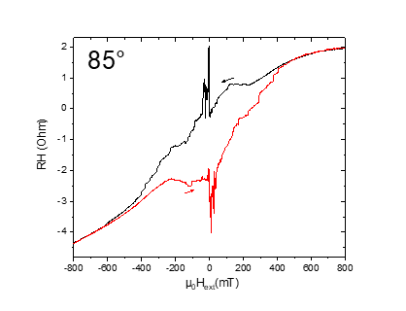



Dienstag, 19. März 2019

07:51

|  |  |
| --- | --- |
| (1) Structures measured | Crosses |
| **(2) Measurement type** | Hloop\_gradiometry |
| **(3) Cables Setup:** | |  |  | | --- | --- | |  | 2-12 | |  | 8-6 | |  | * 1. 7 |  |  |  |  | | --- | --- | --- | | Gate (9) |  |  | |
| **(4) Magnet Setup:** |  |
| **(5) Experiment Setup:** | |  |  | | --- | --- | | T |  | |  |  | |  | 1 MΩ | |  | 3kΩ | |  | 0 | |  | 1 MΩ | |  | 85 | |
| **(6) Lock-In Setup:** | |  |  | | --- | --- | | Sens: | 20 μV | | τ: | 1s | | Float/Ground: | Ground | | AC/DC: | AC | | A/A-B: | A-B | | Reserve: | Normal | | Source: | Internal | |
| **(7) Important Notes:** |  |
| **(8) Filename and data:** | <<m59\_Crosses\_85deg\_Hloop\_down\_\_Gradio\_20190319\_0800\_I1-2-12\_I2-8-6\_GBIP8-14-7\_Vin-2.5V\_R11-1MO\_R12-3kO\_R13-0\_R21-1MO\_C11-1\_C21-6\_T-30K\_SR-0.01-T-min\_B-1T\_gate-0V.dat>>  <<m59\_Crosses\_85deg\_Hloop\_up\_\_Gradio\_20190319\_0800\_I1-2-12\_I2-8-6\_GBIP8-14-7\_Vin-2.5V\_R11-1MO\_R12-3kO\_R13-0\_R21-1MO\_C11-1\_C21-6\_T-30K\_SR-0.01-T-min\_B-1T\_gate-0V.dat>> |

R11 = 60/1000\*50 = 3

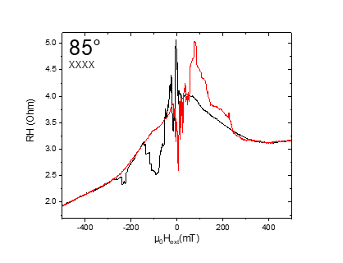

m60: Plusses\_Crosses\_empty\_Hloop\_85deg\_500mT/min

Dienstag, 19. März 2019

15:12

|  |  |
| --- | --- |
| (1) Structures measured | Plusses\_Crosses\_empty |
| (2) Measurement type | Hloop\_parallel |
| **(3) Cables Setup:** | |  |  |  | | --- | --- | --- | |  |  | Plusses (C) | |  |  | Crosses (D) | |  |  | Empty | |  |  |  | | Gate (9) |  |  | |
| **(4) Magnet Setup:** |  |
| **(5) Experiment Setup:** | |  |  | | --- | --- | | T |  | |  |  | |  | 1 MΩ | |  | 85 | |
| **(6) Lock-In Setup:** | |  |  | | --- | --- | | Sens: | 2 mV | | τ: | 1s | | Float/Ground: | Ground | | AC/DC: | AC | | A/A-B: | A-B | | Reserve: | Normal | | Source: | Internal | |
| **(7) Important Notes:** |  |
| **(8) Filename and data:** | <<m60\_cros\_plu\_emp\_85deg\_Hloop\_down\_Parallel\_20190319\_1500\_I-7-14\_GB8-1-13\_GB9-2-12\_GB13-6-8\_Vin-2.5V\_R11-1MO\_C11-1\_C21-6\_T-30K\_SR-0.5-T-min\_B-1T\_gate-0V\_2.dat>>    <<m60\_cros\_plu\_emp\_85deg\_Hloop\_up\_Parallel\_20190319\_1500\_I-7-14\_GB8-1-13\_GB9-2-12\_GB13-6-8\_Vin-2.5V\_R11-1MO\_C11-1\_C21-6\_T-30K\_SR-0.5-T-min\_B-1T\_gate-0V\_2.dat>> |

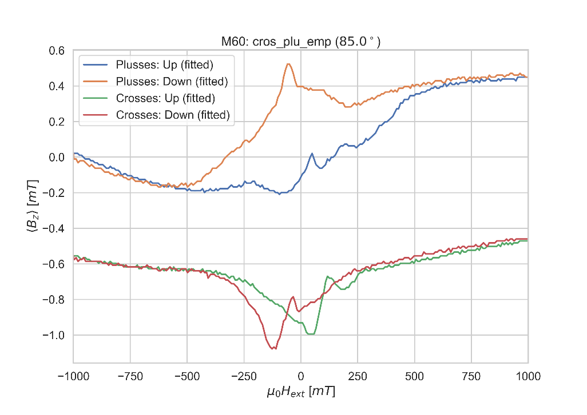

C: Changing angle 80

Dienstag, 19. März 2019

15:12

|  |  |
| --- | --- |
| (1) Structures measured | Empty Cross |
| (2) Measurement type | Angle Changing |
| **(3) Cables Setup:** | |  |  |  | | --- | --- | --- | |  | *14 - 7* |  | |  |  |  | | Gate (9) |  |  | |
| **(4) Magnet Setup:** | B = 1 T |
| **(5) Experiment Setup:** | |  |  | | --- | --- | | T |  | |  |  | |  | 1 MΩ | |  | 85 | |
| **(6) Lock-In Setup:** | |  |  | | --- | --- | | Sens: | 20mV | | τ: | 1s | | Float/Ground: | Ground | | AC/DC: | AC | | A/A-B: | A-B | | Reserve: | Normal | | Source: | Internal | |
| **(7) Important Notes:** |  |
| **(8) Filename and data:** | No File created |

Aiming for Hall Voltage:



**Voltage measured:**





Dienstag, 19. März 2019

15:12

|  |  |
| --- | --- |
| (1) Structures measured | Plusses |
| **(2) Measurement type** | Hloop\_gradiometry |
| **(3) Cables Setup:** | |  |  | | --- | --- | |  | 1-13 | |  | 8-6 | |  | * 1. 7 |  |  |  |  | | --- | --- | --- | | Gate (9) |  |  | |
| **(4) Magnet Setup:** |  |
| **(5) Experiment Setup:** | |  |  | | --- | --- | | T |  | |  |  | |  | 1 MΩ | |  | 3.15kΩ | |  | 0 | |  | 1 MΩ | |  | 80 | |  | 1 | |  | 6 | |
| **(6) Lock-In Setup:** | |  |  | | --- | --- | | Sens: | 10 μV | | τ: | 1s | | Float/Ground: | Ground | | AC/DC: | AC | | A/A-B: | A-B | | Reserve: | Normal | | Source: | Internal | |
| **(7) Important Notes:** |  |
| **(8) Filename and data:** | <<m61\_Plusses\_80deg\_Hloop\_up\_\_Gradio\_20190319\_1530\_I1-1-13\_I2-8-6\_GBIP8-14-7\_Vin-2.5V\_R11-1MO\_R12-3.15kO\_R13-0\_R21-1MO\_C11-1\_C21-6\_T-30K\_SR-0.01-T-min\_B-1T\_gate-0V.dat>>    <<m61\_Plusses\_80deg\_Hloop\_down\_\_Gradio\_20190319\_1530\_I1-1-13\_I2-8-6\_GBIP8-14-7\_Vin-2.5V\_R11-1MO\_R12-3.15kO\_R13-0\_R21-1MO\_C11-1\_C21-6\_T-30K\_SR-0.01-T-min\_B-1T\_gate-0V.dat>> |

R12= 45/1000\*50 = 3,15

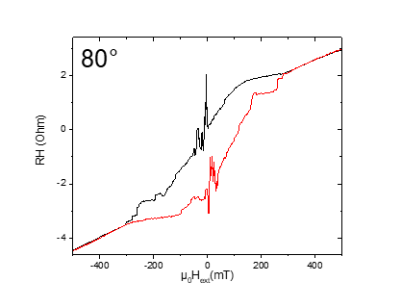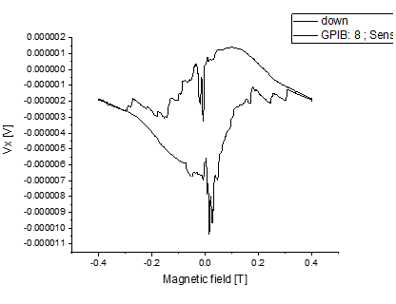



Dienstag, 19. März 2019

22:23

|  |  |
| --- | --- |
| (1) Structures measured | Crosses |
| **(2) Measurement type** | Hloop\_gradiometry |
| **(3) Cables Setup:** | |  |  | | --- | --- | |  | 2-12 | |  | 8-6 (empty) | |  | * 1. 7 |  |  |  |  | | --- | --- | --- | | Gate (9) |  |  | |
| **(4) Magnet Setup:** |  |
| **(5) Experiment Setup:** | |  |  | | --- | --- | | T |  | |  |  | |  | 1 MΩ | |  | 2.25kO | |  | 0 | |  | 1 MΩ | |  | 80 | |  | 1 | |  | 6 | |
| **(6) Lock-In Setup:** | |  |  | | --- | --- | | Sens: | 20 μV | | τ: | 1s | | Float/Ground: | Ground | | AC/DC: | AC | | A/A-B: | A-B | | Reserve: | Normal | | Source: | Internal | |
| **(7) Important Notes:** |  |
| **(8) Filename and data:** | <<m62\_Crosses\_80deg\_Hloop\_down\_\_Gradio\_20190319\_2230\_I1-2-12\_I2-8-6\_GBIP8-14-7\_Vin-2.5V\_R11-1MO\_R12-2.25kO\_R13-0\_R21-1MO\_C11-1\_C21-6\_T-30K\_SR-0.008-T-min\_B-1T\_gate-0V.dat>>  <<m62\_Crosses\_80deg\_Hloop\_up\_\_Gradio\_20190319\_2230\_I1-2-12\_I2-8-6\_GBIP8-14-7\_Vin-2.5V\_R11-1MO\_R12-2.25kO\_R13-0\_R21-1MO\_C11-1\_C21-6\_T-30K\_SR-0.008-T-min\_B-1T\_gate-0V.dat>> |

R12 = 45/1000\*50 = 2,25

Measurement has started at 22:42 :(

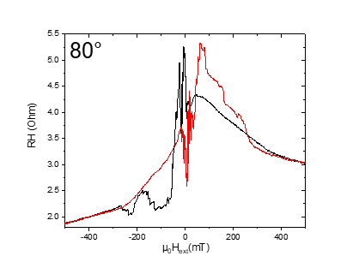

m63: Plusses\_Crosses\_empty\_Hloop\_80deg\_500mT/min

Mittwoch, 20. März 2019

08:28

|  |  |
| --- | --- |
| (1) Structures measured | Plusses\_Crosses\_empty |
| (2) Measurement type | Hloop\_parallel |
| **(3) Cables Setup:** | |  |  |  | | --- | --- | --- | |  |  | Plusses (C) | |  |  | Crosses (D) | |  |  | Empty | |  |  |  | | Gate (9) |  |  | |
| **(4) Magnet Setup:** |  |
| **(5) Experiment Setup:** | |  |  | | --- | --- | | T |  | |  |  | |  | 1 MΩ | |  | 80 | |
| **(6) Lock-In Setup:** | |  |  | | --- | --- | | Sens: | 2 mV | | τ: | 1s | | Float/Ground: | Ground | | AC/DC: | AC | | A/A-B: | A-B | | Reserve: | Normal | | Source: | Internal | |
| **(7) Important Notes:** |  |
| **(8) Filename and data:** | <<m63\_cros\_plu\_emp\_80deg\_Hloop\_down\_Parallel\_20190320\_0800\_I-7-14\_GB8-1-13\_GB9-2-12\_GB13-6-8\_Vin-2.5V\_R11-1MO\_C11-1\_C21-6\_T-30K\_SR-0.5-T-min\_B-1T\_gate-0V\_2.dat>>    <<m63\_cros\_plu\_emp\_80deg\_Hloop\_up\_Parallel\_20190320\_0800\_I-7-14\_GB8-1-13\_GB9-2-12\_GB13-6-8\_Vin-2.5V\_R11-1MO\_C11-1\_C21-6\_T-30K\_SR-0.5-T-min\_B-1T\_gate-0V\_2.dat>> |

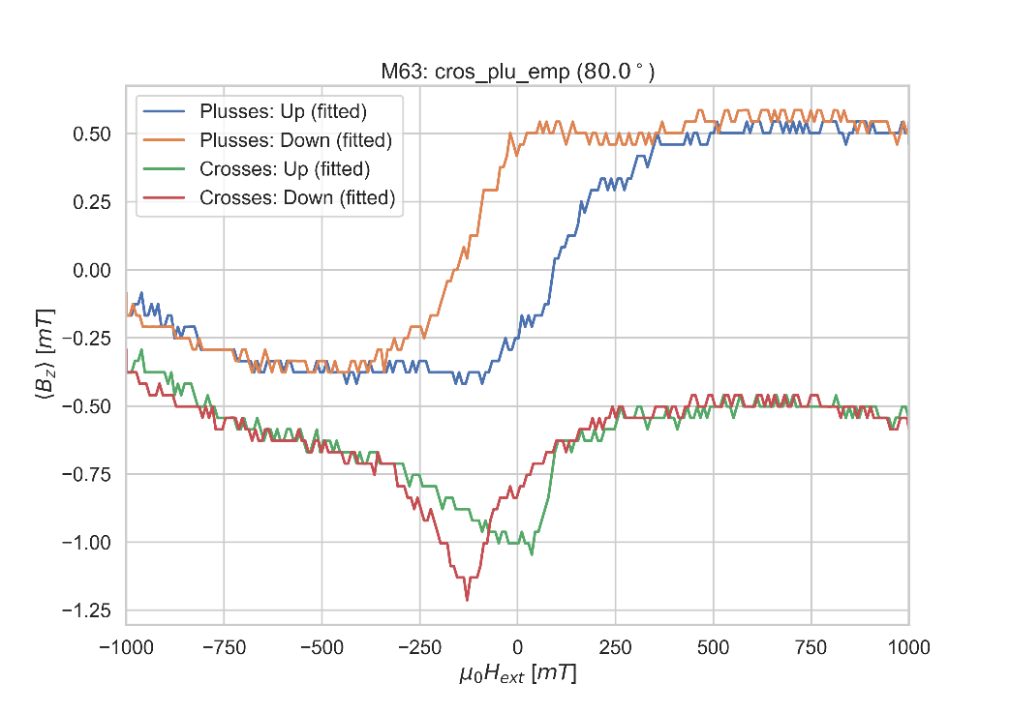

C: Changing angle 75

Mittwoch, 20. März 2019

08:29

|  |  |
| --- | --- |
| (1) Structures measured | Empty Cross |
| (2) Measurement type | Angle Changing |
| **(3) Cables Setup:** | |  |  |  | | --- | --- | --- | |  | *14 - 7* |  | |  |  |  | | Gate (9) |  |  | |
| **(4) Magnet Setup:** | B = 1 T |
| **(5) Experiment Setup:** | |  |  | | --- | --- | | T |  | |  |  | |  | 1 MΩ | |  | 75 | |
| **(6) Lock-In Setup:** | |  |  | | --- | --- | | Sens: | 20mV | | τ: | 1s | | Float/Ground: | Ground | | AC/DC: | AC | | A/A-B: | A-B | | Reserve: | Normal | | Source: | Internal | |
| **(7) Important Notes:** | VH measured before changing the angle: 1.948mV |
| **(8) Filename and data:** | No File created |

Aiming for Hall Voltage:



**Voltage measured:**





Mittwoch, 20. März 2019

08:32

|  |  |
| --- | --- |
| (1) Structures measured | Plusses |
| **(2) Measurement type** | Hloop\_gradiometry |
| **(3) Cables Setup:** | |  |  | | --- | --- | |  | 1-13 | |  | 8-6 | |  | * 1. 7 |  |  |  |  | | --- | --- | --- | | Gate (9) |  |  | |
| **(4) Magnet Setup:** |  |
| **(5) Experiment Setup:** | |  |  | | --- | --- | | T |  | |  |  | |  | 1 MΩ | |  | 3.6kΩ | |  | 0 | |  | 1 MΩ | |  | 75 | |  | 1 | |  | 6 | |
| **(6) Lock-In Setup:** | |  |  | | --- | --- | | Sens: | 20 μV | | τ: | 1s | | Float/Ground: | Ground | | AC/DC: | AC | | A/A-B: | A-B | | Reserve: | Normal | | Source: | Internal | |
| **(7) Important Notes:** |  |
| **(8) Filename and data:** | <<m64\_Plusses\_75deg\_Hloop\_up\_\_Gradio\_20190320\_0800\_I1-1-13\_I2-8-6\_GBIP8-14-7\_Vin-2.5V\_R11-1MO\_R12-3.6kO\_R13-0\_R21-1MO\_C11-1\_C21-6\_T-30K\_SR-0.01-T-min\_B-0.75T\_gate-0V.dat>>    <<m64\_Plusses\_75deg\_Hloop\_down\_\_Gradio\_20190320\_0800\_I1-1-13\_I2-8-6\_GBIP8-14-7\_Vin-2.5V\_R11-1MO\_R12-3.6kO\_R13-0\_R21-1MO\_C11-1\_C21-6\_T-30K\_SR-0.01-T-min\_B-0.75T\_gate-0V.dat>> |

R12= 72/1000\*50 = 3,6

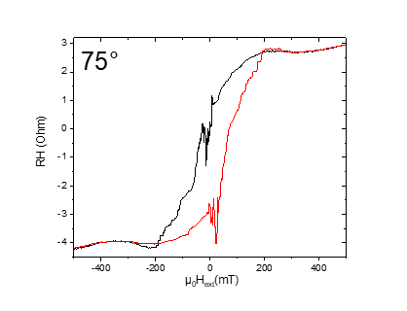



Mittwoch, 20. März 2019

14:48

|  |  |
| --- | --- |
| (1) Structures measured | Crosses |
| **(2) Measurement type** | Hloop\_gradiometry |
| **(3) Cables Setup:** | |  |  | | --- | --- | |  | 2-12 | |  | 8-6 (empty) | |  | * 1. 7 |  |  |  |  | | --- | --- | --- | | Gate (9) |  |  | |
| **(4) Magnet Setup:** |  |
| **(5) Experiment Setup:** | |  |  | | --- | --- | | T |  | |  |  | |  | 1 MΩ | |  | 3.25kO | |  | 0 | |  | 1 MΩ | |  | 75 | |  | 1 | |  | 6 | |
| **(6) Lock-In Setup:** | |  |  | | --- | --- | | Sens: | 20 μV | | τ: | 1s | | Float/Ground: | Ground | | AC/DC: | AC | | A/A-B: | A-B | | Reserve: | Normal | | Source: | Internal | |
| **(7) Important Notes:** |  |
| **(8) Filename and data:** | <<m65\_Crosses\_75deg\_Hloop\_up\_\_Gradio\_20190320\_1430\_I1-2-12\_I2-8-6\_GBIP8-14-7\_Vin-2.5V\_R11-1MO\_R12-3.25kO\_R13-0\_R21-1MO\_C11-1\_C21-6\_T-30K\_SR-0.008-T-min\_B-1T\_gate-0V.dat>>    <<m65\_Crosses\_75deg\_Hloop\_down\_\_Gradio\_20190320\_1430\_I1-2-12\_I2-8-6\_GBIP8-14-7\_Vin-2.5V\_R11-1MO\_R12-3.25kO\_R13-0\_R21-1MO\_C11-1\_C21-6\_T-30K\_SR-0.008-T-min\_B-1T\_gate-0V.dat>> |

R12 = 65/1000\*50 = 3,25

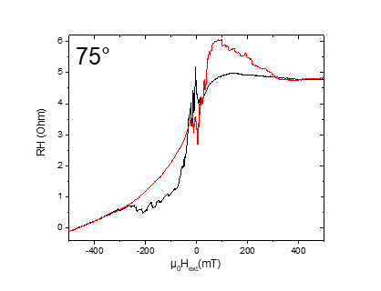

m66: Plusses\_Crosses\_empty\_Hloop\_75deg\_500mT/min

Mittwoch, 20. März 2019

19:22

|  |  |
| --- | --- |
| (1) Structures measured | Plusses\_Crosses\_empty |
| (2) Measurement type | Hloop\_parallel |
| **(3) Cables Setup:** | |  |  |  | | --- | --- | --- | |  |  | Plusses (C) | |  |  | Crosses (D) | |  |  | Empty | |  |  |  | | Gate (9) |  |  | |
| **(4) Magnet Setup:** |  |
| **(5) Experiment Setup:** | |  |  | | --- | --- | | T |  | |  |  | |  | 1 MΩ | |  | 75 | |
| **(6) Lock-In Setup:** | |  |  | | --- | --- | | Sens: | 2 mV | | τ: | 1s | | Float/Ground: | Ground | | AC/DC: | AC | | A/A-B: | A-B | | Reserve: | Normal | | Source: | Internal | |
| **(7) Important Notes:** |  |
| **(8) Filename and data:** | <<m66\_cros\_plu\_emp\_75deg\_Hloop\_down\_Parallel\_20190320\_1900\_I-7-14\_GB8-1-13\_GB9-2-12\_GB13-6-8\_Vin-2.5V\_R11-1MO\_C11-1\_C21-6\_T-30K\_SR-0.5-T-min\_B-1T\_gate-0V\_2.dat>>    <<m66\_cros\_plu\_emp\_75deg\_Hloop\_up\_Parallel\_20190320\_1900\_I-7-14\_GB8-1-13\_GB9-2-12\_GB13-6-8\_Vin-2.5V\_R11-1MO\_C11-1\_C21-6\_T-30K\_SR-0.5-T-min\_B-1T\_gate-0V\_2.dat>> |

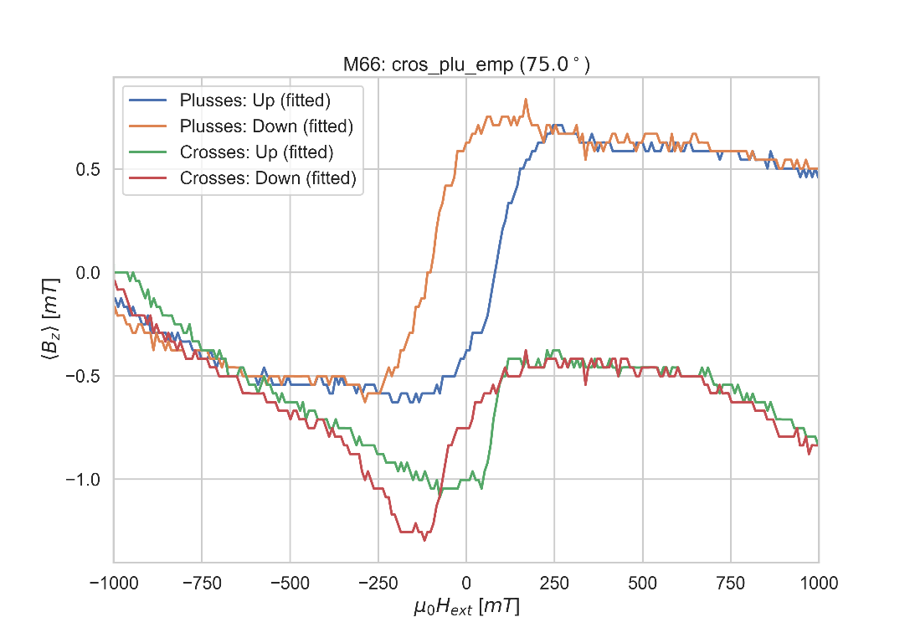

C: Changing angle 70

Mittwoch, 20. März 2019

19:28

|  |  |
| --- | --- |
| (1) Structures measured | Empty Cross |
| (2) Measurement type | Angle Changing |
| **(3) Cables Setup:** | |  |  |  | | --- | --- | --- | |  | *14 - 7* |  | |  |  |  | | Gate (9) |  |  | |
| **(4) Magnet Setup:** | B = 1 T |
| **(5) Experiment Setup:** | |  |  | | --- | --- | | T |  | |  |  | |  | 1 MΩ | |  | 70 | |
| **(6) Lock-In Setup:** | |  |  | | --- | --- | | Sens: | 20mV | | τ: | 1s | | Float/Ground: | Ground | | AC/DC: | AC | | A/A-B: | A-B | | Reserve: | Normal | | Source: | Internal | |
| **(7) Important Notes:** | VH measured before changing the angle: 2.886mV |
| **(8) Filename and data:** | No File created |

Aiming for Hall Voltage:



**Voltage measured:**





Mittwoch, 20. März 2019

20:02

|  |  |
| --- | --- |
| (1) Structures measured | Plusses |
| **(2) Measurement type** | Hloop\_gradiometry |
| **(3) Cables Setup:** | |  |  | | --- | --- | |  | 1-13 | |  | 8-6 | |  | * 1. 7 |  |  |  |  | | --- | --- | --- | | Gate (9) |  |  | |
| **(4) Magnet Setup:** |  |
| **(5) Experiment Setup:** | |  |  | | --- | --- | | T |  | |  |  | |  | 1 MΩ | |  | 5.15kΩ | |  | 0 | |  | 1 MΩ | |  | 70 | |  | 1 | |  | 6 | |
| **(6) Lock-In Setup:** | |  |  | | --- | --- | | Sens: | 10 μV | | τ: | 1s | | Float/Ground: | Ground | | AC/DC: | AC | | A/A-B: | A-B | | Reserve: | Normal | | Source: | Internal | |
| **(7) Important Notes:** |  |
| **(8) Filename and data:** | <<m67\_Plusses\_70deg\_Hloop\_down\_\_Gradio\_20190320\_2000\_I1-1-13\_I2-8-6\_GBIP8-14-7\_Vin-2.5V\_R11-1MO\_R12-5.15kO\_R13-0\_R21-1MO\_C11-1\_C21-6\_T-30K\_SR-0.008-T-min\_B-0.5T\_gate-0V.dat>>    <<m67\_Plusses\_70deg\_Hloop\_up\_\_Gradio\_20190320\_2000\_I1-1-13\_I2-8-6\_GBIP8-14-7\_Vin-2.5V\_R11-1MO\_R12-5.15kO\_R13-0\_R21-1MO\_C11-1\_C21-6\_T-30K\_SR-0.008-T-min\_B-0.5T\_gate-0V.dat>> |

R12= 103/1000\*50 = 5,15

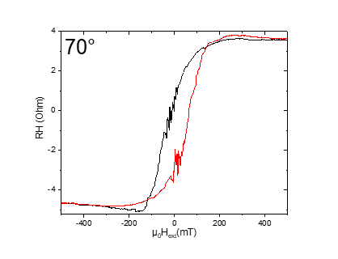



Donnerstag, 21. März 2019

07:11

|  |  |
| --- | --- |
| (1) Structures measured | Crosses |
| **(2) Measurement type** | Hloop\_gradiometry |
| **(3) Cables Setup:** | |  |  | | --- | --- | |  | 2-12 | |  | 8-6 (empty) | |  | * 1. 7 |  |  |  |  | | --- | --- | --- | | Gate (9) |  |  | |
| **(4) Magnet Setup:** |  |
| **(5) Experiment Setup:** | |  |  | | --- | --- | | T |  | |  |  | |  | 1 MΩ | |  | 3.5kO | |  | 0 | |  | 1 MΩ | |  | 70 | |  | 1 | |  | 6 | |
| **(6) Lock-In Setup:** | |  |  | | --- | --- | | Sens: | 20 μV | | τ: | 1s | | Float/Ground: | Ground | | AC/DC: | AC | | A/A-B: | A-B | | Reserve: | Normal | | Source: | Internal | |
| **(7) Important Notes:** |  |
| **(8) Filename and data:** | <<m68\_Crosses\_70deg\_Hloop\_up\_\_Gradio\_20190321\_0700\_I1-2-12\_I2-8-6\_GBIP8-14-7\_Vin-2.5V\_R11-1MO\_R12-3.5kO\_R13-0\_R21-1MO\_C11-1\_C21-6\_T-30K\_SR-0.008-T-min\_B-0.5T\_gate-0V.dat>>    <<m68\_Crosses\_70deg\_Hloop\_down\_\_Gradio\_20190321\_0700\_I1-2-12\_I2-8-6\_GBIP8-14-7\_Vin-2.5V\_R11-1MO\_R12-3.5kO\_R13-0\_R21-1MO\_C11-1\_C21-6\_T-30K\_SR-0.008-T-min\_B-0.5T\_gate-0V.dat>> |

R12 = 70/1000\*50 = 3,5

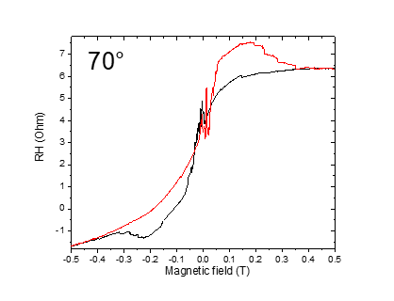

m69: Plusses\_Crosses\_empty\_Hloop\_70deg\_1T/min

Mittwoch, 20. März 2019

19:22

|  |  |
| --- | --- |
| (1) Structures measured | Plusses\_Crosses\_empty |
| (2) Measurement type | Hloop\_parallel |
| **(3) Cables Setup:** | |  |  |  | | --- | --- | --- | |  |  | Plusses (C) | |  |  | Crosses (D) | |  |  | Empty | |  |  |  | | Gate (9) |  |  | |
| **(4) Magnet Setup:** |  |
| **(5) Experiment Setup:** | |  |  | | --- | --- | | T |  | |  |  | |  | 1 MΩ | |  | 70 | |
| **(6) Lock-In Setup:** | |  |  | | --- | --- | | Sens: | 20 mV | | τ: | 1s | | Float/Ground: | Ground | | AC/DC: | AC | | A/A-B: | A-B | | Reserve: | Normal | | Source: | Internal | |
| **(7) Important Notes:** |  |
| **(8) Filename and data:** | <<m69\_cros\_plu\_emp\_70deg\_Hloop\_down\_Parallel\_20190321\_1200\_I-7-14\_GB8-1-13\_GB9-2-12\_GB13-6-8\_Vin-2.5V\_R11-1MO\_C11-1\_C21-6\_T-30K\_SR-0.5-T-min\_B-1T\_gate-0V.dat>>    <<m69\_cros\_plu\_emp\_70deg\_Hloop\_up\_Parallel\_20190321\_1200\_I-7-14\_GB8-1-13\_GB9-2-12\_GB13-6-8\_Vin-2.5V\_R11-1MO\_C11-1\_C21-6\_T-30K\_SR-0.5-T-min\_B-1T\_gate-0V.dat>> |

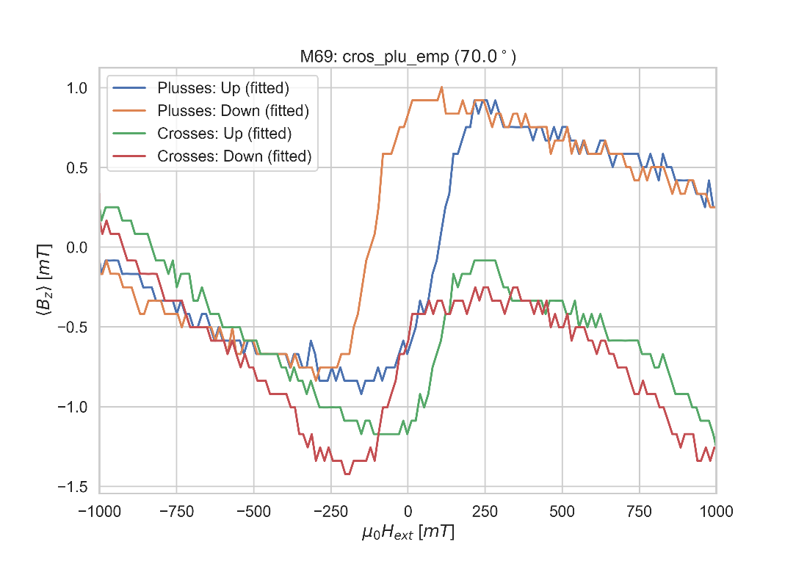

C: Changing angle 65

Donnerstag, 21. März 2019

12:16

|  |  |
| --- | --- |
| (1) Structures measured | Empty Cross |
| (2) Measurement type | Angle Changing |
| **(3) Cables Setup:** | |  |  |  | | --- | --- | --- | |  | *14 - 7* |  | |  |  |  | | Gate (9) |  |  | |
| **(4) Magnet Setup:** | B = 1 T |
| **(5) Experiment Setup:** | |  |  | | --- | --- | | T |  | |  |  | |  | 1 MΩ | |  | 65 | |
| **(6) Lock-In Setup:** | |  |  | | --- | --- | | Sens: | 20mV | | τ: | 1s | | Float/Ground: | Ground | | AC/DC: | AC | | A/A-B: | A-B | | Reserve: | Normal | | Source: | Internal | |
| **(7) Important Notes:** |  |
| **(8) Filename and data:** | No File created |

Aiming for Hall Voltage:



**Voltage measured:**





Donnerstag, 21. März 2019

12:15

|  |  |
| --- | --- |
| (1) Structures measured | Plusses |
| **(2) Measurement type** | Hloop\_gradiometry |
| **(3) Cables Setup:** | |  |  | | --- | --- | |  | 1-13 | |  | 8-6 | |  | * 1. 7 |  |  |  |  | | --- | --- | --- | | Gate (9) |  |  | |
| **(4) Magnet Setup:** |  |
| **(5) Experiment Setup:** | |  |  | | --- | --- | | T |  | |  |  | |  | 1 MΩ | |  | 5.15kΩ | |  | 0 | |  | 1 MΩ | |  | 65 | |  | 1 | |  | 6 | |
| **(6) Lock-In Setup:** | |  |  | | --- | --- | | Sens: | 10 μV | | τ: | 1s | | Float/Ground: | Ground | | AC/DC: | AC | | A/A-B: | A-B | | Reserve: | Normal | | Source: | Internal | |
| **(7) Important Notes:** |  |
| **(8) Filename and data:** | <<m70\_Plusses\_65deg\_Hloop\_down\_\_Gradio\_20190321\_1200\_I1-1-13\_I2-8-6\_GBIP8-14-7\_Vin-2.5V\_R11-1MO\_R12-5.15kO\_R13-0\_R21-1MO\_C11-1\_C21-6\_T-30K\_SR-0.01-T-min\_B-0.5T\_gate-0V.dat>>    <<m70\_Plusses\_65deg\_Hloop\_up\_\_Gradio\_20190321\_1200\_I1-1-13\_I2-8-6\_GBIP8-14-7\_Vin-2.5V\_R11-1MO\_R12-5.15kO\_R13-0\_R21-1MO\_C11-1\_C21-6\_T-30K\_SR-0.01-T-min\_B-0.5T\_gate-0V.dat>> |

R12= 103/1000\*50 = 5,15

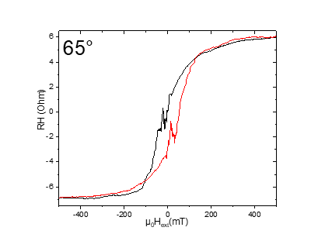



Donnerstag, 21. März 2019

18:50

|  |  |
| --- | --- |
| (1) Structures measured | Crosses |
| **(2) Measurement type** | Hloop\_gradiometry |
| **(3) Cables Setup:** | |  |  | | --- | --- | |  | 2-12 | |  | 8-6 (empty) | |  | * 1. 7 |  |  |  |  | | --- | --- | --- | | Gate (9) |  |  | |
| **(4) Magnet Setup:** |  |
| **(5) Experiment Setup:** | |  |  | | --- | --- | | T |  | |  |  | |  | 1 MΩ | |  | 1,3kO | |  | 0 | |  | 1 MΩ | |  | 65 | |  | 1 | |  | 6 | |
| **(6) Lock-In Setup:** | |  |  | | --- | --- | | Sens: | 20 μV | | τ: | 1s | | Float/Ground: | Ground | | AC/DC: | AC | | A/A-B: | A-B | | Reserve: | Normal | | Source: | Internal | |
| **(7) Important Notes:** |  |
| **(8) Filename and data:** | <<m71\_Crosses\_65deg\_Hloop\_down\_\_Gradio\_20190321\_1900\_I1-2-12\_I2-8-6\_GBIP8-14-7\_Vin-2.5V\_R11-1MO\_R12-1.3kO\_R13-0\_R21-1MO\_C11-1\_C21-6\_T-30K\_SR-0.008-T-min\_B-0.75T\_gate-0V.dat>>    <<m71\_Crosses\_65deg\_Hloop\_up\_\_Gradio\_20190321\_1900\_I1-2-12\_I2-8-6\_GBIP8-14-7\_Vin-2.5V\_R11-1MO\_R12-1.3kO\_R13-0\_R21-1MO\_C11-1\_C21-6\_T-30K\_SR-0.008-T-min\_B-0.75T\_gate-0V.dat>> |

R12 = 26/1000\*50 = 1,3

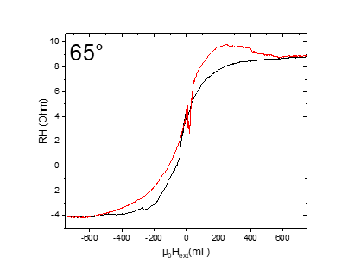

m72: Plusses\_Crosses\_empty\_Hloop\_65deg\_1T/min

Freitag, 22. März 2019

07:39

|  |  |
| --- | --- |
| (1) Structures measured | Plusses\_Crosses\_empty |
| (2) Measurement type | Hloop\_parallel |
| **(3) Cables Setup:** | |  |  |  | | --- | --- | --- | |  |  | Plusses (C) | |  |  | Crosses (D) | |  |  | Empty | |  |  |  | | Gate (9) |  |  | |
| **(4) Magnet Setup:** |  |
| **(5) Experiment Setup:** | |  |  | | --- | --- | | T |  | |  |  | |  | 1 MΩ | |  | 65 | |
| **(6) Lock-In Setup:** | |  |  | | --- | --- | | Sens: | 20 mV | | τ: | 1s | | Float/Ground: | Ground | | AC/DC: | AC | | A/A-B: | A-B | | Reserve: | Normal | | Source: | Internal | |
| **(7) Important Notes:** |  |
| **(8) Filename and data:** | <<m72\_cros\_plu\_emp\_65deg\_Hloop\_up\_Parallel\_20190322\_0700\_I-7-14\_GB8-1-13\_GB9-2-12\_GB13-6-8\_Vin-2.5V\_R11-1MO\_C11-1\_C21-6\_T-30K\_SR-0.5-T-min\_B-1T\_gate-0V\_.dat>>    <<m72\_cros\_plu\_emp\_65deg\_Hloop\_down\_Parallel\_20190322\_0700\_I-7-14\_GB8-1-13\_GB9-2-12\_GB13-6-8\_Vin-2.5V\_R11-1MO\_C11-1\_C21-6\_T-30K\_SR-0.5-T-min\_B-1T\_gate-0V\_.dat>> |

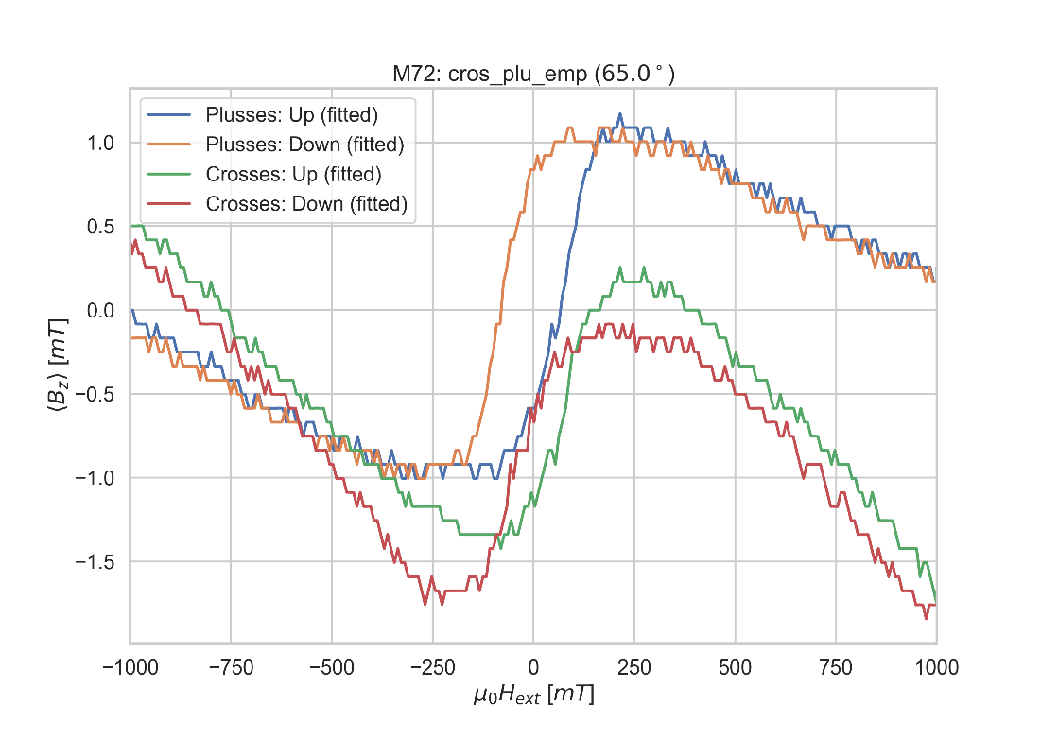

C: Changing angle 60

Freitag, 22. März 2019

12:16

|  |  |
| --- | --- |
| (1) Structures measured | Empty Cross |
| (2) Measurement type | Angle Changing |
| **(3) Cables Setup:** | |  |  |  | | --- | --- | --- | |  | *14 - 7* |  | |  |  |  | | Gate (9) |  |  | |
| **(4) Magnet Setup:** | B = 1 T |
| **(5) Experiment Setup:** | |  |  | | --- | --- | | T |  | |  |  | |  | 1 MΩ | |  | 60 | |
| **(6) Lock-In Setup:** | |  |  | | --- | --- | | Sens: | 20mV | | τ: | 1s | | Float/Ground: | Ground | | AC/DC: | AC | | A/A-B: | A-B | | Reserve: | Normal | | Source: | Internal | |
| **(7) Important Notes:** | VH before changing the angle: 4.706mV |
| **(8) Filename and data:** | No File created |

Aiming for Hall Voltage:



**Voltage measured:**





Freitag, 22. März 2019

08:11

|  |  |
| --- | --- |
| (1) Structures measured | Plusses |
| **(2) Measurement type** | Hloop\_gradiometry |
| **(3) Cables Setup:** | |  |  | | --- | --- | |  | 1-13 | |  | 8-6 | |  | * 1. 7 |  |  |  |  | | --- | --- | --- | | Gate (9) |  |  | |
| **(4) Magnet Setup:** |  |
| **(5) Experiment Setup:** | |  |  | | --- | --- | | T |  | |  |  | |  | 1 MΩ | |  | 3.1kΩ | |  | 0 | |  | 1 MΩ | |  | 60 | |  | 1 | |  | 6 | |
| **(6) Lock-In Setup:** | |  |  | | --- | --- | | Sens: | 20 μV | | τ: | 1s | | Float/Ground: | Ground | | AC/DC: | AC | | A/A-B: | A-B | | Reserve: | Normal | | Source: | Internal | |
| **(7) Important Notes:** |  |
| **(8) Filename and data:** | <<m73\_Plusses\_60deg\_Hloop\_up\_\_Gradio\_20190322\_0800\_I1-1-13\_I2-8-6\_GBIP8-14-7\_Vin-2.5V\_R11-1MO\_R12-3.1kO\_R13-0\_R21-1MO\_C11-1\_C21-6\_T-30K\_SR-0.01-T-min\_B-0.7T\_gate-0V.dat>>    <<m73\_Plusses\_60deg\_Hloop\_down\_\_Gradio\_20190322\_0800\_I1-1-13\_I2-8-6\_GBIP8-14-7\_Vin-2.5V\_R11-1MO\_R12-3.1kO\_R13-0\_R21-1MO\_C11-1\_C21-6\_T-30K\_SR-0.01-T-min\_B-0.7T\_gate-0V.dat>> |

R12= 62/1000\*50 = 3,1

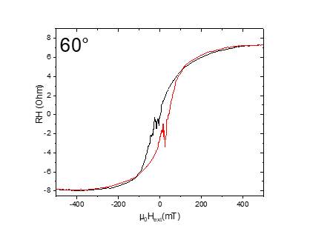



Freitag, 22. März 2019

13:52

|  |  |
| --- | --- |
| (1) Structures measured | Crosses |
| **(2) Measurement type** | Hloop\_gradiometry |
| **(3) Cables Setup:** | |  |  | | --- | --- | |  | 2-12 | |  | 8-6 (empty) | |  | * 1. 7 |  |  |  |  | | --- | --- | --- | | Gate (9) |  |  | |
| **(4) Magnet Setup:** |  |
| **(5) Experiment Setup:** | |  |  | | --- | --- | | T |  | |  |  | |  | 1 MΩ | |  | 2.8kO | |  | 0 | |  | 1 MΩ | |  | 60 | |  | 1 | |  | 6 | |
| **(6) Lock-In Setup:** | |  |  | | --- | --- | | Sens: | 50 μV | | τ: | 1s | | Float/Ground: | Ground | | AC/DC: | AC | | A/A-B: | A-B | | Reserve: | Normal | | Source: | Internal | |
| **(7) Important Notes:** |  |
| **(8) Filename and data:** | <<m74\_Crosses\_60deg\_Hloop\_down\_\_Gradio\_20190322\_1400\_I1-2-12\_I2-8-6\_GBIP8-14-7\_Vin-2.5V\_R11-1MO\_R12-2.8kO\_R13-0\_R21-1MO\_C11-1\_C21-6\_T-30K\_SR-0.01-T-min\_B-0.6T\_gate-0V.dat>>    <<m74\_Crosses\_60deg\_Hloop\_up\_\_Gradio\_20190322\_1400\_I1-2-12\_I2-8-6\_GBIP8-14-7\_Vin-2.5V\_R11-1MO\_R12-2.8kO\_R13-0\_R21-1MO\_C11-1\_C21-6\_T-30K\_SR-0.01-T-min\_B-0.6T\_gate-0V.dat>> |

R12 = 56/1000\*50 = 2,8

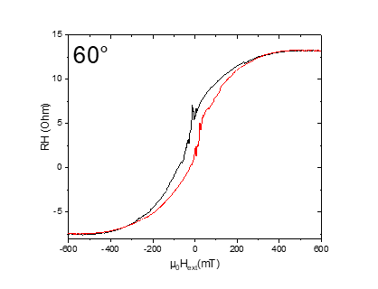

m75: Plusses\_Crosses\_empty\_Hloop\_60deg\_1T/min

Freitag, 22. März 2019

18:16

|  |  |
| --- | --- |
| (1) Structures measured | Plusses\_Crosses\_empty |
| (2) Measurement type | Hloop\_parallel |
| **(3) Cables Setup:** | |  |  |  | | --- | --- | --- | |  |  | Plusses (C) | |  |  | Crosses (D) | |  |  | Empty | |  |  |  | | Gate (9) |  |  | |
| **(4) Magnet Setup:** |  |
| **(5) Experiment Setup:** | |  |  | | --- | --- | | T |  | |  |  | |  | 1 MΩ | |  | 60 | |
| **(6) Lock-In Setup:** | |  |  | | --- | --- | | Sens: | 20 mV | | τ: | 1s | | Float/Ground: | Ground | | AC/DC: | AC | | A/A-B: | A-B | | Reserve: | Normal | | Source: | Internal | |
| **(7) Important Notes:** |  |
| **(8) Filename and data:** | <<m75\_cros\_plu\_emp\_60deg\_Hloop\_down\_Parallel\_20190322\_1800\_I-7-14\_GB8-1-13\_GB9-2-12\_GB13-6-8\_Vin-2.5V\_R11-1MO\_C11-1\_C21-6\_T-30K\_SR-0.5-T-min\_B-1T\_gate-0V\_.dat>>    <<m75\_cros\_plu\_emp\_60deg\_Hloop\_up\_Parallel\_20190322\_1800\_I-7-14\_GB8-1-13\_GB9-2-12\_GB13-6-8\_Vin-2.5V\_R11-1MO\_C11-1\_C21-6\_T-30K\_SR-0.5-T-min\_B-1T\_gate-0V\_.dat>> |

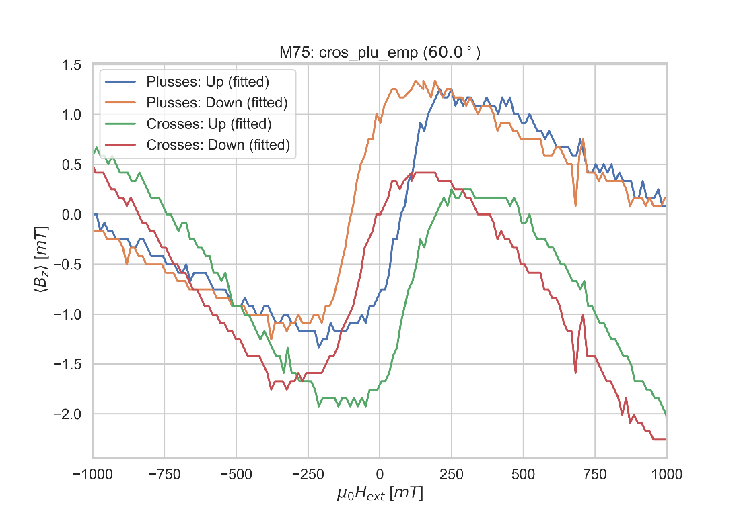

C: Changing angle 55

Freitag, 22. März 2019

18:17

|  |  |
| --- | --- |
| (1) Structures measured | Empty Cross |
| (2) Measurement type | Angle Changing |
| **(3) Cables Setup:** | |  |  |  | | --- | --- | --- | |  | *14 - 7* |  | |  |  |  | | Gate (9) |  |  | |
| **(4) Magnet Setup:** | B = 1 T |
| **(5) Experiment Setup:** | |  |  | | --- | --- | | T |  | |  |  | |  | 1 MΩ | |  | 55 | |
| **(6) Lock-In Setup:** | |  |  | | --- | --- | | Sens: | 20mV | | τ: | 1s | | Float/Ground: | Ground | | AC/DC: | AC | | A/A-B: | A-B | | Reserve: | Normal | | Source: | Internal | |
| **(7) Important Notes:** | VH before changing the angle: 5,561mV |
| **(8) Filename and data:** | No File created |

Aiming for Hall Voltage:



**Voltage measured:**





Freitag, 22. März 2019

18:35

|  |  |
| --- | --- |
| (1) Structures measured | Plusses |
| **(2) Measurement type** | Hloop\_gradiometry |
| **(3) Cables Setup:** | |  |  | | --- | --- | |  | 1-13 | |  | 8-6 | |  | * 1. 7 |  |  |  |  | | --- | --- | --- | | Gate (9) |  |  | |
| **(4) Magnet Setup:** |  |
| **(5) Experiment Setup:** | |  |  | | --- | --- | | T |  | |  |  | |  | 1 MΩ | |  | 4,75kΩ | |  | 0 | |  | 1 MΩ | |  | 55 | |  | 1 | |  | 6 | |
| **(6) Lock-In Setup:** | |  |  | | --- | --- | | Sens: | 20 μV | | τ: | 1s | | Float/Ground: | Ground | | AC/DC: | AC | | A/A-B: | A-B | | Reserve: | Normal | | Source: | Internal | |
| **(7) Important Notes:** |  |
| **(8) Filename and data:** | <<m76\_Plusses\_55deg\_Hloop\_down\_\_Gradio\_20190322\_1900\_I1-1-13\_I2-8-6\_GBIP8-14-7\_Vin-2.5V\_R11-1MO\_R1-4.75kO\_R13-0\_R21-1MO\_C11-1\_C21-6\_T-30K\_SR-0.01-T-min\_B-0.5T\_gate-0V.dat>>  <<m76\_Plusses\_55deg\_Hloop\_up\_\_Gradio\_20190322\_1900\_I1-1-13\_I2-8-6\_GBIP8-14-7\_Vin-2.5V\_R11-1MO\_R1-4.75kO\_R13-0\_R21-1MO\_C11-1\_C21-6\_T-30K\_SR-0.01-T-min\_B-0.5T\_gate-0V.dat>> |

R12= 95/1000\*50 = 4,75

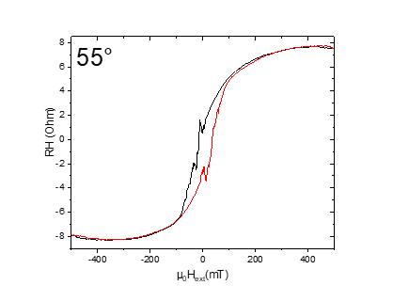



Freitag, 22. März 2019

22:11

|  |  |
| --- | --- |
| (1) Structures measured | Crosses |
| **(2) Measurement type** | Hloop\_gradiometry |
| **(3) Cables Setup:** | |  |  | | --- | --- | |  | 2-12 | |  | 8-6 (empty) | |  | * 1. 7 |  |  |  |  | | --- | --- | --- | | Gate (9) |  |  | |
| **(4) Magnet Setup:** |  |
| **(5) Experiment Setup:** | |  |  | | --- | --- | | T |  | |  |  | |  | 1 MΩ | |  | 2.65kO | |  | 0 | |  | 1 MΩ | |  | 55 | |  | 1 | |  | 6 | |
| **(6) Lock-In Setup:** | |  |  | | --- | --- | | Sens: | 50 μV | | τ: | 1s | | Float/Ground: | Ground | | AC/DC: | AC | | A/A-B: | A-B | | Reserve: | Normal | | Source: | Internal | |
| **(7) Important Notes:** |  |
| **(8) Filename and data:** | <<m77\_Crosses\_55deg\_Hloop\_down\_\_Gradio\_20190322\_2200\_I1-2-12\_I2-8-6\_GBIP8-14-7\_Vin-2.5V\_R11-1MO\_R12-2.65kO\_R13-0\_R21-1MO\_C11-1\_C21-6\_T-30K\_SR-0.008-T-min\_B-0.6T\_gate-0V.dat>>    <<m77\_Crosses\_55deg\_Hloop\_up\_\_Gradio\_20190322\_2200\_I1-2-12\_I2-8-6\_GBIP8-14-7\_Vin-2.5V\_R11-1MO\_R12-2.65kO\_R13-0\_R21-1MO\_C11-1\_C21-6\_T-30K\_SR-0.008-T-min\_B-0.6T\_gate-0V.dat>> |

R12 = 53/1000\*50 = 2,65

I have realized that there is a problem with the cables of current I1. I did change them and everything was fine.

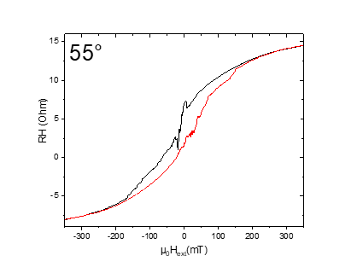

M78: Plusses\_Crosses\_empty\_Hloop\_55deg\_1T/min

Samstag, 23. März 2019

09:09

|  |  |
| --- | --- |
| (1) Structures measured | Plusses\_Crosses\_empty |
| (2) Measurement type | Hloop\_parallel |
| **(3) Cables Setup:** | |  |  |  | | --- | --- | --- | |  |  | Plusses (C) | |  |  | Crosses (D) | |  |  | Empty | |  |  |  | | Gate (9) |  |  | |
| **(4) Magnet Setup:** |  |
| **(5) Experiment Setup:** | |  |  | | --- | --- | | T |  | |  |  | |  | 1 MΩ | |  | 55 | |
| **(6) Lock-In Setup:** | |  |  | | --- | --- | | Sens: | 20 mV | | τ: | 1s | | Float/Ground: | Ground | | AC/DC: | AC | | A/A-B: | A-B | | Reserve: | Normal | | Source: | Internal | |
| **(7) Important Notes:** |  |
| **(8) Filename and data:** | <<m78\_cros\_plu\_emp\_55deg\_Hloop\_up\_Parallel\_20190323\_0900\_I-7-14\_GB8-1-13\_GB9-2-12\_GB13-6-8\_Vin-2.5V\_R11-1MO\_C11-1\_C21-6\_T-30K\_SR-0.5-T-min\_B-1T\_gate-0V\_.dat>>    <<m78\_cros\_plu\_emp\_55deg\_Hloop\_down\_Parallel\_20190323\_0900\_I-7-14\_GB8-1-13\_GB9-2-12\_GB13-6-8\_Vin-2.5V\_R11-1MO\_C11-1\_C21-6\_T-30K\_SR-0.5-T-min\_B-1T\_gate-0V\_.dat>> |

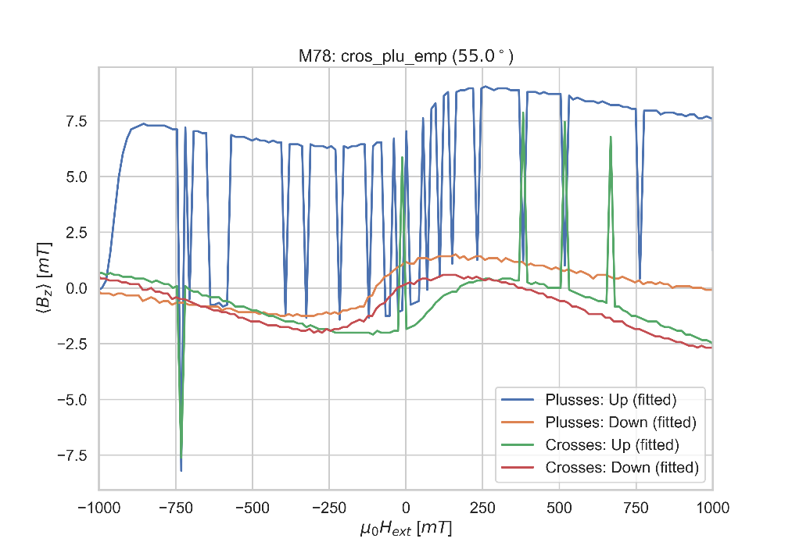

C: Changing angle 50

Samstag, 23. März 2019

09:09

|  |  |
| --- | --- |
| (1) Structures measured | Empty Cross |
| (2) Measurement type | Angle Changing |
| **(3) Cables Setup:** | |  |  |  | | --- | --- | --- | |  | *14 - 7* |  | |  |  |  | | Gate (9) |  |  | |
| **(4) Magnet Setup:** | B = 1 T |
| **(5) Experiment Setup:** | |  |  | | --- | --- | | T |  | |  |  | |  | 1 MΩ | |  | 55 | |
| **(6) Lock-In Setup:** | |  |  | | --- | --- | | Sens: | 20mV | | τ: | 1s | | Float/Ground: | Ground | | AC/DC: | AC | | A/A-B: | A-B | | Reserve: | Normal | | Source: | Internal | |
| **(7) Important Notes:** | VH before changing the angle: 6.429mV |
| **(8) Filename and data:** | No File created |

Aiming for Hall Voltage:



**Voltage measured:**





Samstag, 23. März 2019

09:15

|  |  |
| --- | --- |
| (1) Structures measured | Plusses |
| **(2) Measurement type** | Hloop\_gradiometry |
| **(3) Cables Setup:** | |  |  | | --- | --- | |  | 1-13 | |  | 8-6 | |  | * 1. 7 |  |  |  |  | | --- | --- | --- | | Gate (9) |  |  | |
| **(4) Magnet Setup:** |  |
| **(5) Experiment Setup:** | |  |  | | --- | --- | | T |  | |  |  | |  | 1 MΩ | |  | 6.75kΩ | |  | 0 | |  | 1 MΩ | |  | 50 | |  | 1 | |  | 6 | |
| **(6) Lock-In Setup:** | |  |  | | --- | --- | | Sens: | 50μV | | τ: | 1s | | Float/Ground: | Ground | | AC/DC: | AC | | A/A-B: | A-B | | Reserve: | Normal | | Source: | Internal | |
| **(7) Important Notes:** |  |
| **(8) Filename and data:** | <<m79\_Plusses\_50deg\_Hloop\_down\_\_Gradio\_20190323\_0900\_I1-1-13\_I2-8-6\_GBIP8-14-7\_Vin-2.5V\_R11-1MO\_R1-6.75kO\_R13-0\_R21-1MO\_C11-1\_C21-6\_T-30K\_SR-0.01-T-min\_B-0.4T\_gate-0V\_down.dat>>    <<m79\_Plusses\_50deg\_Hloop\_up\_Gradio\_20190323\_0900\_I1-1-13\_I2-8-6\_GBIP8-14-7\_Vin-2.5V\_R11-1MO\_R1-6.75kO\_R13-0\_R21-1MO\_C11-1\_C21-6\_T-30K\_SR-0.01-T-min\_B-0.4T\_gate-0V\_up.dat>> |

R12= 135/1000\*50 = 6,75

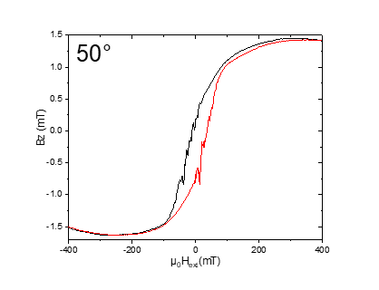



Samstag, 23. März 2019

12:38

|  |  |
| --- | --- |
| (1) Structures measured | Crosses |
| **(2) Measurement type** | Hloop\_gradiometry |
| **(3) Cables Setup:** | |  |  | | --- | --- | |  | 2-12 | |  | 8-6 (empty) | |  | * 1. 7 |  |  |  |  | | --- | --- | --- | | Gate (9) |  |  | |
| **(4) Magnet Setup:** |  |
| **(5) Experiment Setup:** | |  |  | | --- | --- | | T |  | |  |  | |  | 1 MΩ | |  | 6kO | |  | 0 | |  | 1 MΩ | |  | 55 | |  | 1 | |  | 6 | |
| **(6) Lock-In Setup:** | |  |  | | --- | --- | | Sens: | 20 μV | | τ: | 1s | | Float/Ground: | Ground | | AC/DC: | AC | | A/A-B: | A-B | | Reserve: | Normal | | Source: | Internal | |
| **(7) Important Notes:** |  |
| **(8) Filename and data:** | <<m80\_Crosses\_50deg\_Hloop\_down\_\_Gradio\_20190323\_1200\_I1-2-12\_I2-8-6\_GBIP8-14-7\_Vin-2.5V\_R11-1MO\_R12-6kO\_R13-0\_R21-1MO\_C11-1\_C21-6\_T-30K\_SR-0.01-T-min\_B-0.4T\_gate-0V.dat>>    <<m80\_Crosses\_50deg\_Hloop\_up\_\_Gradio\_20190323\_1200\_I1-2-12\_I2-8-6\_GBIP8-14-7\_Vin-2.5V\_R11-1MO\_R12-6kO\_R13-0\_R21-1MO\_C11-1\_C21-6\_T-30K\_SR-0.01-T-min\_B-0.4T\_gate-0V.dat>> |

R12 = 120/1000\*50 = 6

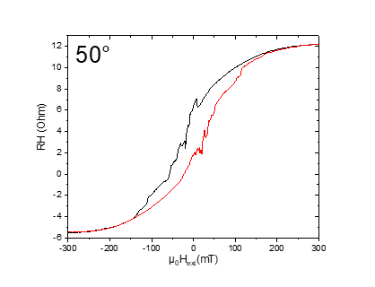

m81: Plusses\_Crosses\_empty\_Hloop\_50deg\_1T/min

Samstag, 23. März 2019

15:31

|  |  |
| --- | --- |
| (1) Structures measured | Plusses\_Crosses\_empty |
| (2) Measurement type | Hloop\_parallel |
| **(3) Cables Setup:** | |  |  |  | | --- | --- | --- | |  |  | Plusses (C) | |  |  | Crosses (D) | |  |  | Empty | |  |  |  | | Gate (9) |  |  | |
| **(4) Magnet Setup:** |  |
| **(5) Experiment Setup:** | |  |  | | --- | --- | | T |  | |  |  | |  | 1 MΩ | |  | 50 | |
| **(6) Lock-In Setup:** | |  |  | | --- | --- | | Sens: | 20 mV | | τ: | 1s | | Float/Ground: | Ground | | AC/DC: | AC | | A/A-B: | A-B | | Reserve: | Normal | | Source: | Internal | |
| **(7) Important Notes:** |  |
| **(8) Filename and data:** | <<m81\_cros\_plu\_emp\_50deg\_Hloop\_up\_Parallel\_20190323\_1500\_I-7-14\_GB8-1-13\_GB9-2-12\_GB13-6-8\_Vin-2.5V\_R11-1MO\_C11-1\_C21-6\_T-30K\_SR-0.5-T-min\_B-1T\_gate-0V\_.dat>>    <<m81\_cros\_plu\_emp\_50deg\_Hloop\_down\_Parallel\_20190323\_1500\_I-7-14\_GB8-1-13\_GB9-2-12\_GB13-6-8\_Vin-2.5V\_R11-1MO\_C11-1\_C21-6\_T-30K\_SR-0.5-T-min\_B-1T\_gate-0V\_.dat>> |

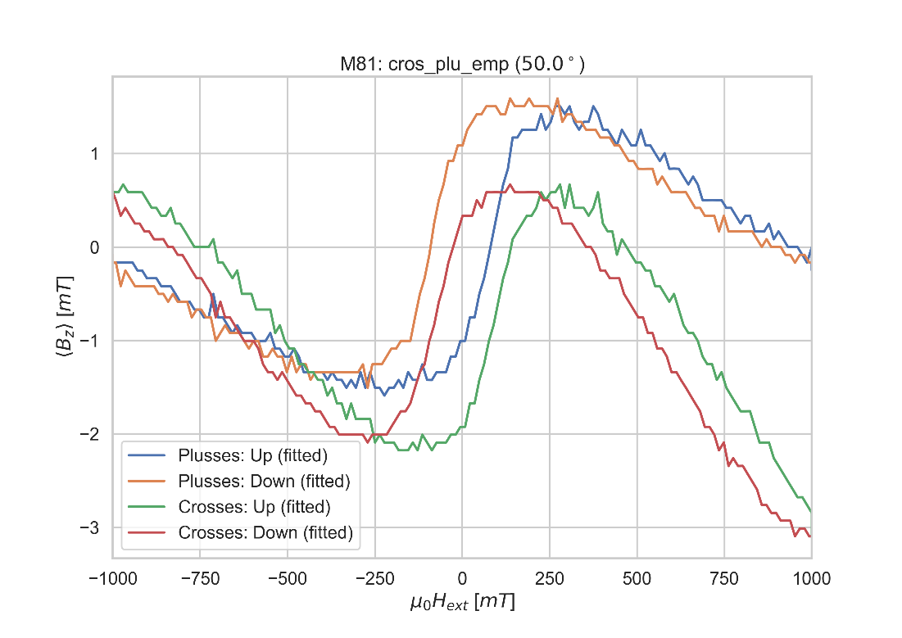

C: Changing angle 95

Samstag, 23. März 2019

15:35

|  |  |
| --- | --- |
| (1) Structures measured | Empty Cross |
| (2) Measurement type | Angle Changing |
| **(3) Cables Setup:** | |  |  |  | | --- | --- | --- | |  | *14 - 7* |  | |  |  |  | | Gate (9) |  |  | |
| **(4) Magnet Setup:** | B = 1 T |
| **(5) Experiment Setup:** | |  |  | | --- | --- | | T |  | |  |  | |  | 1 MΩ | |  | 95 | |
| **(6) Lock-In Setup:** | |  |  | | --- | --- | | Sens: | 20mV | | τ: | 1s | | Float/Ground: | Ground | | AC/DC: | AC | | A/A-B: | A-B | | Reserve: | Normal | | Source: | Internal | |
| **(7) Important Notes:** | VH before changing the angle: 7.166mV |
| **(8) Filename and data:** | No File created |

Aiming for Hall Voltage:



**Voltage measured:**



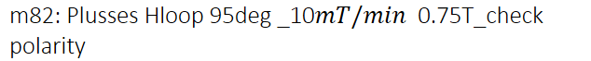

Samstag, 23. März 2019

16:11

|  |  |
| --- | --- |
| (1) Structures measured | Plusses |
| **(2) Measurement type** | Hloop\_gradiometry |
| **(3) Cables Setup:** | |  |  | | --- | --- | |  | 1-13 | |  | 8-6 | |  | * 1. 7 |  |  |  |  | | --- | --- | --- | | Gate (9) |  |  | |
| **(4) Magnet Setup:** |  |
| **(5) Experiment Setup:** | |  |  | | --- | --- | | T |  | |  |  | |  | 1 MΩ | |  | 6,25 kΩ | |  | 0 | |  | 1 MΩ | |  | 95 | |  | 1 | |  | 6 | |
| **(6) Lock-In Setup:** | |  |  | | --- | --- | | Sens: | 20μV | | τ: | 1s | | Float/Ground: | Ground | | AC/DC: | AC | | A/A-B: | A-B | | Reserve: | Normal | | Source: | Internal | |
| **(7) Important Notes:** |  |
| **(8) Filename and data:** | <<m82\_Plusses\_95deg\_Hloop\_down\_\_Gradio\_20190323\_1600\_I1-1-13\_I2-8-6\_GBIP8-14-7\_Vin-2.5V\_R11-1MO\_R1-6.25kO\_R13-0\_R21-1MO\_C11-1\_C21-6\_T-30K\_SR-0.01-T-min\_B-0.75T\_gate-0V\_down\_.dat>>    <<m82\_Plusses\_95deg\_Hloop\_up\_\_Gradio\_20190323\_1600\_I1-1-13\_I2-8-6\_GBIP8-14-7\_Vin-2.5V\_R11-1MO\_R1-6.25kO\_R13-0\_R21-1MO\_C11-1\_C21-6\_T-30K\_SR-0.01-T-min\_B-0.75T\_gate-0V\_up\_.dat>> |

R12= 125/1000\*50 = 6,25

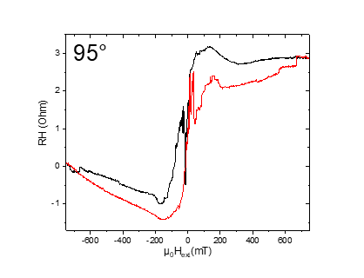

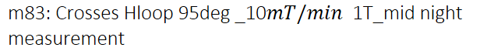

Samstag, 23. März 2019

00:01

|  |  |
| --- | --- |
| (1) Structures measured | Crosses |
| **(2) Measurement type** | Hloop\_gradiometry |
| **(3) Cables Setup:** | |  |  | | --- | --- | |  | 2-12 | |  | 8-6 (empty) | |  | * 1. 7 |  |  |  |  | | --- | --- | --- | | Gate (9) |  |  | |
| **(4) Magnet Setup:** |  |
| **(5) Experiment Setup:** | |  |  | | --- | --- | | T |  | |  |  | |  | 1 MΩ | |  | 2kO | |  | 0 | |  | 1 MΩ | |  | 95 | |  | 1 | |  | 6 | |
| **(6) Lock-In Setup:** | |  |  | | --- | --- | | Sens: | 20 μV | | τ: | 1s | | Float/Ground: | Ground | | AC/DC: | AC | | A/A-B: | A-B | | Reserve: | Normal | | Source: | Internal | |
| **(7) Important Notes:** |  |
| **(8) Filename and data:** | <<m83\_Crosses\_95deg\_Hloop\_up\_\_Gradio\_20190324\_0000\_I1-2-12\_I2-8-6\_GBIP8-14-7\_Vin-2.5V\_R11-1MO\_R12-2kO\_R13-0\_R21-1MO\_C11-1\_C21-6\_T-30K\_SR-0.01-T-min\_B-1T\_gate-0V.dat>>    <<m83\_Crosses\_95deg\_Hloop\_down\_\_Gradio\_20190324\_0000\_I1-2-12\_I2-8-6\_GBIP8-14-7\_Vin-2.5V\_R11-1MO\_R12-2kO\_R13-0\_R21-1MO\_C11-1\_C21-6\_T-30K\_SR-0.01-T-min\_B-1T\_gate-0V.dat>> |

R12 = 40/1000\*50 = 2

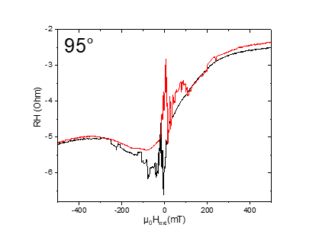

m84: Plusses\_Crosses\_empty\_Hloop\_95deg\_1T/min

Sonntag, 24. März 2019

08:18

|  |  |
| --- | --- |
| (1) Structures measured | Plusses\_Crosses\_empty |
| (2) Measurement type | Hloop\_parallel |
| **(3) Cables Setup:** | |  |  |  | | --- | --- | --- | |  |  | Plusses (C) | |  |  | Crosses (D) | |  |  | Empty | |  |  |  | | Gate (9) |  |  | |
| **(4) Magnet Setup:** |  |
| **(5) Experiment Setup:** | |  |  | | --- | --- | | T |  | |  |  | |  | 1 MΩ | |  | 95 | |
| **(6) Lock-In Setup:** | |  |  | | --- | --- | | Sens: | 5 mV | | τ: | 1s | | Float/Ground: | Ground | | AC/DC: | AC | | A/A-B: | A-B | | Reserve: | Normal | | Source: | Internal | |
| **(7) Important Notes:** |  |
| **(8) Filename and data:** | <<m84\_cros\_plu\_emp\_95deg\_Hloop\_down\_Parallel\_20190324\_0800\_I-7-14\_GB8-1-13\_GB9-2-12\_GB13-6-8\_Vin-2.5V\_R11-1MO\_C11-1\_C21-6\_T-30K\_SR-1-T-min\_B-1T\_gate-0V\_.dat>>    <<m84\_cros\_plu\_emp\_95deg\_Hloop\_up\_Parallel\_20190324\_0800\_I-7-14\_GB8-1-13\_GB9-2-12\_GB13-6-8\_Vin-2.5V\_R11-1MO\_C11-1\_C21-6\_T-30K\_SR-1-T-min\_B-1T\_gate-0V\_.dat>> |

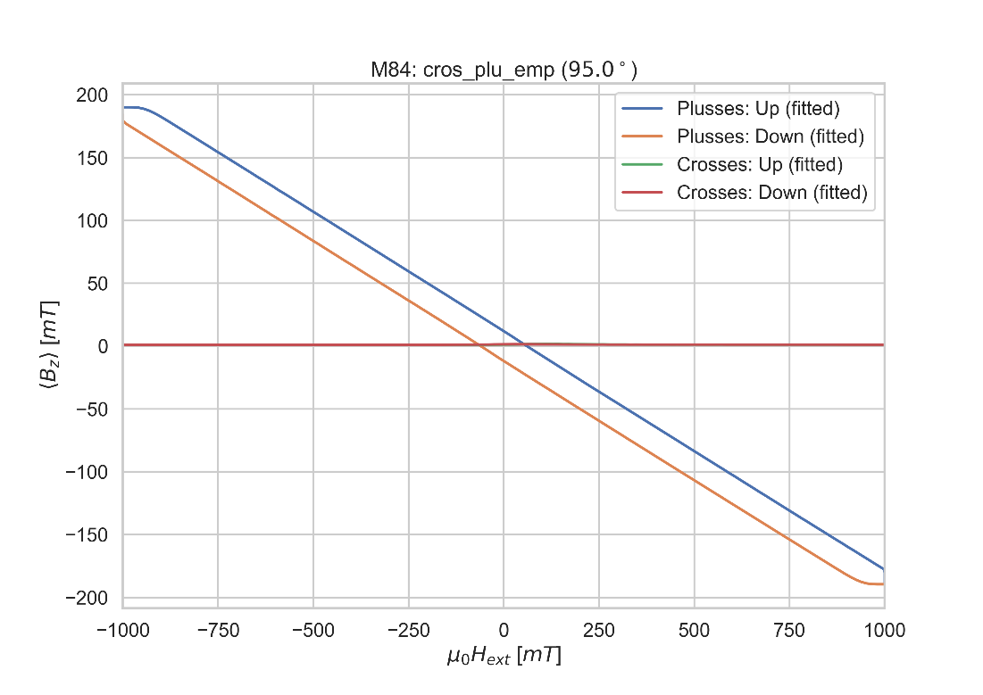

C: Changing angle 100

Sonntag, 24. März 2019

08:20

|  |  |
| --- | --- |
| (1) Structures measured | Empty Cross |
| (2) Measurement type | Angle Changing |
| **(3) Cables Setup:** | |  |  |  | | --- | --- | --- | |  | *14 - 7* |  | |  |  |  | | Gate (9) |  |  | |
| **(4) Magnet Setup:** | B = 1 T |
| **(5) Experiment Setup:** | |  |  | | --- | --- | | T |  | |  |  | |  | 1 MΩ | |  | 95 | |
| **(6) Lock-In Setup:** | |  |  | | --- | --- | | Sens: | 20mV | | τ: | 1s | | Float/Ground: | Ground | | AC/DC: | AC | | A/A-B: | A-B | | Reserve: | Normal | | Source: | Internal | |
| **(7) Important Notes:** | VH before changing the angle: -1.075mV |
| **(8) Filename and data:** | No File created |

Aiming for Hall Voltage:



**Voltage measured:**



**m85:** Plusses\_Hloop\_100deg

Sonntag, 24. März 2019

08:30

|  |  |
| --- | --- |
| Angle of sensor θ | *100* |
|  |  |
|  |  |
|  | |  |  | | --- | --- | |  | *0.75* | |  | 10 | |
|  | R12 = 105/1000\*50 = 5,25 |
|  |  |
| *Period of measurement (min)* | *300* |
| *Notes* |  |
| *Data files* | <<m85\_Plusses\_100deg\_Hloop\_up\_\_Gradio\_20190324\_0800\_I1-1-13\_I2-8-6\_GBIP8-14-7\_Vin-2.5V\_R11-1MO\_R1-5.25kO\_R13-0\_R21-1MO\_C11-1\_C21-6\_T-30K\_SR-0.01-T-min\_B-0.75T\_gate-0V\_up\_.dat>>  <<m85\_Plusses\_100deg\_Hloop\_down\_\_Gradio\_20190324\_0800\_I1-1-13\_I2-8-6\_GBIP8-14-7\_Vin-2.5V\_R11-1MO\_R1-5.25kO\_R13-0\_R21-1MO\_C11-1\_C21-6\_T-30K\_SR-0.01-T-min\_B-0.75T\_gate-0V\_down\_.dat>> |
| *Plot* | Machine generated alternative text: 1 000  -40  40  poi--Vr(mT) |

**m86:**Crosses\_Hloop\_100deg

24/03/2019 17:49

|  |  |
| --- | --- |
| Angle of sensor θ | *100* |
|  |  |
|  |  |
|  | |  |  | | --- | --- | |  | *0.75* | |  | 10 | |
|  | R12 = 45/1000\*50 = 2,25 |
|  |  |
| *Period of measurement (min)* | *300* |
| *Notes* |  |
| *Data files* | <<m86\_Crosses\_100deg\_Hloop\_down\_\_Gradio\_20190324\_1400\_I1-2-12\_I2-8-6\_GBIP8-14-7\_Vin-2.5V\_R11-1MO\_R12-2.25kO\_R13-0\_R21-1MO\_C11-1\_C21-6\_T-30K\_SR-0.01-T-min\_B-0.75T\_gate-0V.dat>>    <<m86\_Crosses\_100deg\_Hloop\_up\_Gradio\_20190324\_1400\_I1-2-12\_I2-8-6\_GBIP8-14-7\_Vin-2.5V\_R11-1MO\_R12-2.25kO\_R13-0\_R21-1MO\_C11-1\_C21-6\_T-30K\_SR-0.01-T-min\_B-0.75T\_gate-0V.dat>> |
| *Plot* | Machine generated alternative text: 1 000  poi--Vr(mT) |

**m87:** PlussesCrossesEmpty\_Parallel Hloop\_100deg

Sonntag, 24. März 2019

19:24

|  |  |
| --- | --- |
| Float/Ground: | Ground |
| AC/DC: | AC |
| A/A-B: | A-B |
| Reserve: | Normal |
| Source: | Internal |

|  |  |
| --- | --- |
| Angle of sensor θ | *100* |
|  |  |
|  |  |
|  | |  |  | | --- | --- | |  | *1* | |  | 1000 | |
|  | R12 = 40/1000\*50 = |
|  |  |
| *Period of measurement (min)* |  |
| *Notes* |  |
| *Data files* | <<m87\_cros\_plu\_emp\_100deg\_Hloop\_down\_Parallel\_20190324\_1900\_I-7-14\_GB8-1-13\_GB9-2-12\_GB13-6-8\_Vin-2.5V\_R11-1MO\_C11-1\_C21-6\_T-30K\_SR-1-T-min\_B-1T\_gate-0V\_.dat>>    <<m87\_cros\_plu\_emp\_100deg\_Hloop\_up\_Parallel\_20190324\_1900\_I-7-14\_GB8-1-13\_GB9-2-12\_GB13-6-8\_Vin-2.5V\_R11-1MO\_C11-1\_C21-6\_T-30K\_SR-1-T-min\_B-1T\_gate-0V\_.dat>> |
| *Plot* |  |

**C: Changing angle 105**

Sonntag, 24. März 2019

19:26

|  |  |
| --- | --- |
| Float/Ground: | Ground |
| AC/DC: | AC |
| A/A-B: | A-B |
| Reserve: | Normal |
| Source: | Internal |

|  |  |
| --- | --- |
| VH(max) (mV) | *11,164* |
| Angle of sensor calculator | V\_H= Cos(105)\*11,164 = -2,889455819524543  Cos(0)=1  Before changing: -1.906mV  Measured: -2.888mV |
|  |  |
|  |  |
|  | |  |  | | --- | --- | |  | *1* | |
|  |  |
| *Period of measurement* |  |
| *Notes* |  |
| *Data files* |  |
| *Plot* |  |

**m88:** Plusses\_Hloop\_105deg

Sonntag, 24. März 2019

20:33

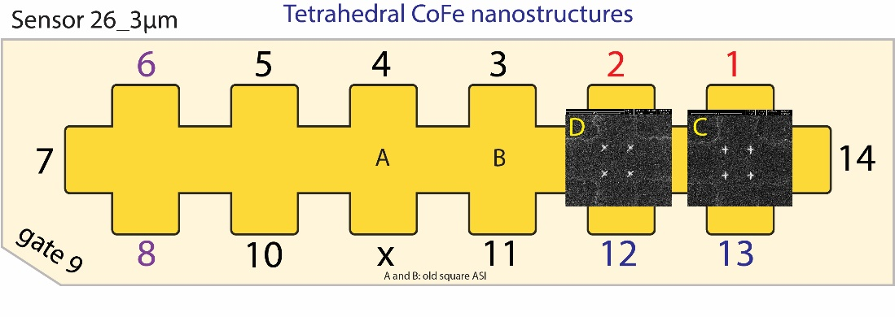

|  |  |
| --- | --- |
| Float/Ground: | Ground |
| AC/DC: | AC |
| A/A-B: | A-B |
| Reserve: | Normal |
| Source: | Internal |

|  |  |
| --- | --- |
| Angle of sensor θ | *105* |
|  |  |
|  |  |
|  | |  |  | | --- | --- | |  | *1* | |  | 10 | |
|  | R12 = 52/1000\*50 = 2,6 |
|  |  |
| *Period of measurement (min)* | *400* |
| *Notes* | *Waiting to fill He and listening to music :)* |
| *Data files* | <<m88\_Plusses\_105deg\_Hloop\_down\_\_Gradio\_20190324\_2000\_I1-1-13\_I2-8-6\_GBIP8-14-7\_Vin-2.5V\_R11-1MO\_R1-2.6kO\_R13-0\_R21-1MO\_C11-1\_C21-6\_T-30K\_SR-0.01-T-min\_B-1T\_gate-0V\_down\_.dat>>    <<m88\_Plusses\_105deg\_Hloop\_up\_\_Gradio\_20190324\_2000\_I1-1-13\_I2-8-6\_GBIP8-14-7\_Vin-2.5V\_R11-1MO\_R1-2.6kO\_R13-0\_R21-1MO\_C11-1\_C21-6\_T-30K\_SR-0.01-T-min\_B-1T\_gate-0V\_up\_.dat>> |
| *Plot* | Machine generated alternative text: 1050  ki--VIt(mT) |

**m89: Crosses\_Hloop\_105deg**

Montag, 25. März 2019

08:10

|  |  |
| --- | --- |
| Float/Ground: | Ground |
| AC/DC: | AC |
| A/A-B: | A-B |
| Reserve: | Normal |
| Source: | Internal |

|  |  |
| --- | --- |
| Angle of sensor θ | *105* |
|  |  |
|  |  |
|  | |  |  | | --- | --- | |  | *0.75* | |  | 10 | |
|  | R12 = 28/1000\*50 = 1,4 |
|  |  |
| *Period of measurement (min)* | *300* |
| *Notes* | *check file names* |
| *Data files* | <<m89\_Crosses\_105deg\_Hloop\_down\_\_Gradio\_20190325\_0800\_I1-1-13\_I2-8-6\_GBIP8-14-7\_Vin-2.5V\_R11-1MO\_R1-1.4kO\_R13-0\_R21-1MO\_C11-1\_C21-6\_T-30K\_SR-0.01-T-min\_B-0.75T\_gate-0V\_down\_.dat>>    <<m89\_Crosses\_105deg\_Hloop\_up\_\_Gradio\_20190325\_0800\_I1-1-13\_I2-8-6\_GBIP8-14-7\_Vin-2.5V\_R11-1MO\_R1-1.4kO\_R13-0\_R21-1MO\_C11-1\_C21-6\_T-30K\_SR-0.01-T-min\_B-0.75T\_gate-0V\_up\_.dat>> |
| *Plot* | Machine generated alternative text: 1 050  ki--VIt(mT) |

**m90:** PlussesCrossesEmpty\_Parallel Hloop\_105deg

Montag, 25. März 2019

13:00

|  |  |
| --- | --- |
| Float/Ground: | Ground |
| AC/DC: | AC |
| A/A-B: | A-B |
| Reserve: | Normal |
| Source: | Internal |

|  |  |
| --- | --- |
| Angle of sensor θ | *105* |
|  |  |
|  |  |
|  | |  |  | | --- | --- | |  | *1* | |  | 1000 | |
|  | R12 = 40/1000\*50 = |
|  |  |
| *Period of measurement (min)* |  |
| *Notes* |  |
| *Data files* | <<m90\_cros\_plu\_emp\_100deg\_Hloop\_down\_Parallel\_20190325\_1300\_I-7-14\_GB8-1-13\_GB9-2-12\_GB13-6-8\_Vin-2.5V\_R11-1MO\_C11-1\_C21-6\_T-30K\_SR-1-T-min\_B-1T\_gate-0V\_.dat>>    <<m90\_cros\_plu\_emp\_100deg\_Hloop\_up\_Parallel\_20190325\_1300\_I-7-14\_GB8-1-13\_GB9-2-12\_GB13-6-8\_Vin-2.5V\_R11-1MO\_C11-1\_C21-6\_T-30K\_SR-1-T-min\_B-1T\_gate-0V\_.dat>> |
| *Plot* |  |

**C: Changing angle 110**

Montag, 25. März 2019

13:48

|  |  |
| --- | --- |
| Float/Ground: | Ground |
| AC/DC: | AC |
| A/A-B: | A-B |
| Reserve: | Normal |
| Source: | Internal |

|  |  |
| --- | --- |
| VH(max) (mV) | *11,164* |
| Angle of sensor calculator | V\_H= Cos(110)\*11,164 = -3,818312880087765  Cos(0)=1  Before changing: -1.906mV  Measured: -3.817mV |
|  |  |
|  |  |
|  | |  |  | | --- | --- | |  | *1* | |
|  |  |
| *Period of measurement* |  |
| *Notes* |  |
| *Data files* |  |
| *Plot* |  |

**m91:** Plusses\_Hloop\_110deg

19 March 2019

08:49



|  |  |
| --- | --- |
| Float/Ground: | Ground |
| AC/DC: | AC |
| A/A-B: | A-B |
| Reserve: | Normal |
| Source: | Internal |

|  |  |
| --- | --- |
| Angle of sensor θ | *110* |
|  |  |
|  |  |
|  | |  |  | | --- | --- | |  | *0,6* | |  | 10 | |
|  | R12 = 103/1000\*50 = 5,15 |
|  |  |
| *Period of measurement (min)* | *240m* |
| *Notes* |  |
| *Data files* | <<m91\_Plusses\_110deg\_Hloop\_down\_\_Gradio\_20190325\_1400\_I1-1-13\_I2-8-6\_GBIP8-14-7\_Vin-2.5V\_R11-1MO\_R12-5.15kO\_R13-0\_R21-1MO\_C11-1\_C21-6\_T-30K\_SR-0.01-T-min\_B-0.6T\_gate-0V\_down\_.dat>>  <<m91\_Plusses\_110deg\_Hloop\_up\_\_Gradio\_20190325\_1400\_I1-1-13\_I2-8-6\_GBIP8-14-7\_Vin-2.5V\_R11-1MO\_R12-5.15kO\_R13-0\_R21-1MO\_C11-1\_C21-6\_T-30K\_SR-0.01-T-min\_B-0.6T\_gate-0V\_up\_.dat>> |
| *Plot* | Computergenerierter Alternativtext: 3.0  2.5  2.0  1.0  0.5  -600  Up (fitted)  Down (fitted)  ¯ 400  M91:  -200  Plusses (110.00)  0.5  oo  200  600 |

**m92: Crosses\_Hloop\_110deg\_overload repeated at 22:00 :( check m93**

Montag, 25. März 2019

18:30

|  |  |
| --- | --- |
| Float/Ground: | Ground |
| AC/DC: | AC |
| A/A-B: | A-B |
| Reserve: | Normal |
| Source: | Internal |

|  |  |
| --- | --- |
| Angle of sensor θ | *100* |
|  |  |
|  |  |
|  | |  |  | | --- | --- | |  | *0.5* | |  | 10 | |
|  | R12 = 45/1000\*50 = 2,25 |
|  |  |
| *Period of measurement (min)* | *200* |
| *Notes* | ***Damit, there was overload!!!!!!!!!!!!!!!!!!!!!!!!!!!!!!!!!!!!!!!!*** |
| *Data files* | <<m92\_Crosses\_110deg\_Hloop\_down\_\_Gradio\_20190325\_1800\_I1-1-13\_I2-8-6\_GBIP8-14-7\_Vin-2.5V\_R11-1MO\_R12-2.25kO\_R13-0\_R21-1MO\_C11-1\_C21-6\_T-30K\_SR-0.01-T-min\_B-0.5T\_gate-0V\_down\_.dat>>  <<m92\_Crosses\_110deg\_Hloop\_up\_\_Gradio\_20190325\_1800\_I1-1-13\_I2-8-6\_GBIP8-14-7\_Vin-2.5V\_R11-1MO\_R12-2.25kO\_R13-0\_R21-1MO\_C11-1\_C21-6\_T-30K\_SR-0.01-T-min\_B-0.5T\_gate-0V\_up\_.dat>> |
| *Plot* | Computergenerierter Alternativtext: 1.0  0.5  ¯ 400  M92: Crosses (110.00)  noo  -0.25  -0.75  -500  250  500  -200  200 |

**m93: Crosses\_Hloop\_110deg**

Montag, 25. März 2019

22:20

|  |  |
| --- | --- |
| Float/Ground: | Ground |
| AC/DC: | AC |
| A/A-B: | A-B |
| Reserve: | Normal |
| Source: | Internal |

|  |  |
| --- | --- |
| Angle of sensor θ | *100* |
|  |  |
|  |  |
|  | |  |  | | --- | --- | |  | *0.5* | |  | 8 | |
|  | R12 = 45/1000\*50 = 2,25 |
|  |  |
| *Period of measurement (min)* | *200* |
| *Notes* |  |
| *Data files* | <<m93\_Crosses\_110deg\_Hloop\_down\_\_Gradio\_20190325\_2200\_I1-1-13\_I2-8-6\_GBIP8-14-7\_Vin-2.5V\_R11-1MO\_R12-2.25kO\_R13-0\_R21-1MO\_C11-1\_C21-6\_T-30K\_SR-0.008-T-min\_B-0.5T\_gate-0V\_down\_.dat>>  <<m93\_Crosses\_110deg\_Hloop\_up\_\_Gradio\_20190325\_2200\_I1-1-13\_I2-8-6\_GBIP8-14-7\_Vin-2.5V\_R11-1MO\_R12-2.25kO\_R13-0\_R21-1MO\_C11-1\_C21-6\_T-30K\_SR-0.008-T-min\_B-0.5T\_gate-0V\_up\_.dat>> |
| *Plot* | Computergenerierter Alternativtext: 1.50  1.25  1.00  0.75  0.50  0.25  0.00  -0.25  -0.50  Up (fitted)  Down (fitted)  ¯ 400  M93: Crosses (110.00)  -0.2  —0.4  -500  250  500  -200  200 |

**M94:** PlussesCrossesEmpty\_Parallel Hloop\_110deg

Dienstag, 26. März 2019

07:26

|  |  |
| --- | --- |
| Float/Ground: | Ground |
| AC/DC: | AC |
| A/A-B: | A-B |
| Reserve: | Normal |
| Source: | Internal |

|  |  |
| --- | --- |
| Angle of sensor θ |  |
|  |  |
|  |  |
|  | |  |  | | --- | --- | |  | *1* | |  | 1000 | |
|  | R12 = 40/1000\*50 = |
|  |  |
| *Period of measurement (min)* |  |
| *Notes* |  |
| *Data files* | <<m94\_cros\_plu\_emp\_100deg\_Hloop\_down\_Parallel\_20190326\_0700\_I-7-14\_GB8-1-13\_GB9-2-12\_GB13-6-8\_Vin-2.5V\_R11-1MO\_C11-1\_C21-6\_T-30K\_SR-1-T-min\_B-1T\_gate-0V\_.dat>>    <<m94\_cros\_plu\_emp\_100deg\_Hloop\_up\_Parallel\_20190326\_0700\_I-7-14\_GB8-1-13\_GB9-2-12\_GB13-6-8\_Vin-2.5V\_R11-1MO\_C11-1\_C21-6\_T-30K\_SR-1-T-min\_B-1T\_gate-0V\_.dat>> |
| *Plot* |  |

: Negative angles



|  |  |
| --- | --- |
| Sens: | 20 μV |
| τ: | 1s |
| Float/Ground: | Ground |
| AC/DC: | AC |
| A/A-B: | A-B |
| Reserve: | Normal |
| Source: | Internal |

**(7) Important Notes:**

**C: Changing angle (-5 )**

Dienstag, 26. März 2019

08:46

|  |  |
| --- | --- |
| Float/Ground: | Ground |
| AC/DC: | AC |
| A/A-B: | A-B |
| Reserve: | Normal |
| Source: | Internal |

|  |  |
| --- | --- |
| VH(max) (mV) | *11,164* |
| Angle of sensor calculator | V\_H= Cos(-5)\*11,164 = 11,12151760949625  Before changing:  Measured:11.121mV |
|  |  |
|  |  |
|  | |  |  | | --- | --- | |  | *1* | |
|  |  |
| *Period of measurement* |  |
| *Notes* |  |
| *Data files* |  |
| *Plot* |  |

**m95:** Plusses\_Hloop\_(-5) deg

Dienstag, 26. März 2019

08:58



|  |  |
| --- | --- |
| Float/Ground: | Ground |
| AC/DC: | AC |
| A/A-B: | A-B |
| Reserve: | Normal |
| Source: | Internal |

|  |  |
| --- | --- |
| Angle of sensor θ | *-5* |
|  |  |
|  |  |
|  | |  |  | | --- | --- | |  | *0.75* | |  | 10 | |
|  | R12 = 73/1000\*50 = 3,65 |
|  |  |
| *Period of measurement (min)* | *300* |
| *Notes* |  |
| *Data files* | <<m95\_Plusses\_neg5deg\_Hloop\_down\_\_Gradio\_20190326\_0900\_I1-1-13\_I2-8-6\_GBIP8-14-7\_Vin-2.5V\_R11-1MO\_R12-3.65kO\_R13-0\_R21-1MO\_C11-1\_C21-6\_T-30K\_SR-0.01-T-min\_B-0.75T\_gate-0V\_down\_.dat>>  <<m95\_Plusses\_neg5deg\_Hloop\_up\_\_Gradio\_20190326\_0900\_I1-1-13\_I2-8-6\_GBIP8-14-7\_Vin-2.5V\_R11-1MO\_R12-3.65kO\_R13-0\_R21-1MO\_C11-1\_C21-6\_T-30K\_SR-0.01-T-min\_B-0.75T\_gate-0V\_up\_.dat>> |
| *Plot* | Computergenerierter Alternativtext:  195 Pluses ( 5.09 )  Up ( fitted )  NoPleat |

**m96: Crosses\_Hloop\_(-5)deg**

Dienstag, 26. März 2019

14:39

|  |  |
| --- | --- |
| Float/Ground: | Ground |
| AC/DC: | AC |
| A/A-B: | A-B |
| Reserve: | Normal |
| Source: | Internal |

|  |  |
| --- | --- |
| Angle of sensor θ | *-5* |
|  |  |
|  |  |
|  | |  |  | | --- | --- | |  | *0.4* | |  | 10 | |
|  | R12 = 65/1000\*50 = 3,25 |
|  |  |
| *Period of measurement (min)* | *160* |
| *Notes* |  |
| *Data files* | <<m96\_Crosses\_-5deg\_Hloop\_down\_\_Gradio\_20190326\_1400\_I1-1-13\_I2-8-6\_GBIP8-14-7\_Vin-2.5V\_R11-1MO\_R12-3.25kO\_R13-0\_R21-1MO\_C11-1\_C21-6\_T-30K\_SR-0.01-T-min\_B-0.4T\_gate-0V\_down\_.dat>>  <<m96\_Crosses\_-5deg\_Hloop\_up\_\_Gradio\_20190326\_1400\_I1-1-13\_I2-8-6\_GBIP8-14-7\_Vin-2.5V\_R11-1MO\_R12-3.25kO\_R13-0\_R21-1MO\_C11-1\_C21-6\_T-30K\_SR-0.01-T-min\_B-0.4T\_gate-0V\_up\_.dat>> |
| *Plot* | Computergenerierter Alternativtext: Up (fitted)  Down (fitted)  ¯ 400  -300  -200  M96: Crosses  -100  (-5.00)  1.0  0.5  100  -20  200  300 |

**m97:** PlussesCrossesEmpty\_Parallel Hloop\_(-5)deg

Dienstag, 26. März 2019

17:29

|  |  |
| --- | --- |
| Float/Ground: | Ground |
| AC/DC: | AC |
| A/A-B: | A-B |
| Reserve: | Normal |
| Source: | Internal |

|  |  |
| --- | --- |
| Angle of sensor θ | *-5* |
|  |  |
|  |  |
|  | |  |  | | --- | --- | |  | *1* | |  | 1000 | |
|  | R12 = 40/1000\*50 = |
|  |  |
| *Period of measurement (min)* |  |
| *Notes* |  |
| *Data files* | <<m97\_cros\_plu\_emp\_-5deg\_Hloop\_down\_Parallel\_20190326\_1700\_I-7-14\_GB8-1-13\_GB9-2-12\_GB13-6-8\_Vin-2.5V\_R11-1MO\_C11-1\_C21-6\_T-30K\_SR-1-T-min\_B-1T\_gate-0V\_\_.dat>>    <<m97\_cros\_plu\_emp\_-5deg\_Hloop\_up\_Parallel\_20190326\_1700\_I-7-14\_GB8-1-13\_GB9-2-12\_GB13-6-8\_Vin-2.5V\_R11-1MO\_C11-1\_C21-6\_T-30K\_SR-1-T-min\_B-1T\_gate-0V\_\_.dat>> |
| *Plot* | Computergenerierter Alternativtext: M97: cros_plu_emp (—  2  -4  —6  -1000  Up (fitted)  Down (fitted)  Crosses: Up (fitted)  Crosses: Down (fitted)  Plusses:  Plusses:  -750  -500  -250  5.00)  250  500  750  1000 |

**C: Changing angle (-10)**

19 March 2019

08:49

|  |  |
| --- | --- |
| Float/Ground: | Ground |
| AC/DC: | AC |
| A/A-B: | A-B |
| Reserve: | Normal |
| Source: | Internal |

|  |  |
| --- | --- |
| VH(max) (mV) | *11,164* |
| Angle of sensor calculator | V\_H= Cos(-10)\*11,164 = 10,99439375462829  Before changing: 10,4  Measured:10,992 |
|  |  |
|  |  |
|  | |  |  | | --- | --- | |  | *1* | |
|  |  |
| *Period of measurement* |  |
| *Notes* |  |
| *Data files* |  |
| *Plot* |  |

**m98:** Plusses\_Hloop\_(-10)deg

19 March 2019

08:49



|  |  |
| --- | --- |
| Float/Ground: | Ground |
| AC/DC: | AC |
| A/A-B: | A-B |
| Reserve: | Normal |
| Source: | Internal |

|  |  |
| --- | --- |
| Angle of sensor θ |  |
|  |  |
|  |  |
|  | |  |  | | --- | --- | |  | *0.3* | |  | 10 | |
|  | R12 = 155/1000\*50 = 7,75 |
|  |  |
| *Period of measurement (min)* | *160* |
| *Notes* |  |
| *Data files* | <<m98\_Plusses\_-10deg\_Hloop\_up\_\_Gradio\_20190326\_1700\_I1-1-13\_I2-8-6\_GBIP8-14-7\_Vin-2.5V\_R11-1MO\_R12-7.75kO\_R13-0\_R21-1MO\_C11-1\_C21-6\_T-30K\_SR-0.01-T-min\_B-0.3T\_gate-0V\_up\_A\_\_.dat>>    <<m98\_Plusses\_-10deg\_Hloop\_up\_\_Gradio\_20190326\_1700\_I1-1-13\_I2-8-6\_GBIP8-14-7\_Vin-2.5V\_R11-1MO\_R12-7.75kO\_R13-0\_R21-1MO\_C11-1\_C21-6\_T-30K\_SR-0.01-T-min\_B-0.3T\_gate-0V\_up\_B\_\_.dat>> |
| *Plot* | Computergenerierter Alternativtext: Plusses  -300  Up (fitted)  Down (fitted)  -200  M98:  -100  (-10.00)  0.5  100  20  200  300 |

**m99: Crosses\_Hloop\_(-10)deg**

Dienstag, 26. März 2019

21:07

|  |  |
| --- | --- |
| Float/Ground: | Ground |
| AC/DC: | AC |
| A/A-B: | A-B |
| Reserve: | Normal |
| Source: | Internal |

|  |  |
| --- | --- |
| Angle of sensor θ |  |
|  |  |
|  |  |
|  | |  |  | | --- | --- | |  | *0.3* | |  | 10 | |
|  | R12 = 128/1000\*50 = 6,4 |
|  |  |
| *Period of measurement (min)* | *160* |
| *Notes* |  |
| *Data files* | <<m99\_Crosses\_-10deg\_Hloop\_down\_\_Gradio\_20190326\_2100\_I1-2-12\_I2-8-6\_GBIP8-14-7\_Vin-2.5V\_R11-1MO\_R12-6.4kO\_R13-0\_R21-1MO\_C11-1\_C21-6\_T-30K\_SR-0.01-T-min\_B-0.3T\_gate-0V\_down\_.dat>>    <<m99\_Crosses\_-10deg\_Hloop\_up\_\_Gradio\_20190326\_2100\_I1-2-12\_I2-8-6\_GBIP8-14-7\_Vin-2.5V\_R11-1MO\_R12-6.4kO\_R13-0\_R21-1MO\_C11-1\_C21-6\_T-30K\_SR-0.01-T-min\_B-0.3T\_gate-0V\_up\_.dat>> |
| *Plot* | Computergenerierter Alternativtext: M99: Crosses  -300  Up (fitted)  Down (fitted)  -200  -100  (-10.00)  1.0  100  20  200  300 |

**m100:** PlussesCrossesEmpty\_Parallel Hloop\_(-10)deg

Mittwoch, 27. März 2019

07:47

|  |  |
| --- | --- |
| Float/Ground: | Ground |
| AC/DC: | AC |
| A/A-B: | A-B |
| Reserve: | Normal |
| Source: | Internal |

|  |  |
| --- | --- |
| Angle of sensor θ | *-15* |
|  |  |
|  |  |
|  | |  |  | | --- | --- | |  | *1* | |  | 1000 | |
|  | R12 = 40/1000\*50 = |
|  |  |
| *Period of measurement (min)* |  |
| *Notes* |  |
| *Data files* | <<m100\_cros\_plu\_emp\_-10deg\_Hloop\_down\_Parallel\_20190327\_0700\_I-7-14\_GB8-1-13\_GB9-2-12\_GB13-6-8\_Vin-2.5V\_R11-1MO\_C11-1\_C21-6\_T-30K\_SR-1-T-min\_B-1T\_gate-0V.dat>>    <<m100\_cros\_plu\_emp\_-10deg\_Hloop\_up\_Parallel\_20190327\_0700\_I-7-14\_GB8-1-13\_GB9-2-12\_GB13-6-8\_Vin-2.5V\_R11-1MO\_C11-1\_C21-6\_T-30K\_SR-1-T-min\_B-1T\_gate-0V.dat>> |
| *Plot* | MI 00: cros_plu_emp (—10.0 0 )  2  -3  -4  -5  -6  -1000  Plusses: Up (fitted)  Plusses: Down (fitted)  Crosses: Up (fitted)  Crosses: Down (fitted)  -750  -500  -250  250  500  750  1000 |

**C: Changing angle (-15)**

Mittwoch, 27. März 2019

07:55

|  |  |
| --- | --- |
| Float/Ground: | Ground |
| AC/DC: | AC |
| A/A-B: | A-B |
| Reserve: | Normal |
| Source: | Internal |

|  |  |
| --- | --- |
| VH(max) (mV) | *11,164* |
| Angle of sensor calculator | V\_H= Cos(-15)\*11,164 = **10,78359592469116**  Before changing:10.568  Measured:10.783mV |
|  |  |
|  |  |
|  | |  |  | | --- | --- | |  | *1* | |
|  |  |
| *Period of measurement* |  |
| *Notes* |  |
| *Data files* |  |
| *Plot* |  |

**m101:** Plusses\_Hloop\_(-15)deg

Mittwoch, 27. März 2019

07:55



|  |  |
| --- | --- |
| Float/Ground: | Ground |
| AC/DC: | AC |
| A/A-B: | A-B |
| Reserve: | Normal |
| Source: | Internal |

|  |  |
| --- | --- |
| Angle of sensor θ | *-15* |
|  |  |
|  |  |
|  | |  |  | | --- | --- | |  | *0.25* | |  | 10 | |
|  | 176/1000\*50=8,8 |
|  |  |
| *Period of measurement (min)* | *100* |
| *Notes* |  |
| *Data files* | <<m101\_Plusses\_-15deg\_Hloop\_down\_\_Gradio\_20190327\_0800\_I1-1-13\_I2-8-6\_GBIP8-14-7\_Vin-2.5V\_R11-1MO\_R12-8.8kO\_R13-0\_R21-1MO\_C11-1\_C21-6\_T-30K\_SR-0.01-T-min\_B-0.25T\_gate-0V\_down\_\_.dat>>    <<m101\_Plusses\_-15deg\_Hloop\_up\_\_Gradio\_20190327\_0800\_I1-1-13\_I2-8-6\_GBIP8-14-7\_Vin-2.5V\_R11-1MO\_R12-8.8kO\_R13-0\_R21-1MO\_C11-1\_C21-6\_T-30K\_SR-0.01-T-min\_B-0.25T\_gate-0V\_up\_\_.dat>> |
| *Plot* | Computergenerierter Alternativtext: Plusses  3.5  3.0  2.5  1.0  0.5  Up (fitted)  Down (fitted)  -200  MIOI:  -100  (-15.00)  -20  100  20  200 |

**m102: Crosses\_Hloop\_(-15)deg**

Mittwoch, 27. März 2019

08:49

|  |  |
| --- | --- |
| Float/Ground: | Ground |
| AC/DC: | AC |
| A/A-B: | A-B |
| Reserve: | Normal |
| Source: | Internal |

|  |  |
| --- | --- |
| Angle of sensor θ | *-15* |
|  |  |
|  |  |
|  | |  |  | | --- | --- | |  | *.25* | |  | 10 | |
|  | R12 = 164/1000\*50 = 8,2 |
|  |  |
| *Period of measurement (min)* | *100* |
| *Notes* |  |
| *Data files* | <<m102\_Crosses\_-15deg\_Hloop\_down\_\_Gradio\_20190327\_1000\_I1-2-12\_I2-8-6\_GBIP8-14-7\_Vin-2.5V\_R11-1MO\_R12-8.2kO\_R13-0\_R21-1MO\_C11-1\_C21-6\_T-30K\_SR-0.01-T-min\_B-0.25T\_gate-0V\_down\_\_.dat>>    <<m102\_Crosses\_-15deg\_Hloop\_up\_\_Gradio\_20190327\_1000\_I1-2-12\_I2-8-6\_GBIP8-14-7\_Vin-2.5V\_R11-1MO\_R12-8.2kO\_R13-0\_R21-1MO\_C11-1\_C21-6\_T-30K\_SR-0.01-T-min\_B-0.25T\_gate-0V\_up\_\_.dat>> |
| *Plot* | Computergenerierter Alternativtext: M102: Crosses  4.0  Up (fitted)  Down (fitted)  3.5  3.0  2.5  2.0  1.0  0.5  -200  -100  (-15.00)  -20  100  20  200 |

**m103:** PlussesCrossesEmpty\_Parallel Hloop\_(-15)deg

Mittwoch, 27. März 2019

12:23

|  |  |
| --- | --- |
| Float/Ground: | Ground |
| AC/DC: | AC |
| A/A-B: | A-B |
| Reserve: | Normal |
| Source: | Internal |

|  |  |
| --- | --- |
| Angle of sensor θ |  |
|  |  |
|  |  |
|  | |  |  | | --- | --- | |  | *1* | |  | 1000 | |
|  | R12 = 40/1000\*50 = |
|  |  |
| *Period of measurement (min)* |  |
| *Notes* |  |
| *Data files* | <<m103\_cros\_plu\_emp\_-15deg\_Hloop\_up\_Parallel\_20190327\_1200\_I-7-14\_GB8-1-13\_GB9-2-12\_GB13-6-8\_Vin-2.5V\_R11-1MO\_C11-1\_C21-6\_T-30K\_SR-1-T-min\_B-1T\_gate-0V.dat>>  <<m103\_cros\_plu\_emp\_-15deg\_Hloop\_down\_Parallel\_20190327\_1200\_I-7-14\_GB8-1-13\_GB9-2-12\_GB13-6-8\_Vin-2.5V\_R11-1MO\_C11-1\_C21-6\_T-30K\_SR-1-T-min\_B-1T\_gate-0V.dat>> |
| *Plot* |  |

**C: Changing angle (-20)**

Mittwoch, 27. März 2019

12:23

|  |  |
| --- | --- |
| Float/Ground: | Ground |
| AC/DC: | AC |
| A/A-B: | A-B |
| Reserve: | Normal |
| Source: | Internal |

|  |  |
| --- | --- |
| VH(max) (mV) | *11,164* |
| Angle of sensor calculator | V\_H= Cos(-20)\*11,164 = 10,49072841845388  Before changing:10,738  Measured:10,492 |
|  |  |
|  |  |
|  | |  |  | | --- | --- | |  | *1* | |
|  |  |
| *Period of measurement* |  |
| *Notes* |  |
| *Data files* |  |
| *Plot* |  |

**m104:** Plusses\_Hloop\_(-20)deg

Mittwoch, 27. März 2019

12:23



|  |  |
| --- | --- |
| Float/Ground: | Ground |
| AC/DC: | AC |
| A/A-B: | A-B |
| Reserve: | Normal |
| Source: | Internal |

|  |  |
| --- | --- |
| Angle of sensor θ | *-20* |
|  |  |
|  |  |
|  | |  |  | | --- | --- | |  | *.25* | |  | 10 | |
|  | R12 = 200/1000\*50 = 10 |
|  |  |
| *Period of measurement (min)* | *100* |
| *Notes* |  |
| *Data files* | <<m104\_Plusses\_-20deg\_Hloop\_down\_\_Gradio\_20190327\_1200\_I1-1-13\_I2-8-6\_GBIP8-14-7\_Vin-2.5V\_R11-1MO\_R12-10kO\_R13-0\_R21-1MO\_C11-1\_C21-6\_T-30K\_SR-0.01-T-min\_B-0.25T\_gate-0V\_down\_\_.dat>>  <<m104\_Plusses\_-20deg\_Hloop\_up\_\_Gradio\_20190327\_1200\_I1-1-13\_I2-8-6\_GBIP8-14-7\_Vin-2.5V\_R11-1MO\_R12-10kO\_R13-0\_R21-1MO\_C11-1\_C21-6\_T-30K\_SR-0.01-T-min\_B-0.25T\_gate-0V\_up\_\_.dat>> |
| *Plot* | Computergenerierter Alternativtext: Plusses  Up (fitted)  3.5  Down (fitted)  3.0  2.5  2.0  1.0  0.5  -200  M104:  -100  (-20.00)  0.5  -20  100  20  200 |

**m105: Crosses\_Hloop\_(-20)deg**

Mittwoch, 27. März 2019

14:14

|  |  |
| --- | --- |
| Float/Ground: | Ground |
| AC/DC: | AC |
| A/A-B: | A-B |
| Reserve: | Normal |
| Source: | Internal |

|  |  |
| --- | --- |
| Angle of sensor θ | *-20* |
|  |  |
|  |  |
|  | |  |  | | --- | --- | |  | *0.25* | |  | 10 | |
|  | R12 = 173/1000\*50 = 8,65 |
|  |  |
| *Period of measurement (min)* | *100* |
| *Notes* |  |
| *Data files* | <<m105\_Crosses\_-20deg\_Hloop\_down\_\_Gradio\_20190327\_1400\_I1-2-12\_I2-8-6\_GBIP8-14-7\_Vin-2.5V\_R11-1MO\_R12-8.65kO\_R13-0\_R21-1MO\_C11-1\_C21-6\_T-30K\_SR-0.01-T-min\_B-0.25T\_gate-0V\_down\_\_.dat>>  <<m105\_Crosses\_-20deg\_Hloop\_up\_\_Gradio\_20190327\_1400\_I1-2-12\_I2-8-6\_GBIP8-14-7\_Vin-2.5V\_R11-1MO\_R12-8.65kO\_R13-0\_R21-1MO\_C11-1\_C21-6\_T-30K\_SR-0.01-T-min\_B-0.25T\_gate-0V\_up\_\_.dat>> |
| *Plot* | Computergenerierter Alternativtext: M105: Crosses  (-20.00)  4.0  3.5  3.0  2.5  2.0  1.0  0.5  Up (fitted)  Down (fitted)  -200  -100  100  20  200 |

**m106:** PlussesCrossesEmpty\_Parallel Hloop\_(-20)deg

19 March 2019

08:49

|  |  |
| --- | --- |
| Float/Ground: | Ground |
| AC/DC: | AC |
| A/A-B: | A-B |
| Reserve: | Normal |
| Source: | Internal |

|  |  |
| --- | --- |
| Angle of sensor θ | *-20* |
|  |  |
|  |  |
|  | |  |  | | --- | --- | |  | *1* | |  | 1000 | |
|  | R12 = 40/1000\*50 = |
|  |  |
| *Period of measurement (min)* |  |
| *Notes* |  |
| *Data files* | <<m106\_cros\_plu\_emp\_-20deg\_Hloop\_up\_Parallel\_20190327\_1600\_I-7-14\_GB8-1-13\_GB9-2-12\_GB13-6-8\_Vin-2.5V\_R11-1MO\_C11-1\_C21-6\_T-30K\_SR-1-T-min\_B-1T\_gate-0V.dat>>    <<m106\_cros\_plu\_emp\_-20deg\_Hloop\_down\_Parallel\_20190327\_1600\_I-7-14\_GB8-1-13\_GB9-2-12\_GB13-6-8\_Vin-2.5V\_R11-1MO\_C11-1\_C21-6\_T-30K\_SR-1-T-min\_B-1T\_gate-0V.dat>> |
| *Plot* | Machine generated alternative text: Ml 06: cros_plu_emp (—20.0 0 )  2  1  —3  -4  —5  -1000  Up (fitted)  Down (fitted)  Crosses: Up (fitted)  Crosses: Down (fitted)  Plusses:  Plusses:  -750  -500  -250  250  500  750  1000 |

**C: Changing angle (-25)**

Mittwoch, 27. März 2019

16:00

|  |  |
| --- | --- |
| Float/Ground: | Ground |
| AC/DC: | AC |
| A/A-B: | A-B |
| Reserve: | Normal |
| Source: | Internal |

|  |  |
| --- | --- |
| VH(max) (mV) | *11,164* |
| Angle of sensor calculator | V\_H= Cos(-25)\*11,164 = 10,11802013447716  Before changing:10,43 mV  Measured: 10,119 mV |
|  |  |
|  |  |
|  | |  |  | | --- | --- | |  | *1* | |
|  |  |
| *Period of measurement* |  |
| *Notes* |  |
| *Data files* |  |
| *Plot* |  |

**m107:** Plusses\_Hloop\_(-25)deg

Mittwoch, 27. März 2019

17:00



|  |  |
| --- | --- |
| Float/Ground: | Ground |
| AC/DC: | AC |
| A/A-B: | A-B |
| Reserve: | Normal |
| Source: | Internal |

|  |  |
| --- | --- |
| Angle of sensor θ | *-25* |
|  |  |
|  |  |
|  | |  |  | | --- | --- | |  | *.25* | |  | 10 | |
|  | R12 = 200/1000\*50 = 10 |
|  |  |
| *Period of measurement (min)* | *100* |
| *Notes* |  |
| *Data files* | <<m107\_Plusses\_-25deg\_Hloop\_up\_\_Gradio\_20190327\_1630\_I1-1-13\_I2-8-6\_GBIP8-14-7\_Vin-2.5V\_R11-1MO\_R12-7.75kO\_R13-0\_R21-1MO\_C11-1\_C21-6\_T-30K\_SR-0.01-T-min\_B-0.25T\_gate-0V\_up\_\_.dat>>    <<m107\_Plusses\_-25deg\_Hloop\_down\_\_Gradio\_20190327\_1630\_I1-1-13\_I2-8-6\_GBIP8-14-7\_Vin-2.5V\_R11-1MO\_R12-7.75kO\_R13-0\_R21-1MO\_C11-1\_C21-6\_T-30K\_SR-0.01-T-min\_B-0.3T\_gate-0V\_down\_\_.dat>> |
| *Plot* | Computergenerierter Alternativtext: Plusses  3.5  3.0  2.5  1.5  1.0  0.5  Up (fitted)  Down (fitted)  -200  M107:  -100  (-25.00)  0.5  200  100  20  200 |

**m108: Crosses\_Hloop\_(-25)deg**

Mittwoch, 27. März 2019

19:32

|  |  |
| --- | --- |
| Float/Ground: | Ground |
| AC/DC: | AC |
| A/A-B: | A-B |
| Reserve: | Normal |
| Source: | Internal |

|  |  |
| --- | --- |
| Angle of sensor θ | *-25* |
|  |  |
|  |  |
|  | |  |  | | --- | --- | |  | *0.25* | |  | 10 | |
|  | R12 = 175/1000\*50 = 8,75 |
|  |  |
| *Period of measurement (min)* | *100* |
| *Notes* |  |
| *Data files* | <<m108\_Crosses\_-25deg\_Hloop\_down\_\_Gradio\_20190327\_1900\_I1-2-12\_I2-8-6\_GBIP8-14-7\_Vin-2.5V\_R11-1MO\_R12-8.75kO\_R13-0\_R21-1MO\_C11-1\_C21-6\_T-30K\_SR-0.01-T-min\_B-0.25T\_gate-0V\_down\_\_.dat>>  <<m108\_Crosses\_-25deg\_Hloop\_up\_\_Gradio\_20190327\_1900\_I1-2-12\_I2-8-6\_GBIP8-14-7\_Vin-2.5V\_R11-1MO\_R12-8.75kO\_R13-0\_R21-1MO\_C11-1\_C21-6\_T-30K\_SR-0.01-T-min\_B-0.25T\_gate-0V\_up\_\_.dat>> |
| *Plot* | Computergenerierter Alternativtext: M108: Crosses  4.0  3.5  3.0  2.5  2.0  1.0  0.5  Up (fitted)  Down (fitted)  -200  -100  (-25.00)  1.0  100  20  200 |

**m109:** PlussesCrossesEmpty\_Parallel Hloop\_(-25)deg

Mittwoch, 27. März 2019

21:24

|  |  |
| --- | --- |
| Float/Ground: | Ground |
| AC/DC: | AC |
| A/A-B: | A-B |
| Reserve: | Normal |
| Source: | Internal |

|  |  |
| --- | --- |
| Angle of sensor θ | *-25* |
|  |  |
|  |  |
|  | |  |  | | --- | --- | |  | *1* | |  | 1000 | |
|  | R12 = 40/1000\*50 = |
|  |  |
| *Period of measurement (min)* |  |
| *Notes* |  |
| *Data files* | <<m109\_cros\_plu\_emp\_-25deg\_Hloop\_down\_Parallel\_20190327\_2100\_I-7-14\_GB8-1-13\_GB9-2-12\_GB13-6-8\_Vin-2.5V\_R11-1MO\_C11-1\_C21-6\_T-30K\_SR-1-T-min\_B-1T\_gate-0V\_.dat>>    <<m109\_cros\_plu\_emp\_-25deg\_Hloop\_up\_Parallel\_20190327\_2100\_I-7-14\_GB8-1-13\_GB9-2-12\_GB13-6-8\_Vin-2.5V\_R11-1MO\_C11-1\_C21-6\_T-30K\_SR-1-T-min\_B-1T\_gate-0V\_.dat>> |
| *Plot* | (Bz)[mT]  丨 4  , 1000  0  2  C 乛 osses … Down (fitted)  C 乛 osses … Up (fitted)  Plusses … Down (fitted 一  Plusses … Up 冖 fitted)  | 750  , 500  M 一 09 … cros_plu_emp 冖 , 25b 。 一  , 250  UoHext 冖 m  0  250  500  750  1000 |

**C: Changing angle (-30)**

Mittwoch, 27. März 2019

21:26

|  |  |
| --- | --- |
| Float/Ground: | Ground |
| AC/DC: | AC |
| A/A-B: | A-B |
| Reserve: | Normal |
| Source: | Internal |

|  |  |
| --- | --- |
| VH(max) (mV) | *11,164* |
| Angle of sensor calculator | V\_H= Cos(-30)\*11,164 = 9,668307607849474  Before changing:10.118  Measured:9.669mV |
|  |  |
|  |  |
|  | |  |  | | --- | --- | |  | *1* | |
|  |  |
| *Period of measurement* |  |
| *Notes* |  |
| *Data files* |  |
| *Plot* |  |

**m110:** Plusses\_Hloop\_(-30)deg

Mittwoch, 27. März 2019

21:36



|  |  |
| --- | --- |
| Float/Ground: | Ground |
| AC/DC: | AC |
| A/A-B: | A-B |
| Reserve: | Normal |
| Source: | Internal |

|  |  |
| --- | --- |
| Angle of sensor θ | *-30* |
|  |  |
|  |  |
|  | |  |  | | --- | --- | |  | *0.25* | |  | 10 | |
|  | R12 = 188/1000\*50 = 9,4 |
|  |  |
| *Period of measurement (min)* | *100* |
| *Notes* |  |
| *Data files* | <<m110\_Plusses\_-30deg\_Hloop\_down\_\_Gradio\_20190327\_2130\_I1-1-13\_I2-8-6\_GBIP8-14-7\_Vin-2.5V\_R11-1MO\_R12-9.4kO\_R13-0\_R21-1MO\_C11-1\_C21-6\_T-30K\_SR-0.01-T-min\_B-0.25T\_gate-0V\_down\_\_.dat>>  <<m110\_Plusses\_-30deg\_Hloop\_up\_\_Gradio\_20190327\_2130\_I1-1-13\_I2-8-6\_GBIP8-14-7\_Vin-2.5V\_R11-1MO\_R12-9.4kO\_R13-0\_R21-1MO\_C11-1\_C21-6\_T-30K\_SR-0.01-T-min\_B-0.25T\_gate-0V\_up\_\_.dat>> |
| *Plot* | Computergenerierter Alternativtext: Plusses  3.5  3.0  2.5  2.0  1.5  1.0  0.5  Up (fitted)  Down (fitted)  -200  MIIO:  -100  (-30.00)  20  100  20  200 |

**m111: Crosses\_Hloop\_(-30)deg**

Donnerstag, 28. März 2019

07:13

|  |  |
| --- | --- |
| Float/Ground: | Ground |
| AC/DC: | AC |
| A/A-B: | A-B |
| Reserve: | Normal |
| Source: | Internal |

|  |  |
| --- | --- |
| Angle of sensor θ | *-30* |
|  |  |
|  |  |
|  | |  |  | | --- | --- | |  | *0.25* | |  | 10 | |
|  | R12 = 175/1000\*50 = 8,75 |
|  |  |
| *Period of measurement (min)* | *100* |
| *Notes* |  |
| *Data files* | <<m111\_Crosses\_-30deg\_Hloop\_down\_\_Gradio\_20190328\_0700\_I1-2-12\_I2-8-6\_GBIP8-14-7\_Vin-2.5V\_R11-1MO\_R12-8.75kO\_R13-0\_R21-1MO\_C11-1\_C21-6\_T-30K\_SR-0.01-T-min\_B-0.25T\_gate-0V\_down\_\_.dat>>  <<m111\_Crosses\_-30deg\_Hloop\_up\_\_Gradio\_20190328\_0700\_I1-2-12\_I2-8-6\_GBIP8-14-7\_Vin-2.5V\_R11-1MO\_R12-8.75kO\_R13-0\_R21-1MO\_C11-1\_C21-6\_T-30K\_SR-0.01-T-min\_B-0.25T\_gate-0V\_up\_\_.dat>> |
| *Plot* | Computergenerierter Alternativtext: 3.5  3.0  2.5  2.0  1.5  1.0  0.5  Up (fitted)  Down (fitted)  200  (-30.00)  Ml 11: Crosses  1.0  0.5  200  100  100  [mTl  200  200 |

**m112:** PlussesCrossesEmpty\_Parallel Hloop\_(-30)deg

Donnerstag, 28. März 2019

08:30

|  |  |
| --- | --- |
| Float/Ground: | Ground |
| AC/DC: | AC |
| A/A-B: | A-B |
| Reserve: | Normal |
| Source: | Internal |

|  |  |
| --- | --- |
| Angle of sensor θ | *-30* |
|  |  |
|  |  |
|  | |  |  | | --- | --- | |  | *1* | |  | 1000 | |
|  | R12 = 40/1000\*50 = |
|  |  |
| *Period of measurement (min)* |  |
| *Notes* |  |
| *Data files* | <<m112\_cros\_plu\_emp\_-30deg\_Hloop\_down\_Parallel\_20190328\_0900\_I-7-14\_GB8-1-13\_GB9-2-12\_GB13-6-8\_Vin-2.5V\_R11-1MO\_C11-1\_C21-6\_T-30K\_SR-1-T-min\_B-1T\_gate-0V\_\_a.dat>>    <<m112\_cros\_plu\_emp\_-30deg\_Hloop\_up\_Parallel\_20190328\_0900\_I-7-14\_GB8-1-13\_GB9-2-12\_GB13-6-8\_Vin-2.5V\_R11-1MO\_C11-1\_C21-6\_T-30K\_SR-1-T-min\_B-1T\_gate-0V\_\_a.dat>> |
| *Plot* | 2  1  -3  —4  -5  -1000  Ml 12: cros_plu_emp (—30.0 0 )  Plusses: Up (fitted)  Plusses: Down (fitted)  Crosses: Up (fitted)  Crosses: Down (fitted)  250  500  750  1000  -750  -500  o  -250 |

**C: Changing angle (-35)**

Donnerstag, 28. März 2019

09:13

|  |  |
| --- | --- |
| Float/Ground: | Ground |
| AC/DC: | AC |
| A/A-B: | A-B |
| Reserve: | Normal |
| Source: | Internal |

|  |  |
| --- | --- |
| VH(max) (mV) | *11,164* |
| Angle of sensor calculator | **V\_H= Cos(-35)\*11,164 = 9,145013422442304**  **Before changing: 9.500mV**  **Measured:9.145mV** |
|  |  |
|  |  |
|  | |  |  | | --- | --- | |  | *1* | |
|  |  |
| *Period of measurement* |  |
| *Notes* |  |
| *Data files* |  |
| *Plot* |  |

**m113:** Plusses\_Hloop\_(-35)deg

Donnerstag, 28. März 2019

09:13



|  |  |
| --- | --- |
| Float/Ground: | Ground |
| AC/DC: | AC |
| A/A-B: | A-B |
| Reserve: | Normal |
| Source: | Internal |

|  |  |
| --- | --- |
| Angle of sensor θ | *-35* |
|  |  |
|  |  |
|  | |  |  | | --- | --- | |  | *0.25* | |  | 10 | |
|  | R12 = 191/1000\*50 = 9,55 |
|  |  |
| *Period of measurement (min)* | *100* |
| *Notes* |  |
| *Data files* | <<m113\_Plusses\_-35deg\_Hloop\_down\_\_Gradio\_20190328\_0900\_I1-2-12\_I2-8-6\_GBIP8-14-7\_Vin-2.5V\_R11-1MO\_R12-9.55kO\_R13-0\_R21-1MO\_C11-1\_C21-6\_T-30K\_SR-0.01-T-min\_B-0.25T\_gate-0V\_down\_\_.dat>>    <<m113\_Plusses\_-35deg\_Hloop\_up\_\_Gradio\_20190328\_0900\_I1-2-12\_I2-8-6\_GBIP8-14-7\_Vin-2.5V\_R11-1MO\_R12-9.55kO\_R13-0\_R21-1MO\_C11-1\_C21-6\_T-30K\_SR-0.01-T-min\_B-0.25T\_gate-0V\_up\_\_.dat>> |
| *Plot* | Computergenerierter Alternativtext: Plusses  3.5  Up (fitted)  Down (fitted)  3.0  2.5  2.0  1.0  0.5  -200  M113:  -100  (-35.00)  0.5  20  100  20  200 |

**m114: Crosses\_Hloop\_(-35)deg**

Donnerstag, 28. März 2019

11:09

|  |  |
| --- | --- |
| Float/Ground: | Ground |
| AC/DC: | AC |
| A/A-B: | A-B |
| Reserve: | Normal |
| Source: | Internal |

|  |  |
| --- | --- |
| Angle of sensor θ | *-35* |
|  |  |
|  |  |
|  | |  |  | | --- | --- | |  | *0.25* | |  | 10 | |
|  | R12 = 180/1000\*50 = 9 |
|  |  |
| *Period of measurement (min)* | *100* |
| *Notes* |  |
| *Data files* | <<m114\_Crosses\_-35deg\_Hloop\_down\_\_Gradio\_20190328\_1100\_I1-2-12\_I2-8-6\_GBIP8-14-7\_Vin-2.5V\_R11-1MO\_R12-9kO\_R13-0\_R21-1MO\_C11-1\_C21-6\_T-30K\_SR-0.01-T-min\_B-0.25T\_gate-0V\_down\_\_.dat>>    <<m114\_Crosses\_-35deg\_Hloop\_up\_\_Gradio\_20190328\_1100\_I1-2-12\_I2-8-6\_GBIP8-14-7\_Vin-2.5V\_R11-1MO\_R12-9kO\_R13-0\_R21-1MO\_C11-1\_C21-6\_T-30K\_SR-0.01-T-min\_B-0.25T\_gate-0V\_up\_\_.dat>> |
| *Plot* | Machine generated alternative text: Ml 14: Crosses  3.5  3.0  2.5  1.5  1.0  0.5  Up (fitted)  Down (fitted)  -200  -100  (-35.00)  1.0  0.5  100  20  200 |

--------------- Testing Noise Measurements ---------------



Test Files:

* 174
* 175

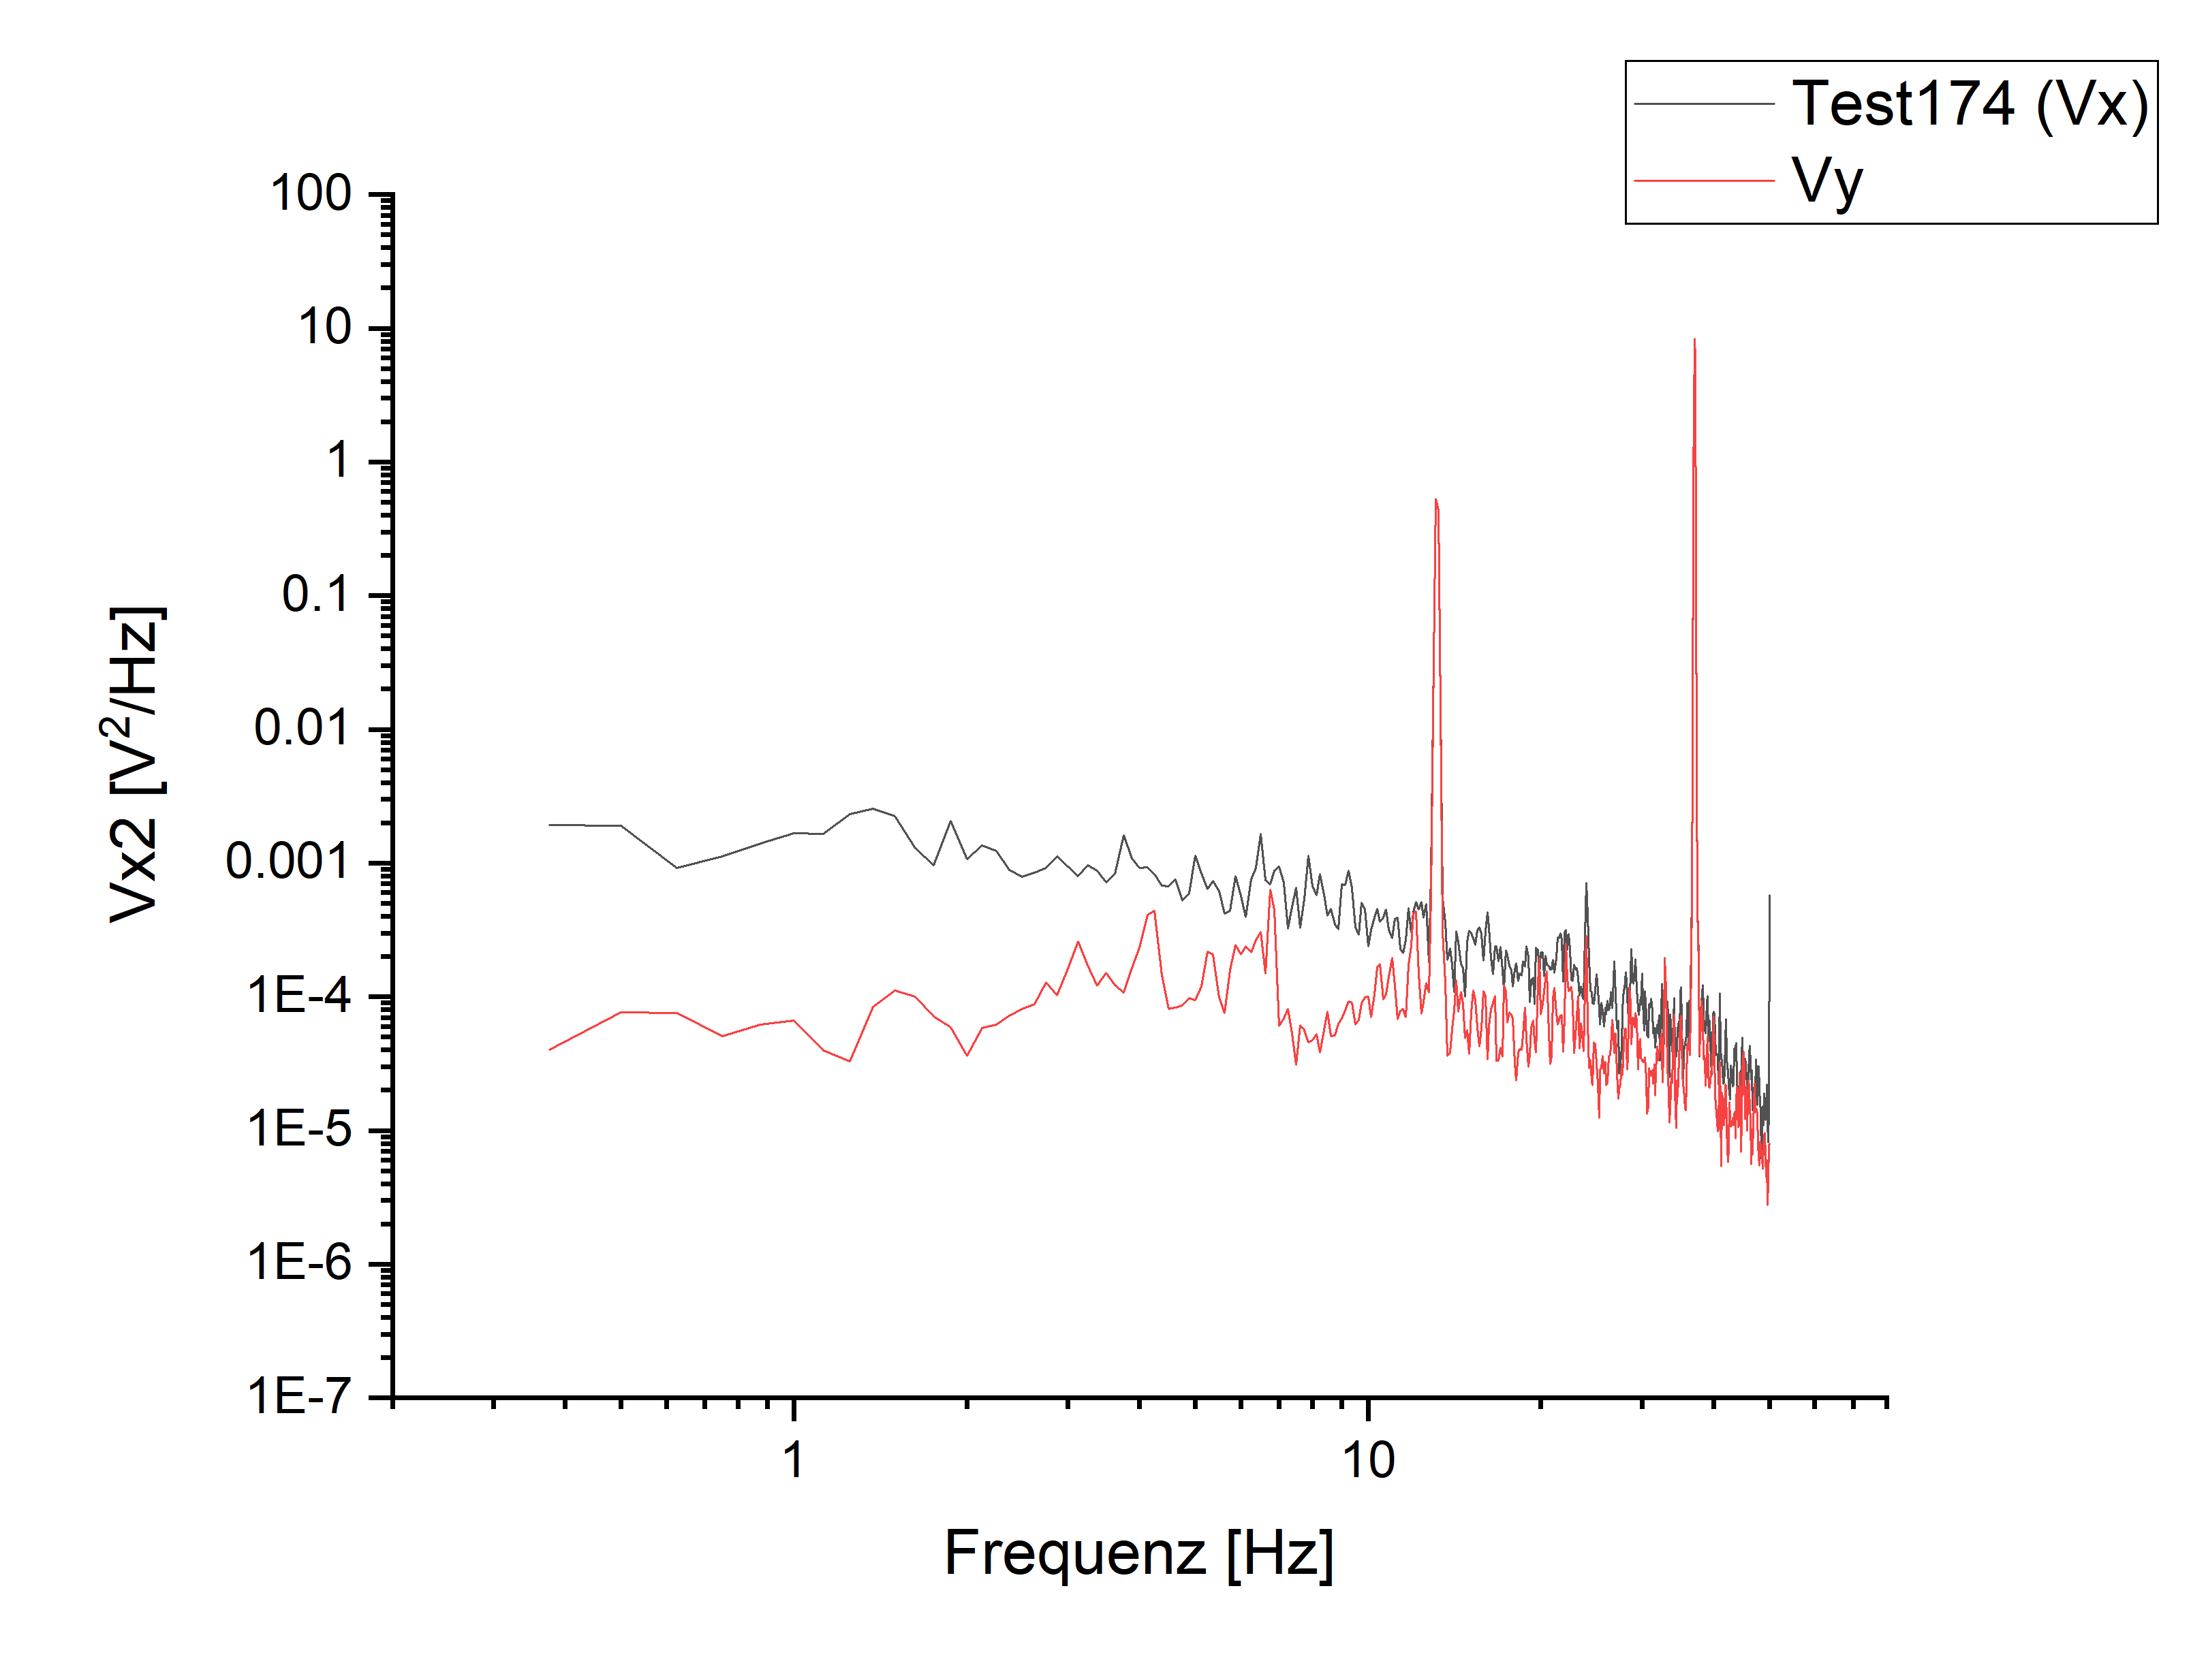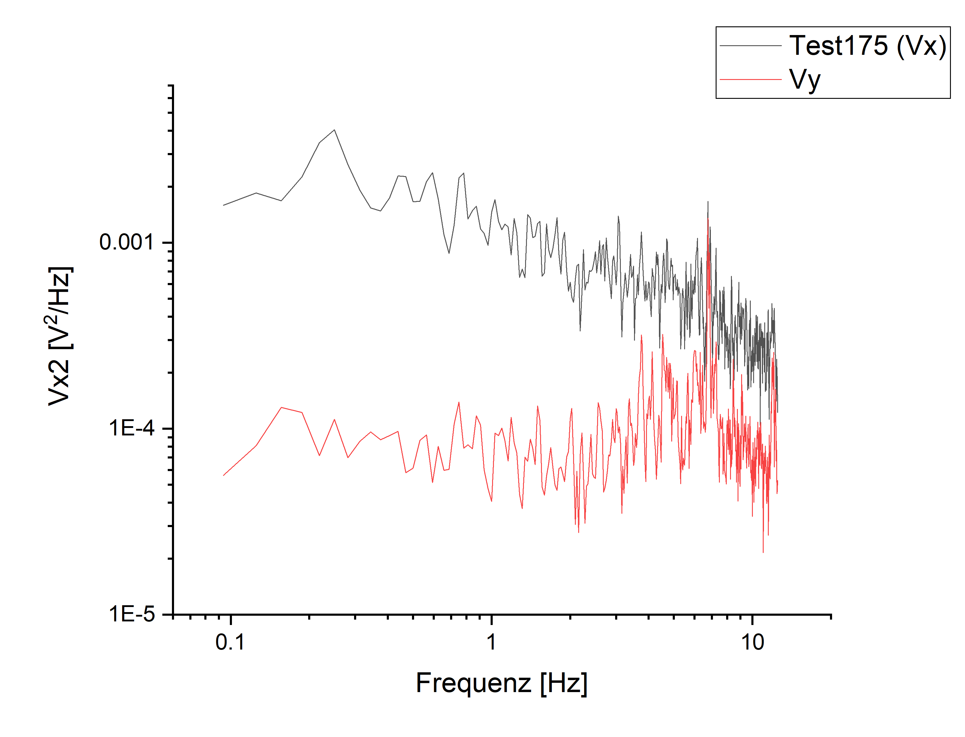

**m115:** PlussesCrossesEmpty\_Parallel Hloop\_(-35)deg

Donnerstag, 28. März 2019

08:49

|  |  |
| --- | --- |
| Float/Ground: | Ground |
| AC/DC: | AC |
| A/A-B: | A-B |
| Reserve: | Normal |
| Source: | Internal |

|  |  |
| --- | --- |
| Angle of sensor θ | *-35* |
|  |  |
|  |  |
|  | |  |  | | --- | --- | |  | *1* | |  | 500 | |
|  | R12 = 40/1000\*50 = |
|  |  |
| *Period of measurement (min)* |  |
| *Notes* |  |
| *Data files* | <<m115\_cros\_plu\_emp\_-35deg\_Hloop\_down\_Parallel\_20190328\_1500\_I-7-14\_GB8-1-13\_GB9-2-12\_GB13-6-8\_Vin-2.5V\_R11-1MO\_C11-1\_C21-6\_T-30K\_SR-1-T-min\_B-1T\_gate-0V\_\_\_\_.dat>>    <<m115\_cros\_plu\_emp\_-35deg\_Hloop\_up\_Parallel\_20190328\_1500\_I-7-14\_GB8-1-13\_GB9-2-12\_GB13-6-8\_Vin-2.5V\_R11-1MO\_C11-1\_C21-6\_T-30K\_SR-1-T-min\_B-1T\_gate-0V\_\_\_\_.dat>> |
| *Plot* |  |

**C: Changing angle (-40)\_after testing the noise measurement setup ??? check later angle 45° to see the right VH(7.515mV)**

Donnerstag, 28. März 2019

15:45

|  |  |
| --- | --- |
| Float/Ground: | Ground |
| AC/DC: | AC |
| A/A-B: | A-B |
| Reserve: | Normal |
| Source: | Internal |

|  |  |
| --- | --- |
| VH(max) (mV) | *11,164* |
| Angle of sensor calculator | **V\_H= Cos(-40)\*11,164 = 8,55212016298027**  **Before changing: 10.940mV ?????? check it? it has been changed after doing noise measurement**  **Measured: 8,551 mV** |
|  |  |
|  |  |
|  | |  |  | | --- | --- | |  | *1* | |
|  |  |
| *Period of measurement* |  |
| *Notes* |  |
| *Data files* |  |
| *Plot* |  |

**m116:** Plusses\_Hloop\_(-40)deg~[47.69°]

Donnerstag, 28. März 2019

15:45



|  |  |
| --- | --- |
| Float/Ground: | Ground |
| AC/DC: | AC |
| A/A-B: | A-B |
| Reserve: | Normal |
| Source: | Internal |

|  |  |
| --- | --- |
| Angle of sensor θ | *-40* |
|  |  |
|  |  |
|  | |  |  | | --- | --- | |  | *0,3* | |  | 10 | |
|  | R12 = 156/1000\*50 = 7,8 |
|  |  |
| *Period of measurement (min)* | *120* |
| *Notes* |  |
| *Data files* | <<m116\_Plusses\_-40deg\_Hloop\_up\_\_Gradio\_20190328\_1600\_I1-2-12\_I2-8-6\_GBIP8-14-7\_Vin-2.5V\_R11-1MO\_R12-7.8kO\_R13-0\_R21-1MO\_C11-1\_C21-6\_T-30K\_SR-0.01-T-min\_B-0.3T\_gate-0V\_up\_\_.dat>>    <<m116\_Plusses\_-40deg\_Hloop\_down\_\_Gradio\_20190328\_1600\_I1-2-12\_I2-8-6\_GBIP8-14-7\_Vin-2.5V\_R11-1MO\_R12-7.8kO\_R13-0\_R21-1MO\_C11-1\_C21-6\_T-30K\_SR-0.01-T-min\_B-0.3T\_gate-0V\_down\_\_.dat>> |
| *Plot* | -300  Up (fitted)  Down (fitted)  -200  Ml 16: Plusses (—40.00  1.0  0.0  100  -100  [mT1  200  300 |

**m117: Crosses\_Hloop\_(-40)deg~[47.69°]**

Donnerstag, 28. März 2019

19:00

|  |  |
| --- | --- |
| Float/Ground: | Ground |
| AC/DC: | AC |
| A/A-B: | A-B |
| Reserve: | Normal |
| Source: | Internal |

|  |  |
| --- | --- |
| Angle of sensor θ | *-40* |
|  |  |
|  |  |
|  | |  |  | | --- | --- | |  | *0.3* | |  | 10 | |
|  | R12 = 128/1000\*50 = 6,4 |
|  |  |
| *Period of measurement (min)* | *120* |
| *Notes* |  |
| *Data files* | <<m117\_Crosses\_-40deg\_Hloop\_down\_\_Gradio\_20190328\_1900\_I1-2-12\_I2-8-6\_GBIP8-14-7\_Vin-2.5V\_R11-1MO\_R12-6.4kO\_R13-0\_R21-1MO\_C11-1\_C21-6\_T-30K\_SR-0.01-T-min\_B-0.3T\_gate-0V\_down\_after noise test\_.dat>>    <<m117\_Crosses\_-40deg\_Hloop\_up\_\_Gradio\_20190328\_1900\_I1-2-12\_I2-8-6\_GBIP8-14-7\_Vin-2.5V\_R11-1MO\_R12-6.4kO\_R13-0\_R21-1MO\_C11-1\_C21-6\_T-30K\_SR-0.01-T-min\_B-0.3T\_gate-0V\_up\_after noise test\_.dat>> |
| *Plot* | 008—  0 ( Ⅱ  0  0  (pauy)  ( J) dn |

**m118:** PlussesCrossesEmpty\_Parallel Hloop\_(-40)deg**~[47.69°]**

Freitag, 29. März 2019

07:12

|  |  |
| --- | --- |
| Float/Ground: | Ground |
| AC/DC: | AC |
| A/A-B: | A-B |
| Reserve: | Normal |
| Source: | Internal |

|  |  |
| --- | --- |
| Angle of sensor θ | *-40* |
|  |  |
|  |  |
|  | |  |  | | --- | --- | |  | *1* | |  | 1000 | |
|  | R12 = 40/1000\*50 = |
|  |  |
| *Period of measurement (min)* |  |
| *Notes* |  |
| *Data files* | <<m118\_cros\_plu\_emp\_-40deg\_Hloop\_up\_Parallel\_20190329\_0700\_I-7-14\_GB8-1-13\_GB9-2-12\_GB13-6-8\_Vin-2.5V\_R11-1MO\_C11-1\_C21-6\_T-30K\_SR-0.5-T-min\_B-1T\_gate-0V\_\_\_\_.dat>>    <<m118\_cros\_plu\_emp\_-40deg\_Hloop\_down\_Parallel\_20190329\_0700\_I-7-14\_GB8-1-13\_GB9-2-12\_GB13-6-8\_Vin-2.5V\_R11-1MO\_C11-1\_C21-6\_T-30K\_SR-0.5-T-min\_B-1T\_gate-0V\_\_\_\_.dat>> |
| *Plot* | MI 18: cros_plu_emp (—40 0  10  5  -10  -15  -1000  Plusses: Up (fitted)  Plusses: Down (fitted)  Crosses: Up (fitted)  Crosses: Down (fitted)  -750  -500  -250  250  500  750  1000 |

**C: Changing angle (-45)deg\_look at VH**

Freitag, 29. März 2019

07:14

|  |  |
| --- | --- |
| Float/Ground: | Ground |
| AC/DC: | AC |
| A/A-B: | A-B |
| Reserve: | Normal |
| Source: | Internal |

|  |  |
| --- | --- |
| VH(max) (mV) | *11,164mV* |
| Angle of sensor calculator | **V\_H= Cos(-45)\*11,164 = 7,894140105166617**  **Before changing the angle: 7.515mV. Note this VH might refer to 47.69°**  **Measured: 7.895mV** |
|  |  |
|  |  |
|  | |  |  | | --- | --- | |  | *1* | |
|  |  |
| *Period of measurement* |  |
| *Notes* |  |
| *Data files* |  |
| *Plot* |  |

**m119:** Plusses\_Hloop\_(-45)deg

Freitag, 29. März 2019

07:17



|  |  |
| --- | --- |
| Float/Ground: | Ground |
| AC/DC: | AC |
| A/A-B: | A-B |
| Reserve: | Normal |
| Source: | Internal |

|  |  |
| --- | --- |
| Angle of sensor θ | *-45* |
|  |  |
|  |  |
|  | |  |  | | --- | --- | |  | *0.25* | |  | 10 | |
|  | R12 = 198/1000\*50 = 9,9 |
|  |  |
| *Period of measurement (min)* | *100* |
| *Notes* |  |
| *Data files* | <<m119\_Plusses\_-45deg\_Hloop\_up\_\_Gradio\_20190329\_0700\_I1-1-13\_I2-8-6\_GBIP8-14-7\_Vin-2.5V\_R11-1MO\_R12-9.9kO\_R13-0\_R21-1MO\_C11-1\_C21-6\_T-30K\_SR-0.01-T-min\_B-0.25T\_gate-0V\_up\_\_.dat>>    <<m119\_Plusses\_-45deg\_Hloop\_down\_\_Gradio\_20190329\_0700\_I1-1-13\_I2-8-6\_GBIP8-14-7\_Vin-2.5V\_R11-1MO\_R12-9.9kO\_R13-0\_R21-1MO\_C11-1\_C21-6\_T-30K\_SR-0.01-T-min\_B-0.25T\_gate-0V\_down\_\_.dat>> |
| *Plot* | Up (fitted)  Down (fitted)  3.0  2.5  2.0  1.5  1.0  0.5  0.0  -200  -100  M 119: Plusses (—45.00)  1.0  0.5  0.0  100  200 |

**m120: Crosses\_Hloop\_(-45)deg**

Freitag, 29. März 2019

10:00

|  |  |
| --- | --- |
| Float/Ground: | Ground |
| AC/DC: | AC |
| A/A-B: | A-B |
| Reserve: | Normal |
| Source: | Internal |

|  |  |
| --- | --- |
| Angle of sensor θ | *-45* |
|  |  |
|  |  |
|  | |  |  | | --- | --- | |  | *0.25* | |  | 10 | |
|  | R12 = 210/1000\*50 = 10,5 |
|  |  |
| *Period of measurement (min)* | *100* |
| *Notes* |  |
| *Data files* | <<m120\_Crosses\_-45deg\_Hloop\_up\_\_Gradio\_20190329\_1000\_I1-2-12\_I2-8-6\_GBIP8-14-7\_Vin-2.5V\_R11-1MO\_R12-10.5kO\_R13-0\_R21-1MO\_C11-1\_C21-6\_T-30K\_SR-0.01-T-min\_B-0.25T\_gate-0V\_up\_.dat>>    <<m120\_Crosses\_-45deg\_Hloop\_down\_\_Gradio\_20190329\_1000\_I1-2-12\_I2-8-6\_GBIP8-14-7\_Vin-2.5V\_R11-1MO\_R12-10.5kO\_R13-0\_R21-1MO\_C11-1\_C21-6\_T-30K\_SR-0.01-T-min\_B-0.25T\_gate-0V\_down\_.dat>> |
| *Plot* | Machine generated alternative text: Ml 20: Crosses (  —45.00)  Up (fitted)  Down (fitted)  3.0  2.5  2.0  1.0  0.5  -200  -100  0.5  -20  100  20  200 |

**m121:** PlussesCrossesEmpty\_Parallel Hloop\_(-45)deg

Freitag, 29. März 2019

11:58

|  |  |
| --- | --- |
| Float/Ground: | Ground |
| AC/DC: | AC |
| A/A-B: | A-B |
| Reserve: | Normal |
| Source: | Internal |

|  |  |
| --- | --- |
| Angle of sensor θ | *-45* |
|  |  |
|  |  |
|  | |  |  | | --- | --- | |  | *1* | |  | 1000 | |
|  | R12 = 40/1000\*50 = |
|  |  |
| *Period of measurement (min)* |  |
| *Notes* |  |
| *Data files* | <<m121\_cros\_plu\_emp\_-45deg\_Hloop\_down\_Parallel\_20190329\_1200\_I-7-14\_GB8-1-13\_GB9-2-12\_GB13-6-8\_Vin-2.5V\_R11-1MO\_C11-1\_C21-6\_T-30K\_SR-0.5-T-min\_B-1T\_gate-0V\_a.dat>>    <<m121\_cros\_plu\_emp\_-45deg\_Hloop\_up\_Parallel\_20190329\_1200\_I-7-14\_GB8-1-13\_GB9-2-12\_GB13-6-8\_Vin-2.5V\_R11-1MO\_C11-1\_C21-6\_T-30K\_SR-0.5-T-min\_B-1T\_gate-0V\_a.dat>> |
| *Plot* |  |

**C: Changing angle (-50)**

Freitag, 29. März 2019

08:49

|  |  |
| --- | --- |
| Float/Ground: | Ground |
| AC/DC: | AC |
| A/A-B: | A-B |
| Reserve: | Normal |
| Source: | Internal |

|  |  |
| --- | --- |
| VH(max) (mV) | *11,164mV* |
| Angle of sensor calculator | **V\_H= Cos(-50)\*11,164 = 7,176080874540525mV**  **Before changing: 7,834 mV**  **Measured: 7,175 mV** |
|  |  |
|  |  |
|  | |  |  | | --- | --- | |  | *1* | |
|  |  |
| *Period of measurement* |  |
| *Notes* |  |
| *Data files* |  |
| *Plot* |  |

**m122:** Plusses\_Hloop\_(-50)deg

Freitag, 29. März 2019

12:00



|  |  |
| --- | --- |
| Float/Ground: | Ground |
| AC/DC: | AC |
| A/A-B: | A-B |
| Reserve: | Normal |
| Source: | Internal |

|  |  |
| --- | --- |
| Angle of sensor θ | *-50* |
|  |  |
|  |  |
|  | |  |  | | --- | --- | |  | *0.2* | |  | 10 | |
|  | R12 = 245/1000\*50 = 12,25 |
|  |  |
| *Period of measurement (min)* | *80* |
| *Notes* |  |
| *Data files* | <<m122\_Plusses\_-50deg\_Hloop\_down\_\_Gradio\_20190329\_1200\_I1-1-13\_I2-8-6\_GBIP8-14-7\_Vin-2.5V\_R11-1MO\_R12-12.25kO\_R13-0\_R21-1MO\_C11-1\_C21-6\_T-30K\_SR-0.01-T-min\_B-0.2T\_gate-0V\_down\_\_.dat>>    <<m122\_Plusses\_-50deg\_Hloop\_up\_\_Gradio\_20190329\_1200\_I1-1-13\_I2-8-6\_GBIP8-14-7\_Vin-2.5V\_R11-1MO\_R12-12.25kO\_R13-0\_R21-1MO\_C11-1\_C21-6\_T-30K\_SR-0.01-T-min\_B-0.2T\_gate-0V\_up\_\_.dat>> |
| *Plot* | 2.5  2.0  1.5  1.0  0.5  0.0  -200  Up (fitted)  Down (fitted)  -150  M122: Plusses  -50  -50.00)  0.5  0.0  50  [mT1  100  150  200  -100 |

**m123: Crosses\_Hloop\_deg(-50)deg**

Dienstag, 19. März 2019

13:47

|  |  |
| --- | --- |
| Float/Ground: | Ground |
| AC/DC: | AC |
| A/A-B: | A-B |
| Reserve: | Normal |
| Source: | Internal |

|  |  |
| --- | --- |
| Angle of sensor θ | *-50* |
|  |  |
|  |  |
|  | |  |  | | --- | --- | |  | *0.2* | |  | 10 | |
|  | R12 = 245/1000\*50 = 12,25 |
|  |  |
| *Period of measurement (min)* | *80* |
| *Notes* |  |
| *Data files* | <<m123\_Crosses\_-50deg\_Hloop\_down\_\_Gradio\_20190329\_1400\_I1-2-12\_I2-8-6\_GBIP8-14-7\_Vin-2.5V\_R11-1MO\_R12-12.25kO\_R13-0\_R21-1MO\_C11-1\_C21-6\_T-30K\_SR-0.01-T-min\_B-0.2T\_gate-0V\_down\_.dat>>    <<m123\_Crosses\_-50deg\_Hloop\_up\_\_Gradio\_20190329\_1400\_I1-2-12\_I2-8-6\_GBIP8-14-7\_Vin-2.5V\_R11-1MO\_R12-12.25kO\_R13-0\_R21-1MO\_C11-1\_C21-6\_T-30K\_SR-0.01-T-min\_B-0.2T\_gate-0V\_up\_.dat>> |
| *Plot* | 00 Ⅰ 一  OGI—  (pauy)  ( J) dn |

**m124:** PlussesCrossesEmpty\_Parallel Hloop\_(-50)deg

Freitag, 29. März 2019

17:30

|  |  |
| --- | --- |
| Float/Ground: | Ground |
| AC/DC: | AC |
| A/A-B: | A-B |
| Reserve: | Normal |
| Source: | Internal |

|  |  |
| --- | --- |
| Angle of sensor θ | *-50* |
|  |  |
|  |  |
|  | |  |  | | --- | --- | |  | *1* | |  | 500 | |
|  | R12 = 40/1000\*50 = |
|  |  |
| *Period of measurement (min)* |  |
| *Notes* |  |
| *Data files* | <<m124\_cros\_plu\_emp\_-50deg\_Hloop\_up\_Parallel\_20190329\_1600\_I-7-14\_GB8-1-13\_GB9-2-12\_GB13-6-8\_Vin-2.5V\_R11-1MO\_C11-1\_C21-6\_T-30K\_SR-0.5-T-min\_B-1T\_gate-0V.dat>>    <<m124\_cros\_plu\_emp\_-50deg\_Hloop\_down\_Parallel\_20190329\_1600\_I-7-14\_GB8-1-13\_GB9-2-12\_GB13-6-8\_Vin-2.5V\_R11-1MO\_C11-1\_C21-6\_T-30K\_SR-0.5-T-min\_B-1T\_gate-0V.dat>> |
| *Plot* |  |

**C: Changing angle (-55)**

Freitag, 29. März 2019

17:30

|  |  |
| --- | --- |
| Float/Ground: | Ground |
| AC/DC: | AC |
| A/A-B: | A-B |
| Reserve: | Normal |
| Source: | Internal |

|  |  |
| --- | --- |
| VH(max) (mV) | *11,164mV* |
| Angle of sensor calculator | **V\_H= Cos(-55)\*11,164 = 6,40340733542308**  **Before changing: 7,165 mV**  **Measured: 6,4025 mV** |
|  |  |
|  |  |
|  | |  |  | | --- | --- | |  | *1* | |
|  |  |
| *Period of measurement* |  |
| *Notes* |  |
| *Data files* |  |
| *Plot* |  |

**m125:** Plusses\_Hloop\_(-55)deg

Freitag, 29. März 2019

17:30



|  |  |
| --- | --- |
| Float/Ground: | Ground |
| AC/DC: | AC |
| A/A-B: | A-B |
| Reserve: | Normal |
| Source: | Internal |

|  |  |
| --- | --- |
| Angle of sensor θ | *-55* |
|  |  |
|  |  |
|  | |  |  | | --- | --- | |  | *0.15* | |  | 10 | |
|  | R12 = 370/1000\*50 = 18,5 |
|  |  |
| *Period of measurement (min)* | *60* |
| *Notes* |  |
| *Data files* | <<m125\_Plusses\_-55deg\_Hloop\_down\_\_Gradio\_20190328\_1600\_I1-1-13\_I2-8-6\_GBIP8-14-7\_Vin-2.5V\_R11-1MO\_R12-18.5kO\_R13-0\_R21-1MO\_C11-1\_C21-6\_T-30K\_SR-0.01-T-min\_B-0.25T\_gate-0V\_down\_\_.dat>>    <<m125\_Plusses\_-55deg\_Hloop\_up\_\_Gradio\_20190328\_1600\_I1-1-13\_I2-8-6\_GBIP8-14-7\_Vin-2.5V\_R11-1MO\_R12-18.5kO\_R13-0\_R21-1MO\_C11-1\_C21-6\_T-30K\_SR-0.01-T-min\_B-0.25T\_gate-0V\_up\_\_.dat>> |
| *Plot* | -55.00)  1.50  1.25  1.00  0.75  0.50  0.25  0.00  -150  Up (fitted)  Down (fitted)  -100  M 125: Plusses (  -50  50  100  100  150 |

**m126: Crosses\_Hloop\_(-55)deg**

Freitag, 29. März 2019

17:30

|  |  |
| --- | --- |
| Float/Ground: | Ground |
| AC/DC: | AC |
| A/A-B: | A-B |
| Reserve: | Normal |
| Source: | Internal |

|  |  |
| --- | --- |
| Angle of sensor θ | *-55* |
|  |  |
|  |  |
|  | |  |  | | --- | --- | |  | *0.15* | |  | 10 | |
|  | R12 = 370/1000\*50 = 18,5 |
|  |  |
| *Period of measurement (min)* | *60* |
| *Notes* |  |
| *Data files* | <<m126\_Crosses\_-55deg\_Hloop\_down\_\_Gradio\_20190328\_1700\_I1-2-12\_I2-8-6\_GBIP8-14-7\_Vin-2.5V\_R11-1MO\_R12-18.5kO\_R13-0\_R21-1MO\_C11-1\_C21-6\_T-30K\_SR-0.01-T-min\_B-0.15T\_gate-0V\_down\_\_.dat>>    <<m126\_Crosses\_-55deg\_Hloop\_up\_\_Gradio\_20190328\_1700\_I1-2-12\_I2-8-6\_GBIP8-14-7\_Vin-2.5V\_R11-1MO\_R12-18.5kO\_R13-0\_R21-1MO\_C11-1\_C21-6\_T-30K\_SR-0.01-T-min\_B-0.15T\_gate-0V\_up\_\_.dat>> |
| *Plot* | OCI  001  001  冖 。 0 | 一 .9ÜIbN  [Jtu]  冖 pauy)  冖 pauy) d n  001 |  FO |

**m127:** PlussesCrossesEmpty\_Parallel Hloop\_(-55)deg

Freitag, 29. März 2019

18:43

|  |  |
| --- | --- |
| Float/Ground: | Ground |
| AC/DC: | AC |
| A/A-B: | A-B |
| Reserve: | Normal |
| Source: | Internal |

|  |  |
| --- | --- |
| Angle of sensor θ | *-55* |
|  |  |
|  |  |
|  | |  |  | | --- | --- | |  | *1* | |  | 500 | |
|  | R12 = 40/1000\*50 = |
|  |  |
| *Period of measurement (min)* |  |
| *Notes* |  |
| *Data files* | <<m127\_cros\_plu\_emp\_-55deg\_Hloop\_down\_Parallel\_20190329\_1900\_I-7-14\_GB8-1-13\_GB9-2-12\_GB13-6-8\_Vin-2.5V\_R11-1MO\_C11-1\_C21-6\_T-30K\_SR-0.5-T-min\_B-1T\_gate-0V\_.dat>>    <<m127\_cros\_plu\_emp\_-55deg\_Hloop\_up\_Parallel\_20190329\_1900\_I-7-14\_GB8-1-13\_GB9-2-12\_GB13-6-8\_Vin-2.5V\_R11-1MO\_C11-1\_C21-6\_T-30K\_SR-0.5-T-min\_B-1T\_gate-0V\_.dat>> |
| *Plot* |  |

**C: Changing angle (-60)**

Freitag, 29. März 2019

18:46

|  |  |
| --- | --- |
| Float/Ground: | Ground |
| AC/DC: | AC |
| A/A-B: | A-B |
| Reserve: | Normal |
| Source: | Internal |

|  |  |
| --- | --- |
| VH(max) (mV) | *11,164mV* |
| Angle of sensor calculator | **V\_H= Cos(-60)\*11,164 = 5,582000000000001**  **Before changing:6.372mv**  **Measured:5.581mV** |
|  |  |
|  |  |
|  | |  |  | | --- | --- | |  | *1* | |
|  |  |
| *Period of measurement* |  |
| *Notes* |  |
| *Data files* |  |
| *Plot* |  |

**m128:** Plusses\_Hloop\_deg(-60)

Freitag, 29. März 2019

18:47



|  |  |
| --- | --- |
| Float/Ground: | Ground |
| AC/DC: | AC |
| A/A-B: | A-B |
| Reserve: | Normal |
| Source: | Internal |

|  |  |
| --- | --- |
| Angle of sensor θ | *-60* |
|  |  |
|  |  |
|  | |  |  | | --- | --- | |  | *0.25* | |  | 10 | |
|  | R12 =235/1000\*50=11.75 |
|  |  |
| *Period of measurement (min)* | *80* |
| *Notes* |  |
| *Data files* | <<m128\_Plusses\_-60deg\_Hloop\_up\_\_Gradio\_20190329\_1900\_I1-1-13\_I2-8-6\_GBIP8-14-7\_Vin-2.5V\_R11-1MO\_R12-11.75kO\_R13-0\_R21-1MO\_C11-1\_C21-6\_T-30K\_SR-0.01-T-min\_B-0.25T\_gate-0V\_up\_.dat>>    <<m128\_Plusses\_-60deg\_Hloop\_down\_\_Gradio\_20190329\_1900\_I1-1-13\_I2-8-6\_GBIP8-14-7\_Vin-2.5V\_R11-1MO\_R12-11.75kO\_R13-0\_R21-1MO\_C11-1\_C21-6\_T-30K\_SR-0.01-T-min\_B-0.25T\_gate-0V\_down\_\_.dat>> |
| *Plot* | M 128: Plusses (  -60.00)  2.5  2.0  1.5  1.0  0.5  0.0  Up (fitted)  Down (fitted)  -200  -100  0.5  0.0  100  200 |

**m129: Crosses\_Hloop\_deg(-60)**

Freitag, 29. März 2019

08:49

|  |  |
| --- | --- |
| Float/Ground: | Ground |
| AC/DC: | AC |
| A/A-B: | A-B |
| Reserve: | Normal |
| Source: | Internal |

|  |  |
| --- | --- |
| Angle of sensor θ | *-60* |
|  |  |
|  |  |
|  | |  |  | | --- | --- | |  | *0.2 5* | |  | 10 | |
|  | R12 = 220/1000\*50 = 11 |
|  |  |
| *Period of measurement (min)* | *80* |
| *Notes* |  |
| *Data files* | <<m129\_Crosses\_-60deg\_Hloop\_down\_\_Gradio\_20190329\_2100\_I1-2-12\_I2-8-6\_GBIP8-14-7\_Vin-2.5V\_R11-1MO\_R12-11kO\_R13-0\_R21-1MO\_C11-1\_C21-6\_T-30K\_SR-0.01-T-min\_B-0.25T\_gate-0V\_down\_\_.dat>>    <<m129\_Crosses\_-60deg\_Hloop\_up\_\_Gradio\_20190329\_2100\_I1-2-12\_I2-8-6\_GBIP8-14-7\_Vin-2.5V\_R11-1MO\_R12-11kO\_R13-0\_R21-1MO\_C11-1\_C21-6\_T-30K\_SR-0.01-T-min\_B-0.25T\_gate-0V\_up\_\_.dat>> |
| *Plot* | 砬 (mT) |

**m130:** PlussesCrossesEmpty\_Parallel Hloop\_(-60)deg

Samstag, 30. März 2019

08:39

|  |  |
| --- | --- |
| Float/Ground: | Ground |
| AC/DC: | AC |
| A/A-B: | A-B |
| Reserve: | Normal |
| Source: | Internal |

|  |  |
| --- | --- |
| Angle of sensor θ | *-60* |
|  |  |
|  |  |
|  | |  |  | | --- | --- | |  | *1* | |  | 1000 | |
|  | R12 = 40/1000\*50 = |
|  |  |
| *Period of measurement (min)* |  |
| *Notes* |  |
| *Data files* | <<m130\_cros\_plu\_emp\_-60deg\_Hloop\_down\_Parallel\_20190330\_0800\_I-7-14\_GB8-1-13\_GB9-2-12\_GB13-6-8\_Vin-2.5V\_R11-1MO\_C11-1\_C21-6\_T-30K\_SR-0.5-T-min\_B-1T\_gate-0V\_.dat>>    <<m130\_cros\_plu\_emp\_-60deg\_Hloop\_up\_Parallel\_20190330\_0800\_I-7-14\_GB8-1-13\_GB9-2-12\_GB13-6-8\_Vin-2.5V\_R11-1MO\_C11-1\_C21-6\_T-30K\_SR-0.5-T-min\_B-1T\_gate-0V\_.dat>> |
| *Plot* |  |

**C: Changing angle (-65)**

Samstag, 30. März 2019

08:40

|  |  |
| --- | --- |
| Float/Ground: | Ground |
| AC/DC: | AC |
| A/A-B: | A-B |
| Reserve: | Normal |
| Source: | Internal |

|  |  |
| --- | --- |
| VH(max) (mV) | *11,164mV* |
| Angle of sensor calculator | **V\_H= Cos(-65)\*11,164 = 4,718110274073169 Before changing: 5.436mV**  **Measured:4.719mV** |
|  |  |
|  |  |
|  | |  |  | | --- | --- | |  | *1* | |
|  |  |
| *Period of measurement* |  |
| *Notes* |  |
| *Data files* |  |
| *Plot* |  |

**m131:** Plusses\_Hloop\_(-65)deg

Samstag, 30. März 2019

08:51



|  |  |
| --- | --- |
| Float/Ground: | Ground |
| AC/DC: | AC |
| A/A-B: | A-B |
| Reserve: | Normal |
| Source: | Internal |

|  |  |
| --- | --- |
| Angle of sensor θ | *-65* |
|  |  |
|  |  |
|  | |  |  | | --- | --- | |  | *0.35* | |  | 10 | |
|  | R12 = 165/1000\*50 = 8,25 |
|  |  |
| *Period of measurement (min)* | *140* |
| *Notes* |  |
| *Data files* | <<m131\_Plusses\_-65deg\_Hloop\_down\_\_Gradio\_20190330\_0900\_I1-1-13\_I2-8-6\_GBIP8-14-7\_Vin-2.5V\_R11-1MO\_R12-8.25kO\_R13-0\_R21-1MO\_C11-1\_C21-6\_T-30K\_SR-0.01-T-min\_B-0.35T\_gate-0V\_down\_\_.dat>>    <<m131\_Plusses\_-65deg\_Hloop\_up\_\_Gradio\_20190330\_0900\_I1-1-13\_I2-8-6\_GBIP8-14-7\_Vin-2.5V\_R11-1MO\_R12-8.25kO\_R13-0\_R21-1MO\_C11-1\_C21-6\_T-30K\_SR-0.01-T-min\_B-0.35T\_gate-0V\_up\_\_.dat>> |
| *Plot* | Machine generated alternative text: Plusses  3.0  2.5  2.0  1.0  0.5  Up (fitted)  Down (fitted)  -300  -200  M131:  -100  (-65.00)  1.0  0.5  20  100  200  20  300 |

**m132: Crosses\_Hloop\_(-65)deg**

Samstag, 30. März 2019

11:00

|  |  |
| --- | --- |
| Float/Ground: | Ground |
| AC/DC: | AC |
| A/A-B: | A-B |
| Reserve: | Normal |
| Source: | Internal |

|  |  |
| --- | --- |
| Angle of sensor θ | *-65* |
|  |  |
|  |  |
|  | |  |  | | --- | --- | |  | *0.35* | |  | 10 | |
|  | R12 = 135/1000\*50 = 6,75 |
|  |  |
| *Period of measurement (min)* | *140* |
| *Notes* |  |
| *Data files* | <<m132\_Crosses\_-65deg\_Hloop\_down\_\_Gradio\_20190330\_1100\_I1-2-12\_I2-8-6\_GBIP8-14-7\_Vin-2.5V\_R11-1MO\_R12-6.75kO\_R13-0\_R21-1MO\_C11-1\_C21-6\_T-30K\_SR-0.01-T-min\_B-0.35T\_gate-0V\_down\_\_.dat>>    <<m132\_Crosses\_-65deg\_Hloop\_up\_\_Gradio\_20190330\_1100\_I1-2-12\_I2-8-6\_GBIP8-14-7\_Vin-2.5V\_R11-1MO\_R12-6.75kO\_R13-0\_R21-1MO\_C11-1\_C21-6\_T-30K\_SR-0.01-T-min\_B-0.35T\_gate-0V\_up\_\_.dat>> |
| *Plot* | M 132: Crosses (  -65.00)  2.5  2.0  1.0  0.5  0.0  Up (fitted)  Down (fitted)  -300  -200  -100  0.50  0.00  100  200  300 |

**m133:** PlussesCrossesEmpty\_Parallel Hloop\_(-65)deg

Samstag, 30. März 2019

15:09

|  |  |
| --- | --- |
| Float/Ground: | Ground |
| AC/DC: | AC |
| A/A-B: | A-B |
| Reserve: | Normal |
| Source: | Internal |

|  |  |
| --- | --- |
| Angle of sensor θ | *-65* |
|  |  |
|  |  |
|  | |  |  | | --- | --- | |  | *1* | |  | 1000 | |
|  | R12 = 40/1000\*50 = |
|  |  |
| *Period of measurement (min)* |  |
| *Notes* |  |
| *Data files* | <<m133\_cros\_plu\_emp\_-65deg\_Hloop\_down\_Parallel\_20190330\_1500\_I-7-14\_GB8-1-13\_GB9-2-12\_GB13-6-8\_Vin-2.5V\_R11-1MO\_C11-1\_C21-6\_T-30K\_SR-0.5-T-min\_B-1T\_gate-0V\_\_.dat>>    <<m133\_cros\_plu\_emp\_-65deg\_Hloop\_up\_Parallel\_20190330\_1500\_I-7-14\_GB8-1-13\_GB9-2-12\_GB13-6-8\_Vin-2.5V\_R11-1MO\_C11-1\_C21-6\_T-30K\_SR-0.5-T-min\_B-1T\_gate-0V\_\_.dat>> |
| *Plot* | 0.5  0.0  -Ä -0.5  -1.0  -1.5  -2.0  -2.5  -1000  • (titted)  Crosses: Up (fitted)  Crosses: Down (fitted)  -750  -500  -250  250  goHext [mn  500  750  1000 |

**C: Changing angle (-70)**

Samstag, 30. März 2019

15:09

|  |  |
| --- | --- |
| Float/Ground: | Ground |
| AC/DC: | AC |
| A/A-B: | A-B |
| Reserve: | Normal |
| Source: | Internal |

|  |  |
| --- | --- |
| VH(max) (mV) | *11,164mV* |
| Angle of sensor calculator | **V\_H= Cos(-70)\*11,164 = 3,818312880087767 mv**  **Before changing:4.712mV**  **Measured: 3.816mV** |
|  |  |
|  |  |
|  | |  |  | | --- | --- | |  | *1* | |
|  |  |
| *Period of measurement* |  |
| *Notes* |  |
| *Data files* |  |
| *Plot* |  |

**m134:** Plusses\_Hloop\_deg(-70)

Samstag, 30. März 2019

15:10



|  |  |
| --- | --- |
| Float/Ground: | Ground |
| AC/DC: | AC |
| A/A-B: | A-B |
| Reserve: | Normal |
| Source: | Internal |

|  |  |
| --- | --- |
| Angle of sensor θ | *-70* |
|  |  |
|  |  |
|  | |  |  | | --- | --- | |  | *0.35* | |  | 10 | |
|  | R12 = 188/1000\*50 = 9,4 |
|  |  |
| *Period of measurement (min)* | *140* |
| *Notes* |  |
| *Data files* | <<m134\_Plusses\_-70deg\_Hloop\_up\_\_Gradio\_20190330\_1500\_I1-1-13\_I2-8-6\_GBIP8-14-7\_Vin-2.5V\_R11-1MO\_R12-9.4kO\_R13-0\_R21-1MO\_C11-1\_C21-6\_T-30K\_SR-0.01-T-min\_B-0.35T\_gate-0V\_up\_\_.dat>>    <<m134\_Plusses\_-70deg\_Hloop\_down\_\_Gradio\_20190330\_1500\_I1-1-13\_I2-8-6\_GBIP8-14-7\_Vin-2.5V\_R11-1MO\_R12-9.4kO\_R13-0\_R21-1MO\_C11-1\_C21-6\_T-30K\_SR-0.01-T-min\_B-0.35T\_gate-0V\_down\_\_.dat>> |
| *Plot* | 2.5  Up (fitted)  Down (fitted)  2.0  22 1.0  0.5  0.0  -300  -200  M 134: Plusses  -100  (-70.00)  0.5  0.0  100  200  300 |

**m135: Crosses\_Hloop\_deg(-70)**

Dienstag, 2. April 2019

12:30

|  |  |
| --- | --- |
| Float/Ground: | Ground |
| AC/DC: | AC |
| A/A-B: | A-B |
| Reserve: | Normal |
| Source: | Internal |

|  |  |
| --- | --- |
| Angle of sensor θ | *-70* |
|  |  |
|  |  |
|  | |  |  | | --- | --- | |  | *0,35* | |  | 10 | |
|  | R12 = 130/1000\*50 = 6,5 |
|  |  |
| *Period of measurement (min)* | *140* |
| *Notes* | *Hysteresis didn't close. Going to 0.5 T and repeating with same settings.* |
| *Data files* | <<m135\_Crosses\_-70deg\_Hloop\_down\_\_Gradio\_20190402\_1200\_I1-2-12\_I2-8-6\_GBIP8-14-7\_Vin-2.5V\_R11-1MO\_R12-6.5kO\_R13-0\_R21-1MO\_C11-1\_C21-6\_T-30K\_SR-0.01-T-min\_B-0.35T\_gate-0V\_down\_\_.dat>>    <<m135\_Crosses\_-70deg\_Hloop\_up\_\_Gradio\_20190402\_1200\_I1-2-12\_I2-8-6\_GBIP8-14-7\_Vin-2.5V\_R11-1MO\_R12-6.5kO\_R13-0\_R21-1MO\_C11-1\_C21-6\_T-30K\_SR-0.01-T-min\_B-0.35T\_gate-0V\_up\_\_.dat>> |
| *Plot* | Computergenerierter Alternativtext: o n00020  o n00018  o n00016  o n00014  o n00012  o n00010  o n00008  o nooooa  o n00004  o n00002  Magnetic feld (Tl |

**m136: Crosses\_Hloop\_deg(-70) repeat \w 0.5T**

Dienstag, 2. April 2019

12:30

|  |  |
| --- | --- |
| Float/Ground: | Ground |
| AC/DC: | AC |
| A/A-B: | A-B |
| Reserve: | Normal |
| Source: | Internal |

|  |  |
| --- | --- |
| Angle of sensor θ | *-70* |
|  |  |
|  |  |
|  | |  |  | | --- | --- | |  | *0,5* | |  | 10 | |
|  | R12 = 130/1000\*50 = 6,5 |
|  |  |
| *Period of measurement (min)* | *200* |
| *Notes* |  |
| *Data files* | <<m136\_Crosses\_-70deg\_Hloop\_down\_\_Gradio\_20190402\_1500\_I1-2-12\_I2-8-6\_GBIP8-14-7\_Vin-2.5V\_R11-1MO\_R12-6.5kO\_R13-0\_R21-1MO\_C11-1\_C21-6\_T-30K\_SR-0.01-T-min\_B-0.5T\_gate-0V\_down\_\_.dat>>    <<m136\_Crosses\_-70deg\_Hloop\_up\_\_Gradio\_20190402\_1500\_I1-2-12\_I2-8-6\_GBIP8-14-7\_Vin-2.5V\_R11-1MO\_R12-6.5kO\_R13-0\_R21-1MO\_C11-1\_C21-6\_T-30K\_SR-0.01-T-min\_B-0.5T\_gate-0V\_up\_\_.dat>> |
| *Plot* | 2.0  Up (fitted)  Down (fitted)  1.5  g 1.0  0.5  0.0  -400  M136•. Crosses (-70.00)  0.0  -0.2  -500  -200  [mT1  200  500  250  400 |

**m137:** PlussesCrossesEmpty\_Parallel Hloop\_(-70)deg

Dienstag, 2. April 2019

19:00

|  |  |
| --- | --- |
| Float/Ground: | Ground |
| AC/DC: | AC |
| A/A-B: | A-B |
| Reserve: | Normal |
| Source: | Internal |

|  |  |
| --- | --- |
| Angle of sensor θ |  |
|  |  |
|  |  |
|  | |  |  | | --- | --- | |  | *1* | |  | 1000 | |
|  | R12 = 40/1000\*50 = |
|  |  |
| *Period of measurement (min)* |  |
| *Notes* |  |
| *Data files* | <<m137\_cros\_plu\_emp\_-70deg\_Hloop\_down\_Parallel\_20190402\_1800\_I-7-14\_GB8-1-13\_GB9-2-12\_GB13-6-8\_Vin-2.5V\_R11-1MO\_C11-1\_C21-6\_T-30K\_SR-1-T-min\_B-1T\_gate-0V.dat>>    <<m137\_cros\_plu\_emp\_-70deg\_Hloop\_up\_Parallel\_20190402\_1800\_I-7-14\_GB8-1-13\_GB9-2-12\_GB13-6-8\_Vin-2.5V\_R11-1MO\_C11-1\_C21-6\_T-30K\_SR-1-T-min\_B-1T\_gate-0V.dat>> |
| *Plot* | 1.0  0.5  g 0.0  -0.5  -1.0  -1.5  -1000  M 137: cros_plu_emp (—70.0 0 )  Plusses: Up (fitted)  Plusses: Down (fitted)  Crosses: Up (fitted)  Crosses: Down (fitted)  -750  -500  -250  250  500  750  1000 |

**C: Changing angle (-75)**

Dienstag, 2. April 2019

19:01

|  |  |
| --- | --- |
| Float/Ground: | Ground |
| AC/DC: | AC |
| A/A-B: | A-B |
| Reserve: | Normal |
| Source: | Internal |

|  |  |
| --- | --- |
| VH(max) (mV) | *11,164mV* |
| Angle of sensor calculator | **V\_H= Cos(-75)\*11,164 = 2,889455819524541**  **Before changing: 3,868 mV**  **Measured: 2,8886 mV** |
|  |  |
|  |  |
|  | |  |  | | --- | --- | |  | *1* | |
|  |  |
| *Period of measurement* |  |
| *Notes* |  |
| *Data files* |  |
| *Plot* |  |

**m138:** Plusses\_Hloop\_(-75)deg

Dienstag, 2. April 2019

19:01



|  |  |
| --- | --- |
| Float/Ground: | Ground |
| AC/DC: | AC |
| A/A-B: | A-B |
| Reserve: | Normal |
| Source: | Internal |

|  |  |
| --- | --- |
| Angle of sensor θ | *-75* |
|  |  |
|  |  |
|  | |  |  | | --- | --- | |  | *1* | |  | 10 | |
|  | R12 = 40/1000\*50 = 2 |
|  |  |
| *Period of measurement (min)* | *400* |
| *Notes* |  |
| *Data files* | <<m138\_Plusses\_-75deg\_Hloop\_down\_\_Gradio\_20190402\_1900\_I1-1-13\_I2-8-6\_GBIP8-14-7\_Vin-2.5V\_R11-1MO\_R12-2kO\_R13-0\_R21-1MO\_C11-1\_C21-6\_T-30K\_SR-0.01-T-min\_B-1T\_gate-0V\_down\_\_.dat>>    <<m138\_Plusses\_-75deg\_Hloop\_up\_\_Gradio\_20190402\_1900\_I1-1-13\_I2-8-6\_GBIP8-14-7\_Vin-2.5V\_R11-1MO\_R12-2kO\_R13-0\_R21-1MO\_C11-1\_C21-6\_T-30K\_SR-0.01-T-min\_B-1T\_gate-0V\_up\_\_.dat>> |
| *Plot* | Computergenerierter Alternativtext: Plusses  2.5  2.0  1.5  1.0  0.5  -1000  Up (fitted)  Down (fitted)  -750  -500  M138:  -250  (-75.00)  0.50  0.00  000  250  500  750  100  1000 |

**m139: Crosses\_Hloop\_(-75)deg**

Mittwoch, 3. April 2019

10:00

|  |  |
| --- | --- |
| Float/Ground: | Ground |
| AC/DC: | AC |
| A/A-B: | A-B |
| Reserve: | Normal |
| Source: | Internal |

|  |  |
| --- | --- |
| Angle of sensor θ | *-75* |
|  |  |
|  |  |
|  | |  |  | | --- | --- | |  | *0,5* | |  | 10 | |
|  | R12 = 60/1000\*50 = 3 |
|  |  |
| *Period of measurement (min)* | *200* |
| *Notes* |  |
| *Data files* | <<m139\_Crosses\_-75deg\_Hloop\_down\_\_Gradio\_20190403\_1000\_I1-2-12\_I2-8-6\_GBIP8-14-7\_Vin-2.5V\_R11-1MO\_R12-3kO\_R13-0\_R21-1MO\_C11-1\_C21-6\_T-30K\_SR-0.01-T-min\_B-0.5T\_gate-0V\_down\_\_.dat>>    <<m139\_Crosses\_-75deg\_Hloop\_up\_\_Gradio\_20190403\_1000\_I1-2-12\_I2-8-6\_GBIP8-14-7\_Vin-2.5V\_R11-1MO\_R12-3kO\_R13-0\_R21-1MO\_C11-1\_C21-6\_T-30K\_SR-0.01-T-min\_B-0.5T\_gate-0V\_up\_\_.dat>> |
| *Plot* |  |

**m140: Crosses\_Hloop\_(-75)deg again**

Mittwoch, 3. April 2019

17:20

|  |  |
| --- | --- |
| Float/Ground: | Ground |
| AC/DC: | AC |
| A/A-B: | A-B |
| Reserve: | Normal |
| Source: | Internal |

|  |  |
| --- | --- |
| Angle of sensor θ | *-75* |
|  |  |
|  |  |
|  | |  |  | | --- | --- | |  | *0,5* | |  | 10 | |
|  | R12 = 60/1000\*50 = 3 |
|  |  |
| *Period of measurement (min)* | *200* |
| *Notes* | *Filling Heliox during measurement (14:00 -- 17:20, filling between 15:00 -- 16:00)*  *Exactly the same measurement as 139* |
| *Data files* | <<m140\_Crosses\_-75deg\_Hloop\_down\_\_Gradio\_20190403\_1400\_I1-2-12\_I2-8-6\_GBIP8-14-7\_Vin-2.5V\_R11-1MO\_R12-3kO\_R13-0\_R21-1MO\_C11-1\_C21-6\_T-30K\_SR-0.01-T-min\_B-0.5T\_gate-0V\_down\_\_.dat>>    <<m140\_Crosses\_-75deg\_Hloop\_up\_\_Gradio\_20190403\_1400\_I1-2-12\_I2-8-6\_GBIP8-14-7\_Vin-2.5V\_R11-1MO\_R12-3kO\_R13-0\_R21-1MO\_C11-1\_C21-6\_T-30K\_SR-0.01-T-min\_B-0.5T\_gate-0V\_up\_\_.dat>> |
| *Plot* |  |

139-140 comparison

Samstag, 6. April 2019

10:02

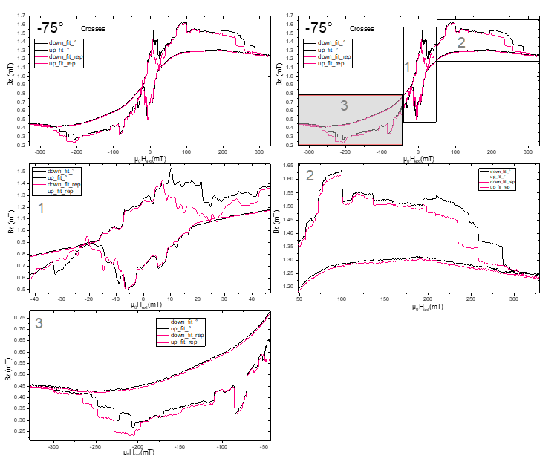

**m141:** PlussesCrossesEmpty\_Parallel Hloop\_(-75)deg

Mittwoch, 3. April 2019

17:24

|  |  |
| --- | --- |
| Float/Ground: | Ground |
| AC/DC: | AC |
| A/A-B: | A-B |
| Reserve: | Normal |
| Source: | Internal |

|  |  |
| --- | --- |
| Angle of sensor θ | *-75* |
|  |  |
|  |  |
|  | |  |  | | --- | --- | |  | *1* | |  | 1000 | |
|  | R12 = 40/1000\*50 = |
|  |  |
| *Period of measurement (min)* |  |
| *Notes* |  |
| *Data files* | <<m141\_cros\_plu\_emp\_-75deg\_Hloop\_up\_Parallel\_20190403\_1700\_I-7-14\_GB8-1-13\_GB9-2-12\_GB13-6-8\_Vin-2.5V\_R11-1MO\_C11-1\_C21-6\_T-30K\_SR-1-T-min\_B-1T\_gate-0V.dat>>    <<m141\_cros\_plu\_emp\_-75deg\_Hloop\_down\_Parallel\_20190403\_1700\_I-7-14\_GB8-1-13\_GB9-2-12\_GB13-6-8\_Vin-2.5V\_R11-1MO\_C11-1\_C21-6\_T-30K\_SR-1-T-min\_B-1T\_gate-0V.dat>> |
| *Plot* |  |

**C: Changing angle (-40) again**

Mittwoch, 3. April 2019

17:25

|  |  |
| --- | --- |
| Float/Ground: | Ground |
| AC/DC: | AC |
| A/A-B: | A-B |
| Reserve: | Normal |
| Source: | Internal |

|  |  |
| --- | --- |
| VH(max) (mV) | *11,164mV* |
| Angle of sensor calculator | **V\_H= Cos(-40)\*11,164 = 8,55212016298027**  **Before changing: 2,818 mV**  **Measured: 8.555 mV** |
|  |  |
|  |  |
|  | |  |  | | --- | --- | |  | *1* | |
|  |  |
| *Period of measurement* |  |
| *Notes* | *We had done this measurment after noise and there was difference in the Hall voltage measured directly after the noise test setup. Next day we have seen that we have measured 47.69° angle.* |
| *Data files* |  |
| *Plot* |  |

**m142:** PlussesCrossesEmpty\_Parallel Hloop\_(-40)deg

Mittwoch, 3. April 2019

18:00

|  |  |
| --- | --- |
| Float/Ground: | Ground |
| AC/DC: | AC |
| A/A-B: | A-B |
| Reserve: | Normal |
| Source: | Internal |

|  |  |
| --- | --- |
| Angle of sensor θ |  |
|  |  |
|  |  |
|  | |  |  | | --- | --- | |  | *1* | |  | 1000 | |
|  | R12 = 40/1000\*50 = |
|  |  |
| *Period of measurement (min)* |  |
| *Notes* |  |
| *Data files* | <<m142\_cros\_plu\_emp\_-40deg\_Hloop\_up\_Parallel\_20190403\_1730\_I-7-14\_GB8-1-13\_GB9-2-12\_GB13-6-8\_Vin-2.5V\_R11-1MO\_C11-1\_C21-6\_T-30K\_SR-1-T-min\_B-1T\_gate-0V.dat>>    <<m142\_cros\_plu\_emp\_-40deg\_Hloop\_down\_Parallel\_20190403\_1730\_I-7-14\_GB8-1-13\_GB9-2-12\_GB13-6-8\_Vin-2.5V\_R11-1MO\_C11-1\_C21-6\_T-30K\_SR-1-T-min\_B-1T\_gate-0V.dat>> |
| *Plot* |  |

**m143:** Plusses\_Hloop\_(-40)deg

Mittwoch, 3. April 2019

19:00



|  |  |
| --- | --- |
| Float/Ground: | Ground |
| AC/DC: | AC |
| A/A-B: | A-B |
| Reserve: | Normal |
| Source: | Internal |

|  |  |
| --- | --- |
| Angle of sensor θ | *-40* |
|  |  |
|  |  |
|  | |  |  | | --- | --- | |  | *1* | |  | 8 | |
|  | R12 = 60/1000\*50 = 3 |
|  |  |
| *Period of measurement (min)* | *500* |
| *Notes* |  |
| *Data files* | <<m143\_Plusses\_-40deg\_Hloop\_up\_\_Gradio\_20190403\_1900\_I1-1-13\_I2-8-6\_GBIP8-14-7\_Vin-2.5V\_R11-1MO\_R12-3kO\_R13-0\_R21-1MO\_C11-1\_C21-6\_T-30K\_SR-0.008-T-min\_B-1T\_gate-0V\_up\_\_.dat>> |
| *Plot* | az(mT) |

<<m143\_Plusses\_-40deg\_Hloop\_down\_\_Gradio\_20190403\_1900\_I1-1-13\_I2-8-6\_GBIP8-14-7\_Vin-2.5V\_R11-1MO\_R12-3kO\_R13-0\_R21-1MO\_C11-1\_C21-6\_T-30K\_SR-0.008-T-min\_B-1T\_gate-0V\_down\_\_.dat>>

**m144:** Plusses\_Hloop\_(-40)deg repeated **for comparison**



Mittwoch, 3. April 2019

19:00

|  |  |
| --- | --- |
| Float/Ground: | Ground |
| AC/DC: | AC |
| A/A-B: | A-B |
| Reserve: | Normal |
| Source: | Internal |

|  |  |
| --- | --- |
| Angle of sensor θ | *-40* |
|  |  |
|  |  |
|  | |  |  | | --- | --- | |  | *1* | |  | 8 | |
|  | R12 = 60/1000\*50 = 3 |
|  |  |
| *Period of measurement (min)* | *500* |
| *Notes* | *Repeated automatically over night with script* |
| *Data files* | <<m144\_Plusses\_-40deg\_Hloop\_up\_\_Gradio\_20190404\_0200\_I1-1-13\_I2-8-6\_GBIP8-14-7\_Vin-2.5V\_R11-1MO\_R12-3kO\_R13-0\_R21-1MO\_C11-1\_C21-6\_T-30K\_SR-0.008-T-min\_B-1T\_gate-0V\_up\_\_.dat>>  <<m144\_Plusses\_-40deg\_Hloop\_down\_\_Gradio\_20190404\_0200\_I1-1-13\_I2-8-6\_GBIP8-14-7\_Vin-2.5V\_R11-1MO\_R12-3kO\_R13-0\_R21-1MO\_C11-1\_C21-6\_T-30K\_SR-0.008-T-min\_B-1T\_gate-0V\_down\_\_.dat>> |
| *Plot* | Both m 143 and m144 (40 0  4.0  3.5  3.0  2.5  2.0  1.5  1.0  0.5  0.0  -100  Up (m143)  Down (ml 43)  Up (m 144)  Down (ml 44)  -75  -50  -25  25  50  75  100 |

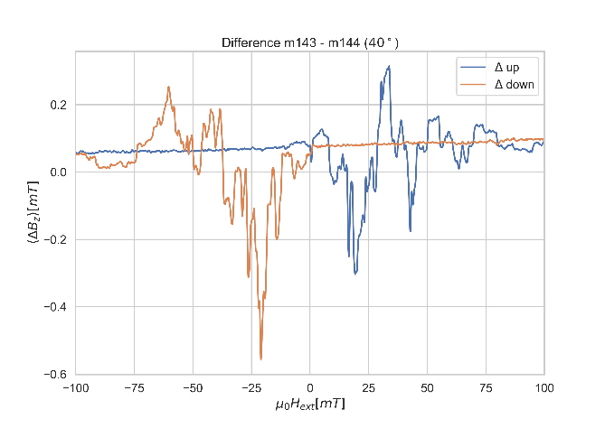

143-144 comparison

07 April 2019

13:19

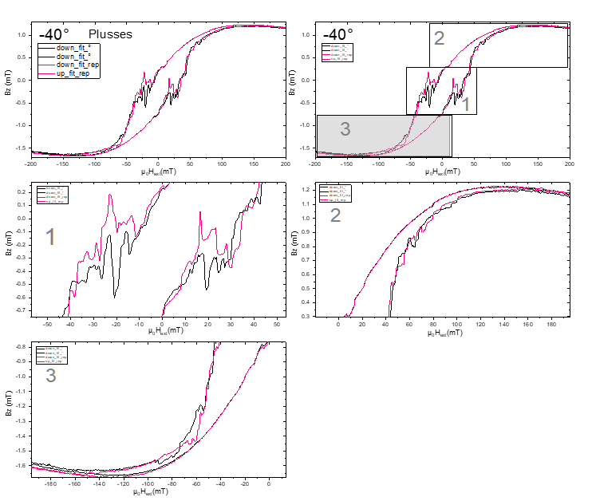<<-40deg\_Hloops\_2run\_plusses.pdf>>

**m145: Crosses\_Hloop\_(-40)deg**

Donnerstag, 4. April 2019

10:00

|  |  |
| --- | --- |
| Float/Ground: | Ground |
| AC/DC: | AC |
| A/A-B: | A-B |
| Reserve: | Normal |
| Source: | Internal |

|  |  |
| --- | --- |
| Angle of sensor θ | *-40* |
|  |  |
|  |  |
|  | |  |  | | --- | --- | |  | *0.4* | |  | 10 | |
|  | R12 = 100/1000\*50 = 5 |
|  |  |
| *Period of measurement (min)* | *160* |
| *Notes* |  |
| *Data files* | <<m145\_Crosses\_-40deg\_Hloop\_down\_\_Gradio\_20190404\_1300\_I1-2-12\_I2-8-6\_GBIP8-14-7\_Vin-2.5V\_R11-1MO\_R12-5kO\_R13-0\_R21-1MO\_C11-1\_C21-6\_T-30K\_SR-0.01-T-min\_B-0.4T\_gate-0V\_down\_\_.dat>>    <<m145\_Crosses\_-40deg\_Hloop\_up\_\_Gradio\_20190404\_1300\_I1-2-12\_I2-8-6\_GBIP8-14-7\_Vin-2.5V\_R11-1MO\_R12-5kO\_R13-0\_R21-1MO\_C11-1\_C21-6\_T-30K\_SR-0.01-T-min\_B-0.4T\_gate-0V\_up\_\_.dat>> |
| *Plot* | Machine generated alternative text: —400  UoHez(mT) |

**m146:** PlussesCrossesEmpty\_Parallel Hloop\_(-40)deg

19 March 2019

08:49

|  |  |
| --- | --- |
| Float/Ground: | Ground |
| AC/DC: | AC |
| A/A-B: | A-B |
| Reserve: | Normal |
| Source: | Internal |

|  |  |
| --- | --- |
| Angle of sensor θ | *-40* |
|  |  |
|  |  |
|  | |  |  | | --- | --- | |  | *1* | |  | 1000 | |
|  | R12 = 40/1000\*50 = |
|  |  |
| *Period of measurement (min)* |  |
| *Notes* |  |
| *Data files* | <<m146\_cros\_plu\_emp\_-40deg\_Hloop\_down\_Parallel\_20190404\_1600\_I-7-14\_GB8-1-13\_GB9-2-12\_GB13-6-8\_Vin-2.5V\_R11-1MO\_C11-1\_C21-6\_T-30K\_SR-1-T-min\_B-1T\_gate-0V.dat>>    <<m146\_cros\_plu\_emp\_-40deg\_Hloop\_up\_Parallel\_20190404\_1600\_I-7-14\_GB8-1-13\_GB9-2-12\_GB13-6-8\_Vin-2.5V\_R11-1MO\_C11-1\_C21-6\_T-30K\_SR-1-T-min\_B-1T\_gate-0V.dat>> |
| *Plot* |  |

**C: Changing angle (-80)**

Samstag, 6. April 2019

09:53

|  |  |
| --- | --- |
| Float/Ground: | Ground |
| AC/DC: | AC |
| A/A-B: | A-B |
| Reserve: | Normal |
| Source: | Internal |

|  |  |
| --- | --- |
| VH(max) (mV) | *11,164mV* |
| Angle of sensor calculator | **V\_H= Cos(-80)\*11,164 = 1,938608255473611**  **Before changing: 8.439mV**  **Measured: 1.938mV** |
|  |  |
|  |  |
|  | |  |  | | --- | --- | |  | *1* | |
|  |  |
| *Period of measurement* |  |
| *Notes* |  |
| *Data files* |  |
| *Plot* |  |

**m147:** Plusses\_Hloop\_(-80)deg

Samstag, 6. April 2019

10:09



|  |  |
| --- | --- |
| Float/Ground: | Ground |
| AC/DC: | AC |
| A/A-B: | A-B |
| Reserve: | Normal |
| Source: | Internal |

|  |  |
| --- | --- |
| Angle of sensor θ | *-80* |
|  |  |
|  |  |
|  | |  |  | | --- | --- | |  | *0.5* | |  | 10 | |
|  | R12 = 165/1000\*50 = 8,25 |
|  |  |
| *Period of measurement (min)* |  |
| *Notes* |  |
| *Data files* | <<m147\_Plusses\_-80deg\_Hloop\_up\_\_Gradio\_20190406\_1000\_I1-1-13\_I2-8-6\_GBIP8-14-7\_Vin-2.5V\_R11-1MO\_R12-8.25kO\_R13-0\_R21-1MO\_C11-1\_C21-6\_T-30K\_SR-0.01-T-min\_B-0.5T\_gate-0V\_up\_\_.dat>>    <<m147\_Plusses\_-80deg\_Hloop\_down\_\_Gradio\_20190406\_1000\_I1-1-13\_I2-8-6\_GBIP8-14-7\_Vin-2.5V\_R11-1MO\_R12-8.25kO\_R13-0\_R21-1MO\_C11-1\_C21-6\_T-30K\_SR-0.01-T-min\_B-0.5T\_gate-0V\_down\_\_.dat>> |
| *Plot* | -800 |

**m148:** Plusses\_Hloop\_(-80)deg\_repeated for comparison



Samstag, 6. April 2019

10:09

|  |  |
| --- | --- |
| Float/Ground: | Ground |
| AC/DC: | AC |
| A/A-B: | A-B |
| Reserve: | Normal |
| Source: | Internal |

|  |  |
| --- | --- |
| Angle of sensor θ | *-80* |
|  |  |
|  |  |
|  | |  |  | | --- | --- | |  | *0.5* | |  | 10 | |
|  | R12 = 165/1000\*50 = 8,25 |
|  |  |
| *Period of measurement (min)* |  |
| *Notes* |  |
| *Data files* | <<m148\_Plusses\_-80deg(rep. for compar)\_Hloop\_up\_\_Gradio\_20190406\_1200\_I1-1-13\_I2-8-6\_GBIP8-14-7\_Vin-2.5V\_R11-1MO\_R12-8.25kO\_R13-0\_R21-1MO\_C11-1\_C21-6\_T-30K\_SR-0.01-T-min\_B-0.5T\_gate-0V\_up\_\_.dat>>    <<m148\_Plusses\_-80deg(rep. for compar)\_Hloop\_down\_\_Gradio\_20190406\_1200\_I1-1-13\_I2-8-6\_GBIP8-14-7\_Vin-2.5V\_R11-1MO\_R12-8.25kO\_R13-0\_R21-1MO\_C11-1\_C21-6\_T-30K\_SR-0.01-T-min\_B-0.5T\_gate-0V\_down\_\_.dat>> |
| *Plot* |  |

147-148comparison

Samstag, 6. April 2019

10:02

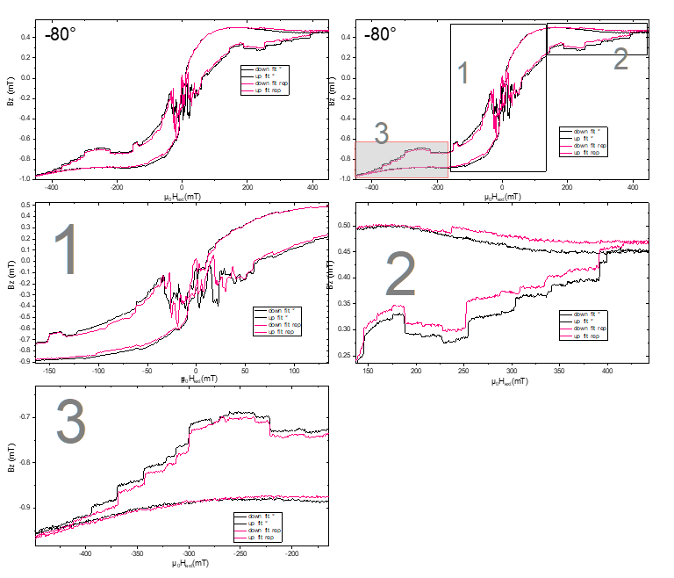

**m149: Crosses\_Hloop\_(-80)deg**

Samstag, 6. April 2019

17:30

|  |  |
| --- | --- |
| Float/Ground: | Ground |
| AC/DC: | AC |
| A/A-B: | A-B |
| Reserve: | Normal |
| Source: | Internal |

|  |  |
| --- | --- |
| Angle of sensor θ | *-80* |
|  |  |
|  |  |
|  | |  |  | | --- | --- | |  | *0.5* | |  | 10 | |
|  | R12 = 75/1000\*50 = 3,75 |
|  |  |
| *Period of measurement (min)* |  |
| *Notes* |  |
| *Data files* | <<m149\_Crosses\_-80deg\_Hloop\_down\_\_Gradio\_20190406\_17000\_I1-2-12\_I2-8-6\_GBIP8-14-7\_Vin-2.5V\_R11-1MO\_R12-3.75kO\_R13-0\_R21-1MO\_C11-1\_C21-6\_T-30K\_SR-0.01-T-min\_B-0.5T\_gate-0V\_down\_\_.dat>>    <<m149\_Crosses\_-80deg\_Hloop\_up\_\_Gradio\_20190406\_17000\_I1-2-12\_I2-8-6\_GBIP8-14-7\_Vin-2.5V\_R11-1MO\_R12-3.75kO\_R13-0\_R21-1MO\_C11-1\_C21-6\_T-30K\_SR-0.01-T-min\_B-0.5T\_gate-0V\_up\_\_.dat>> |
| *Plot* | 008- |

**m150: Crosses\_Hloop\_(-80)deg\_repeated for comparison**

Samstag, 6. April 2019

20:00

|  |  |
| --- | --- |
| Float/Ground: | Ground |
| AC/DC: | AC |
| A/A-B: | A-B |
| Reserve: | Normal |
| Source: | Internal |

|  |  |
| --- | --- |
| Angle of sensor θ | *-80* |
|  |  |
|  |  |
|  | |  |  | | --- | --- | |  | *0.5* | |  | 10 | |
|  | R12 = 40/1000\*50 = |
|  |  |
| *Period of measurement (min)* |  |
| *Notes* |  |
| *Data files* | <<m150\_Crosses\_-80deg(rep. for compar)\_Hloop\_down\_\_Gradio\_20190406\_17000\_I1-2-12\_I2-8-6\_GBIP8-14-7\_Vin-2.5V\_R11-1MO\_R12-3.75kO\_R13-0\_R21-1MO\_C11-1\_C21-6\_T-30K\_SR-0.01-T-min\_B-0.5T\_gate-0V\_down\_\_.dat>>    <<m150\_Crosses\_-80deg(rep. for compar)\_Hloop\_up\_\_Gradio\_20190406\_17000\_I1-2-12\_I2-8-6\_GBIP8-14-7\_Vin-2.5V\_R11-1MO\_R12-3.75kO\_R13-0\_R21-1MO\_C11-1\_C21-6\_T-30K\_SR-0.01-T-min\_B-0.5T\_gate-0V\_up\_\_.dat>> |
| *Plot* |  |

149-150comparison

Samstag, 6. April 2019

10:02

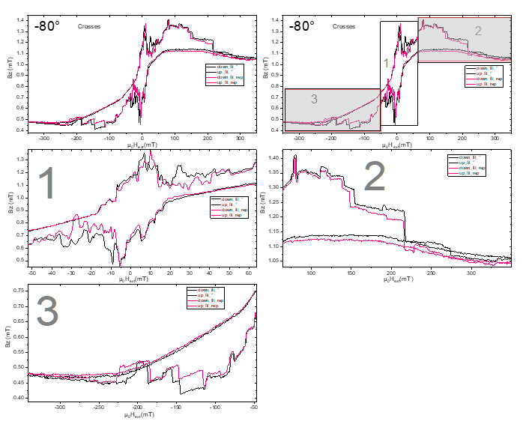

**m151:** PlussesCrossesEmpty\_Parallel Hloop\_(-80)deg

Sonntag, 7. April 2019

01:12

|  |  |
| --- | --- |
| Float/Ground: | Ground |
| AC/DC: | AC |
| A/A-B: | A-B |
| Reserve: | Normal |
| Source: | Internal |

|  |  |
| --- | --- |
| Angle of sensor θ |  |
|  |  |
|  |  |
|  | |  |  | | --- | --- | |  | *1* | |  | 1000 | |
|  | R12 = 40/1000\*50 = |
|  |  |
| *Period of measurement (min)* |  |
| *Notes* |  |
| *Data files* | <<m151\_cros\_plu\_emp\_-80deg\_Hloop\_down\_Parallel\_20190407\_0100\_I-7-14\_GB8-1-13\_GB9-2-12\_GB13-6-8\_Vin-2.5V\_R11-1MO\_C11-1\_C21-6\_T-30K\_SR-1-T-min\_B-1T\_gate-0V.dat>>    <<m151\_cros\_plu\_emp\_-80deg\_Hloop\_up\_Parallel\_20190407\_0100\_I-7-14\_GB8-1-13\_GB9-2-12\_GB13-6-8\_Vin-2.5V\_R11-1MO\_C11-1\_C21-6\_T-30K\_SR-1-T-min\_B-1T\_gate-0V.dat>> |
| *Plot* |  |

**C: Changing angle (-85)\_midnight**

Sonntag, 7. April 2019

01:19

|  |  |
| --- | --- |
| Float/Ground: | Ground |
| AC/DC: | AC |
| A/A-B: | A-B |
| Reserve: | Normal |
| Source: | Internal |

|  |  |
| --- | --- |
| VH(max) (mV) | *11,164mV* |
| Angle of sensor calculator | **V\_H= Cos(-85)\*11,164 = 0,973006712034855**  **Before changing: 2.004mV**  **Measured:0.973mV** |
|  |  |
|  |  |
|  | |  |  | | --- | --- | |  | *1* | |
|  |  |
| *Period of measurement* |  |
| *Notes* |  |
| *Data files* |  |
| *Plot* |  |

**m152:** Plusses\_Hloop\_(-85)deg\_1am morning

Sonntag, 7. April 2019

01:34



|  |  |
| --- | --- |
| Float/Ground: | Ground |
| AC/DC: | AC |
| A/A-B: | A-B |
| Reserve: | Normal |
| Source: | Internal |

|  |  |
| --- | --- |
| Angle of sensor θ | *-85* |
|  |  |
|  |  |
|  | |  |  | | --- | --- | |  | *0.75* | |  | 10 | |
|  | R12 = 150/1000\*50 = 7,5 |
|  |  |
| *Period of measurement (min)* | *300* |
| *Notes* |  |
| *Data files* | <<m152\_Plusses\_-85deg\_Hloop\_down\_\_Gradio\_20190407\_0133\_I1-1-13\_I2-8-6\_GBIP8-14-7\_Vin-2.5V\_R11-1MO\_R12-7.5kO\_R13-0\_R21-1MO\_C11-1\_C21-6\_T-30K\_SR-0.01-T-min\_B-0.75T\_gate-0V\_down\_\_.dat>>    <<m152\_Plusses\_-85deg\_Hloop\_up\_\_Gradio\_20190407\_0133\_I1-1-13\_I2-8-6\_GBIP8-14-7\_Vin-2.5V\_R11-1MO\_R12-7.5kO\_R13-0\_R21-1MO\_C11-1\_C21-6\_T-30K\_SR-0.01-T-min\_B-0.75T\_gate-0V\_up\_\_.dat>> |
| *Plot* | -850  -401 |

**m153: Crosses\_Hloop\_(-85)deg**

Sonntag, 7. April 2019

10:01

|  |  |
| --- | --- |
| Float/Ground: | Ground |
| AC/DC: | AC |
| A/A-B: | A-B |
| Reserve: | Normal |
| Source: | Internal |

|  |  |
| --- | --- |
| Angle of sensor θ | *-85* |
|  |  |
|  |  |
|  | |  |  | | --- | --- | |  | *0.75* | |  | 10 | |
|  | R12 = 80/1000\*50 = 4 |
|  |  |
| *Period of measurement (min)* | *300* |
| *Notes* |  |
| *Data files* | <<m153\_Crosses\_-85deg\_Hloop\_down\_\_Gradio\_20190407\_1000\_I1-2-12\_I2-8-6\_GBIP8-14-7\_Vin-2.5V\_R11-1MO\_R12-4kO\_R13-0\_R21-1MO\_C11-1\_C21-6\_T-30K\_SR-0.01-T-min\_B-0.75T\_gate-0V\_down\_\_.dat>>    <<m153\_Crosses\_-85deg\_Hloop\_up\_\_Gradio\_20190407\_1000\_I1-2-12\_I2-8-6\_GBIP8-14-7\_Vin-2.5V\_R11-1MO\_R12-4kO\_R13-0\_R21-1MO\_C11-1\_C21-6\_T-30K\_SR-0.01-T-min\_B-0.75T\_gate-0V\_up\_\_.dat>> |
| *Plot* | -850 |

**m154:** PlussesCrossesEmpty\_Parallel Hloop\_(-85)deg

Sonntag, 7. April 2019

15:12

|  |  |
| --- | --- |
| Float/Ground: | Ground |
| AC/DC: | AC |
| A/A-B: | A-B |
| Reserve: | Normal |
| Source: | Internal |

|  |  |
| --- | --- |
| Angle of sensor θ | *-85* |
|  |  |
|  |  |
|  | |  |  | | --- | --- | |  | *1* | |  | 1000 | |
|  | R12 = 40/1000\*50 = |
|  |  |
| *Period of measurement (min)* |  |
| *Notes* |  |
| *Data files* | <<m154\_cros\_plu\_emp\_-85deg\_Hloop\_down\_Parallel\_20190407\_1500\_I-7-14\_GB8-1-13\_GB9-2-12\_GB13-6-8\_Vin-2.5V\_R11-1MO\_C11-1\_C21-6\_T-30K\_SR-1-T-min\_B-1T\_gate-0V\_.dat>>    <<m154\_cros\_plu\_emp\_-85deg\_Hloop\_up\_Parallel\_20190407\_1500\_I-7-14\_GB8-1-13\_GB9-2-12\_GB13-6-8\_Vin-2.5V\_R11-1MO\_C11-1\_C21-6\_T-30K\_SR-1-T-min\_B-1T\_gate-0V\_.dat>> |
| *Plot* |  |

**C: Changing angle (-90)**

Sonntag, 7. April 2019

22:15

|  |  |
| --- | --- |
| Float/Ground: | Ground |
| AC/DC: | AC |
| A/A-B: | A-B |
| Reserve: | Normal |
| Source: | Internal |

|  |  |
| --- | --- |
| VH(max) (mV) | *11,164mV* |
| Angle of sensor calculator | **V\_H= Cos(-90)\*11,164 = 0**  **Before changing:0.9878mv**  **Measured: -0.0009mV** |
|  |  |
|  |  |
|  | |  |  | | --- | --- | |  | *1* | |
|  |  |
| *Period of measurement* |  |
| *Notes* |  |
| *Data files* |  |
| *Plot* |  |

**m155:** PlussesCrossesEmpty\_Parallel Hloop\_(-90)deg\_10mT/min

Sonntag, 7. April 2019

22:15

|  |  |
| --- | --- |
| Float/Ground: | Ground |
| AC/DC: | AC |
| A/A-B: | A-B |
| Reserve: | Normal |
| Source: | Internal |

|  |  |
| --- | --- |
| Angle of sensor θ | *-90* |
|  |  |
|  |  |
|  | |  |  | | --- | --- | |  | *1* | |  | 10 | |
|  | R12 = 40/1000\*50 = |
|  |  |
| *Period of measurement (min)* |  |
| *Notes* |  |
| *Data files* | <<m155\_cros\_plu\_emp\_-90deg\_Hloop\_up\_Parallel\_20190407\_1500\_I-7-14\_GB8-1-13\_GB9-2-12\_GB13-6-8\_Vin-2.5V\_R11-1MO\_C11-1\_C21-6\_T-30K\_SR-10-T-min\_B-1T\_gate-0V\_b\_.dat>>    <<m155\_cros\_plu\_emp\_-90deg\_Hloop\_down\_Parallel\_20190407\_1500\_I-7-14\_GB8-1-13\_GB9-2-12\_GB13-6-8\_Vin-2.5V\_R11-1MO\_C11-1\_C21-6\_T-30K\_SR-10-T-min\_B-1T\_gate-0V\_a\_.dat>> |
| *Plot*  Machine generated alternative text: -900  N 12  -40  poi--Vr(mT) | Machine generated alternative text: -900  -400  poi--Vr(mT) |

Final picture of the angles (Plusses)

09 April 2019

14:01

<<NegHloopP.pdf>>

<<PosHloopP.pdf>>

Final picture of the angles (Crosses)

09 April 2019

14:01

<<PosHloopC.pdf>>

<<NegHloopC.pdf>>

:

10 April 2019

17:38



|  |  |
| --- | --- |
| (1) Structures measured |  |

|  |  |
| --- | --- |
| **(2) Measurement type** | Hloop\_gradiometry |
|  |  |
|  |  |
|  |  |

**(3) Cables Setup:**

|  |  |  |
| --- | --- | --- |
|  |  |  |
|  |  |  |
|  |  |  |
| Gate (9) |  |  |

**(4) Magnet Setup:**

|  |  |
| --- | --- |
| Range: |  |
| Rate: |  |

**(5) Experiment Setup:**

|  |  |
| --- | --- |
| T |  |
|  |  |
|  | 1 MΩ |
|  | 0 |
|  | 0 |
|  | 1 MΩ |
|  | μA |
|  | μA |
|  | 0 |
|  |  |

**(8) Filename and data:**

**(6) Lock-In Setup:**

|  |  |
| --- | --- |
| Sens: | 20 μV |
| τ: | 1s |
| Float/Ground: | Ground |
| AC/DC: | AC |
| A/A-B: | A-B |
| Reserve: | Normal |
| Source: | Internal |

**(7) Important Notes:**

**m408:** PlussesCrossesEmpty\_Parallel Hloop\_(90)deg\_10mT/min

Montag, 2. März 2020

09:58

|  |  |
| --- | --- |
| Float/Ground: | Ground |
| AC/DC: | AC |
| A/A-B: | A-B |
| Reserve: | Normal |
| Source: | Internal |

|  |  |
| --- | --- |
| Angle of sensor θ | *90* |
|  |  |
|  |  |
|  | |  |  | | --- | --- | |  | *1* | |  | 10 | |
|  | R12 = 40/1000\*50 = |
|  |  |
| *Period of measurement (min)* |  |
| *Notes* | *Temperature not stabilized during up sweep* |
| *Data files* |  |
| *Plot* |  |

**m409:** PlussesCrossesEmpty\_Parallel Hloop\_(90)deg\_10mT/min

Montag, 2. März 2020

10:00

|  |  |
| --- | --- |
| Float/Ground: | Ground |
| AC/DC: | AC |
| A/A-B: | A-B |
| Reserve: | Normal |
| Source: | Internal |

|  |  |
| --- | --- |
| Angle of sensor θ | *90* |
|  |  |
|  |  |
|  | |  |  | | --- | --- | |  | *1* | |  | 10 | |
|  | R12 = 40/1000\*50 = |
|  |  |
| *Period of measurement (min)* |  |
| *Notes* |  |
| *Data files* |  |
| *Plot* |  |

**Change Angle 90: m410:** ParallelFast Hloop\_(90)deg\_300mT/min

Montag, 2. März 2020

10:01

|  |  |
| --- | --- |
| Float/Ground: | Ground |
| AC/DC: | AC |
| A/A-B: | A-B |
| Reserve: | Normal |
| Source: | Internal |

|  |  |
| --- | --- |
| Angle of sensor θ | *90* |
|  |  |
|  |  |
|  | |  |  | | --- | --- | |  | *1* | |  | 300 | |
|  | R12 = 40/1000\*50 = |
|  |  |
| *Period of measurement (min)* |  |
| *Notes* | *Fast sweep after rebalancing Angle to zero! (Signal now max. ±15 μV instead of ± 200)* |
| *Data files* |  |
| *Plot* |  |

**m411:** PlussesCrossesEmpty\_Parallel Hloop\_(90)deg\_10mT/min

Montag, 2. März 2020

10:03

|  |  |
| --- | --- |
| Float/Ground: | Ground |
| AC/DC: | AC |
| A/A-B: | A-B |
| Reserve: | Normal |
| Source: | Internal |

|  |  |
| --- | --- |
| Angle of sensor θ | *90* |
|  |  |
|  |  |
|  | |  |  | | --- | --- | |  | *1* | |  | 10 | |
|  | R12 = 40/1000\*50 = |
|  |  |
| *Period of measurement (min)* |  |
| *Notes* | *Only up sweep before filling Cryostat! After Filling Signal changed.* |
| *Data files* |  |
| *Plot* |  |

**Change Angle 90: m412/413:** ParallelFast Hloop\_(90)deg\_300mT/min

Montag, 2. März 2020

10:05

|  |  |
| --- | --- |
| Float/Ground: | Ground |
| AC/DC: | AC |
| A/A-B: | A-B |
| Reserve: | Normal |
| Source: | Internal |

|  |  |
| --- | --- |
| Angle of sensor θ | *90* |
|  |  |
|  |  |
|  | |  |  | | --- | --- | |  | *1* | |  | 300 | |
|  | R12 = 40/1000\*50 = |
|  |  |
| *Period of measurement (min)* |  |
| *Notes* | *Changing Angle after filling because signal changed!* |
| *Data files* |  |
| *Plot* |  |

**Compare m414-419** Repeated measurements

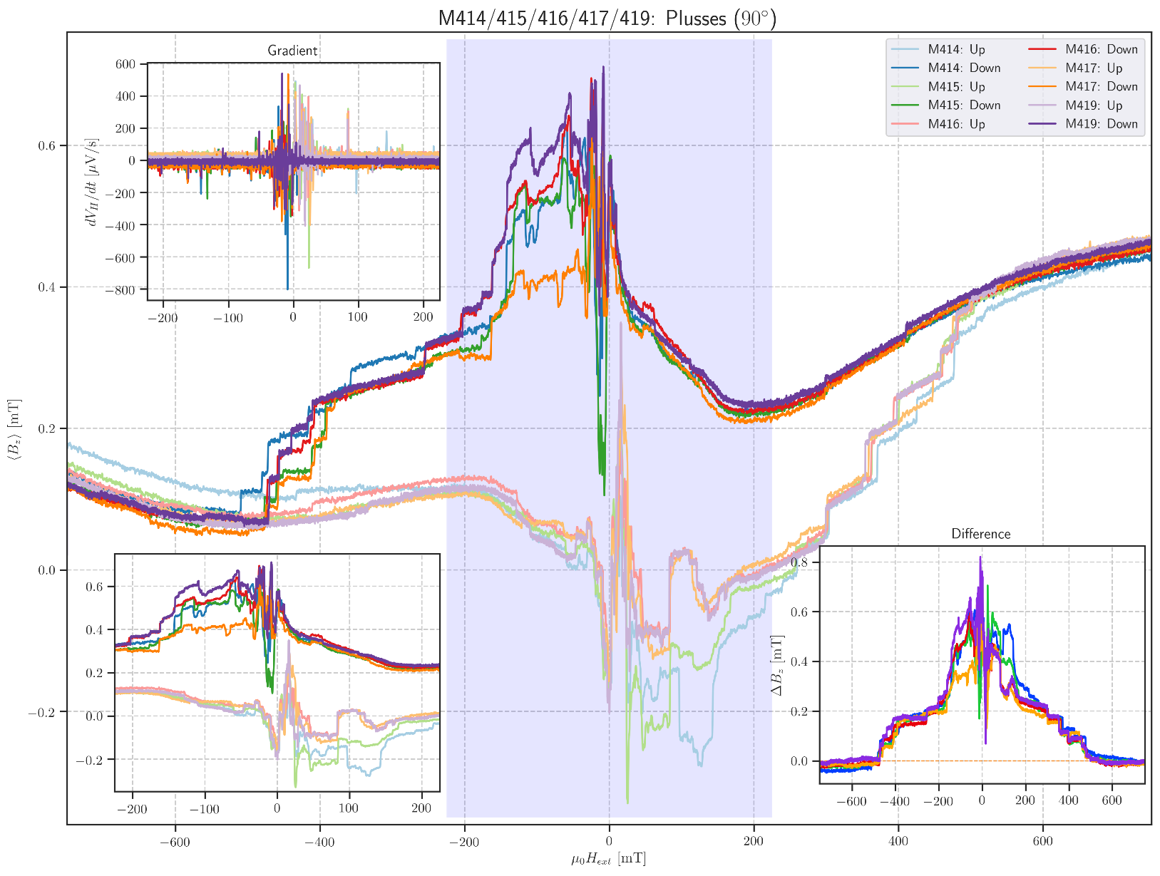

Montag, 2. März 2020

11:34

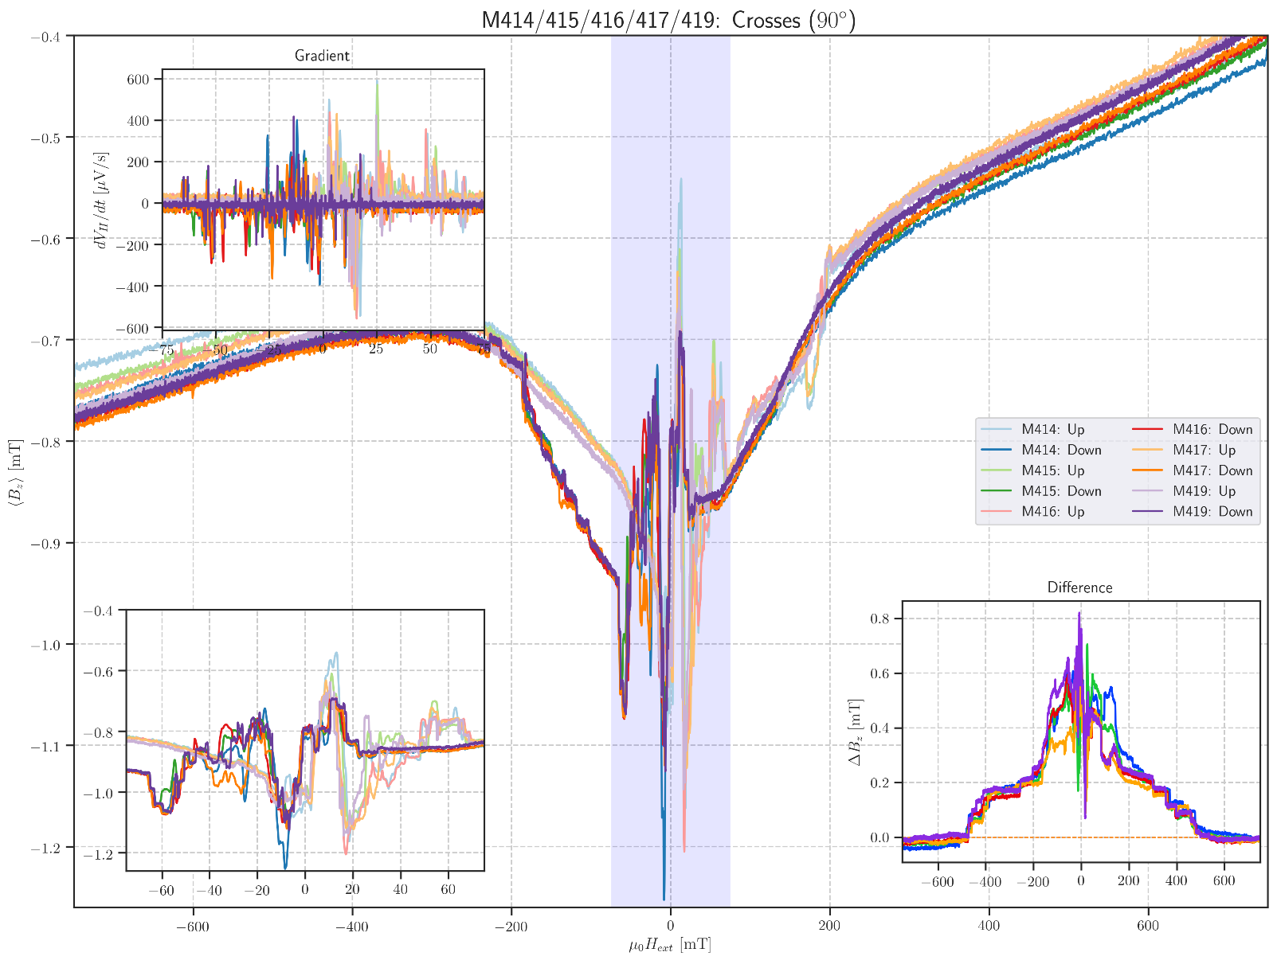

**m414:** PlussesCrossesEmpty\_Parallel Hloop\_(90)deg\_10mT/min

Montag, 2. März 2020

10:06

|  |  |
| --- | --- |
| Float/Ground: | Ground |
| AC/DC: | AC |
| A/A-B: | A-B |
| Reserve: | Normal |
| Source: | Internal |

|  |  |
| --- | --- |
| Angle of sensor θ | *90* |
|  |  |
|  |  |
|  | |  |  | | --- | --- | |  | *1* | |  | 10 | |
|  | R12 = 40/1000\*50 = |
|  |  |
| *Period of measurement (min)* |  |
| *Notes* |  |
| *Data files* |  |
| *Plot* |  |

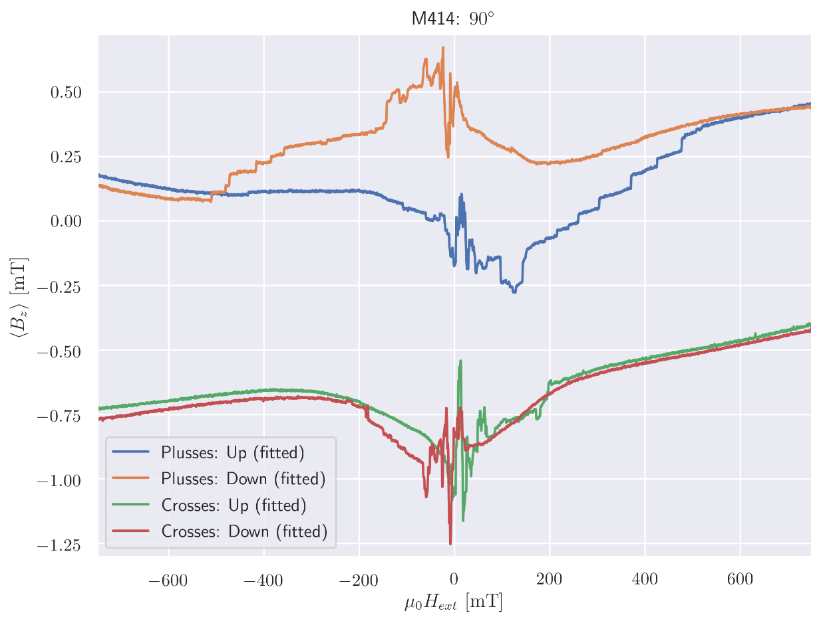

**m415:** PlussesCrossesEmpty\_Parallel Hloop\_(90)deg\_10mT/min

Montag, 2. März 2020

10:06

|  |  |
| --- | --- |
| Float/Ground: | Ground |
| AC/DC: | AC |
| A/A-B: | A-B |
| Reserve: | Normal |
| Source: | Internal |

|  |  |
| --- | --- |
| Angle of sensor θ | *90* |
|  |  |
|  |  |
|  | |  |  | | --- | --- | |  | *1* | |  | 10 | |
|  | R12 = 40/1000\*50 = |
|  |  |
| *Period of measurement (min)* |  |
| *Notes* |  |
| *Data files* |  |
| *Plot* |  |

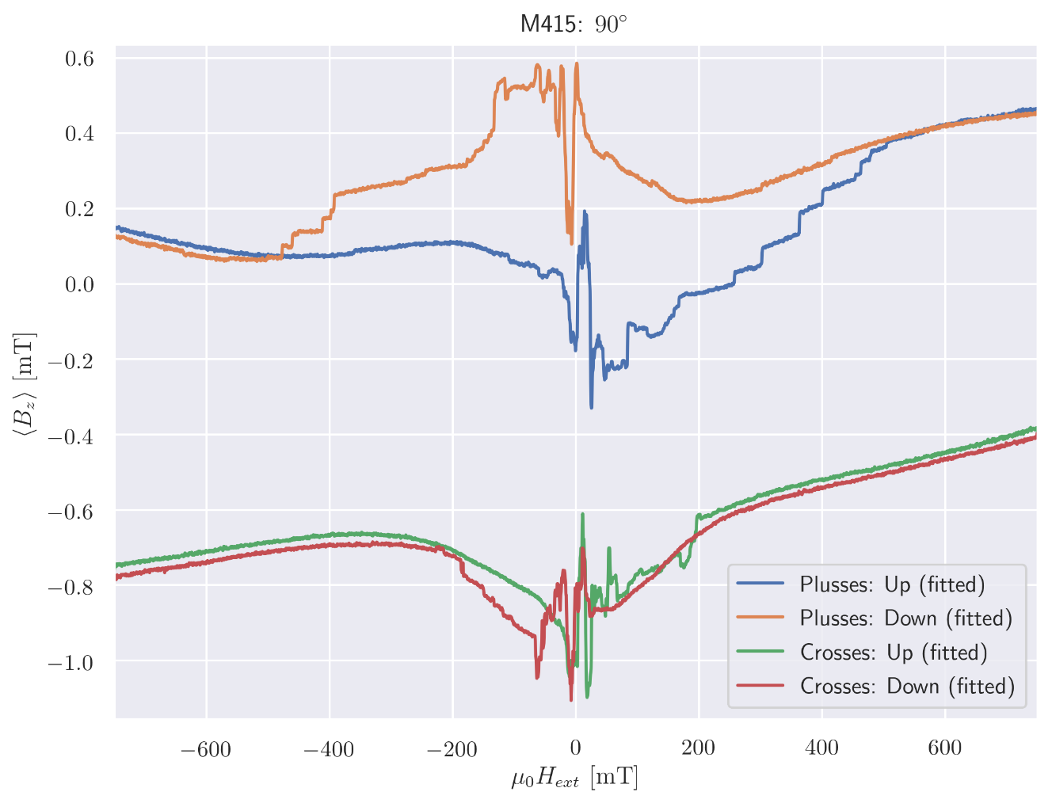

**m416:** PlussesCrossesEmpty\_Parallel Hloop\_(90)deg\_10mT/min

Montag, 2. März 2020

10:06

|  |  |
| --- | --- |
| Float/Ground: | Ground |
| AC/DC: | AC |
| A/A-B: | A-B |
| Reserve: | Normal |
| Source: | Internal |

|  |  |
| --- | --- |
| Angle of sensor θ | *90* |
|  |  |
|  |  |
|  | |  |  | | --- | --- | |  | *1* | |  | 10 | |
|  | R12 = 40/1000\*50 = |
|  |  |
| *Period of measurement (min)* |  |
| *Notes* |  |
| *Data files* |  |
| *Plot* |  |

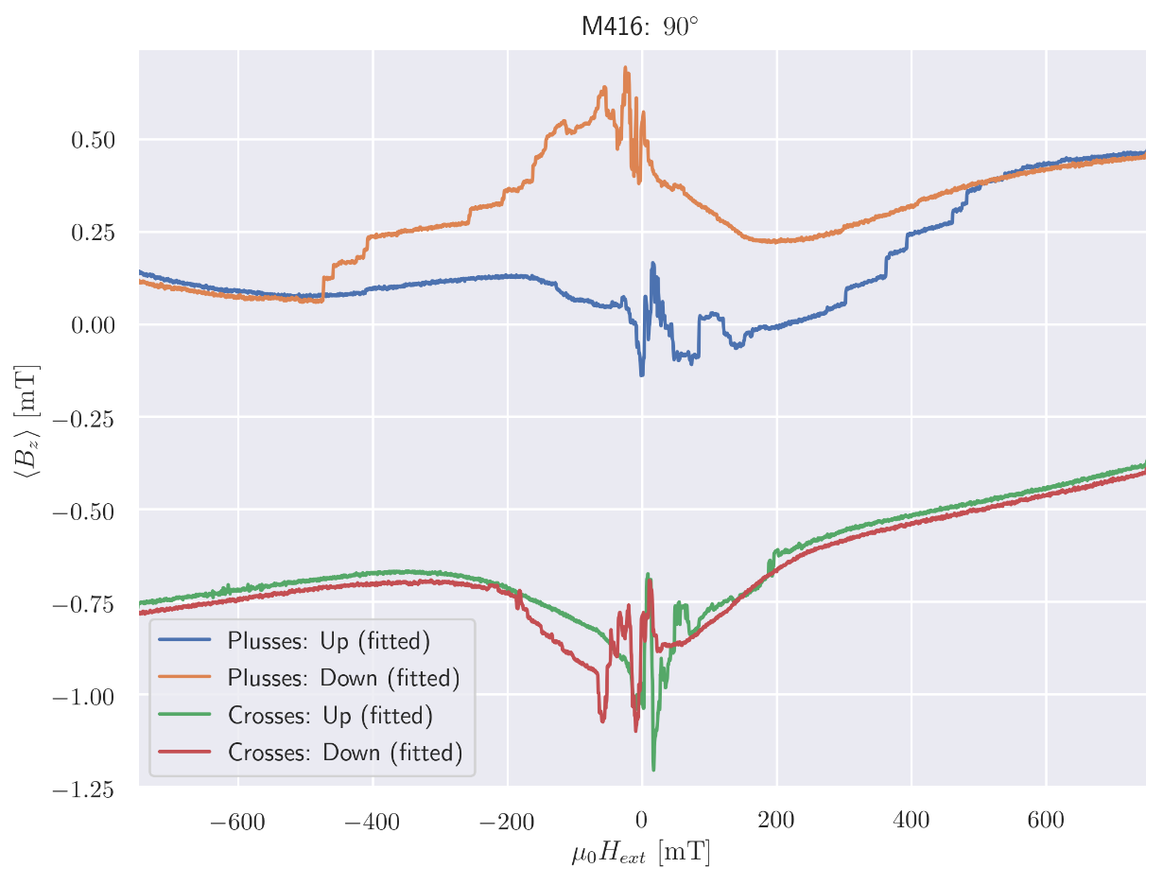

**m417:** PlussesCrossesEmpty\_Parallel Hloop\_(90)deg\_10mT/min

Montag, 2. März 2020

10:07

|  |  |
| --- | --- |
| Float/Ground: | Ground |
| AC/DC: | AC |
| A/A-B: | A-B |
| Reserve: | Normal |
| Source: | Internal |

|  |  |
| --- | --- |
| Angle of sensor θ | *90* |
|  |  |
|  |  |
|  | |  |  | | --- | --- | |  | *1* | |  | 10 | |
|  | R12 = 40/1000\*50 = |
|  |  |
| *Period of measurement (min)* |  |
| *Notes* |  |
| *Data files* |  |
| *Plot* |  |

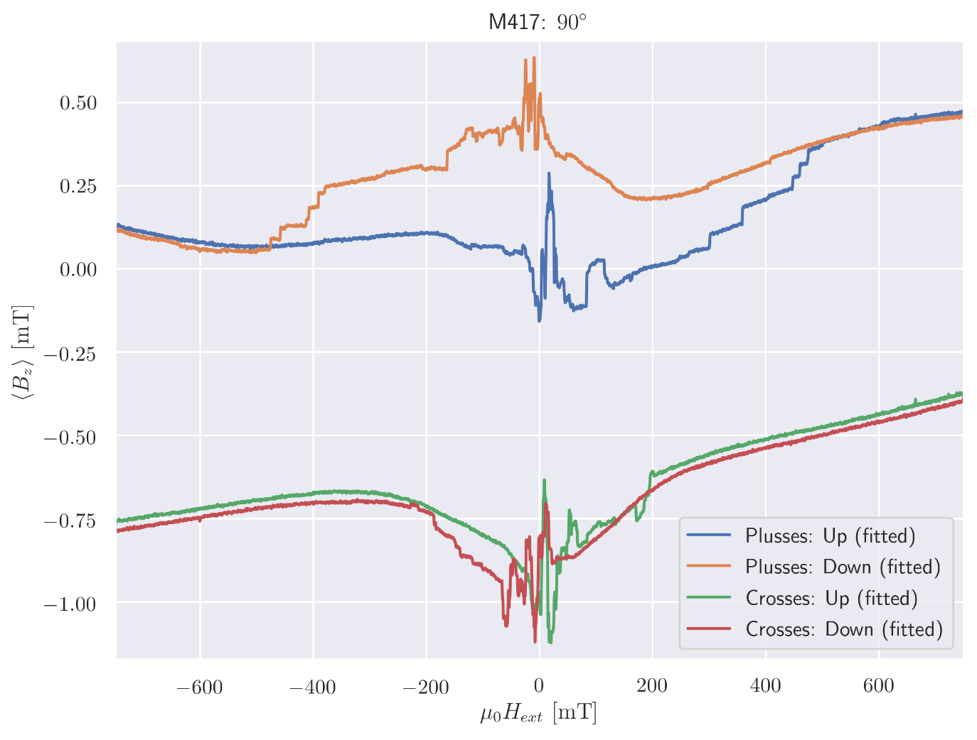

**m418:** PlussesCrossesEmpty\_Parallel Hloop\_(90)deg\_10mT/min

Montag, 2. März 2020

10:07

|  |  |
| --- | --- |
| Float/Ground: | Ground |
| AC/DC: | AC |
| A/A-B: | A-B |
| Reserve: | Normal |
| Source: | Internal |

|  |  |
| --- | --- |
| Angle of sensor θ | *90* |
|  |  |
|  |  |
|  | |  |  | | --- | --- | |  | *1* | |  | 10 | |
|  | R12 = 40/1000\*50 = |
|  |  |
| *Period of measurement (min)* |  |
| *Notes* | *Python experienced an error on down sweep!*  *Only up sweep available.* |
| *Data files* |  |
| *Plot* |  |

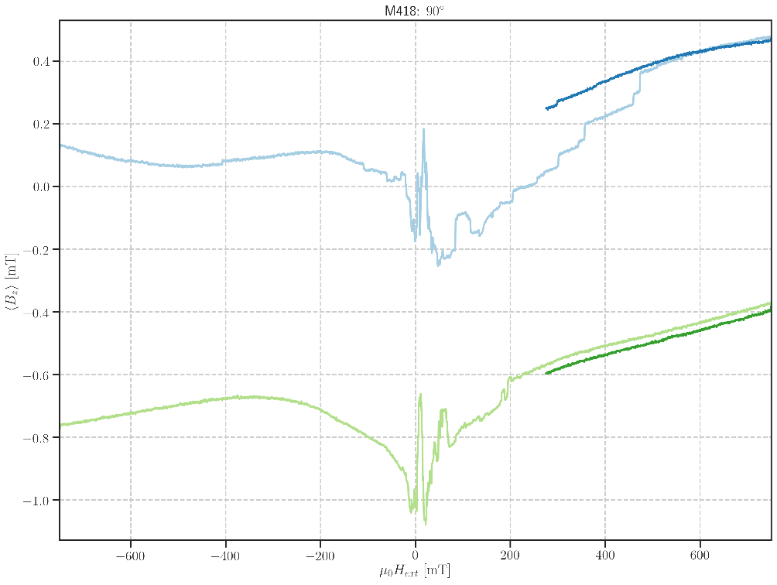

**m419: SLOW** PlussesCrossesEmpty\_Parallel Hloop\_(90)deg\_2mT/min

Montag, 2. März 2020

10:14

|  |  |
| --- | --- |
| Float/Ground: | Ground |
| AC/DC: | AC |
| A/A-B: | A-B |
| Reserve: | Normal |
| Source: | Internal |

|  |  |
| --- | --- |
| Angle of sensor θ | *90* |
|  |  |
|  |  |
|  | |  |  | | --- | --- | |  | *1* | |  | 2 | |
|  | R12 = 40/1000\*50 = |
|  |  |
| *Period of measurement (min)* |  |
| *Notes* | *Weird values in Lock-in 9: (Lines with weird values removed from evaluation.)* |
| *Data files* |  |
| *Plot* |  |

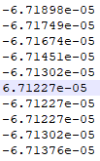

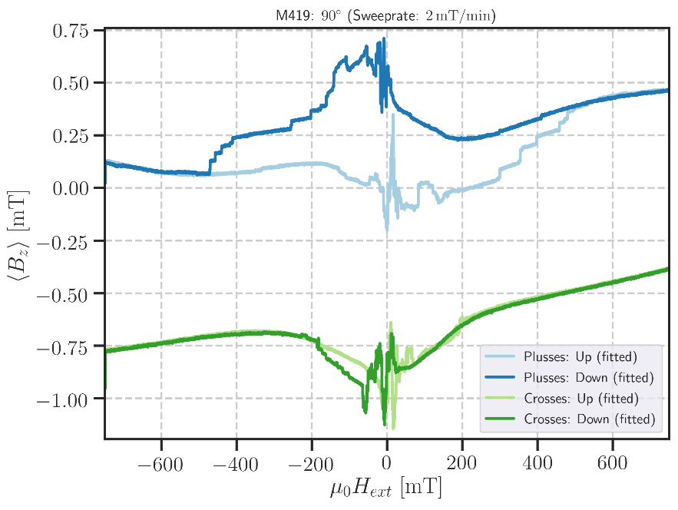

**m420:** PlussesCrossesEmpty\_Parallel Hloop\_(90)deg\_10mT/min

Mittwoch, 4. März 2020

16:29

|  |  |
| --- | --- |
| Float/Ground: | Ground |
| AC/DC: | AC |
| A/A-B: | A-B |
| Reserve: | Normal |
| Source: | Internal |

|  |  |
| --- | --- |
| Angle of sensor θ | *90* |
|  |  |
|  |  |
|  | |  |  | | --- | --- | |  | *1* | |  | 10 | |
|  | R12 = 40/1000\*50 = |
|  |  |
| *Period of measurement (min)* |  |
| *Notes* | *Measurement stopped because of python error on up sweep around 0 field.*  *Only down sweep available!* |
| *Data files* |  |
| *Plot* |  |

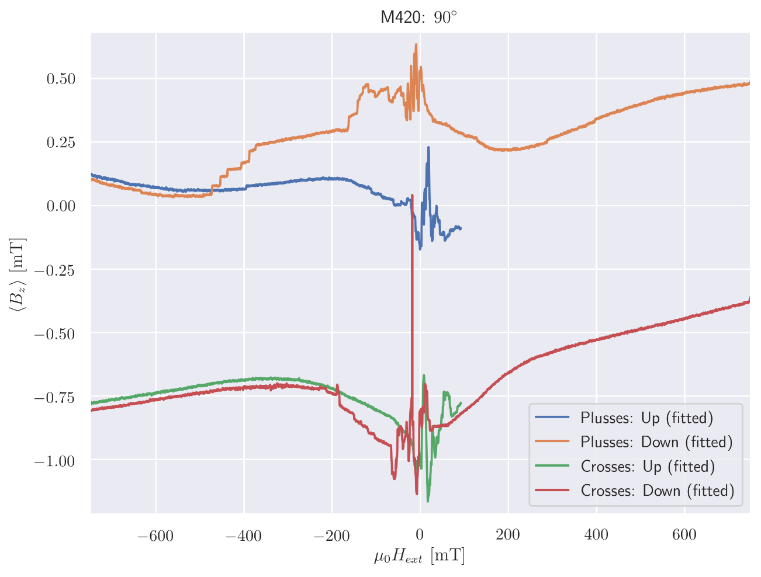

**m421:** PlussesCrossesEmpty\_Parallel Hloop\_(90)deg\_10mT/min

Mittwoch, 4. März 2020

16:31

|  |  |
| --- | --- |
| Float/Ground: | Ground |
| AC/DC: | AC |
| A/A-B: | A-B |
| Reserve: | Normal |
| Source: | Internal |

|  |  |
| --- | --- |
| Angle of sensor θ | *90* |
|  |  |
|  |  |
|  | |  |  | | --- | --- | |  | *1* | |  | 10 | |
|  | R12 = 40/1000\*50 = |
|  |  |
| *Period of measurement (min)* |  |
| *Notes* |  |
| *Data files* |  |
| *Plot* |  |

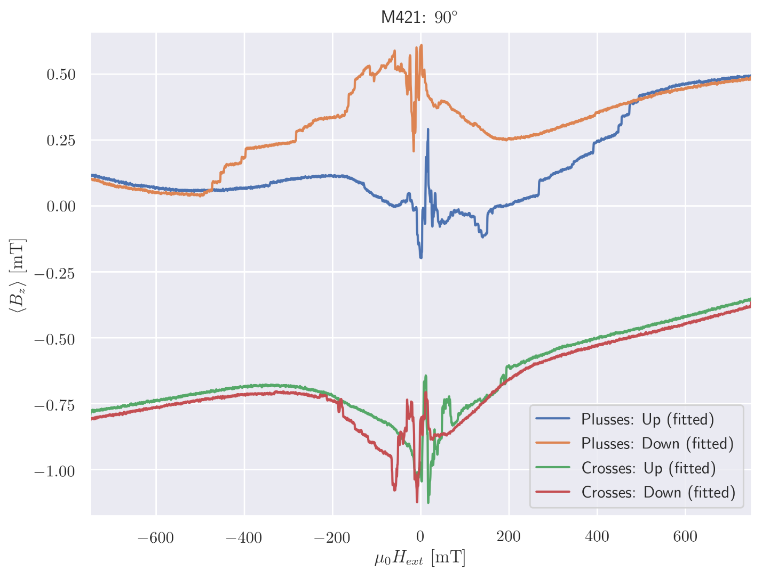

**m422:** PlussesCrossesEmpty\_Parallel Hloop\_(90)deg\_10mT/min

Mittwoch, 4. März 2020

16:32

|  |  |
| --- | --- |
| Float/Ground: | Ground |
| AC/DC: | AC |
| A/A-B: | A-B |
| Reserve: | Normal |
| Source: | Internal |

|  |  |
| --- | --- |
| Angle of sensor θ | *90* |
|  |  |
|  |  |
|  | |  |  | | --- | --- | |  | *1* | |  | 10 | |
|  | R12 = 40/1000\*50 = |
|  |  |
| *Period of measurement (min)* |  |
| *Notes* |  |
| *Data files* |  |
| *Plot* |  |

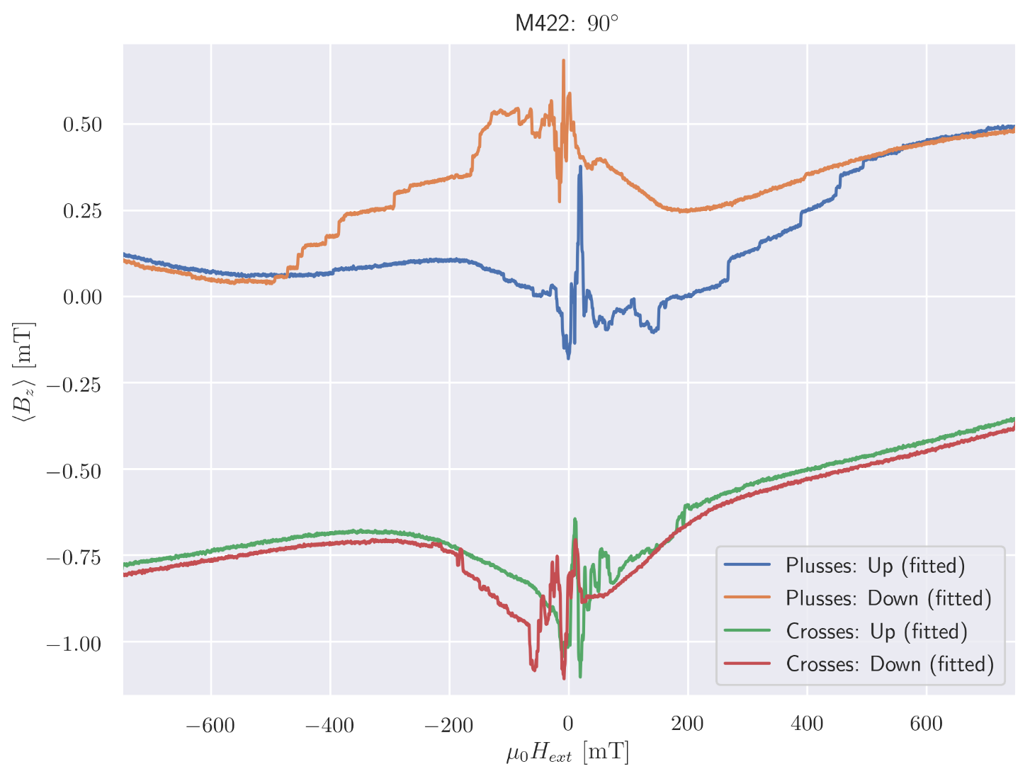

**m423:** PlussesCrossesEmpty\_Parallel Hloop\_(90)deg\_10mT/min

Mittwoch, 4. März 2020

16:32

|  |  |
| --- | --- |
| Float/Ground: | Ground |
| AC/DC: | AC |
| A/A-B: | A-B |
| Reserve: | Normal |
| Source: | Internal |

|  |  |
| --- | --- |
| Angle of sensor θ | *90* |
|  |  |
|  |  |
|  | |  |  | | --- | --- | |  | *1* | |  | 10 | |
|  | R12 = 40/1000\*50 = |
|  |  |
| *Period of measurement (min)* |  |
| *Notes* |  |
| *Data files* |  |
| *Plot* |  |

**Change Angle m424:** ParallelFast Hloop\_(90)deg\_100mT/min

Dienstag, 10. März 2020

13:43

|  |  |
| --- | --- |
| Float/Ground: | Ground |
| AC/DC: | AC |
| A/A-B: | A-B |
| Reserve: | Normal |
| Source: | Internal |

|  |  |
| --- | --- |
| Angle of sensor θ | *90* |
|  |  |
|  |  |
|  | |  |  | | --- | --- | |  | *1* | |  | 10 | |
|  | R12 = 40/1000\*50 = |
|  |  |
| *Period of measurement (min)* |  |
| *Notes* | *Minimizing the Signal again for parallel Setup.* |
| *Data files* |  |
| *Plot* |  |

**m425/26:** PlussesCrossesEmpty\_Parallel Relaxation\_(90)deg\_5mT/min

Dienstag, 10. März 2020

13:44

|  |  |
| --- | --- |
| Float/Ground: | Ground |
| AC/DC: | AC |
| A/A-B: | A-B |
| Reserve: | Normal |
| Source: | Internal |

|  |  |
| --- | --- |
| Angle of sensor θ | *90* |
|  |  |
|  |  |
|  | |  |  | | --- | --- | |  | *1 -> -.015* | |  | 5 | |
|  |  |
| *Period of measurement (min)* |  |
| *Notes* | *Measuring Relaxation effect (stopping at -15 mT and waiting).* |
| *Data files* |  |
| *Plot* |  |

**m427:** PlussesCrossesEmpty\_Parallel Relaxation\_(90)deg\_5mT/min

Dienstag, 10. März 2020

13:47

|  |  |
| --- | --- |
| Float/Ground: | Ground |
| AC/DC: | AC |
| A/A-B: | A-B |
| Reserve: | Normal |
| Source: | Internal |

|  |  |
| --- | --- |
| Angle of sensor θ | *90* |
|  |  |
|  |  |
|  | |  |  | | --- | --- | |  | *1 -> -0.014* | |  | 5 | |
|  | R12 = 40/1000\*50 = |
|  |  |
| *Period of measurement (min)* |  |
| *Notes* |  |
| *Data files* |  |
| *Plot* |  |

**m428:** PlussesCrossesEmpty\_Parallel Hloop\_(90)deg\_10mT/min

Dienstag, 10. März 2020

13:48

|  |  |
| --- | --- |
| Float/Ground: | Ground |
| AC/DC: | AC |
| A/A-B: | A-B |
| Reserve: | Normal |
| Source: | Internal |

|  |  |
| --- | --- |
| Angle of sensor θ | *90* |
|  |  |
|  |  |
|  | |  |  | | --- | --- | |  | *0.75* | |  | 10 | |
|  | R12 = 40/1000\*50 = |
|  |  |
| *Period of measurement (min)* |  |
| *Notes* |  |
| *Data files* |  |

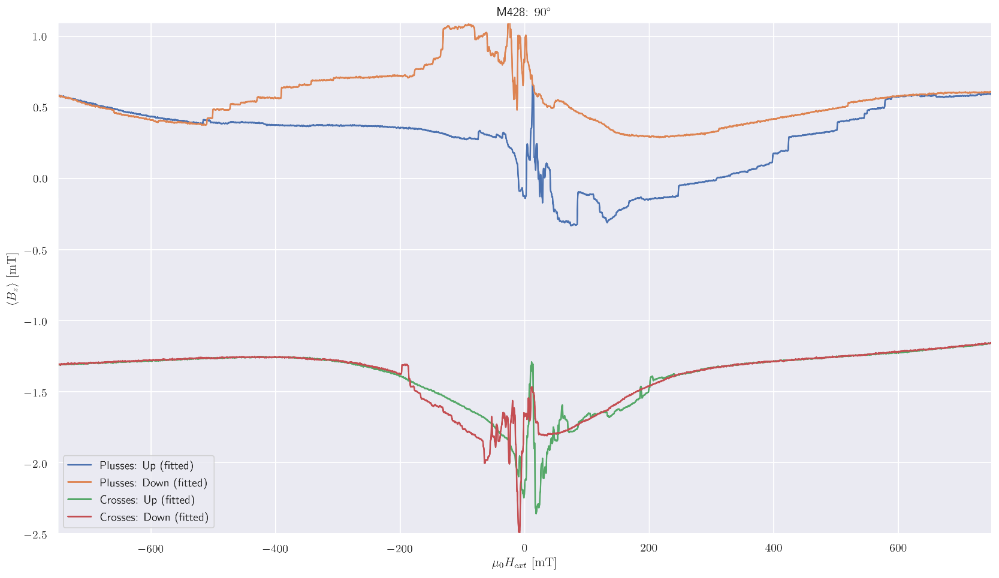

**Change Angle:** 10deg

Mittwoch, 11. März 2020

12:02

|  |  |
| --- | --- |
| Float/Ground: | Ground |
| AC/DC: | AC |
| A/A-B: | A-B |
| Reserve: | Normal |
| Source: | Internal |

|  |  |
| --- | --- |
| Angle of sensor θ | *10* |
|  |  |
|  |  |
|  | |  |  | | --- | --- | |  | *1* | |
|  |  |
| *Notes* | *Changing Angle to 0deg to measure new maximum Voltage: V\_Max = 11.717 mV* |

Aiming for Hall Voltage:



**Voltage measured:**



**m429:** Plusses\_Hloop\_(10)deg

Sonntag, 7. April 2019

01:34



|  |  |
| --- | --- |
| Float/Ground: | Ground |
| AC/DC: | AC |
| A/A-B: | A-B |
| Reserve: | Normal |
| Source: | Internal |

|  |  |
| --- | --- |
| Angle of sensor θ | *10* |
|  |  |
|  |  |
|  | |  |  | | --- | --- | |  | *0.5* | |  | 5 | |
|  | R12 = 260/1000\*50 = 13 |
|  |  |
| *Period of measurement (min)* | *400* |
| *Notes* |  |
| *Data files* | |  |  |  | | --- | --- | --- | | <<M429.0\_Plusses\_10deg\_Hloop\_test\_\_GradioFast\_20200310\_1400\_I1-1-13\_I2-8-6\_GBIP8-14-7\_Vin-2.5V\_R11-1MO\_R12-8kO\_R13-0\_R21-1MO\_C11-1\_C21-6\_T-30K\_SR-0.2-T-min\_B-0.5T\_gate-0V.dat>> |  | Balancing Gradiometry (fast) | | <<M429.1\_Plusses\_10deg\_Hloop\_down\_\_GradioFast\_20200310\_1400\_I1-1-13\_I2-8-6\_GBIP8-14-7\_Vin-2.5V\_R11-1MO\_R12-13kO\_R13-0\_R21-1MO\_C11-1\_C21-1\_T-30K\_SR-0.1-T-min\_B-0.5T\_gate-0V.dat>> | <<M429.1\_Plusses\_10deg\_Hloop\_down\_\_GradioFast\_20200310\_1400\_I1-1-13\_I2-8-6\_GBIP8-14-7\_Vin-2.5V\_R11-1MO\_R12-13kO\_R13-0\_R21-1MO\_C11-1\_C21-1\_T-30K\_SR-0.005-T-min\_B-0.5T\_gate-0tEST2.dat>> | *Balancing Sensitivity (fast)* | | <<M429\_Plusses\_10deg\_Hloop\_up\_\_Gradio\_20200310\_1500\_I1-1-13\_I2-8-6\_GBIP8-14-7\_Vin-2.5V\_R11-1MO\_R12-13kO\_R13-0\_R21-1MO\_C11-1\_C21-1\_T-30K\_SR-0.005-T-min\_B-0.5T\_gate-0V.dat>> | <<M429\_Plusses\_10deg\_Hloop\_down\_\_Gradio\_20200310\_1500\_I1-1-13\_I2-8-6\_GBIP8-14-7\_Vin-2.5V\_R11-1MO\_R12-13kO\_R13-0\_R21-1MO\_C11-1\_C21-1\_T-30K\_SR-0.005-T-min\_B-0.5T\_gate-0V.dat>> | *Measurement* | |

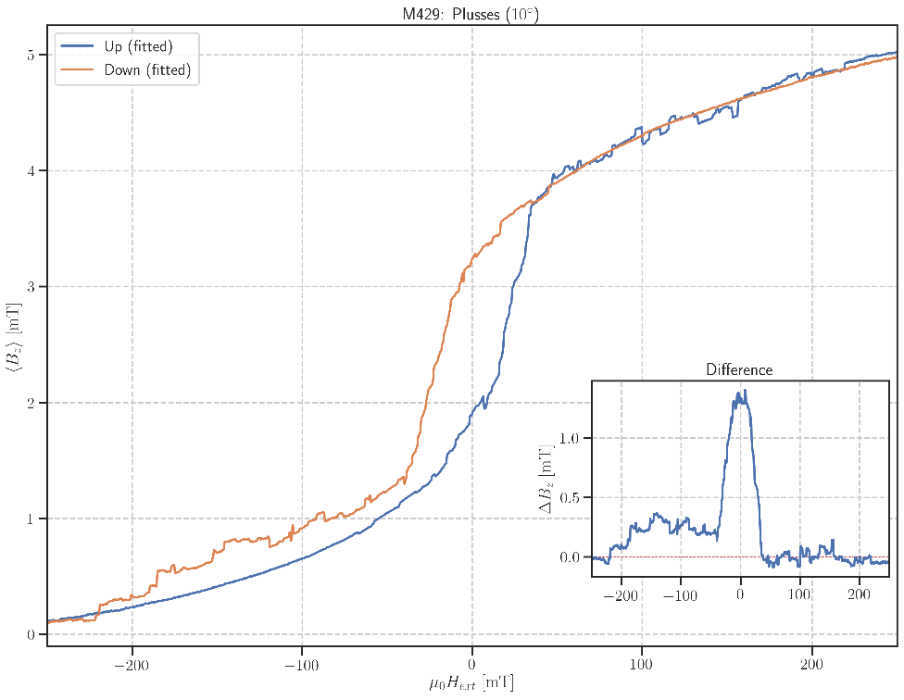

**Change Angle:** 45deg

Mittwoch, 11. März 2020

12:02

|  |  |
| --- | --- |
| Float/Ground: | Ground |
| AC/DC: | AC |
| A/A-B: | A-B |
| Reserve: | Normal |
| Source: | Internal |

|  |  |
| --- | --- |
| Angle of sensor θ | *10* |
|  |  |
|  |  |
|  | |  |  | | --- | --- | |  | *1* | |
|  |  |
| *Notes* | *Changing Angle to 0deg to measure new maximum Voltage: V\_Max = 11.733 mV* |

Aiming for Hall Voltage:



**Voltage measured:**



**m430:** Plusses\_Gradio Hloop\_(45)deg\_10mT/min

Mittwoch, 11. März 2020

15:01

|  |  |
| --- | --- |
| Float/Ground: | Ground |
| AC/DC: | AC |
| A/A-B: | A-B |
| Reserve: | Normal |
| Source: | Internal |

|  |  |
| --- | --- |
| Angle of sensor θ | *90* |
|  |  |
|  | *I2 = 8-6* |
|  | |  |  | | --- | --- | |  | *.4* | |  | 10 | |
|  | R12 = 270/1000\*50 = 13,5 |
|  |  |
| *Period of measurement (min)* |  |
| *Notes* |  |
| *Data files* |  |
| *Plot* |  |